4CS012 –Server Management and Virtualisation

Workshop 2 - Windows Server Roles

STUDENT NAME: Injun Kim
STUDENT NUMBER: 2612972
You will need to complete the workshop tasks, answer the questions and then submit this Word file, complete with your screenshots and answers, via Canvas.
The Windows Server that you have set up can perform many Server Roles. In this workshop, your existing Windows Server installation will be configured to perform file storage server. First it will be configured as a network Windows File Server, and then as a FTP Server.

Part 1 - Setting up as a Windows File Server
In this first part, we are setting up the server as a network file server.
Task 1 - Configuring the Windows File Server
- First you need to make sure EC2 firewall rules are set to accept FTP traffic.
- Go on the AWS instances page, select your server and click on the Security Groups Settings
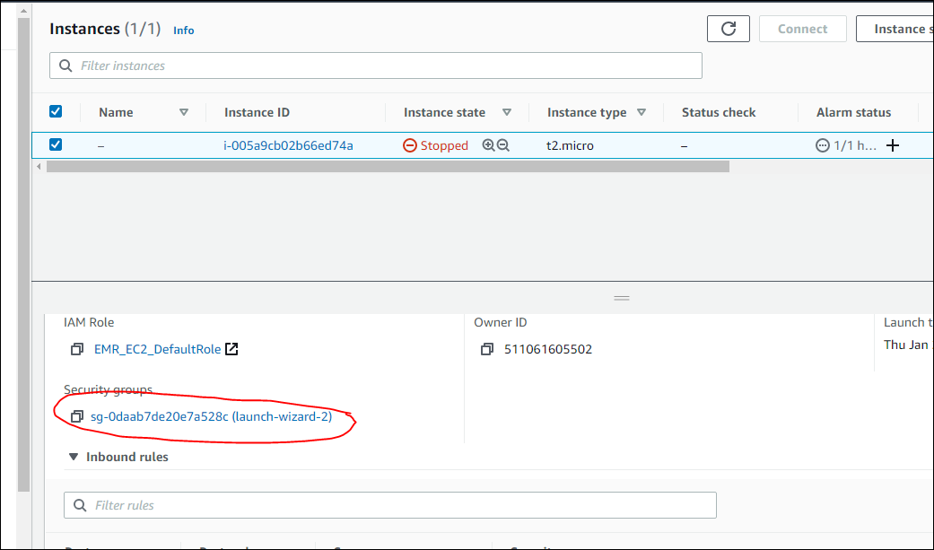
- You are now going to add a firewall rule to allow FTP. Click on Edit inbound rules
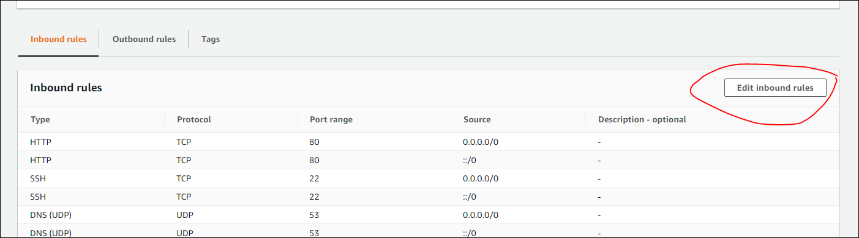
- Add rule and select a “Custom TCP”, add port “21” and allow from “Anywhere”. Add rule and exit.
- You also have to add rules to accept passive FTP connections. Using the same process as above, add a rule with port range “49152-65534”
- Now Start up your Windows Server virtual machine and log in.
- In order for the Windows File Server to authenticate its resources, you need to have users on the server.
- Please refer to the details of the user you created in Workshop 1 (your user should be your student ID and a password of ABCdef123).
- Start “Server Manager” if it is not already running.
- Click “Add roles and features” and click next.
- For “Installation Type”, make sure “Role-based or feature-based installation” is selected, then click “Next”.
- On “Server Selection”, click “Next”.
- On “Server Roles”, click on “File and Storage Services” to expand the list, as below:
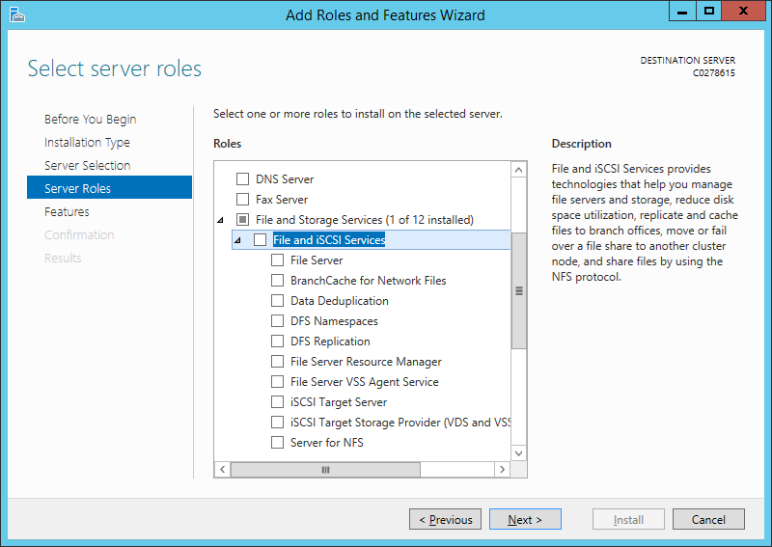
- Select “File Server” and click “Next”.
- On “Features”, keep the default, and click “Next”.
- On “Confirmation”, click “Install”.
- Open “File Explorer”, and go to the C: drive. Create a new folder, called “Shared”.
- Click on “Shared”, and click “Share”

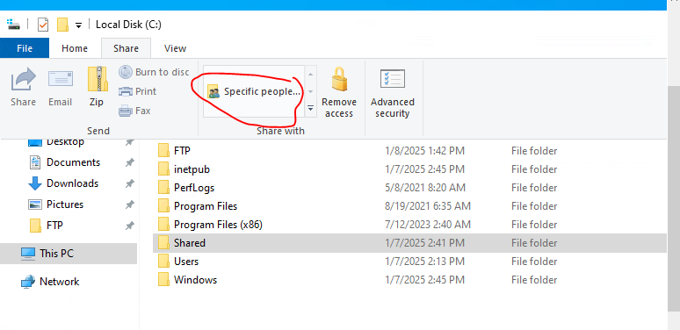

  - Type your username in the box and click “add”. Change the permissions of the user to “Read/Write” and click “Share”

Task 2 - Connecting to the File Server from the client
- You will now connect to the folder hosted on your server using the username they have created with your ID
- First get your server’s public IP address note it down here

[Your IP address]
98.93.214.108
- Start Windows Explorer on your client machine
- In the Address field, enter \\”your server’s IP” address, for example:
\\54.167.23.179
(Obviously, use your own server's IP address)
- You will be prompted for a login. Use the username and password of the user with your ID.
- Open up the “Shared” folder on the server and create a new text file with your Student ID:
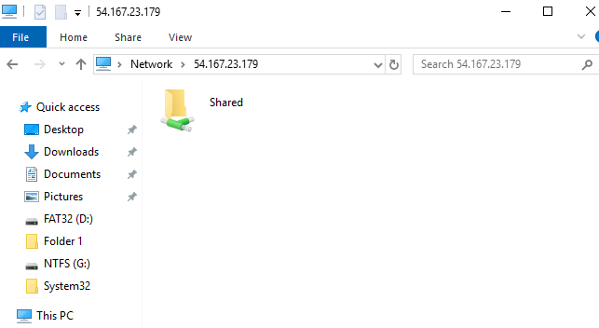

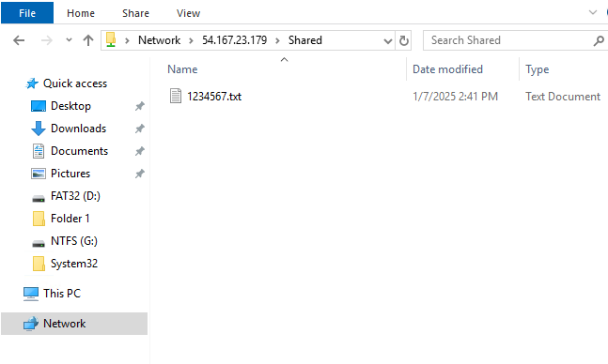
- Capture and paste your screen below:
[Paste your screen shot here] (marks) 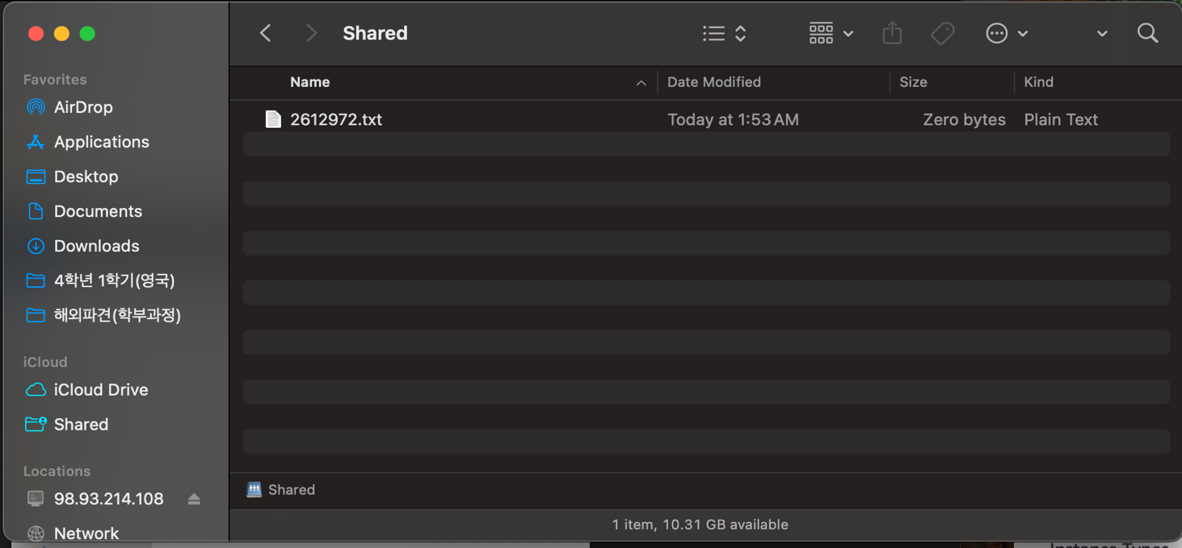

Task 4 - Create another shared folder
- On your Windows Server, go to the "Server Manager" screen, click on "File and Storage Services".
- Click on “Shares”. You should get the following screen:
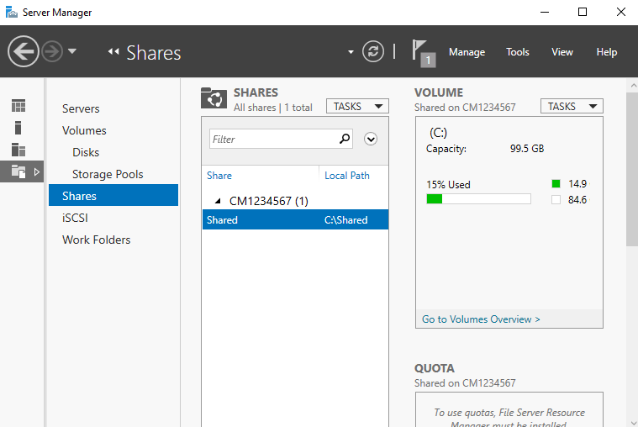
- Right-click in the white space under “Shared”, and click “New Share…”
- In “New Share Wizard”, click “Next”.
- On the “Share Location” screen, click “Type a custom path”, and then click “Browse”.
- In “Select Folder”, browse to the C: drive, then create a new folder there. Click “Select folder”. Make sure that the path now points to the folder that you have created.
- 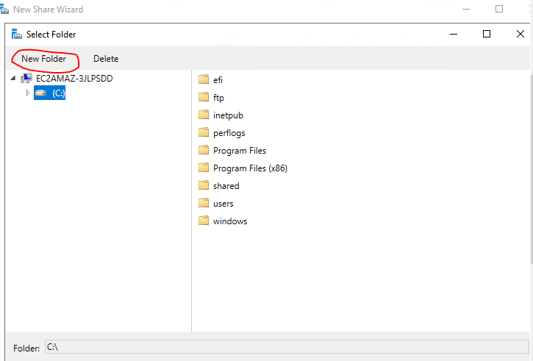
- Click “Next” to get to the “Share Name” screen, and give the Share a name. Click “Next”.
- On “Other Settings”, click “Next”.
- On “Permissions”, click “Customize Permissions”.
- On the new window, click “Add”.
- Click where it says “Select a principal”:
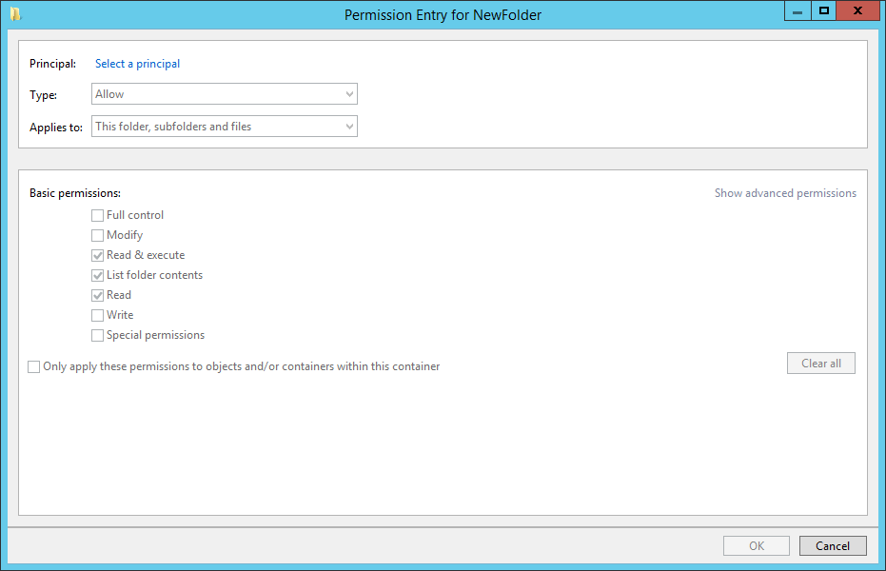
- In the “Select User or Group” box, type in your username, and then click “Check Names”.
- Click “OK” to close.
- Make sure “Full control” is ticked for “Basic Permissions” (All boxes ticked, except Special Permissions”), before clicking “OK”.
- Click the “Share” tab.
- Click “Add”.
- Click where it says “Select a principal”:
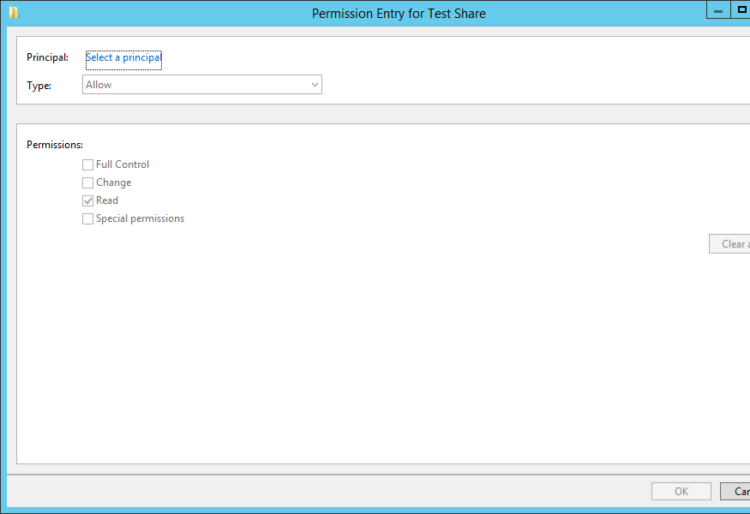
- In the “Select User or Group” box, type in your username, and then click “Check Names”.
- Click “OK” to close.
- Under “Permissions”, make sure “Full Control”, “Change” and “Read” are selected, then click “OK”.
- Click “Apply”, followed by “OK”.
- Click “Next”, and finally “Create”. When complete, click “Close”.
- You will now connect from you client to the new shared folder create a new file with your name.
[Paste your screen shot here] (marks)

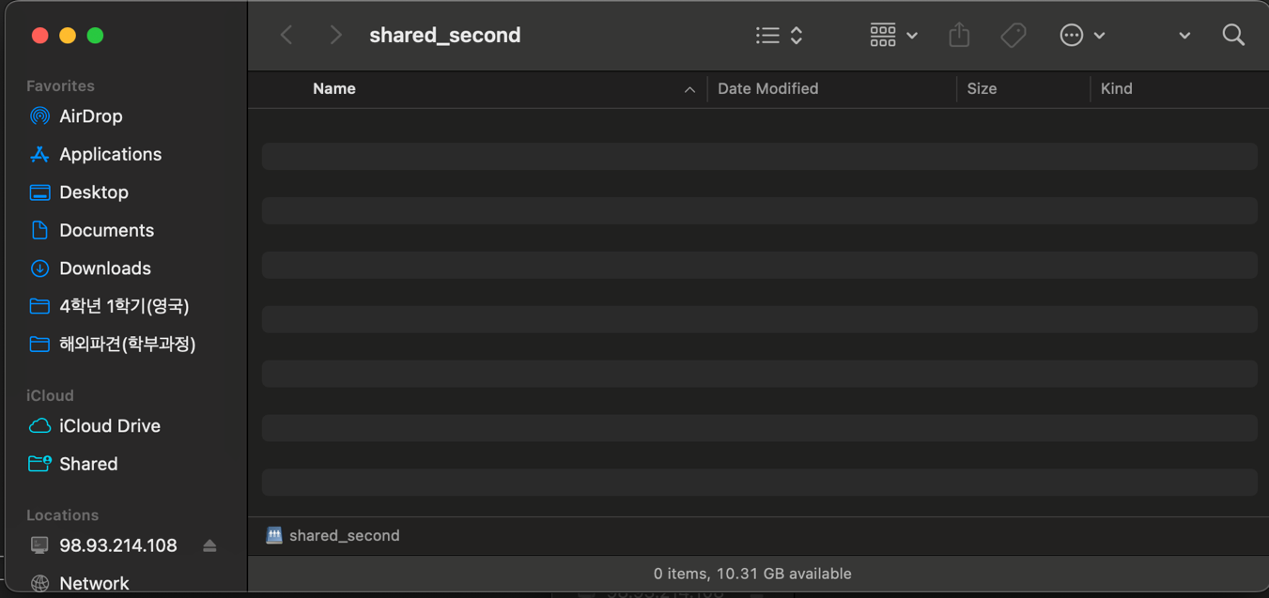

Part 2 - Windows Server as an FTP Server

As you have seen in the previous task, Windows Server can perform a number of Server Roles. In this part of the workshop, your existing Windows Server installation will be configured to perform as an FTP Server.
In order to access the server however, a client will be need. You can use your existing Windows machine you are accessing the cloud on (not the server) .
You need to find out the IP address of the client machine. Investigate how you can find it and record the IP address below:
Question: What is your IP address of your client? 10.132.234.3

Task 2 - Installing the FTP Server Service
- Bring up the Server Manager (if it’s closed, you can re-open it from the taskbar)
- In the top right, click “Manage” and then “Add Roles and Features”, as below:
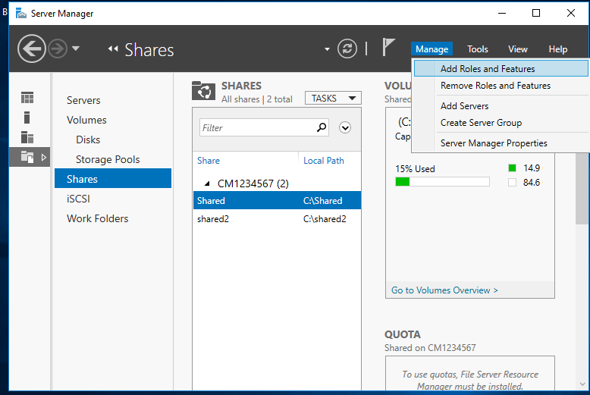
- In the Add Roles and Features Wizard, click “Next”.
- Tick “Role-based or feature-based installation”, click “Next”.
- Select this server, and click “Next”.
- On the “Server Roles” screen, click “Web Server (IIS)”. Another window should pop up.
- Make sure “Include management tools” is ticked, and click “Add features”.
- Now you can click “Next”.
- On the “Features” screen, click “Next”.
- On the “Web Server Role (IIS)” screen, click “Next”.
- On “Role Services”, scroll down the list, making sure all options are UNTICKED.
- Finally, tick FTP Service, and “IIS Management Console”, as below.

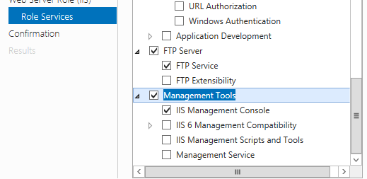

- Click “Next”, and then “Install”. The FTP server will install – and when it’s complete, click “Close”.
- If you open the Windows Search box and type “IIS”, you should see “Internet Information Services (IIS) Manager” appear. Click it
- IIS will load – this is the management console for creating websites and FTP sites on Windows Server.
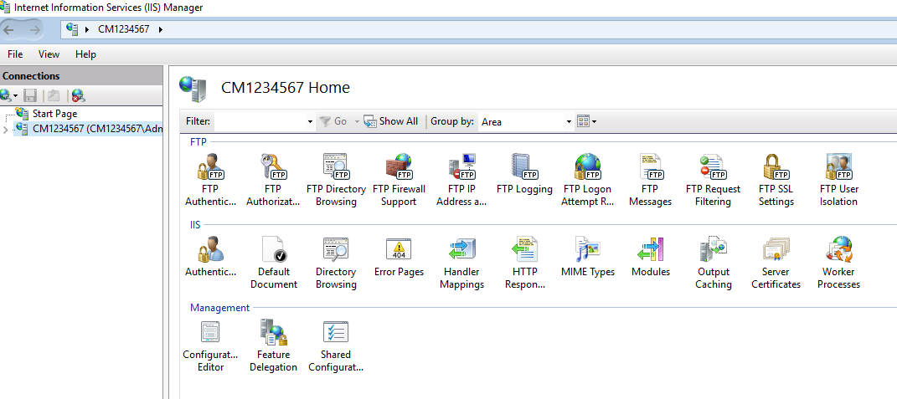
- If you click on the small triangle, next to your server name in the list on the left, it will expand to reveal:
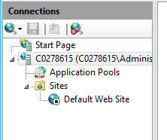

- Right-click on “Sites”, and select “Add FTP Site…”.
- For the FTP site name, call it your student number.
- For Physical Location, click the browser button (…), and navigate to the C: drive. Click “Make New Folder”, and create a new folder called “FTP” inside C:
- Your screen should look like:
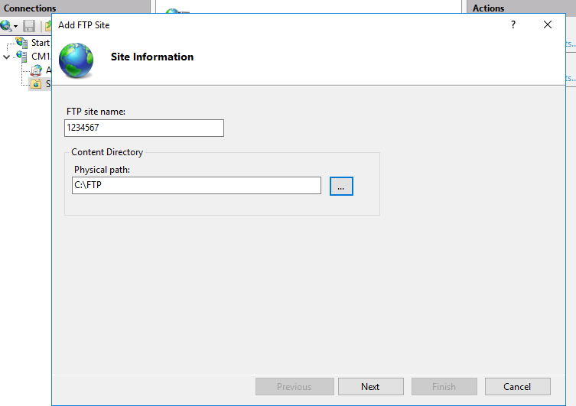
- Click “Next”.
- For IP address, leave “All unassigned”, and leave the port at 21.
- Tick “No SSL”, and then click “Next”.
- For “Authentication”, click “Anonymous”, and for “Authorization” select “Anonymous users”. Make sure “Read” is ticked for “Permissions” and then click “Finish”.
- Click on your new site (called your student number), and take a screenshot. It will look like:
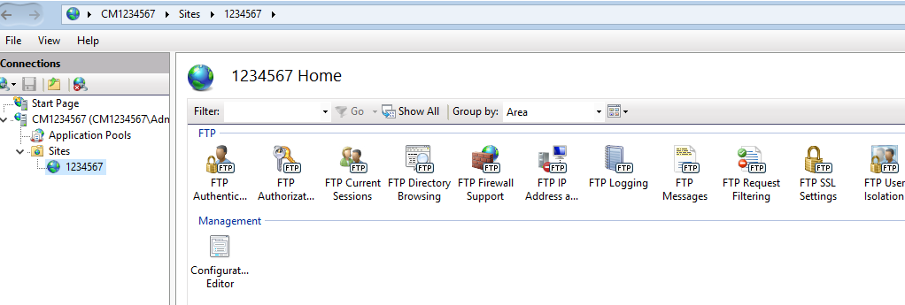

[Paste your screen shot here] (marks)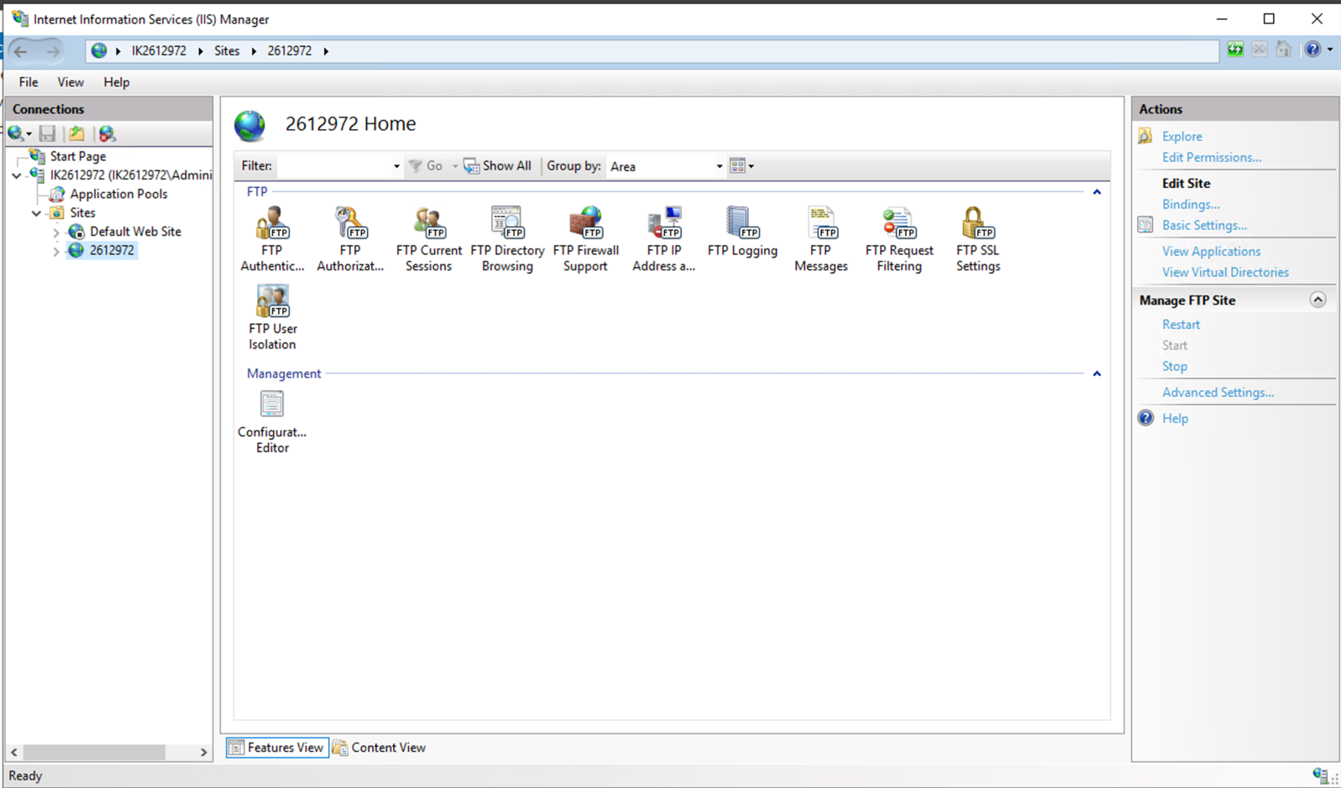

- Using File Explorer, browse to the C:\FTP folder you created.
- Create a new text file in the folder, called “Student number”FTP – it will look similar to:
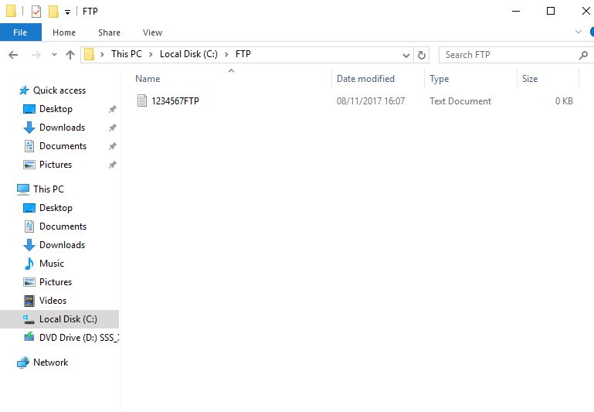
- Finally, we need to turn set the firewall rules to allow FTP traffic through.
- First go back to the IIS server page, and select the server name
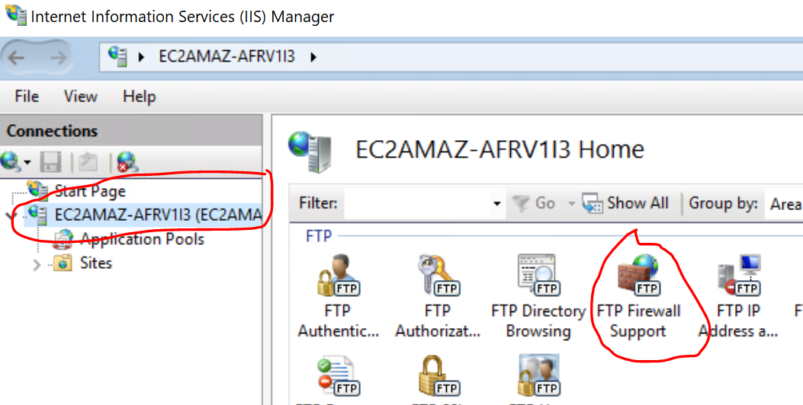

- Select FTP Firewall Support
- In the “Data port range” enter “49152-65534”
- You will now need to add the same ports on the Windows Firewall and AWS inbound port rules.
- Go to the Start Menu, and type in Firewall – “Windows Defender Firewall” should appear. Click it.
- Click on “Advanced Settings” and locate and click on “Inbound Rules”.
- Click “New rule” and then “port”. Complete the port numbers as below:
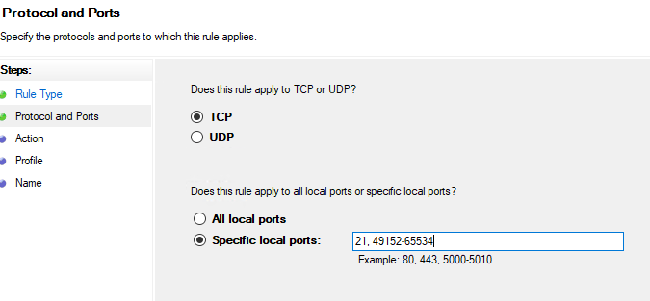
- Allow the connection and name it “FTP” in the last dialog window.

Task 4 - Installing and configuring a Graphical FTP Client
Download “Filezilla Client” and install it on your machine.
Start Filezilla and connect to your remote server using its “Public IP address”. In the Username box, type “anonymous”. Leave the password empty and put “21” in the port box and click “Quickconnect”.
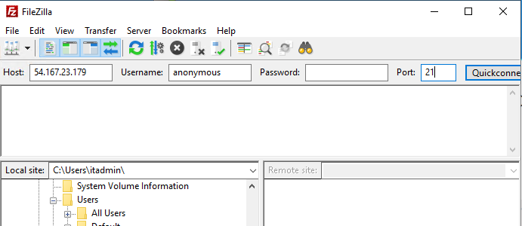
You will now be connected to your FTP server and you should see your file. Take a screenshot similar to the one below:
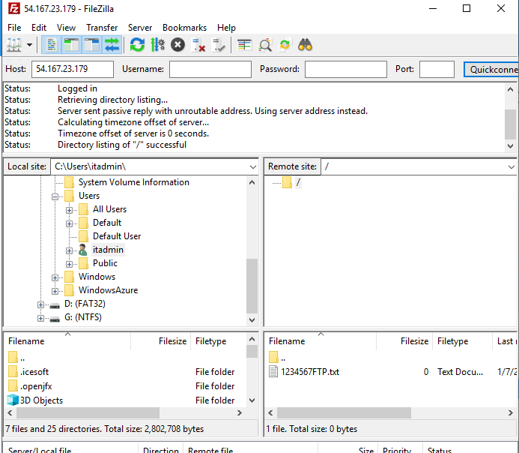

[Paste your screen shot here] (marks)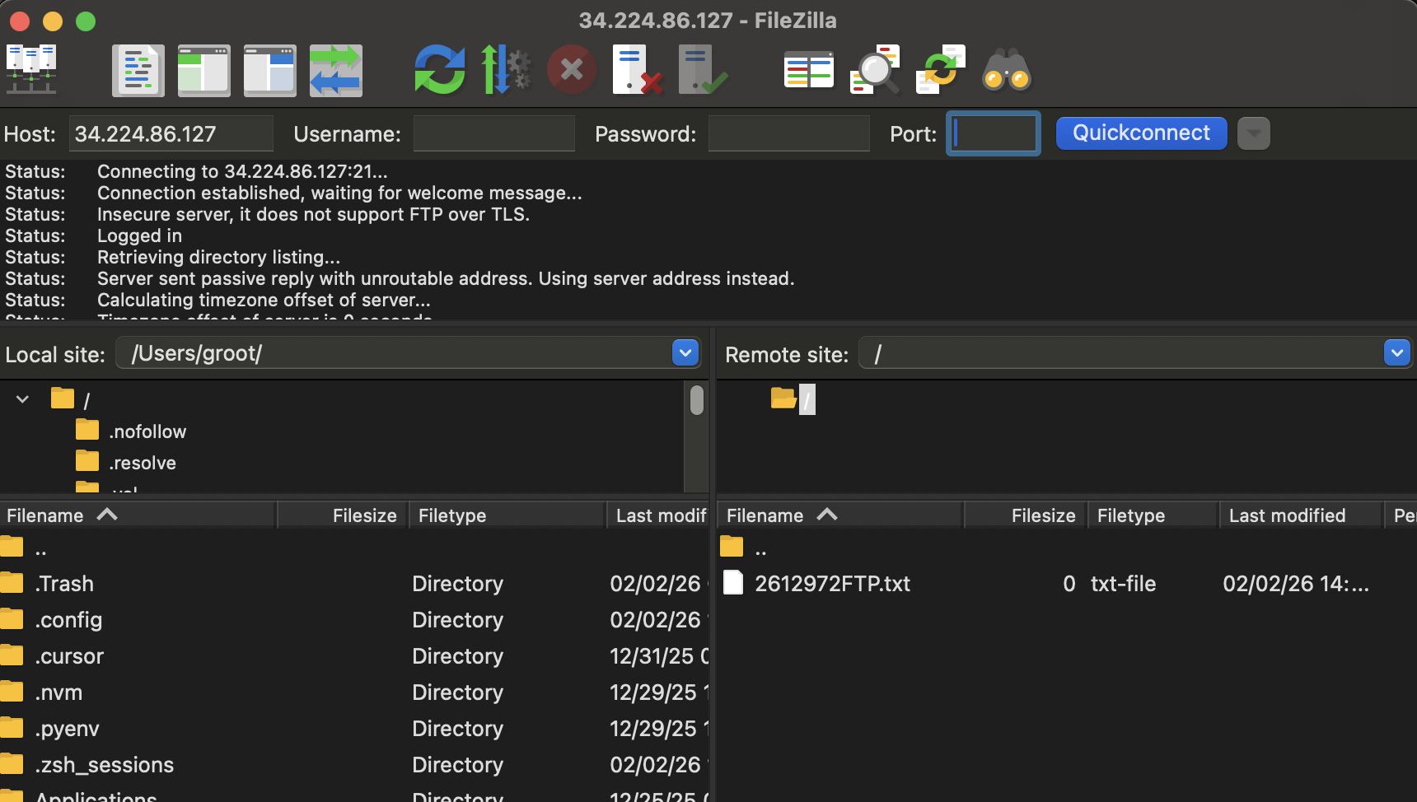

Task 4 - Configuring the FTP Server for authenticated user logins
- On your Windows Server, go to the IIS Manager.
- Click on your FTP site.
- Double click on FTP Authentication.
- Disable “Anonymous Authentication”.
- Enable “Basic Authentication”.
- Click on your site name to go back to the main menu.
- Double click on “FTP Authorization Rules”.
- Where it says “Allow”, “All Users”, right-click and select “Edit…”.
- Under “Permissions”, make sure both Read and Write are ticked. Click “OK”.
- Double click on “FTP User Isolation”.
- Under “Isolate users”, enable “User name directory (disable global virtual directories)”.
- Go back to your client and start “Filezilla”. Connect to the server but this time use the username and password you created earlier

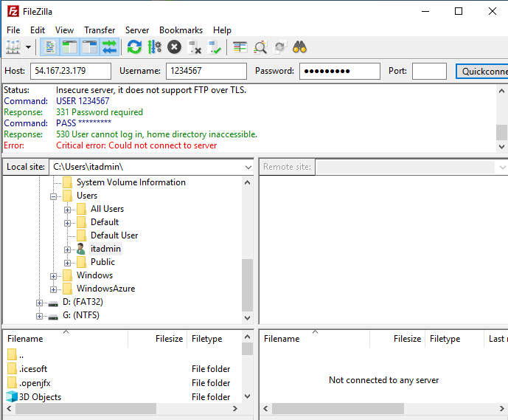
[Paste your screen shot here] (marks)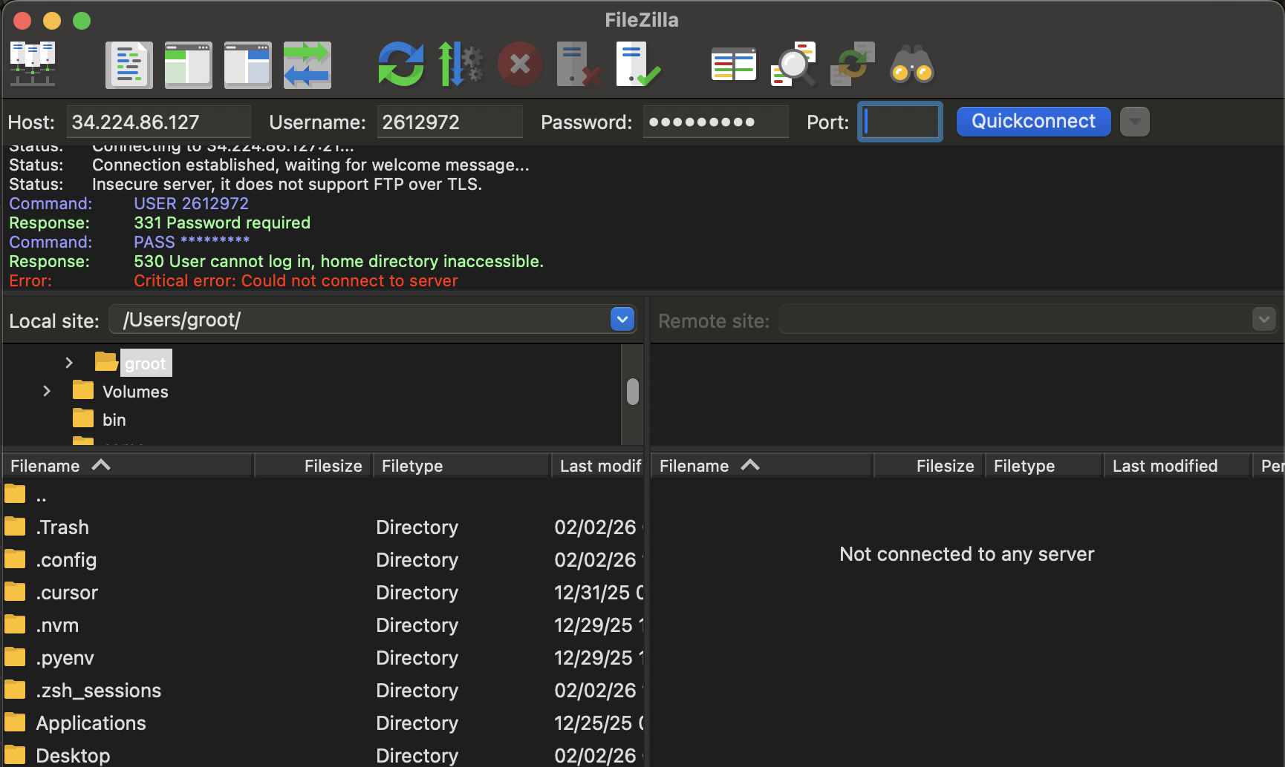

- Take note of the error you are getting.
- Go back to the FTP folder you created on the C:\ drive on your server
- Inside C:\FTP, create a new folder, called “LocalUser”. Type this exactly, with the correct casing, and no space.
- Inside “LocalUser”, create another new folder. Put in the username of the account you created earlier in the workshop.
- Copy the usernameFTP.txt file you created earlier, from the C:\FTP folder to the C:\FTP\LocalUser\username folder.
- When complete, your folder should look like this:
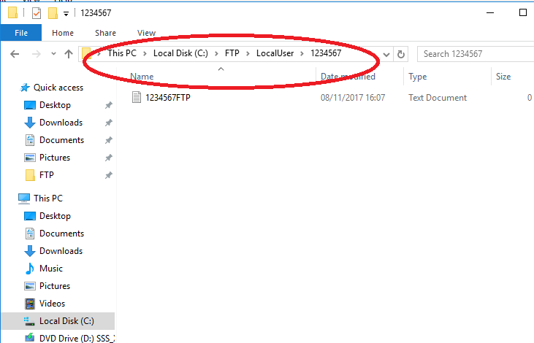
- Reconnect to the FTP on Filezilla
- When you are successful, you should be able to see your directory on the server
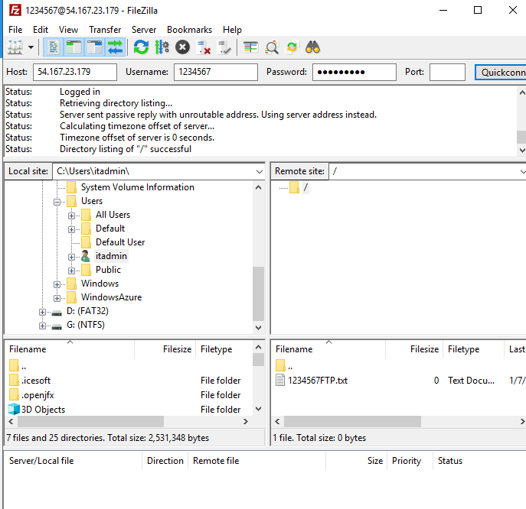
[Paste your screen shot here] (marks)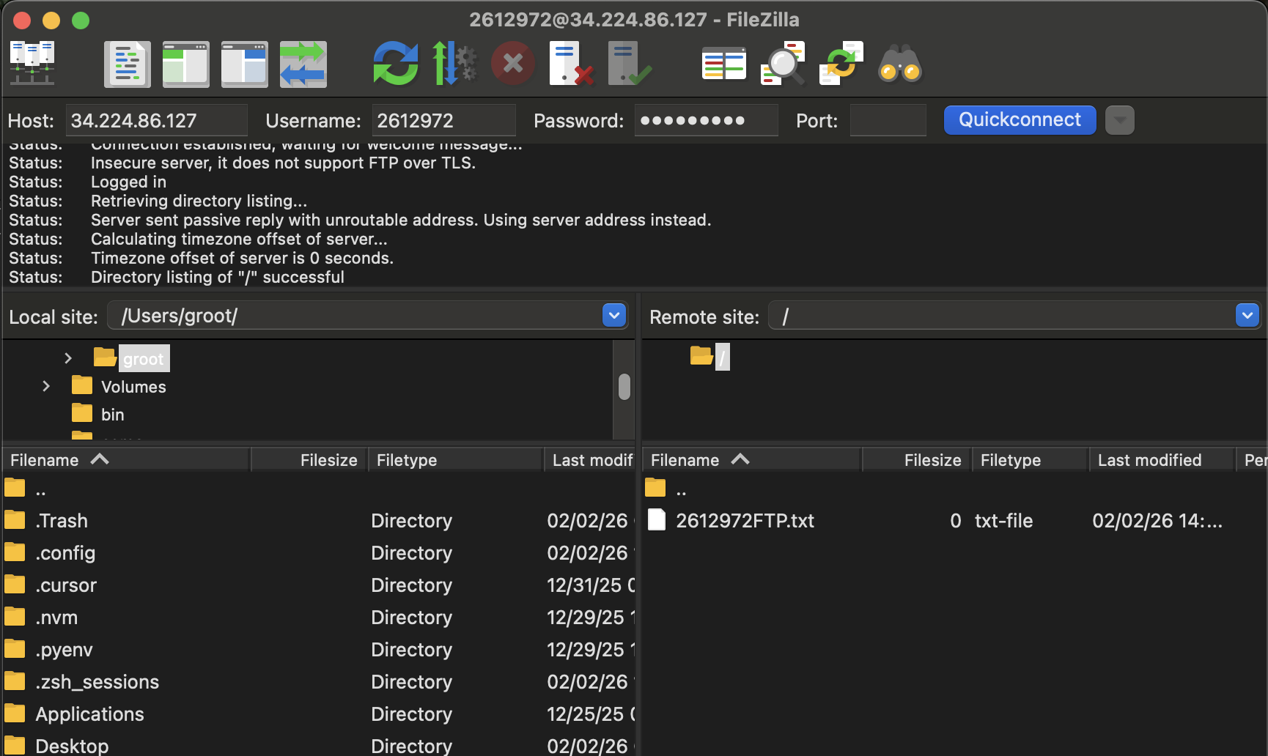
- Now shutdown your Windows Server as explained in previous workshop.
Task 5
Do research into FTP Service trying to identify any challenges with this service and how they can be overcome. Max 500 words (marks)
FTP (File Transfer Protocol) is a service used to transfer files between a client and a server. It is widely used because it is simple and easy to set up. However, there are several challenges when using FTP.
One main problem is security. FTP does not encrypt data, which means usernames, passwords, and files can be seen by attackers. This can be dangerous, especially when sending sensitive information. To solve this problem, more secure versions such as FTPS or SFTP can be used. These protocols encrypt the data and make the connection safer.
Another issue is firewall and network configuration. FTP uses multiple ports, which can cause connection problems, especially with passive mode. Sometimes users cannot connect to the server because the ports are blocked. This problem can be solved by correctly configuring firewall rules and opening the required ports, such as port 21 and the passive port range.
FTP also has user access and permission challenges. If permissions are not set correctly, users may not be able to access files or may have too much control. This can be solved by properly setting user authentication and permissions on the server.
In conclusion, FTP is useful but has some security and configuration challenges. These problems can be solved by using secure protocols, correct firewall settings, and proper user management.

This is the end of this workshop. If you have finished the workshop, please submit it to Canvas.

