4CS012 – Server Management and Virtualisation

Workshop 6: Linux Server

STUDENT NAME: Injun Kim
STUDENT NUMBER: 2612972
You will need to complete the workshop tasks, answer the questions and then submit this Word file, complete with your screenshots and answers, via Canvas.
- On the AWS services page, choose “EC2” under ‘Compute’
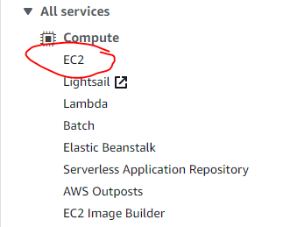
- Create a AWS VM by clicking on ‘Launch Instance’
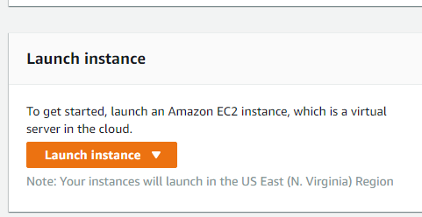
- In the name and tags, name your instance using your initials and student number, eg: CM1234567. In the Applications and OS Images, click on “Ubuntu”.

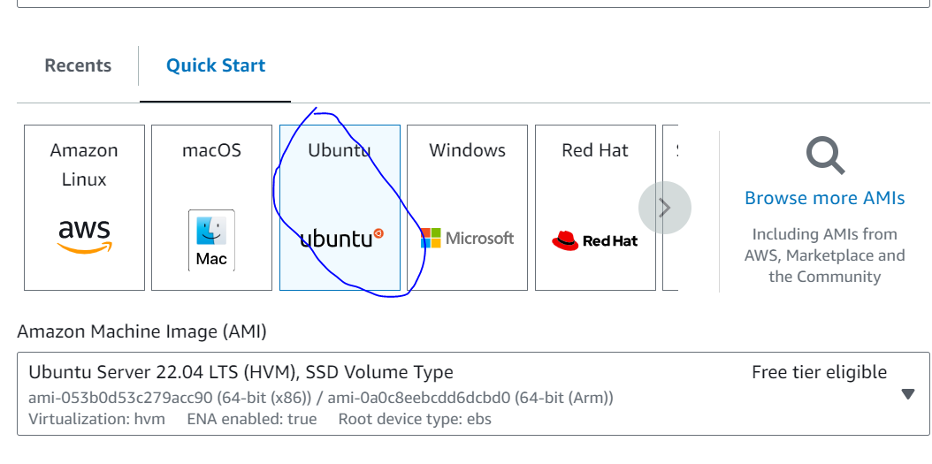

- Scroll down and choose “t2.medium” in the instance type and in the Key pair (login), select “vockey” as the Key pair name.
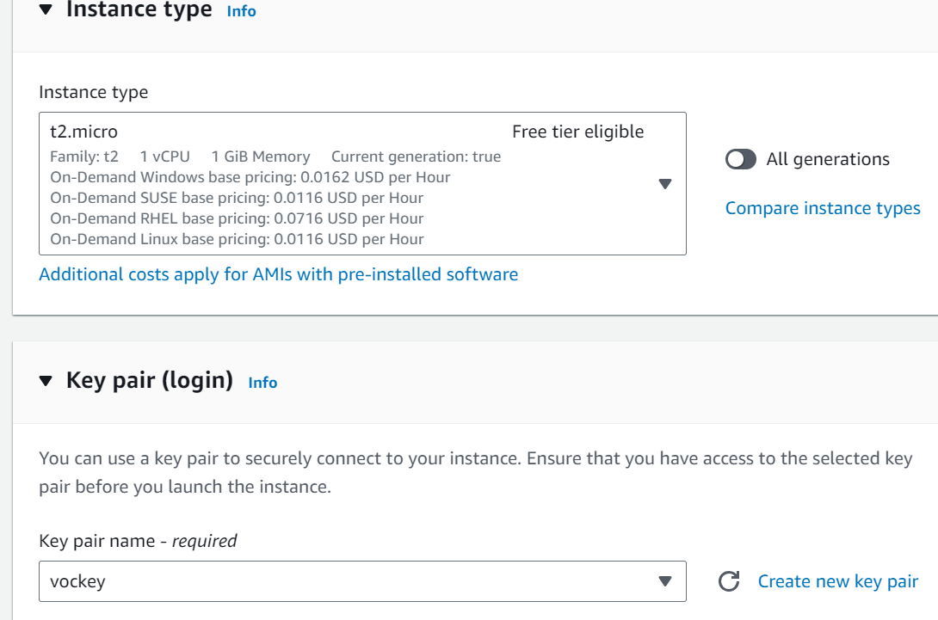

- On the “Configure Security Group”, you are going to allow traffic to your server. The RDP rule is already added but you need to specify the IP addresses allowed. Under the “Source” column dropdown menu, choose “Anywhere”. Make sure you also select HTTP and HTTPs.
- Click on “Launch Instance” to confirm your instance creation.
- Go back on “Instances” and your server should be up and running after a minute or so:
- Next select your instance, select “Connect”
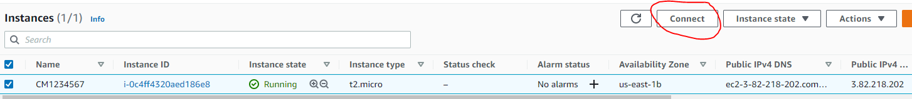

- On the “Connect to instance” page
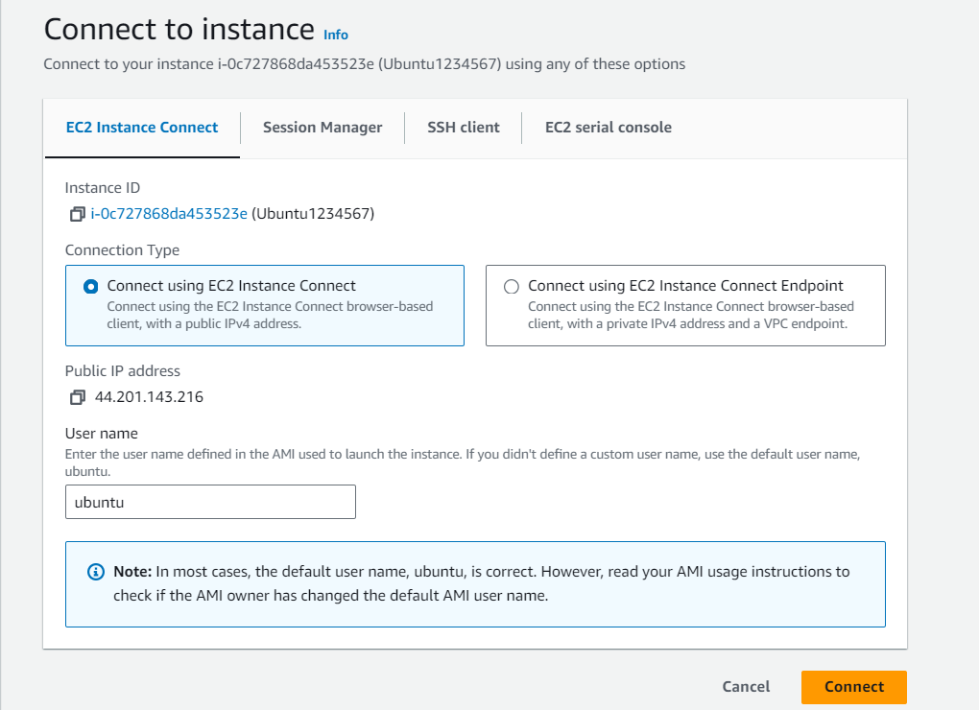

Your Linux server is up and running, you can now carry on with the rest of the practical.
A virtual Ubuntu Server will then open in a new browser window, similar to below
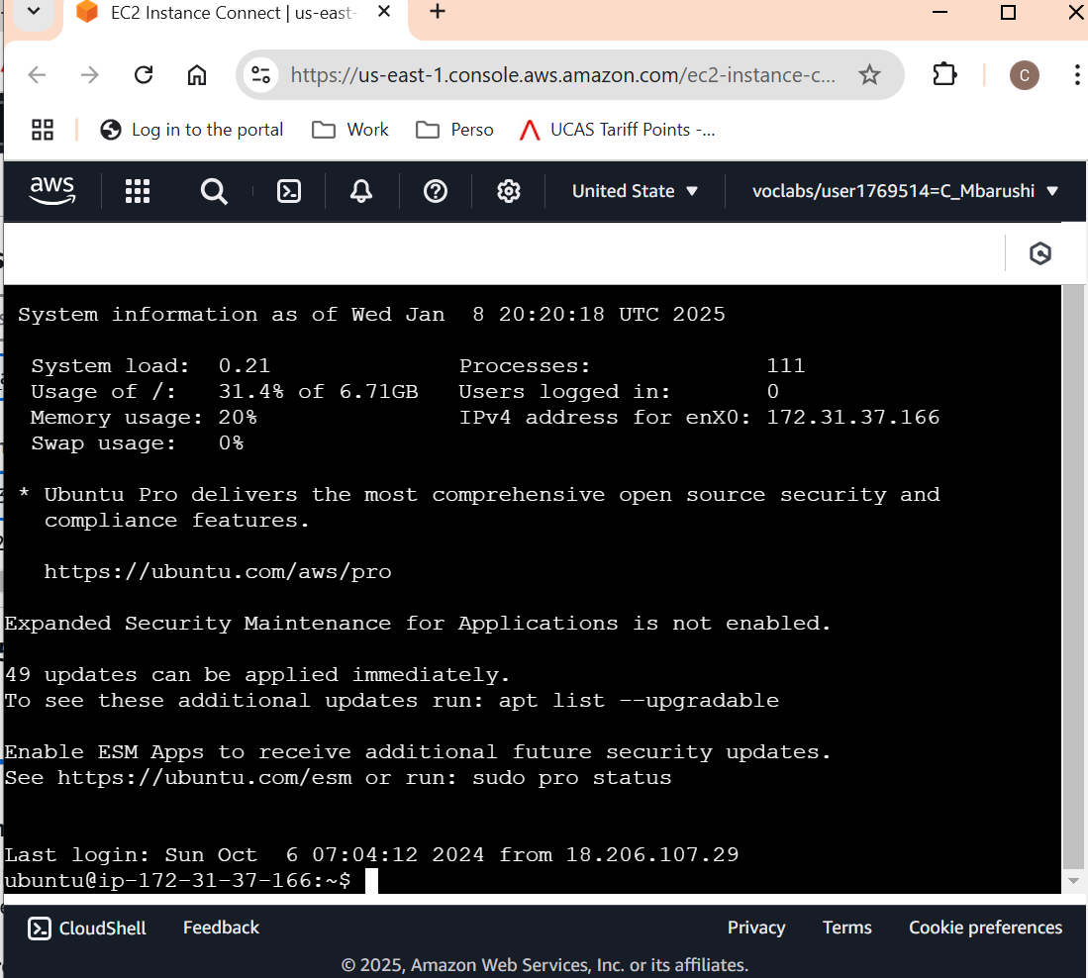

- Capture your server screen and paste it here
[paste your screenshot here](marks)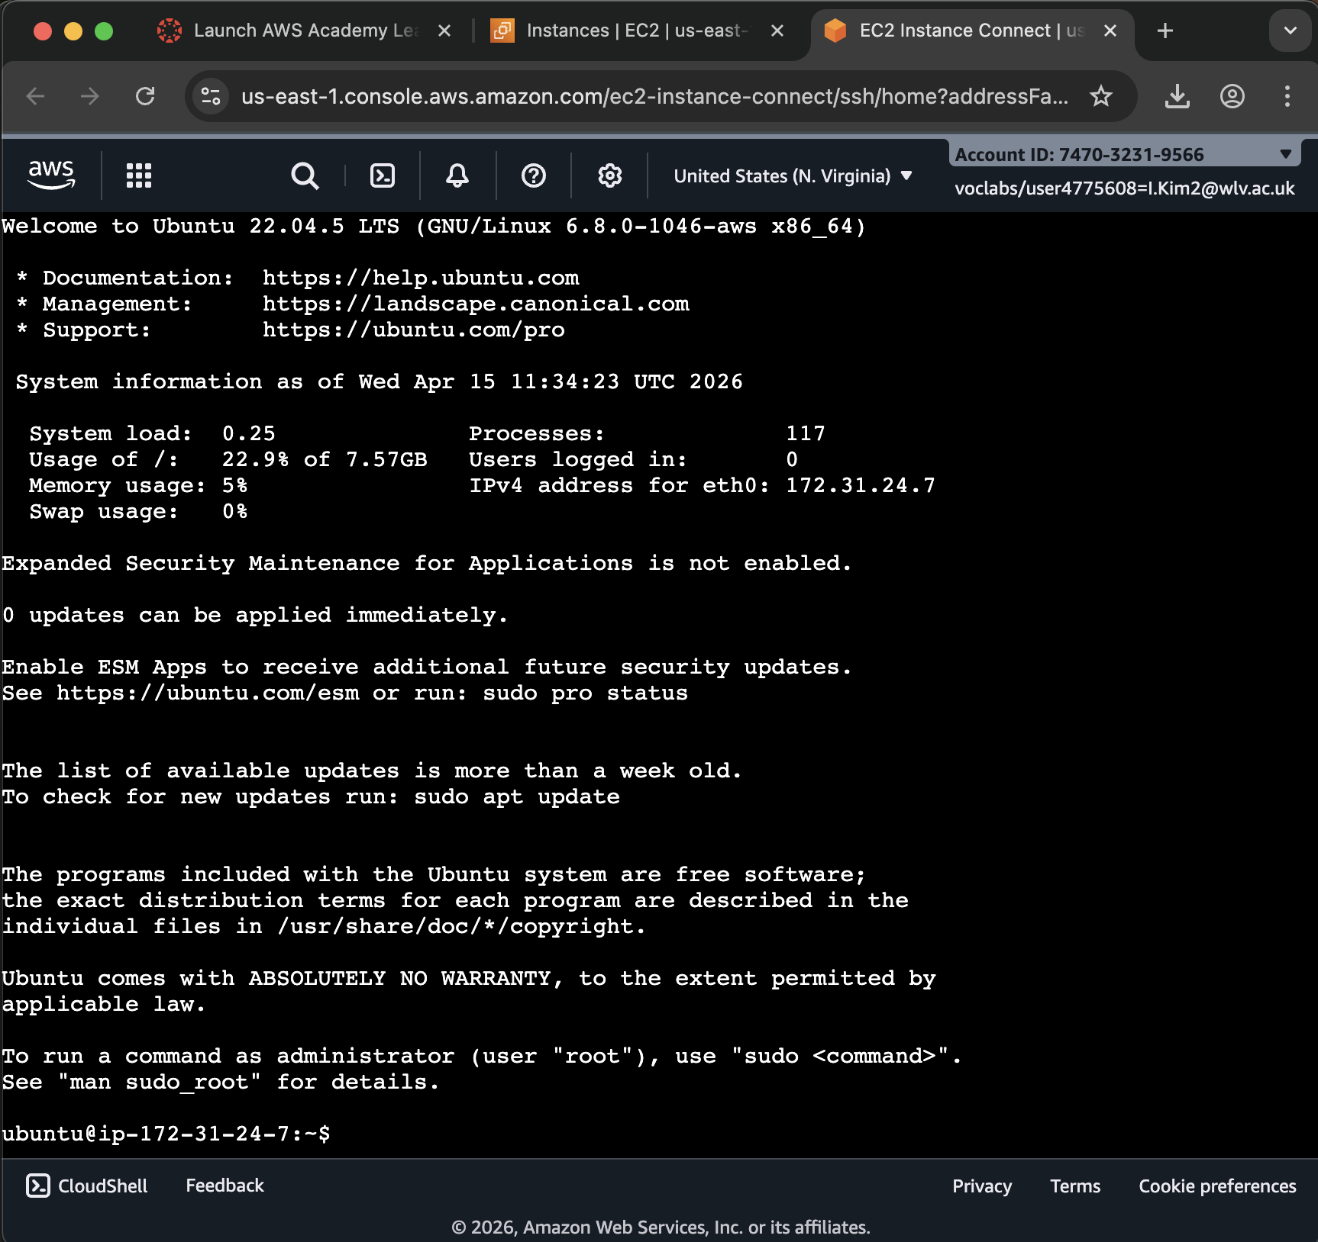

- Go Back to the EC Console and take a note of your server’s IP Addresses shown there.

Internal IP address: 172.31.24.7
External IP address: 54.157.245.6

Question: What’s the significance of these two addresses? (marks)

The Internal IP address is used in communication with the same network computer like between servers in AWS.
The external IP address is used to access the computer from outside network like internet.

How do you display the IP address in the linux shell?
Hint: you might need to install the net-tools package first

sudo apt install net-tools

I can display the IP address at the Linux shell by installing net-tools and using ifconfig command.

- Set the root password by entering the following command
sudo passwd root

- Choose a password for you server and confirm it – take a note of your password
Lovewolverhampton!1

- Login as root by entering the following command (use the password created in Step 8)
su root

- Capture your screen and paste it here
[paste your screenshot here](marks)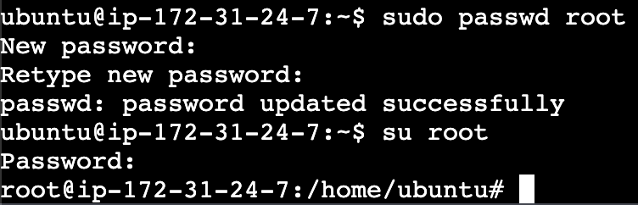

Task 2 - Linux Bash Shell Commands
- Make sure that you are logged in as root
- Create a user:
  - Enter the following command into the Linux shell, substituting “yourusername” with your own name:
adduser yourusername
It prompts for password and other info, complete these login details as the created user and verify the group it’s allocated
How do you display the new user you just created and the group they belong in?
Capture the screen, showing the new user and their group

I can display a new user and their group by using id command.
[paste your screenshot here](marks)
  - Research how to create a group, create a new group called “yourusernamegroup” and move your user to the new group
Capture the screen, showing the new user’s details, and paste the screen below:
[paste your screenshot here](marks)
  - Now log out of the current shell with the command:
exit
- Log in with the new username that you have just created by entering the following command

su yourusername

  - Try and look into a restricted directory:
ls -al /root
Question: Could you do this, and why?
[your answer here](marks)
No, I couldn’t access the /root directory. Because the directory is limited to the root user. So normal users don’t have permission to view it.
  - To perform “superuser” or "root" functions, you need to use the “sudo” command prefix. Try it now by entering:
sudo ls -al /root
You will find that the system prevents you from doing it.
  - In order to perform superuser functions, the new user needs to be entered in the “sudoers” file, and you can only do this as a root user.
  - Log out, and log back in as the root user.
  - The sudoers file in located at /etc/sudoers. Check that it is there by entering the command:
ls -al /etc/sudoers
Capture the screen, showing the sudoers file:
[paste your screenshot here](marks)
  - The sudoers file is set as read-only. Thus, even the root user wouldn’t be able to change it. To change it you need to change the permissions:
chmod +w /etc/sudoers
  - Now edit the sudoers file using the original Linux test editor “vi”:
vi /etc/sudoers
  - The vi editors will start and fill the screen with the sudoers file. Scroll down using the down arrow key until you get to the end of the file.
  - Now append to the file by typing the letter “a”. The message “-- INSERT --“ will appear at the bottom of the shell window indicating that you are now in "insertion" mode.
  - Using the cursor/arrow keys, make sure you are at the end of the final entry (within the sudoers file.

(The final entry, may look similar to includedir /etc/sudoers.d)

  - Press the Enter key (on your keyboard), and on the new line, enter the following command (to add your new user into the sudoers file).
IMPORTANT: Make sure you use the new username that you created.
yourusername ALL=(ALL:ALL) ALL
  - Now to save the file, press the "Esc" key, then the colon key ":" and then "w" (for write), and Enter.

  - When the file has been saved, there will be a message near the bottom of the shell window to say that it is written.

  - To exit the vi editor, Press the "esc" key, the the colon key ":", then the "q" key and then the Enter key.
  - Then change the permissions on the "sudoers" file back:
chmod -w /etc/sudoers
  - Now log out and log back in as the new user.
  - Once logged in, try using the sudo command prefix by entering:
sudo ls -al /root
The shell will ask you for your password and then run the command.
Capture the screen, showing the root user's files and paste the screenshot below:
[paste your screenshot here](marks)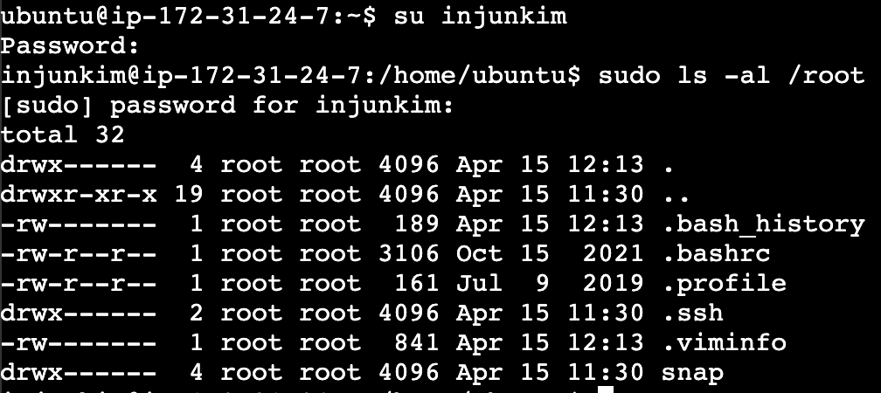
  - Logout
- Creating directories and files:
  - Log in as the root user.
  - Create a new sub-directory by entering the command:
mkdir DirA
  - Change your working directory to the new directory by entering the command:
cd DirA
  - Confirm that your working directory is now the new directory by entering the command:
pwd
  - The pwd command stands for "Print Working Directory". Record what the pwd command reported below:
[what is your working directory as reported by pwd] (marks)
/home/ubuntu/DirA
  - Create another sub-directory by entering the command:
mkdir DirB
  - Change your working directory to the new directory by entering the command:
cd DirB
  - Now create a file by entering the command:
touch FileA
  - Move back up a directory by entering the command:
cd ..
That's the letters "c" then "d" then space and then 2 full-stops.

  - Enter the command "pwd" to confirm that you are now back in directory "DirA".
  - Now create yet another sub-directory by entering the command:
mkdir DirC
  - Change your working directory to the new directory by entering the command:
cd DirC
  - Now create a file by entering the command:
touch FileB
  - Move back up 2 directory levels by entering the command:
cd ../..
That's the letters "c" then "d" then space and then 2 full-stops, then forward-slash , then 2 full-stops, again.
  - Enter the command "pwd" again to check that you are now in the directory "/root".
  - Now enter the following command:

Ls -R

  - You should now get a display of the directories and files that you have just created in a tree-like structure:
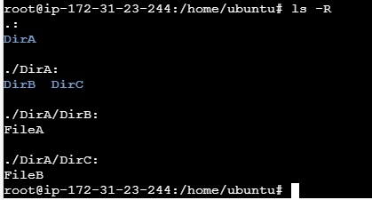
  - Now capture your screen and paste it below:
[paste your screenshot here](marks)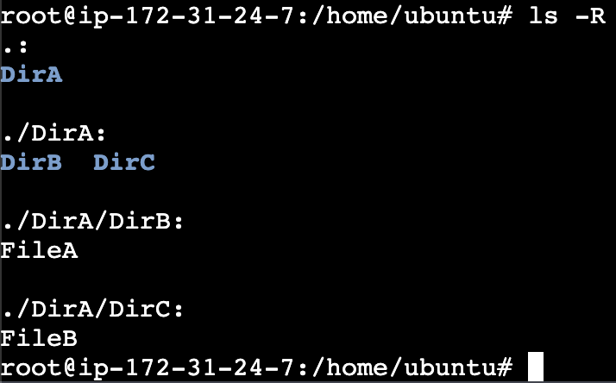
  - Now, using the same commands that you have just learnt, create the following directory arrangements:
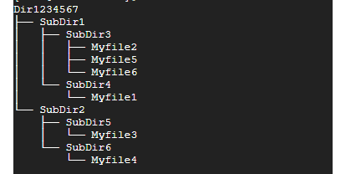
Make sure that you use your own Student ID for the first directory "Dir1234567".
  - When successful, capture your screen and paste it below:
[paste your screenshot here](marks)
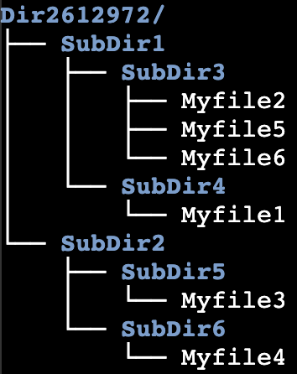
Return to EC2 main screen and stop the instance.

Final Questions:
- Why do you think we are managing the Linux server in text mode rather than graphical mode? (Write what you think. Do not ask the workshop tutors the question.)

Linux servers are often managed in text mode because it uses less storage and makes the system faster. This is because servers do not need a graphical interface.
(your answer here) (marks)
- What are the advantages of having your server on the cloud? What are the disadvantages?

(your answer here) (marks)
They are easy to access from anywhere and scalable. They also do not require physical space for hardware in a company. However, they also have disadvantages. They depend on internet status and may have security problems. Finally, they may spend a lot money over time.
This is the end of this workshop. If you have finished the workshop, please submit it to Canvas.

