4CS012 – Server Management and Virtualisation

Workshop 8: Database Server

STUDENT NAME: Injun Kim
STUDENT NUMBER: 2612972
You will need to complete the workshop tasks, answer the questions and then submit this Word file, complete with your screenshots and answers, via Canvas, before the deadline stated on canvas.

Objective
You will be re-configuring your Ubuntu Linux server to act as web server for individual users on the server to have their own “home” web pages. Users on your server will have URL of the form http://yourname.here/~theUserName/ .
Then you will configure MySQL, a popular relational database server, and connect to it via the scripting language, PHP.

Preparing the Linux Server
- Login to your cloud environment
- Locate and start the Ubuntu Linux VM that you created from the previous workshop.
- Login to the Ubuntu Linux as root
- Check your Linux Server Public IP address:
[ip address here]
98.94.0.220

Task 1 - Setting up Apache Webserver for User Home Pages

- As you did in the previous workshop, you will be accessing your Linux Server via a client Windows machine. Thus, start the client VM.
- Start the web browser and then go to the URL: https://XXX.XXX.XXX.XXX:10000/ [Substitute XXX.XXX.XXX.XXX with your Linux server's IP address. Eg. If your Linux server's IP address is 35.204.55.123 go to https://35.204.55.123:10000
- Login to Webmin as root
- Next, create a new user with Webmin called “phpuser” and set the password to “password”. If you do not know how to do this, again, refer back to your previous workshop. Your lab tutors will NOT help you with this, as you are suppose to learn and remember what you are doing and have done.
- Using the Webmin File Manager, navigator to the phpuser’s home directory “/home/phpuser”
- Then create a new directory in the phpuser’s home directory, name the new directory “public_html”,
- Set the new folder permissions to 0755. Change the ownership of the directory to phpuser and www-data for group.
- Still in the Webmin File Manager, navigate into the “public_html” directory and create a new file. Call this new file “index.html”.
- Edit the index.html file and put the following text: “Hello from [InitialsMy Student ID]!”. Make sure that you change the [My Student ID] to your own student ID, or you will get no marks.
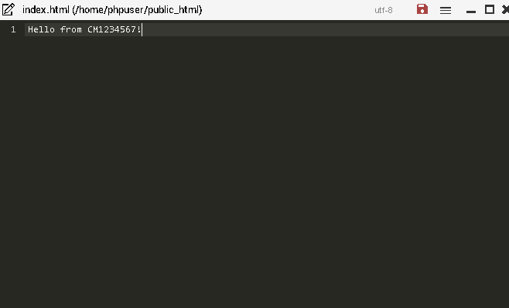
- Now with your web browser, go to the phpuser’s new website by going to the URL of http://35.204.55.123/~phpuser/ . Make sure you use your own server’s IP address! You show see your version of the following page:
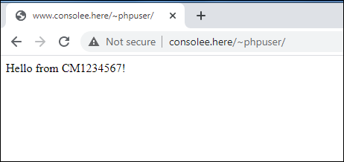
- Now screen capture and paste your version below:
[paste your screenshot here](marks)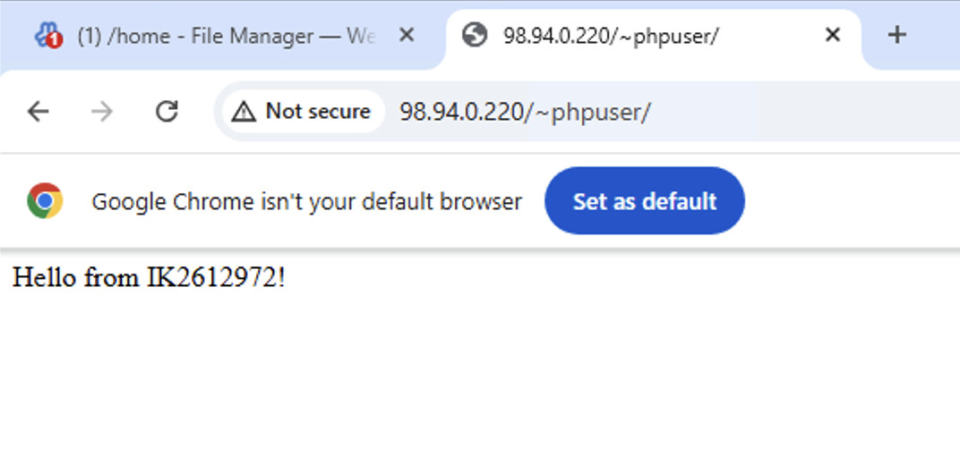

Task 2 - Setting up a PHP info page

- PHP settings: Click on “Global configuration” on Apache Webserver then “Edit Config Files”. In the dropdown list choose the php7.4 conf (or equivalent)
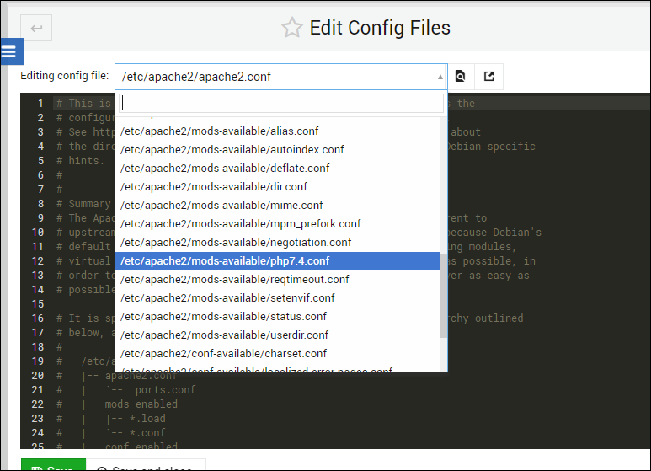
- Inside the configuration file, comment out the following lines:
<IfModule mod_userdir.c>
<Directory /home/*/public_html>
php_admin_flag engine Off
</Directory>
</IfModule>

- PHP is one of the most common web application programming languages in use today. We are now going to create a PHP web page.
- Using Webmin’s File Manager, create a file in the phpuser’s “public_html” directory, called “info.php”.
- Insert the following code into the “info.php” file:
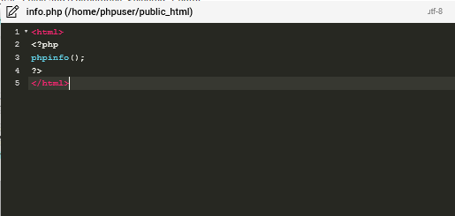
- The change the “info.php” file permissions to 0755.
- Now with your web browser, go to http://35.204.55.123/~phpuser/info.php . Make sure you use your own server’s IP address! You show see your version of the following page:
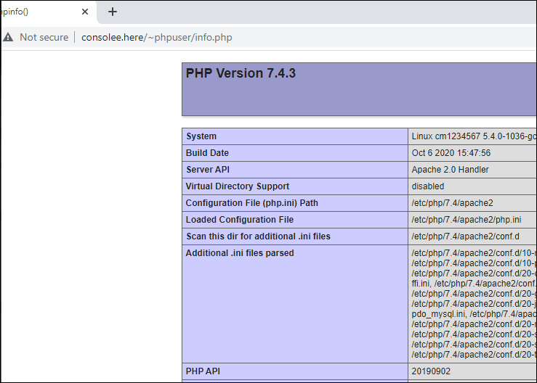
Now screen capture and paste your version below:
[paste your screenshot here](marks)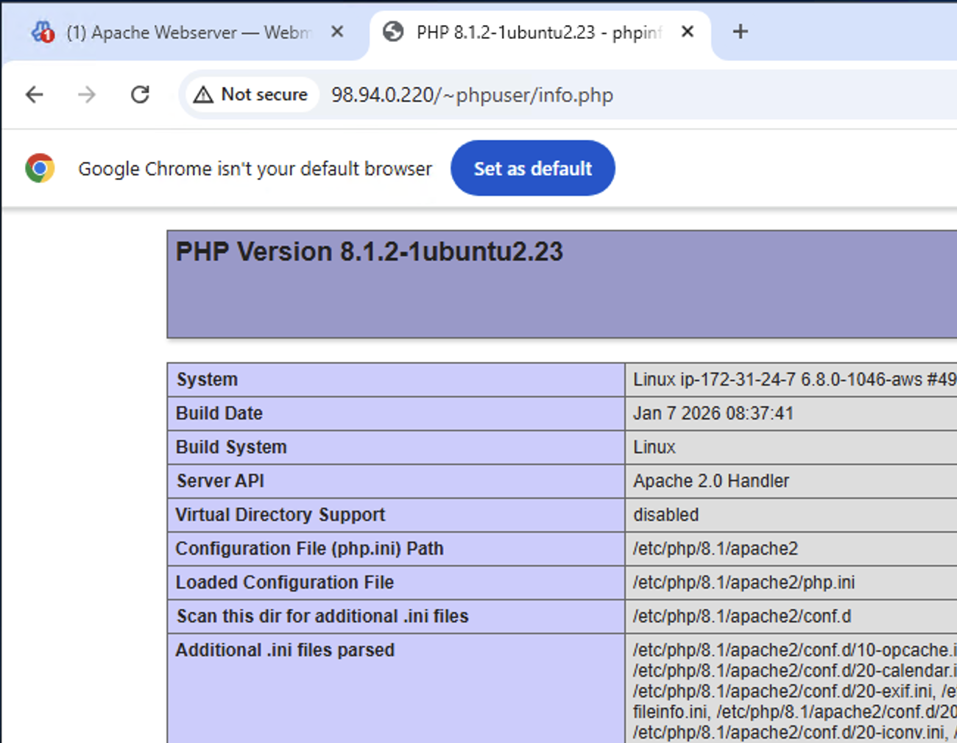

Task 3 - Setting up the MySQL Database Server

- On the left hand side of Webmin, under Servers and then click on “MySQL Database Server”.
- Then in the right hand pane, click “Start MySQL Server” if it’s not running.
- Login with root and the database password you set in workshop 6 if it’s not logged in.

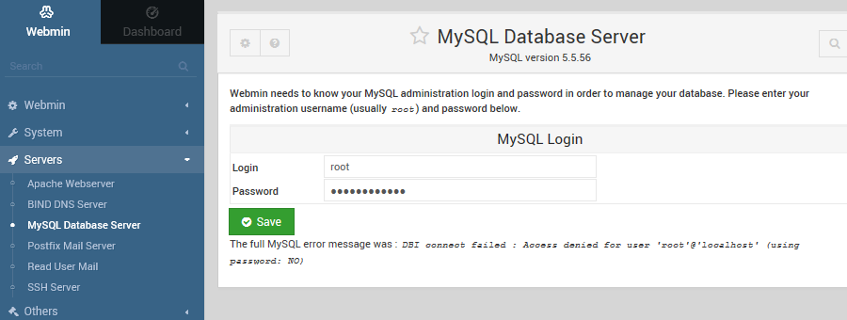

- When the MySQL Database Server has started, you should see the right hand pane of Webmin change to display “MySQL Databases” containing the “information_schema”, ”mysql” and ”performance_schema” databases , as well as the “Global Options”.
- Click on the “mysql” database and Webmin will display the database tables within the “mysql” database. Capture this screen and paste your screenshot below:
[paste your screenshot here](marks)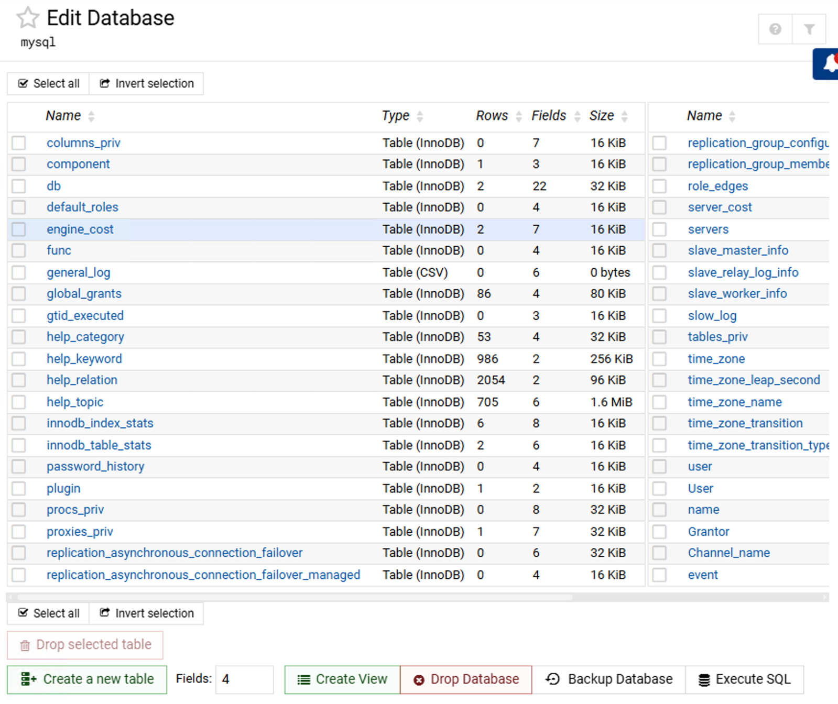
- Then click “Return to database list” to return to the previous screen.

Creating a new MySQL database and table

- On the left hand side of Webmin, under Servers and then click on “MySQL Database Server”.
- Click “Create a new database”
- Give your new database the name of your student ID prefixed with the letters “db”. Thus if your student ID is 1234567, creating a new database with the name of “db1234567”. Make sure you use your student ID. Name the initial table “Contacts” and populate it with the information shown below

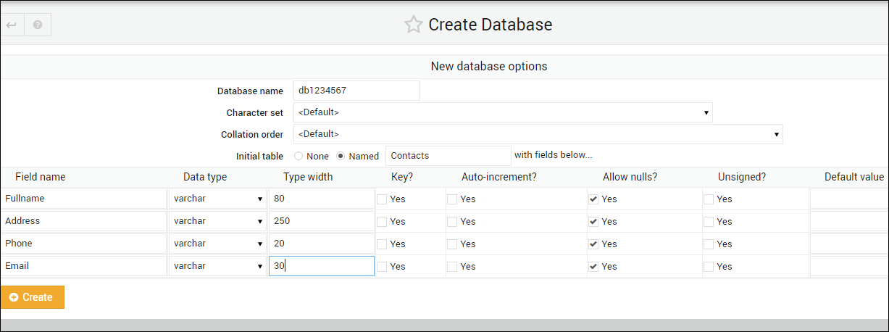

- Click “Create” to create the table.
- On the next screen, click on your new database and your Contacts table, to display its fields or columns. Capture this screen and paste your screenshot below:
[paste your screenshot here](marks)
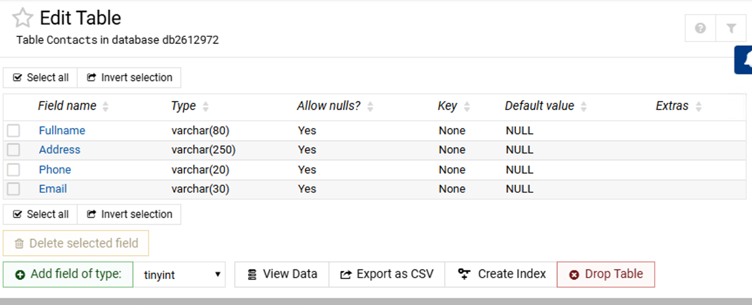

Task 4 - Entering data into the Contacts table
- Go on “MySQL Database Server and install the missing PERL modules as shown below
- Click "Return to table list" to go back to the "Edit Database" view.
- Click on the "Execute SQL" button.
- Enter the following SQL statement into the box and then click the "Execute" button. Make sure you get the spaces, commas, and single-quotes correct:
INSERT INTO Contacts VALUES ('Firstname Surname', 'Your address', 'Yourphone number', 'email@wlv.ac.uk');

- Then click "Return to table list"
- Double Click on the Contacts table and then "View Data".
- You should see the data that you have just entered into the "Contacts" table. Capture this screen.
[paste your screenshot here](marks)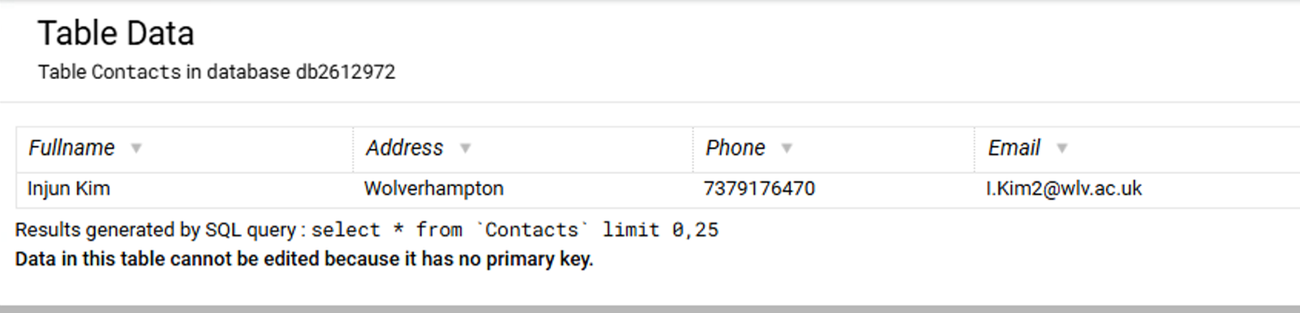
- Repeat the procedure to create 4 more different contacts, using different values, and then capture the screen show all the contacts data, and paste it below:
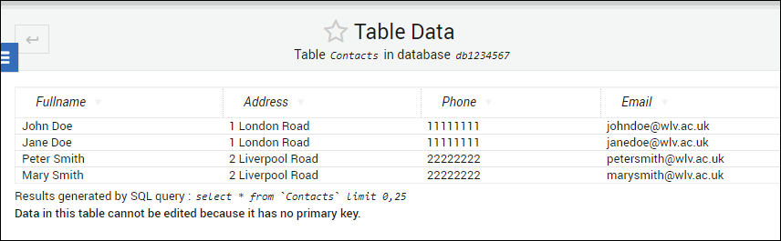
[paste your screenshot here](marks)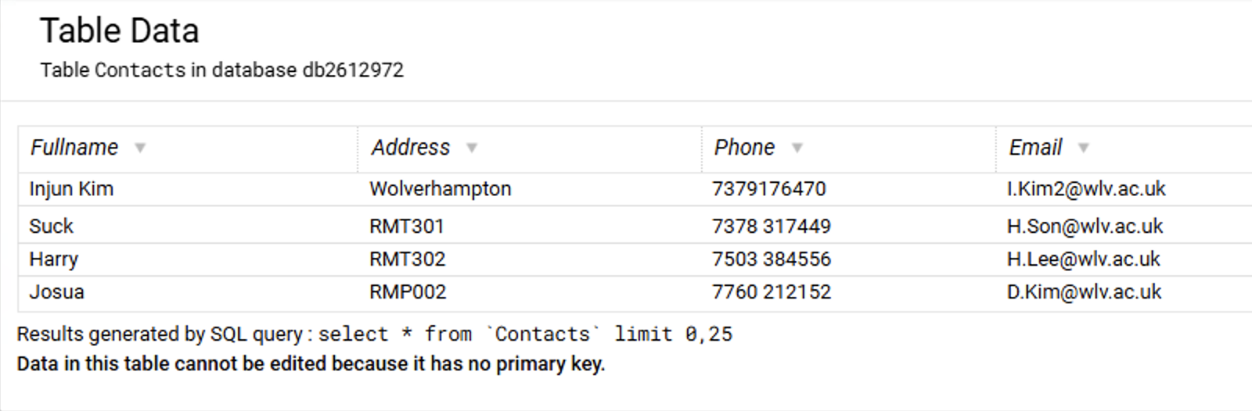

Task 5 - Connecting Apache/PHP to MySQL
- Go to the MySQL main screen showing all databases.
- Click on "User Permissions"
- Click on "Create new user"
- Create a new database user called "phpuser" with a password of "Password123!", set the Hosts to "localhost", and select all the permissions:
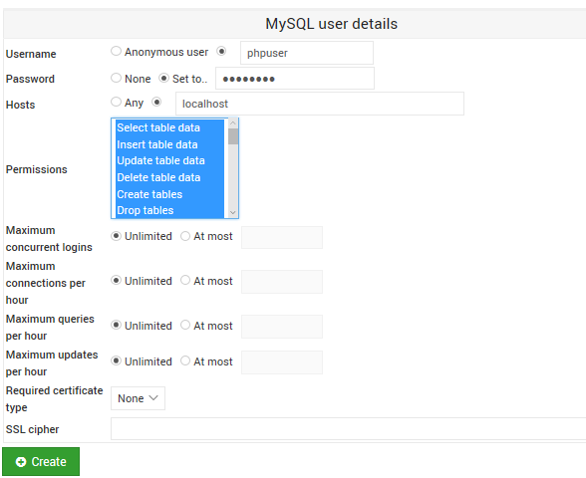
- Click "Create".
- Click "Return to database list"
- Click on “Database Permissions”, and then click on “Create new database permissions”
- Select the Database of “db1234567” (make sure you select your own database), and set the rest of the details as shown below:
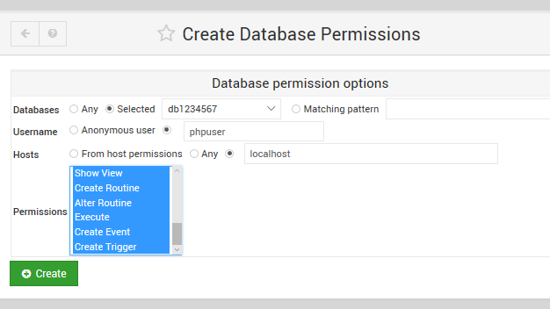
- Click "Create".
- Click "Return to database list"
- Stop and then re-start the MySQL Database server.
- Go back to the Webmin Filemanager, and browser to the phpuser's public_html directory.
- Create a new file called "contacts.php".
- Enter the following code into the PHP file. Make sure you use your own database name:
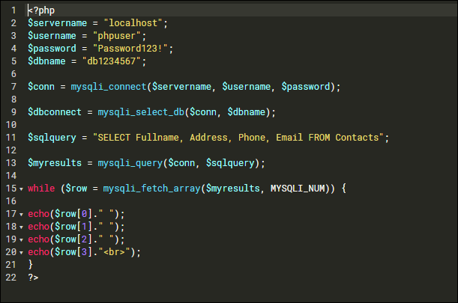
- Make sure you don't get the curly brackets {} mixed up with the round ones ()!
- Save the file and then set its permissions to 0755 and both ownership fields to “phpuser”
- Now with your web browser, go to http://35.204.55.123/~phpuser/contacts.php . Make sure you use your own server’s IP address! You show see your version of the following page:
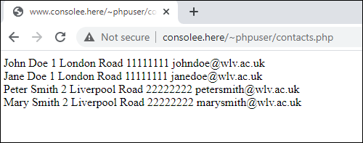
Now screen capture and paste your version below:
[paste your screenshot here](marks)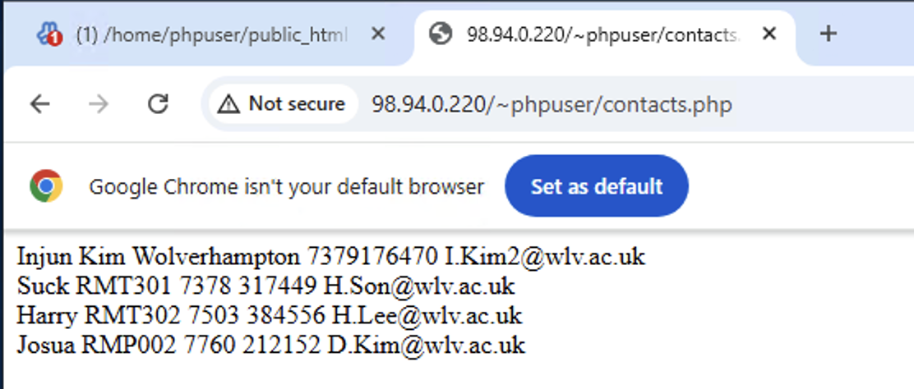
- Shutdown your Linux Server.

- Write a small paragraph (no more than 300 words) explaining the different services used in this exercise and summarising the different steps taken to achieve the final output. (marks)

We used a couple of services like apache2, php, mysql and webmin. Apache2 is a web server that allows users to open web pages in a browser. PHP is a scripting language used to create dynamic web pages. Mysql is a database used to store and manage data. Webmin is a tool that helps us manage the Linux server easily.

Firstly we created a new user called ‘phpuser’ and set up a folder called ‘public_html’ to store web files. And Then, we create a simple html page and checked it in a web browser. And then, we configured apache to allow php and create a php page using phpinfo().

Secondly, we started the mysql server and created a new database. We also created a table and added some data using sql commands.

Finally, we created a php script to connect to the mysql database. The script displayed the data from the contacts table in browser. This shows how those services work to create a dynamic website.

This is the end of this workshop. If you have finished the workshop, please save a copy of your file securely and then submit it to Canvas.

