4CS012 – Systems and Server Management

Workshop 9: WordPress

STUDENT NAME: Injun Kim
STUDENT NUMBER: 2612972
You will need to complete the workshop tasks, answer the questions and then submit this Word file, complete with your screenshots and answers, via Canvas, before the deadline.

Objective
You will install WordPress, a web blogging and Content Management Platform on a specific user’s homepage. You will need skills and knowledge acquired in your previous workshops. You can’t do this workshop before you have completed all the previous workshops.

Preliminaries

Task 1 - Preparing the Ubuntu Linux Server
- Locate and start the Ubuntu Linux VM that you installed from the previous workshop.
- Login as root

Task 2 - Preparing for WordPress
- As you did in the previous workshop, you will be accessing your Linux Server via a client Windows machine. Thus, start a client machine.
- Start the web browser and then go to the URL: https://XXX.XXX.XXX.XXX:10000/ [Substitute XXX.XXX.XXX.XXX with your Linux server's IP address. Eg. If your Linux server's IP address is 35.204.55.123 go to https://35.204.55.123:10000
- Login to Webmin as root
- Create a new Linux system user with Webmin called “wordpress” and set the password to “password”. If you do not know how to do this, refer back to your previous workshops. Your lab tutors will NOT help you with this.
- Using the Webmin File Manager, navigate to the wordpress user’s home directory “/home/wordpress”
- Then create a new directory in the “wordpress” user’s home directory. Name the new directory “public_html”, and click “Create”
- Change the ownership for both user and group of the “public_html” directory to “wordpress”. Also change it’s permissions to “0755”
- Still in the Webmin File Manager, navigate into the “public_html” directory and create a new file called “index.html”. This part is a repeat of your previous workshop, so if you can’t remember how to do this, please refer back to your previous workshop. Again, your lab tutors will NOT help you with this. Put into your new file the text “Hello from wordpress! [My Student ID]”. Make sure that you change the [My Student ID] to your own student ID, or you will get no marks.
- Check that the Apache webserver is running. Start it, if it is not.
- Now with your web browser, go to the “wordpress” user’s new website by going to the URL of http://35.204.55.123/~wordpress . Make sure you use your own server’s IP address! You show see your version of the following page:
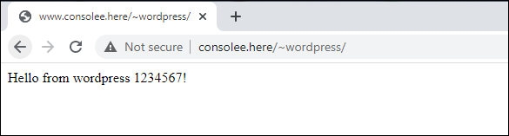
- Now screen capture and paste your version below:
[paste your screenshot here](marks)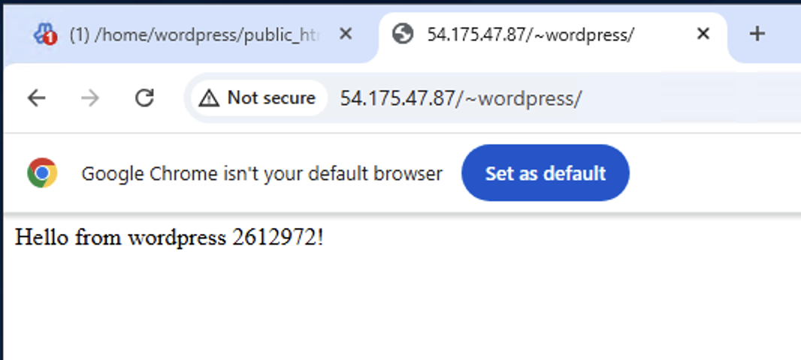

Task 3 - Setting up MySQL for WordPress

- In Webmin, click on “MySQL Database Server”, and then click “Start MySQL Server”.
- Click “Create a new database” and create a new database with the name of “wordpress”.
- Click “User Permissions” and click “Create new user”
- Set the Username to “wordpress”, the Password to "Password123!", Hosts to "localhost", select all permissions and then click “Create”.
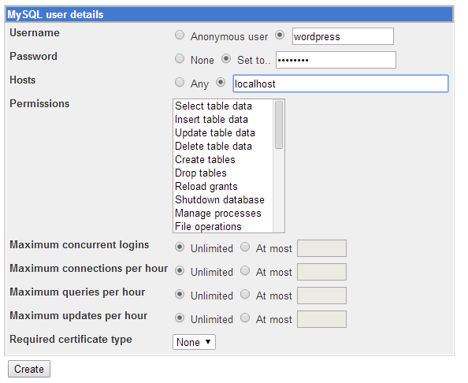
- Then click “Return to database list”
- Click on “Database Permissions”, and then click on “Create new database permissions”
- Select the Database of “wordpress”, enter Username of "wordpress", and enter "localhost" for the Hosts, and then select all the Permissions, as shown below:
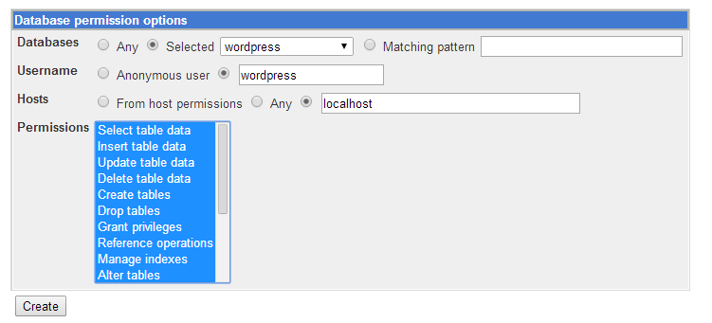
Click “Create”
- Then click “Return to database list”. The MySQL Database server is now ready for the installation of WordPress.
[paste a screenshot of your database list view here] (marks)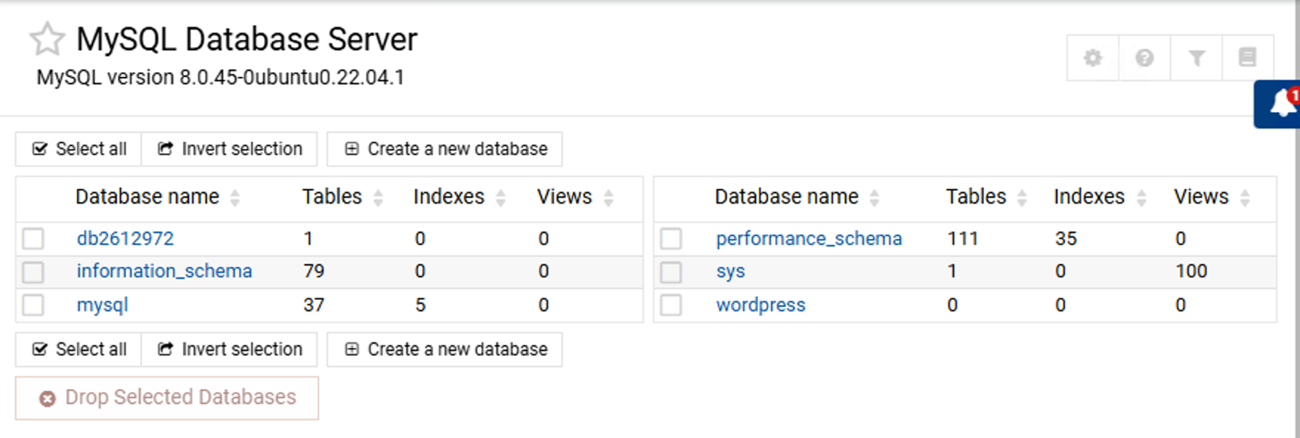

Task 4 - Setting up WordPress

Installing Additional PHP Extensions: When setting up our LAMP stack, we only required a very minimal set of extensions in order to get PHP to communicate with MySQL. WordPress and many of its plugins leverage additional PHP extensions.
- Open the command shell
- We can download and install some of the most popular PHP extensions for use with WordPress by typing:
apt update
apt install php-curl php-gd php-mbstring php-xml php-xmlrpc php-soap php-intl php-zip
This will lay the groundwork for installing additional plugins into our WordPress site.
We will need to restart Apache to load these new extensions, we’ll be doing more configurations on Apache in the next section, so you can wait until then, or restart now to complete the PHP extension process.
systemctl restart apache2
- Change the working directory to /home/wordpress
- Get the WordPress files by entering the command
wget http://wordpress.org/latest.zip
- Unzip the WordPress zip file by
unzip -q latest.zip
- Copy the extracted files to the correct location in the “public_html” directory by entering command:
cp –r wordpress/* public_html
- Go back to webmin and make sure that the files have been extracted and copied to the wordpress/public_html folder
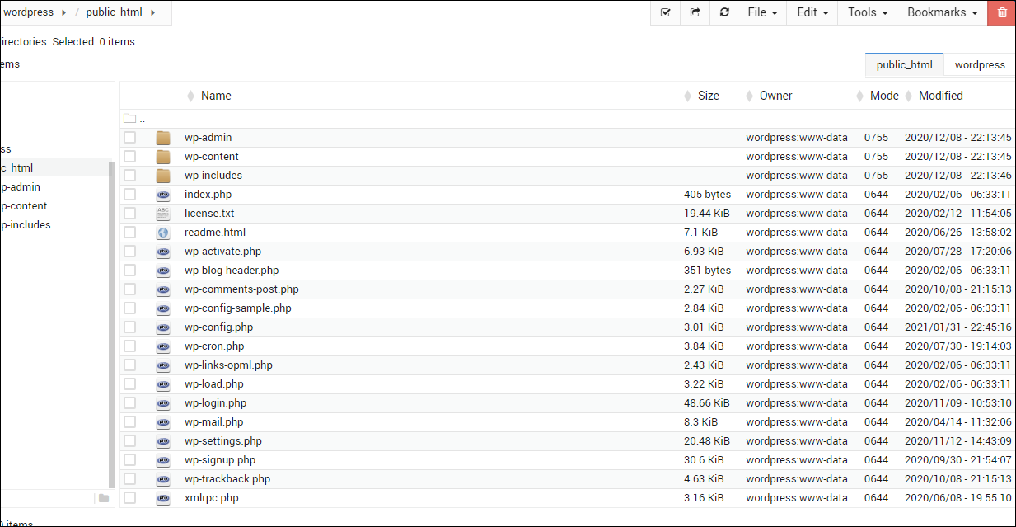

Task 5- Setting Up the WordPress Configuration File
Now, we need to make some changes to the main WordPress configuration file.
When we open the file, our first task will be to adjust some secret keys to provide a level of security for our installation. WordPress provides a secure generator for these values so that you do not have to try to come up with good values on your own. These are only used internally, so it won’t hurt usability to have complex, secure values here.
- To grab secure values from the WordPress secret key generator, type at the shell
curl -s https://api.wordpress.org/secret-key/1.1/salt/

- You will get back unique values that resemble output similar to the block below.
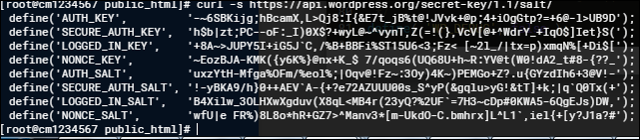
Warning! It is important that you request unique values each time. Do NOT copy the values above!
- These are configuration lines that we can paste directly in our configuration file to set secure keys. Copy the output you received now.
- From Webmin file manager right click to edit the WordPress sample configuration file wp-config-sample.php:
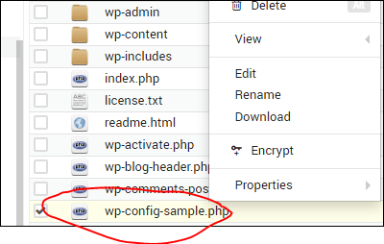
- Make sure the database values match what you set earlier
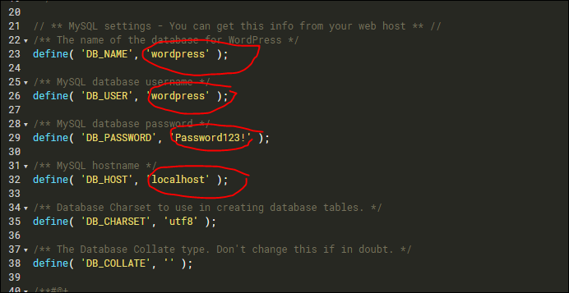
- Scroll down to the “Authentication Keys and salts”
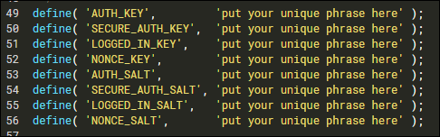
- And insert you generated values like below (from step2):
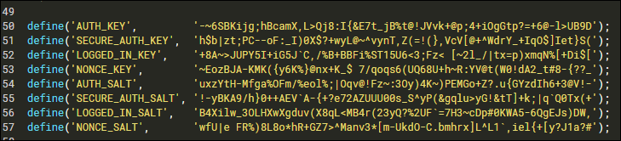
- Save this file as “wp-config.php”. Make sure this file and public_html directorty permissions are set to 0755 and ownership to wordpress for user and www-data for group.
- Start the WordPress installation process by pointing your browser to http://35.204.55.123/~wordpress/index.php . Make sure you use your own server’s IP address!
- You should see the following screen:
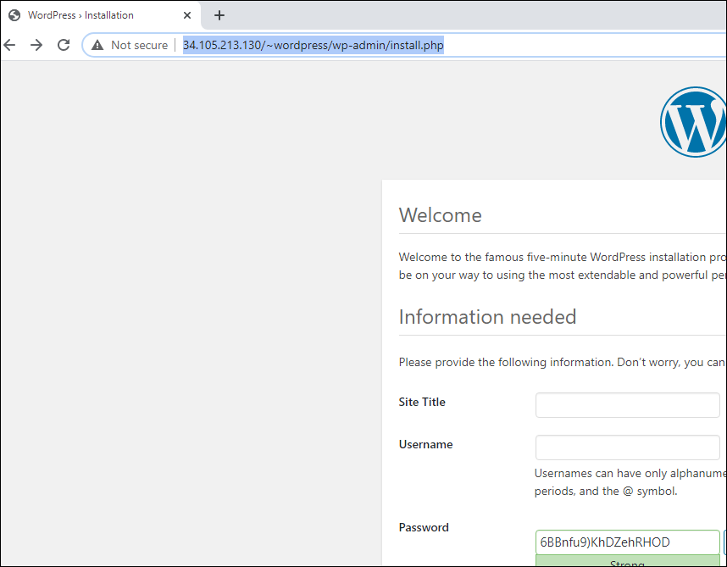
[paste your screenshot here](marks)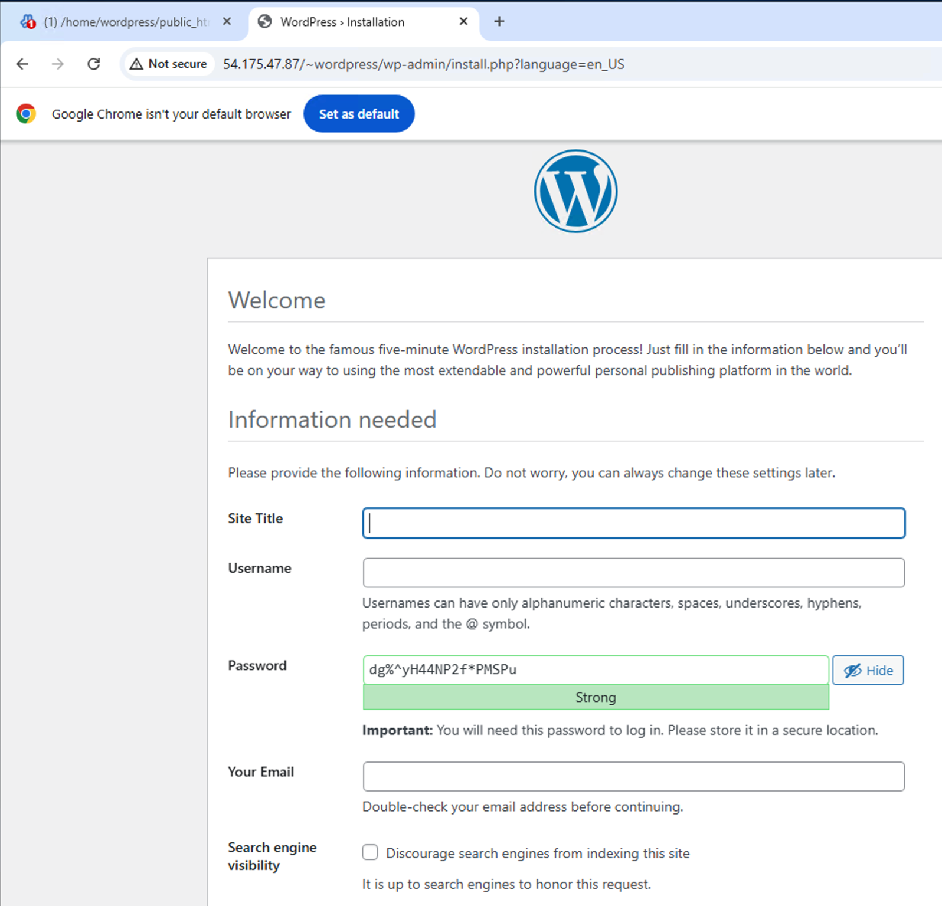

- Fill in the following screen so that it looks like:
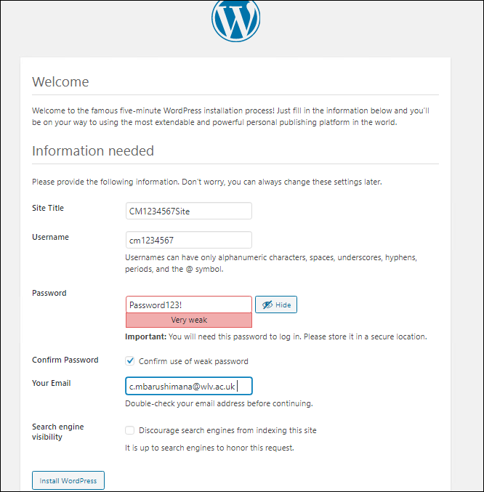
- Click “Install Wordpress”
- Login into your newly created site
- You should see the following:
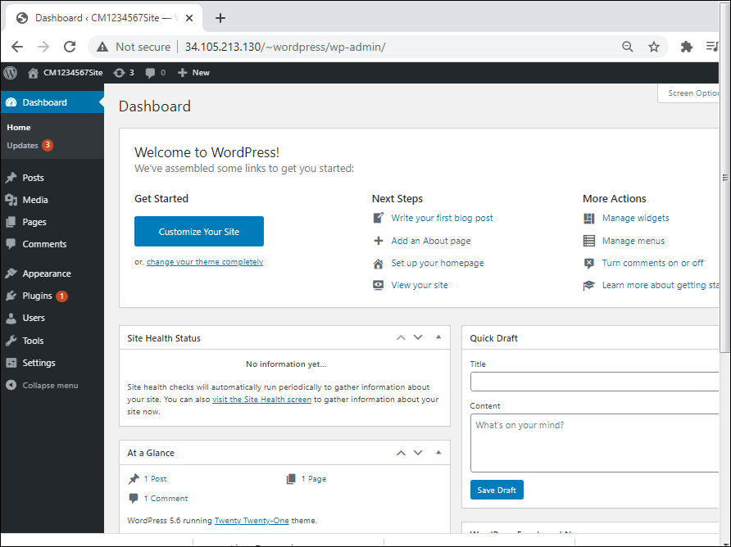
- Take a screen capture of your WordPress Admin Dashboard and paste it below:
[paste your screenshot here](marks)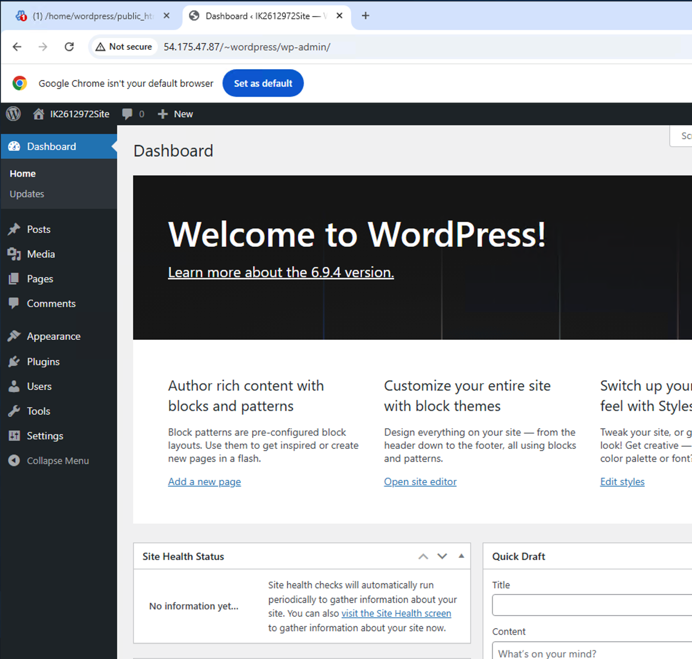
- Create your first blog message and publish it
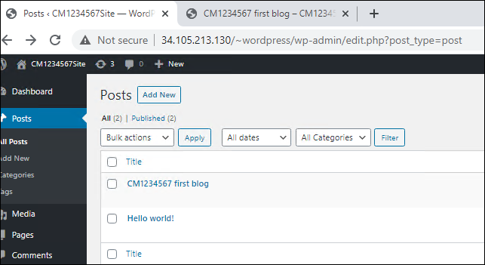
[paste your screenshot here](marks)
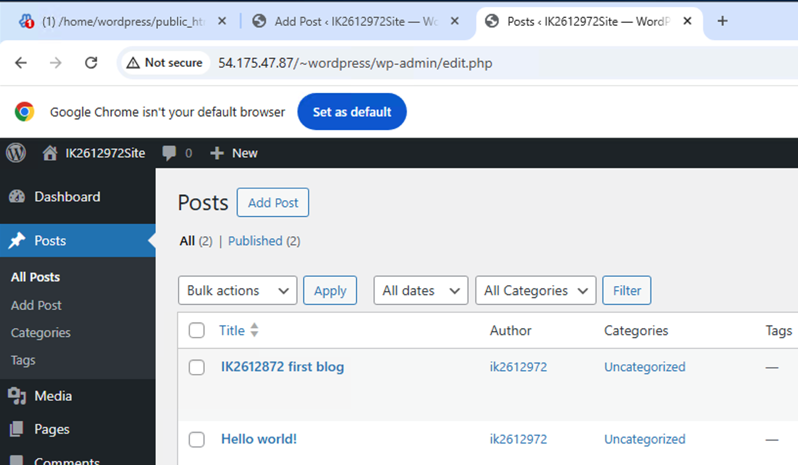
- Then to see your new message on your new WordPress site, click on the Site Name near the top left of the dashboard
- When the browser shows your new WordPress site with your message, take a screen capture and paste it below:
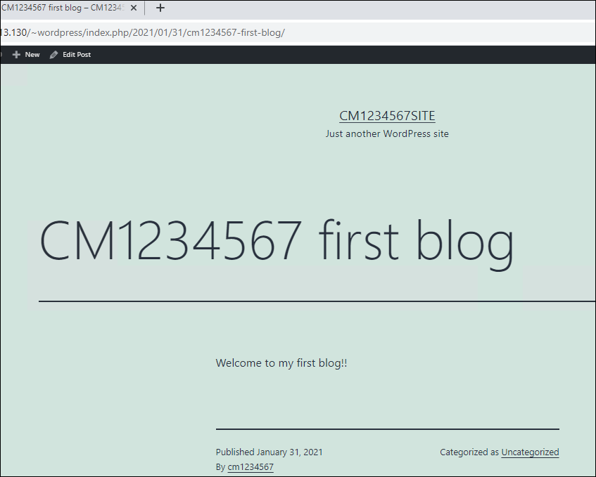
[paste your screenshot here](marks)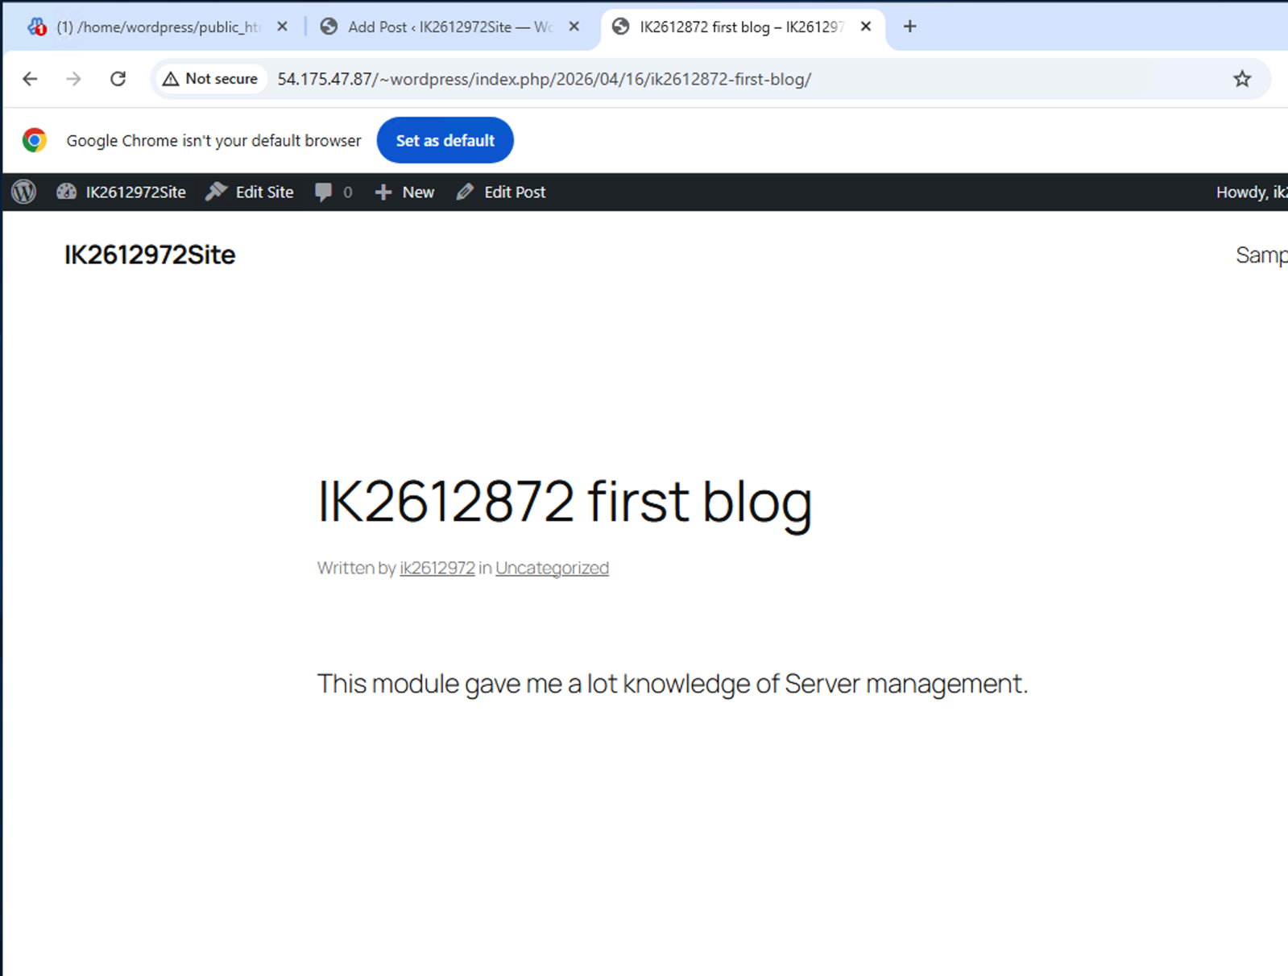

Task 6 - Creating a WordPress website

- A WordPress site can also be used for a website by using its Pages facility. Use the information on the following website to understand how to use WordPress’ Pages:
http://codex.wordpress.org/Pages
- Then create 4 pages, names Page 1, Page 2, Page 3 and Page 4 and arrange them so that their structure looks like the following screen capture:
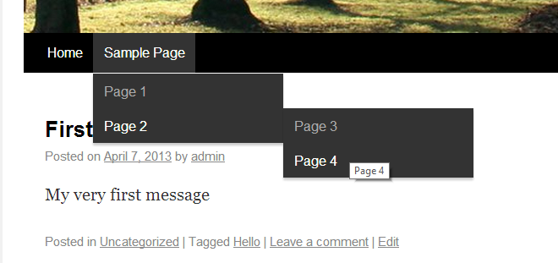
- When you are successful, paste your version of the screen capture below:
[paste your screenshot here](marks)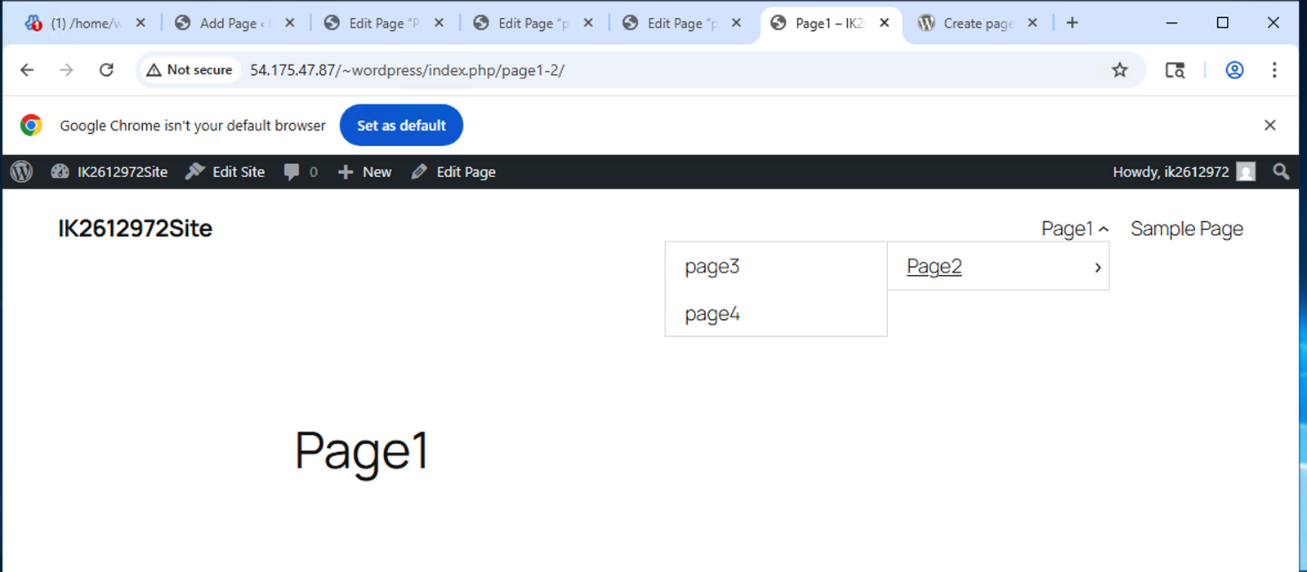

Task 6 - Creating another WordPress website

To demonstrate that you have understood all the steps required to install WordPress, create another WordPress website from scratch using another new Linux user on your server. This time use the username of wp1234567 (change the 1234567 bit to your own student ID). This means that you have to create a new Linux user, a new MySQL user, and a new MySQL database.
Your second installation of WordPress will thus be at the URL of http://123.456.789.12/~wp1234567 (obviously with your Student ID instead of 1234567)
When you are successful, paste the screen capture of your new WordPress website below:
[paste your screenshot here](lots of marks)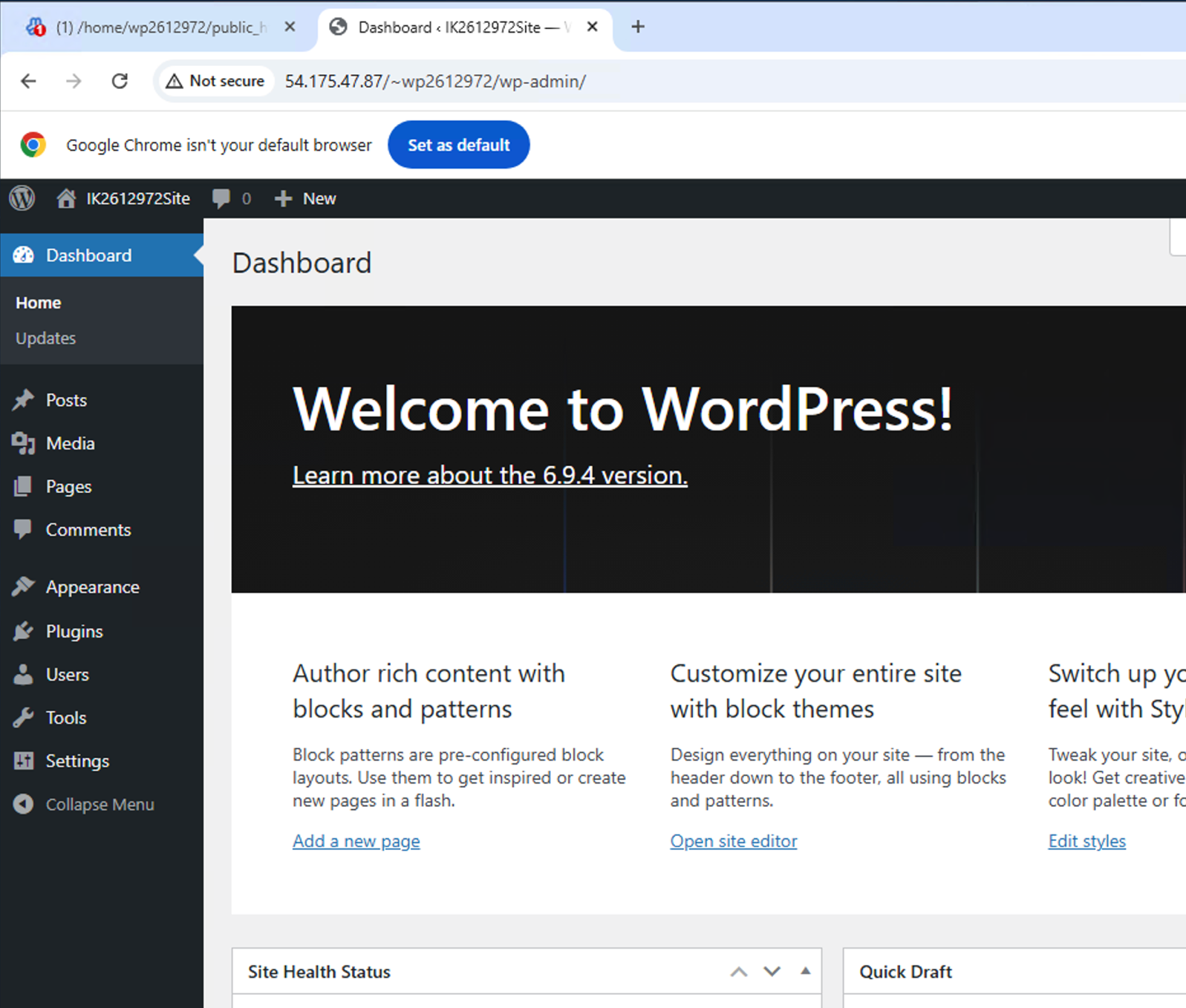
Shutdown your Linux Server.
This is the end of this workshop. If you have finished the workshop, please submit it to Canvas.
Congratulations! You have completed all the workshops for 4CS012 Server Management and Virtualisation.

