EM characterization of SMPS for modeling complex appliances

Manoj Gulati¹
¹ PhD Scholar, Indraprastha Institute of Information Technology, Delhi-110020, India

Abstract— Since appliances driven using SMPS have non deterministic power consumption behavior and even complex machine learning approaches fail to model these power signatures. Our modeling approach using EM noise generated from load regulator section of SMPS provides significant deterministic and unique signature in frequency domain aligned around its switching frequency and its odd harmonics.

Index Terms— Buck Convertor, SMPS (Switched mode power supply), NILM (Non-intrusive load monitoring), HMM (Hidden markov models), FHMM (Factorial Hidden markov models), DAQ (Data acquisition system), HS (High Speed)

INTRODUCTION
Appliance level disaggregation is being a topic of research since Hart et al wrote his seminal work on NILM got published in 1989 providing significant insights about indoor activities recognition, load prediction, individual energy apportionment leveraging several applications like demand response prediction, normalizing power grid distribution, variable billing scheme’s on basis of demand hours.

After 2 decades of research in NILM significant number of appliance level modeling approaches were proposed. Standard techniques for disaggregation are state based modeling like HMM having further extensions like FHMM, Bayesian HMM, classification techniques like k-means clustering for classifying appliance power signature with pre-recorded signatures are followed. Apart from vast amount of work in this domain still modeling complex loads i.e. lcd, laptop, CFL, dimmers is inexpedient. One approach so far followed by Siddhant et al in there ElectriSense^{[1]} work provided some satisfactory results for modeling loads using EMI noise generated from SMPS driven complex loads.

Overview of SMPS
- A switched-mode power supply (switching-mode power supply, SMPS, or switcher) is an electronic power supply that incorporates a switching regulator to convert electrical power efficiently.
Unlike a linear power supply, the pass transistor of a switching-mode supply continually switches between low-dissipation, full-on and full-off states, and spends very little time in the high dissipation transitions, which minimizes wasted energy. Ideally, a switched-mode power supply dissipates no power. Voltage regulation is achieved by varying the ratio of on-to-off time. In contrast, a linear power supply regulates the output voltage by continuously dissipating power in the pass transistor.
This higher power conversion efficiency is an important advantage of a switched-mode power supply. Switched-mode power supplies may also be substantially smaller and lighter than a linear supply due to the smaller transformer size and weight.
- Working Principal
A linear regulator provides the desired output voltage by dissipating excess power in ohmic losses (e.g., in a resistor or in the collector–emitter region of a pass transistor in its active mode). In contrast, a switched-mode power supply regulates either output voltage or current by switching ideal storage elements, like inductors and capacitors, into and out of different electrical configurations. Ideal switching elements (e.g., transistors operated outside of their active mode) have no resistance when "closed" and carry no current when "open", and so the converters can theoretically operate with 100% efficiency (i.e., all input power is delivered to the load; no power is wasted as dissipated heat).
In an SMPS, the output current flow depends on the input power signal, the storage elements and circuit topologies used, and also on the pattern used (e.g. pulse-width modulation with an adjustable duty cycle) to drive the switching elements. The spectral density of these switching waveforms has energy concentrated at relatively high frequencies. As such, switching transients and ripple introduced onto the output waveforms can be filtered with small LC filters.

Block wise explanation of SMPS
- EMI/Transient Filter: Suppress incoming and out coming EMI/RFI generated by high frequency electronic circuits and protects from voltage spikes as well. The cause of this EMI is discussed after this block diagram.

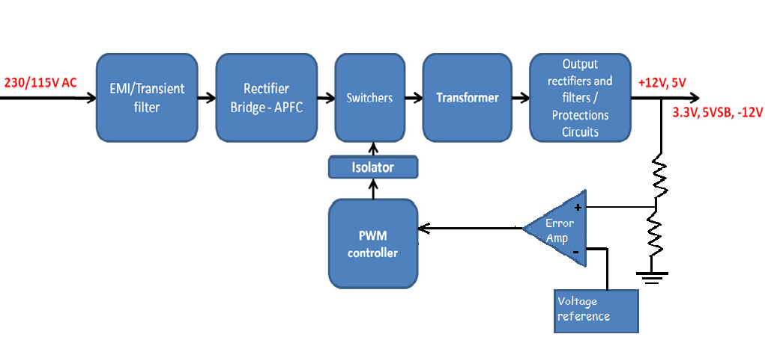

- Bridge Rectifier: Rectifies the main AC power stream to DC. This essentially forms the primary section of every power supply unit.
- PFC/APFC: Power factor control unit/ Active power factor control unit this essentially controls the current supplied to the PSU so that the current waveform is proportional to the mains voltage waveform. In DC-DC convertor the output LC coupling introduces a significant phase shift in voltage and current waveforms leading to imbalanced power factor. But typically to regulate the requirements of power factor a power factor control circuitry (PFC) is included as part of a SMPS.
EMI/Transient Filter, bridge rectifier and power factor control unit essentially forms the primary part of a SMPS.
- Main Switches/Convertor: This plays the pivotal role behind working of every SMPS. It essentially does the DC-DC or DC-AC conversion. Chop the DC signal to very small energy packets, with high frequency. This consists of a load regulator section having a solid state device like BJT or MOSFET for switching constant DC usually driven by PWM controller.
This can broadly categorized in to two categories:
    - DC-DC Convertors (i.e. SMPS)
        - Step down (Buck) Convertors
        - Step up (Boost) Convertors
        - Buck-Boost Convertor (fly back convertor)
        - Cu’k DC-DC Convertor
    - DC-AC Convertors (i.e. invertor, UPS)
        - Sinusoidal DC-AC convertors (Single phase/3-phase invertors)

- HF Transformer: Isolates primary from secondary side and converts (steps down) the voltage if required.
- Output Rectifiers & Filters: Generate the DC outputs and filter them. This is essentially second order filter to further smoothen the output voltage ripples.
- Protection Circuits: Shut down the PSU when something goes wrong. I.e. Sometimes a surge of rapid inrush current/spike of over voltage can damage the load side sensitive electronic circuitry (like motherboard) in order to avoid such damages usually protection circuitry is added to secondary side of SMPS. This consists of surge/spike protection circuits.
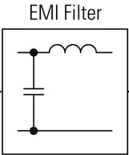 | 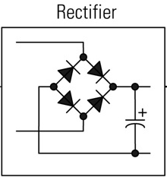 | 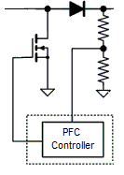
- EMI Filter | - Rectifier | - PFC controller
- PWM Controller: Adjusts the duty cycle of the main switches, in order to keep steady output voltage under all loads. This essentially maintains the duty cycle of output PWM high frequency pulsating DC in order to account for variable load impedance and input voltage fluctuations.
- Isolator: Isolates the voltage feedback that comes from the DC outputs and heads to the PWM controller.

Buck Convertor
Buck convertor is a simple dc-dc convertor which essentially consists of switching regulator section, PWM driver, LC coupling and P or PI based feedback loop.
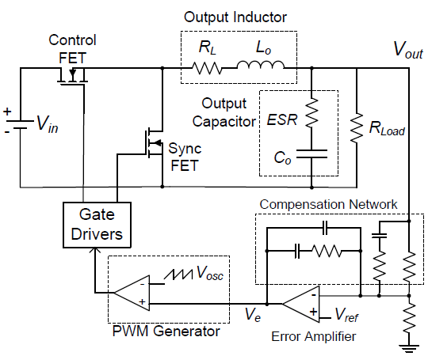
Buck Convertor used in SMPS ^{[6]}
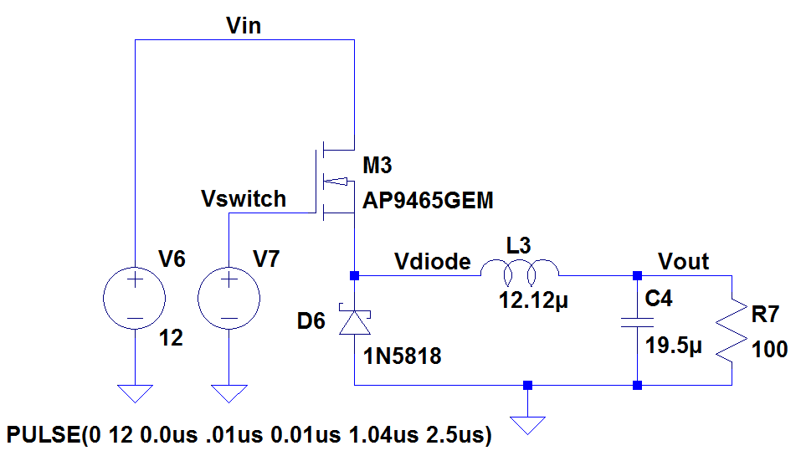
Buck convertor design as per Microchip design reference ^{[3]}

The above circuit shown is simulated in LT spice and device parameters were calculated as per microchip SMPS design guide for buck convertor design.
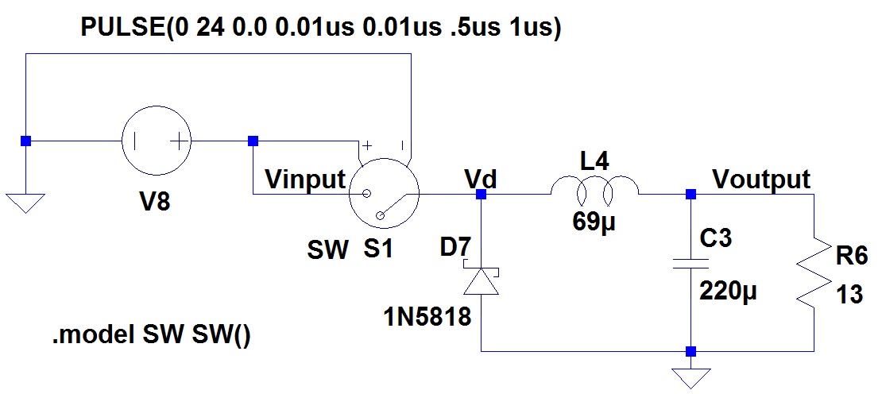
Simplified version of Buck convertor [LT Spice IV]

Frequency Domain Analysis
Shown below are some traces captured from regulator section showing FFT of voltage and current across freewheeling diode, LC circuit and load.

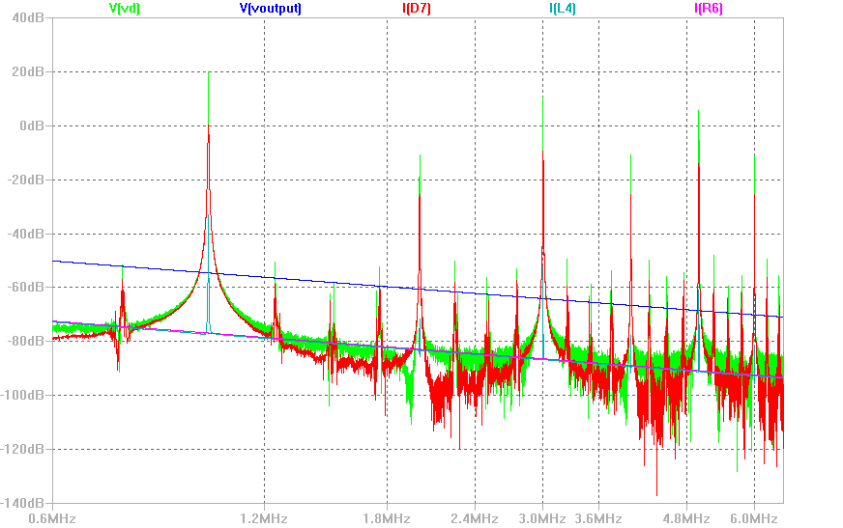

This justifies the initial trace shown in ElectriSense work showing Gaussian curve fit for EMI trace captured on a power line using HS DAQ USRP N100 sampling at 1 MHz.
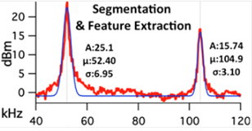
EMI trace taken from ElectriSense^{[1]}

Currently small experimental setup has been laid to verify actual EMI traces from power line having a high pass filter for blocking low frequency high amplitude AC signal (220VAC ~50Hz) and allowing high frequency EMI signal to propagate through. DAQ part is yet to be implemented.
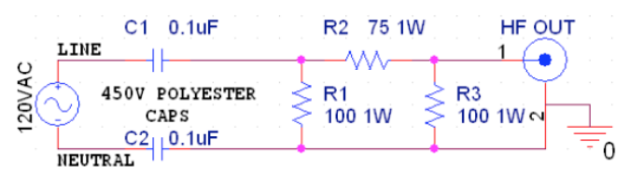
Actual schematic of plug in power line modem for verifying actual EMI trace from power line.

EM Noise generation and Coupling
Electromagnetic interference ^{[8]} is caused by undesirable radiated electromagnetic fields or conducted voltages and currents. The interference is produced by a source “aggressor” and is detected by a “victim” via coupling path ^{[7]}.

Resistive (or Galvanic) coupling
- Noise signal propagates through electrical connections
- Common impedance can be classified as galvanic coupling
- Occurs due to sharing of current paths [4] [5]

Capacitive coupling
- Electric fields form the main coupling path

Inductive coupling
- High frequency switching currents in Inductors
- Cause strong magnetic fields at high frequencies
- Occurs quite often in SMPS

Wave coupling
- Noise is transmitted via Electromagnetic wave
- Come in to picture at high frequencies usually in Ghz range

Future Work
Currently this SMPS design is in a preliminary state. In order to extract accurate trace of EMI signature PI based feedback control has to be implemented to drive the PWM control section. Several EMI traces have to be captured from diverse variety of appliance models in simulation including both active and reactive loads. Also experimental setup has to be laid down to collect actual traces of EMI which require (HS) high speed ADC’s approx. at 5-7 MHz sampling rate. In future this can be implemented as low cost EMI sensor for disaggregating complex loads.

CONCLUSION
A conclusion section is not required. Although a conclusion may review the main points of the paper, do not replicate the abstract in the conclusion. A conclusion might elaborate on the importance of the work or suggest applications and extensions.

ACKNOWLEDGMENT

I would like to acknowledge Dr. Mohammad Hashmi (PhD, EC University of Cardiff), Dr. Shobha Sundar Ram (PhD, EC UT Austin), Mr. Makarand Mijar (Senior Design Engineer Qualcomm, India) for their significant support and guidance during course of this project.

REFERENCES
[1] Gupta, Sidhant, Matthew S. Reynolds, and Shwetak N. Patel. "ElectriSense: single-point sensing using EMI for electrical event detection and classification in the home." Proceedings of the 12th ACM international conference on Ubiquitous computing, 2010.

[2] Enev, Miro, Sidhant Gupta, Tadayoshi Kohno, and Shwetak N. Patel. "Televisions, video privacy, and powerline electromagnetic interference." In Proceedings of the 18th ACM conference on Computer and communications security, pp. 537-550. ACM, 2011.

[3]www.simonthenerd.com/files/smps/SMPSBuckDesign_031809.pdf‎

[4]http://www.learnemc.com/tutorials/Common_Impedance_Coupling/conducted_coupling.html

[5]http://www.learnemc.com/tutorials/Current_Paths/Current_Paths.html

[6] AN: 1162 Compensator Design Procedure for Buck Converter with Voltage-Mode Error-Amplifier

[7] Antonini, Giulio, Saverio Cristina, and Antonio Orlandi. "EMC characterization of SMPS devices: circuit and radiated emissions model." Electromagnetic Compatibility, IEEE Transactions on 38.3 (1996): 300-309.

[8]http://www.fairchildsemi.com/Assets/zSystem/documents/collateral/onlineSeminars/Electromagnetic-Interference-EMI-in-Power-Supplies-WP.pdf

 

