Gabriel Lee | Eunwon Moon | Oscar Kwan | Krystle Bulalakaw

glokkbewm | <https://github.com/glokkbewm/commaudio>

CommAudio

User Manual

COMP4985 – Final Project

Table of Contents

Introduction 2

Getting Started 2

Prerequisite 2

Compilation 3

Execute 3

How-To 4

Client 4

Connecting to the Server 4

Communicating with Other Clients 4

Server 5

# Introduction

CommAudio is a final project designed and developed by Krystle Bulalakaw, Oscar Kwan, Eunwon Moon, and Gabriel Lee. The application is developed using Windows sockets programming techniques to transfer sound data using TCP/IP protocol suite.

The interface is built in Qt where is it connected with Win32 API. A server and client application is built where the server can have multicast abilities to stream music to multiple clients. Server is able to select from a playlist to stream from.

This document outlines how to properly use the project. It covers all aspects from compiling, starting the server, and to streaming music to the client application.

# Getting Started

Using the CommAudio project is easy! But there are some simple steps you need to follow first.

## Prerequisite

Before you can start using the application, there’s couple things you need first:

1. Install Qt via <http://www.qt.io/download-open-source/>
2. Follow the install wizard using default configurations.

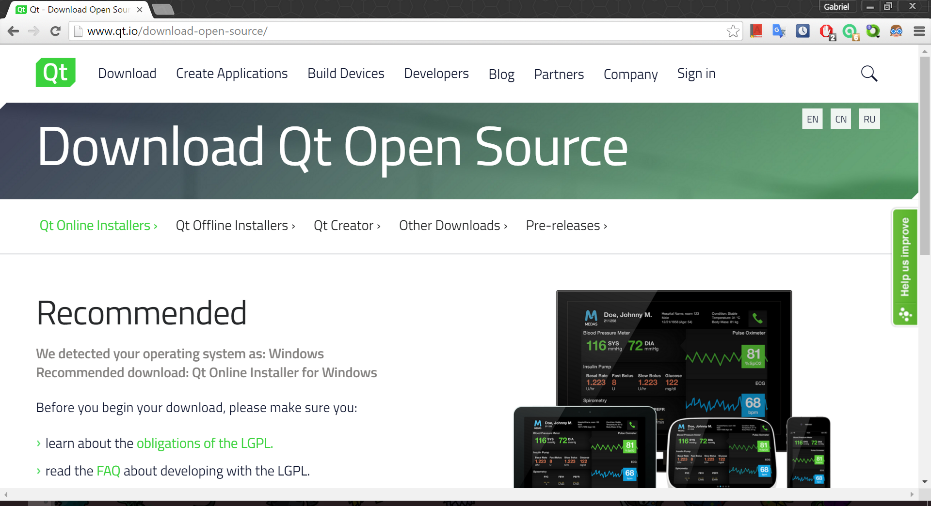

## Compilation

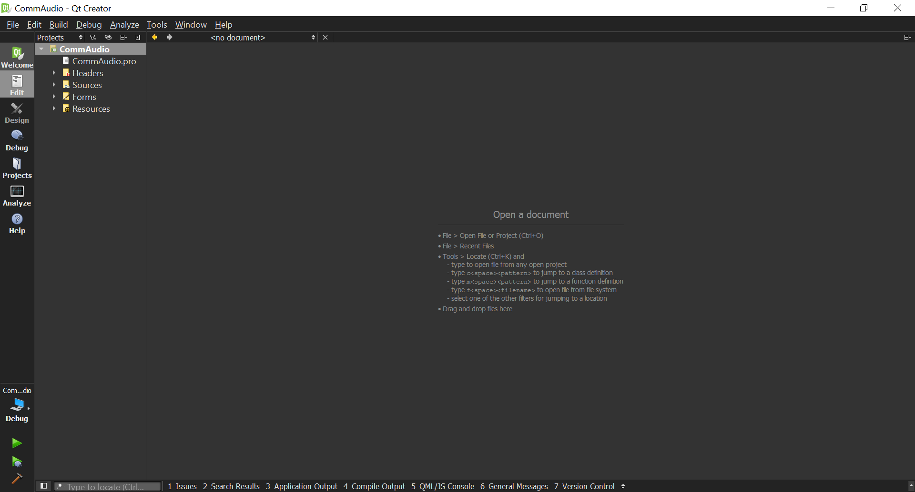

After you have installed Qt, you have to build the project.

1. Open the .pro file from the QtCreator application.
2. Press Ctrl+t to bring up the compilation modes.
3. Select desired mode. (Debug for default)
4. Press Ctrl+b to build the project.
   * Alternatively, select “Build” from the windows menu bar and click “Build Project…”

If you’d like to create a standalone .exe for the project, follow these steps: <https://wiki.qt.io/Build_Standalone_Qt_Application_for_Windows>

## Execute

You are almost there! In order to properly run the application, you can:

* Press Ctrl+r to run from the QtCreator application.
* Select “Build” from the windows menu bar and click “run”
* Double-click the .exe file in the build folder if you compiled the project as a standalone.

# How-To

## Client

### Connecting to the Server

Our application is designed to join the multicast as soon as it is started. So, you don’t have to worry about connecting to the server! As long as there is a server running, starting the client will handle joining the multicast for you!

### Communicating with Other Clients

If you’d like to send an audio message to another client in the multicast, it’s easy:

1. Input Port (socket) in the Connect tab.
2. Input IP address in the Connect tab.

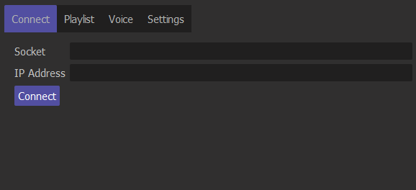

1. Press “Connect”

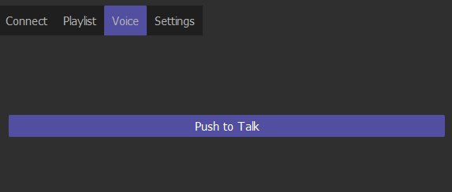

1. Press “Push to Talk” in the Voice tab.

And that’s it. You can send audio messages to anyone in the multicast.

## Server

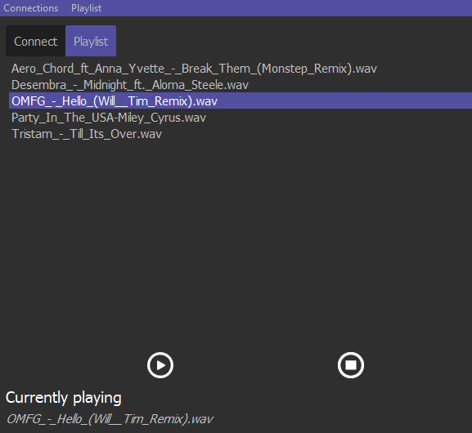

Starting the Server is very simple. It only takes 1, 2, 3 steps!

1. Select Connections -> Join Multicast.
2. Select Playlist -> Add Songs
3. Select a song and click the play button.

Now your server will start broadcasting to any clients who joins the multicast.