## 面试测试题参考答案

1.

a.队列

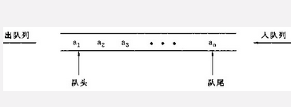

b.堆栈

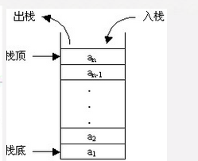

```

var a=new Array();

a.unshift(1);

a.unshift(2);

a.unshift(3);

a.unshift(4);

console.log("先进先出")

1. pop()

var a=new Array();

a.push(1);

a.push(2);

a.push(3);

a.push(4);

console.log("后进先出")

a.pop()

```

1. 代码实现如下：

```

/**

*funcDes 十进制数转换成三十二进制

*decNum Number

*retern Number

*/

var cardinalNum = 32, duoNum = ‘’;

function decToDuo(decNum){

var c = duoNum;

If (decNum !== 0) {

var a = Math.floor(decNum / cardinalNum);

var b = decNum % cardinalNum;

duoNum += String(b);

c = duoNum;

decToDuo(a)

}else{

return parseInt(c.reverse());

}

}

```

3.

```

[‘abc’, ‘123’, ‘abc123’]

```

4.

```

i: 5

I: 5

i: 5

I: 5

i: 5

5

```

```

‘1’: 0

‘1’: 1

‘1’: 2

‘1’: 3

‘1’: 4

5

‘2’: 5

‘2’: 5

‘2’: 5

‘2’: 5

‘2’: 5

```

```

for(let i = 0;i < 5;i++){

setTimeout(() => {

console.log(‘i’: i);

})

}

console.log(i)

```

```

1, 3, 4, 6, 8, 5, 2, 7

```

5.

```

var anArr = [],

randN = Math.floor(Math.random() * 1000);

for(var i = 0;i < randN;i++){

anArr.push(i);

}

console.log(anArr);

var first = 0, last, anoArr = anArr.slice();

/**

* 每隔两个成员删除给定数组中的某个成员，

* 遍历到数组结尾时循环至新数组开始，

* 直至最后一个成员，输出次成员

*

* @Author Alan

* @DateTime 2017-05-03

* @arr Array

* @return Number

*/

function iter(arr) {

var start = !!!first? 2 : 0;

first = 1;

var newArr = arr, len = arr.length;

if (len > 1) {

for(var i = start;i < len;i += 2) {

newArr.splice(i, 1);

}

iter(newArr);

}

else {

console.log(newArr);

last = parseInt(newArr.join(''));

}

}

iter(anArr);

console.log(anoArr.indexOf(last));

```