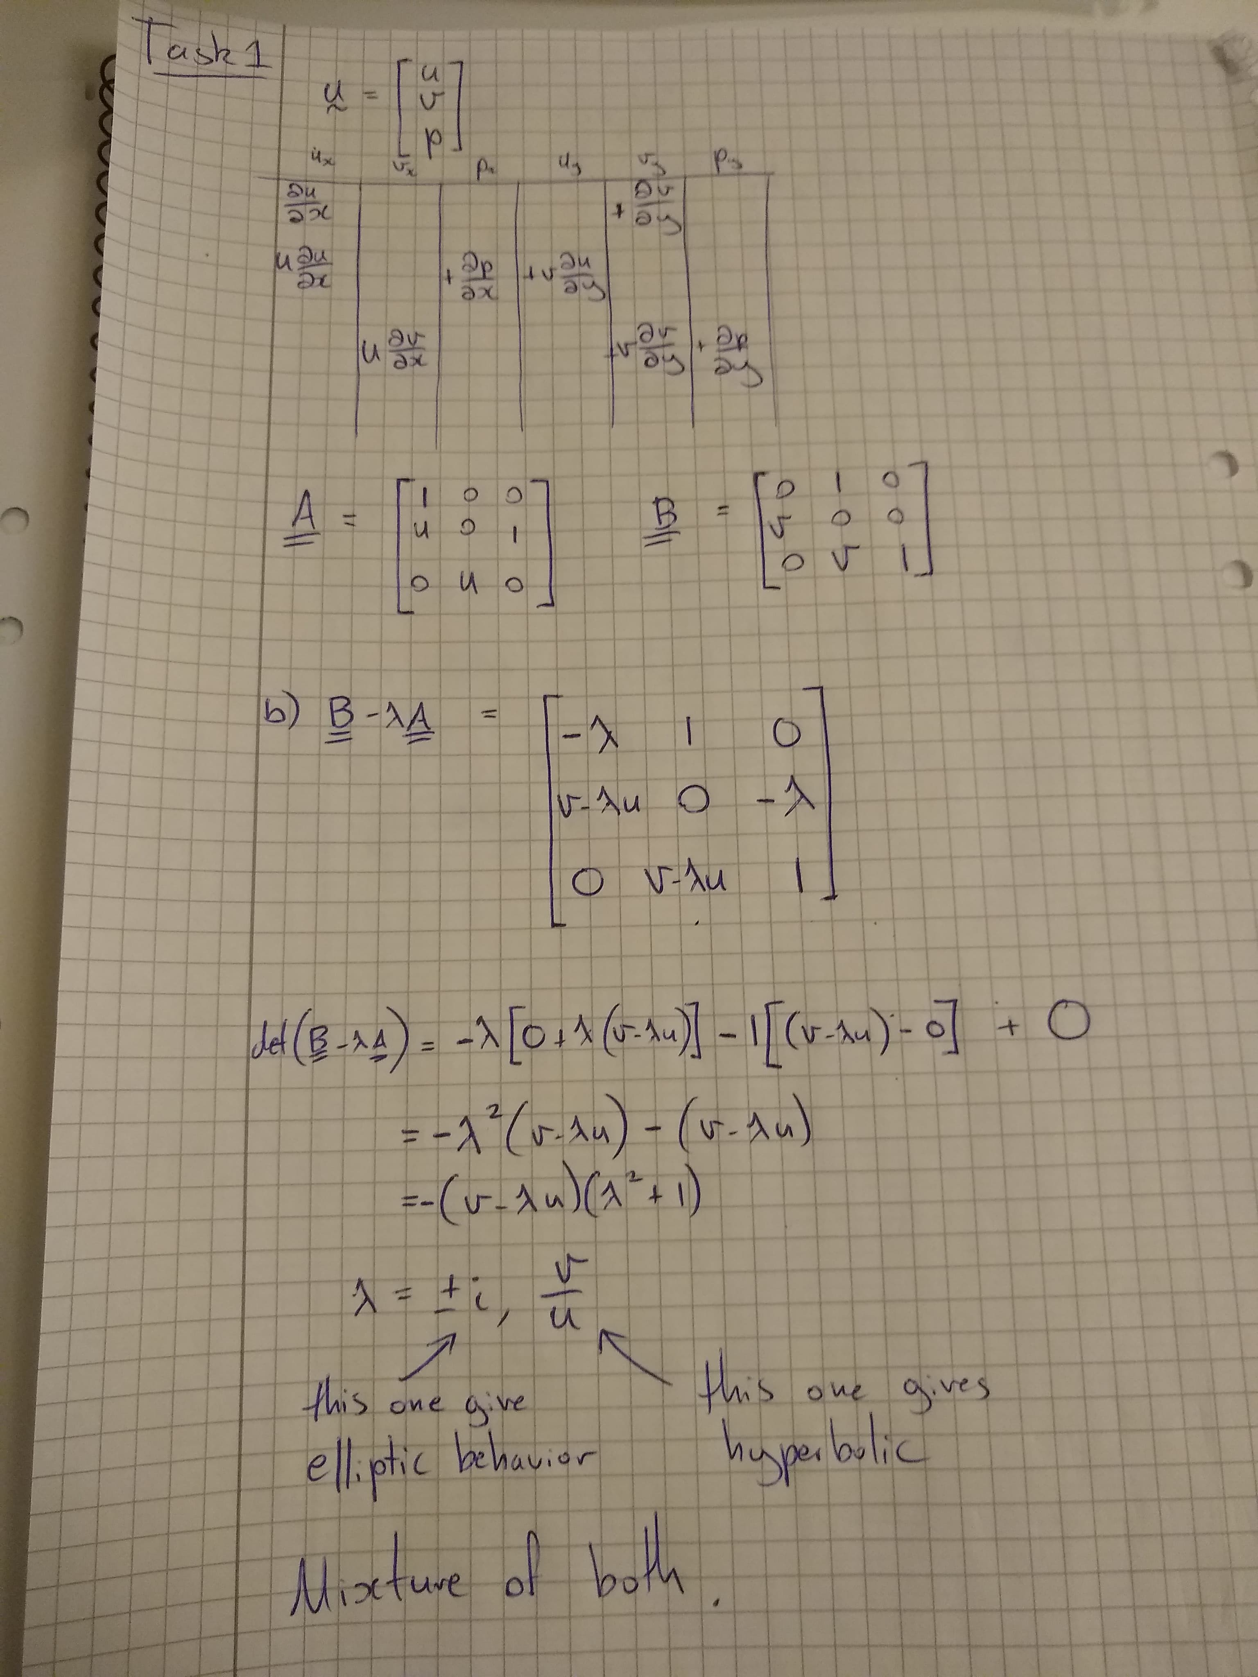
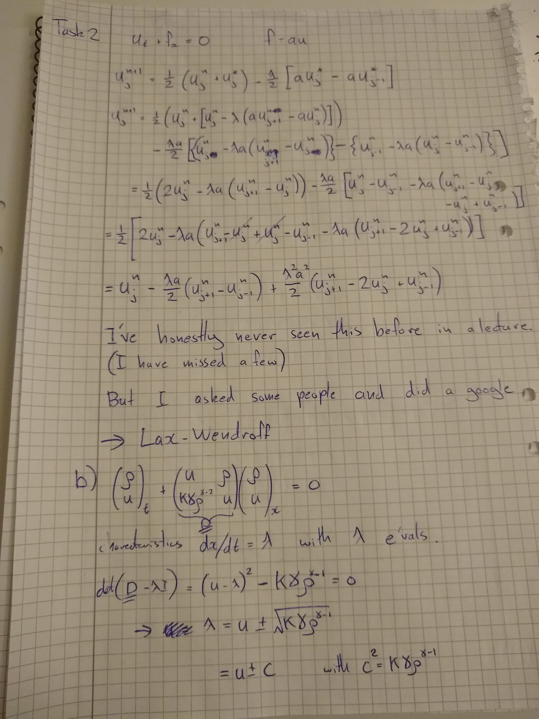
C0 = 0.05, C2 = 0.45

CN = 0.5 CN = 0.9
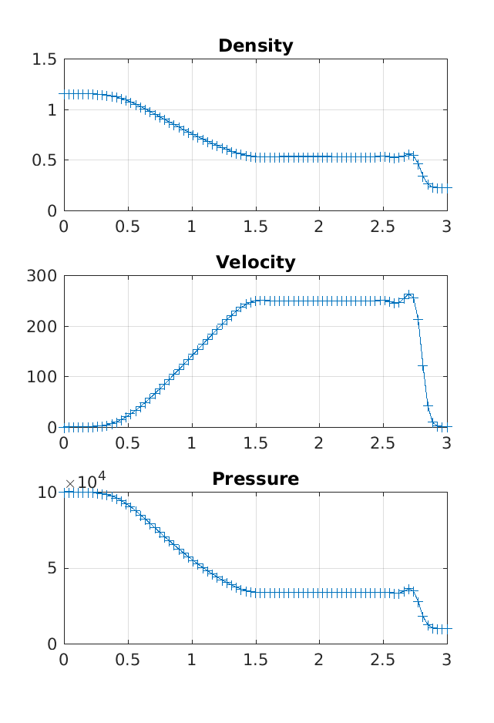
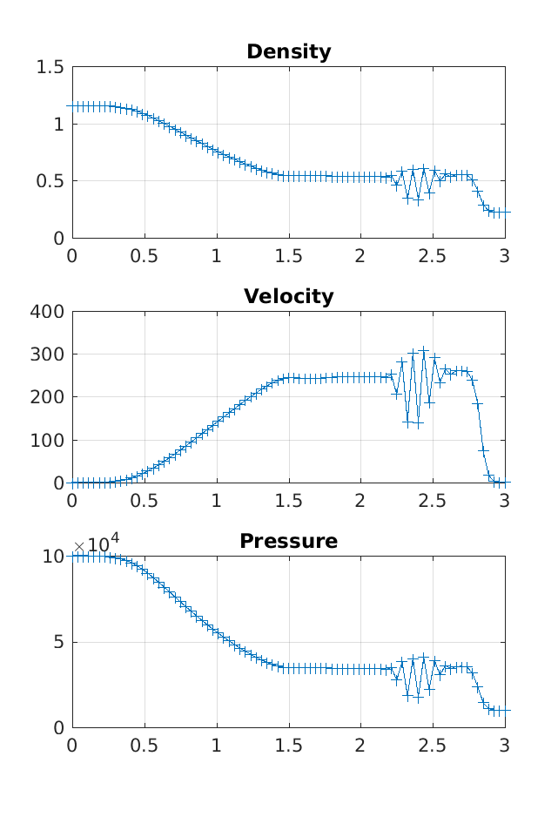
C0 = 0.05, C2 = 0.05

CN = 0.5 CN = 0.9
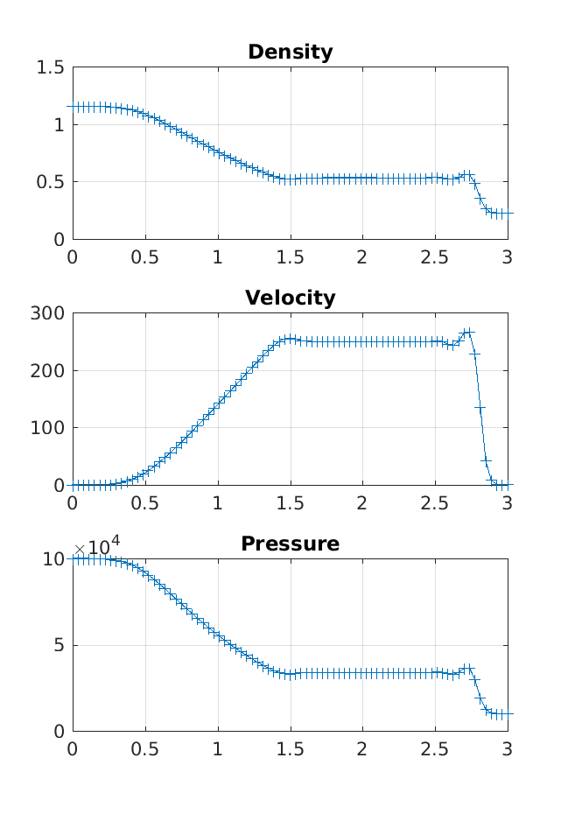
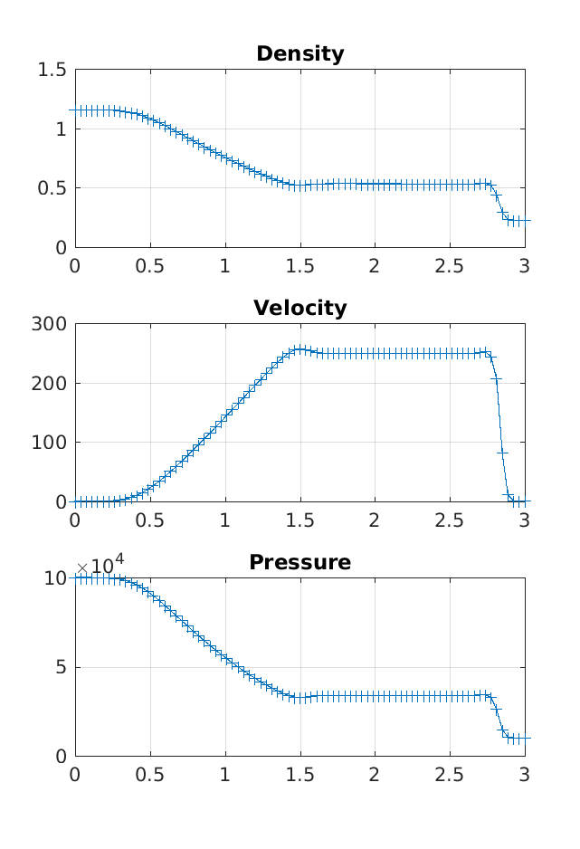
C0 = 0.4, C2 = 0.05

CN = 0.5 CN = 0.9
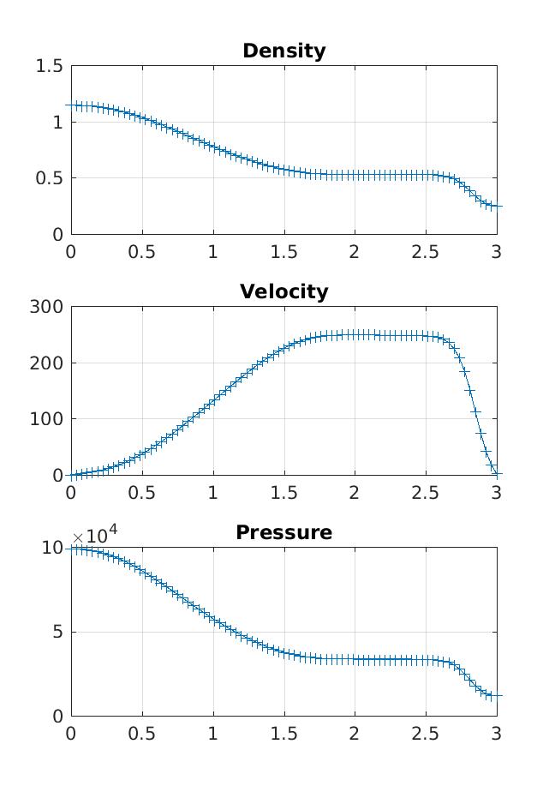
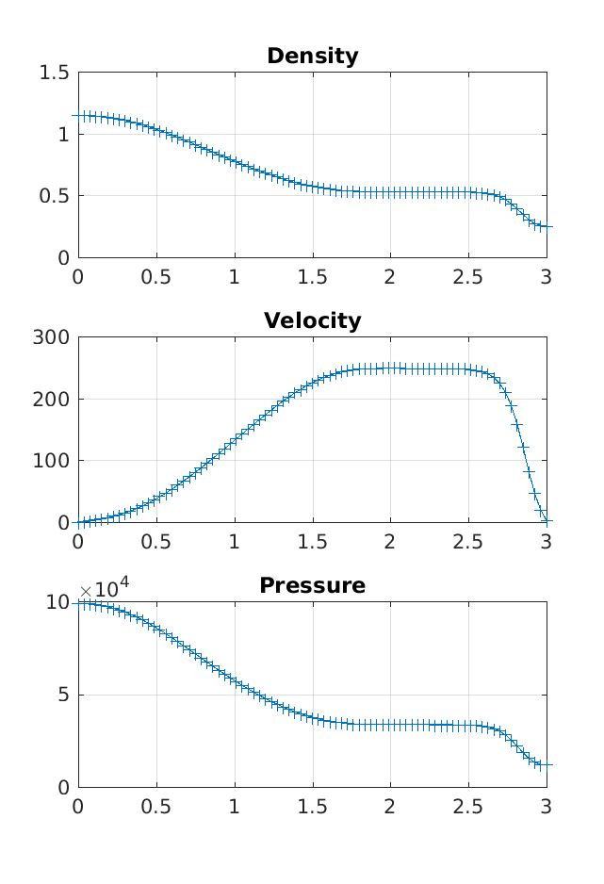
C0 = 0.05, C2 = 0.25

CN = 0.5 CN = 0.9
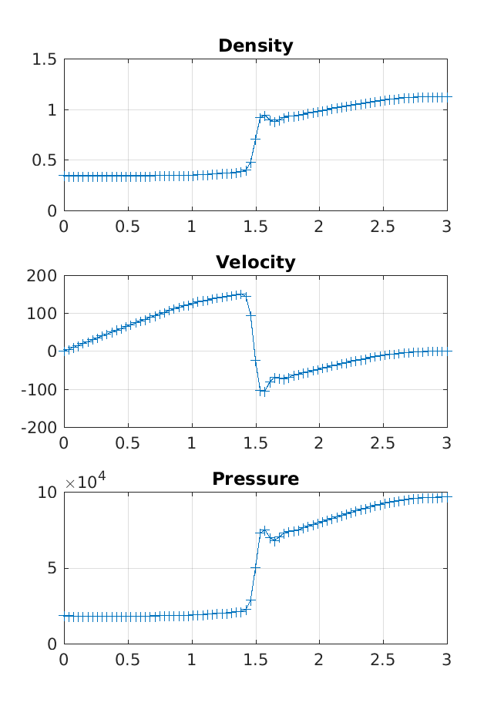
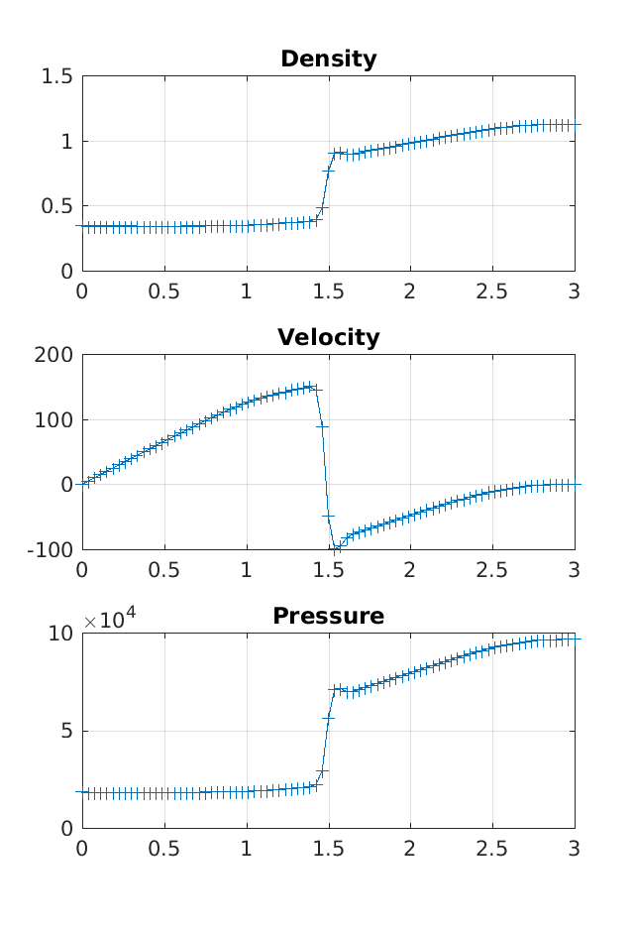
Part C:

An exerpt from my Matlab code for how I calculated the speed of the shock:

% -----------------------------------------------------------------------
% Track shock
% I know this is a dodgy way of tracking the shock.
% (it doesn't work after reflection)

% shock(:,1) x location of shock
% shock(:,2) time
% shock(:,3) estimated shock velocity from Rankine-Hugoniot condition

if t_cum > 0.001 && t_cum < 0.003
k = k+1;
d_rho = (rho(2:end) - rho(1:end-1)); % slope of density
shock_index = find(abs(d_rho) == max(abs(d_rho))); % assume shock has highest slope
shock(k,1) = X(shock_index);
shock(k,2) = t_cum;
d_rhoU = (U(2:end,2) - U(1:end-1,2))/DX; % slope of rho*U
rhoUL = mean(U([d_rhoU;0] < 10 & u > 10,2)); % mean of the flat part & non zero of rho*U
rhoL = mean(U([d_rhoU;0] < 10 & u > 10,1)); % mean of the flat part & non zero of rho*U
shock(k,3) = rhoUL/(rhoL-RHO1);
end
% -----------------------------------------------------------------------

The velocity is then estimated with a linear fit:

coefs = polyfit(shock(10:end,2),shock(10:end,1),1); % tendline for shock
s = mean(shock(10:end,3)); % average of analytic solution
disp(['CN:',num2str(CN(j)),', C0:',num2str(C0_in(i)),', C2:',num2str(C2_in(i)),...
' Measured: ',num2str(coefs(1)),'m/s Analytic: ',num2str(s),'m/s'])

These were my results:

CN:0.5, C0:0.05, C2:0.45 Measured: 428.7524m/s Analytic: 426.2748m/s
CN:0.5, C0:0.05, C2:0.05 Measured: 426.0985m/s Analytic: 430.1961m/s
CN:0.5, C0:0.4, C2:0.05 Measured: 430.0152m/s Analytic: 416.1131m/s
CN:0.5, C0:0.05, C2:0.25 Measured: 429.1039m/s Analytic: 427.1592m/s
CN:0.9, C0:0.05, C2:0.45 Measured: 310.4498m/s Analytic: 428.6295m/s
CN:0.9, C0:0.05, C2:0.05 Measured: 430.3273m/s Analytic: 430.0618m/s
CN:0.9, C0:0.4, C2:0.05 Measured: 424.1953m/s Analytic: 416.4721m/s
CN:0.9, C0:0.05, C2:0.25 Measured: 426.6384m/s Analytic: 427.5941m/s

The CN:0.9, C0:0.05, C2:0.45 case doesn’t count because it had wiggles and I bet my assumption that “the shock has the highest slope” was violated in that case.

