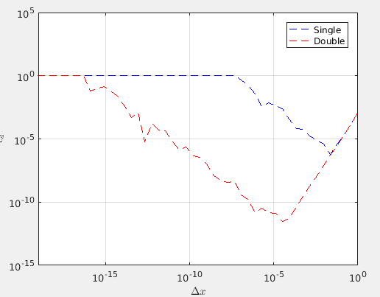
Figure 1: Loglog plot of Δx against relative discretization error for both single and double precision.

It can be seen that ε = 1 for very small Δx (indicating Matlab has evaluated is f’_n(x) = 0). It is clear that the notion of “very small Δx” is dependent on whether single or double precision is used.
As Δx increases, ε decreases. This trend continues until a certain minimum at which point the relative discretization error increases again.
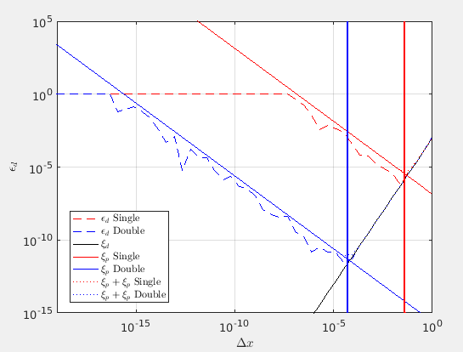
Figure 2: Loglog plot of Δx against relative discretization error for ξd ξp ξg.

The trend in figure 1 is explained in more detail here. A similar trend can be seen for both single and double precision albeit somewhat skewed and shifted.
The decrease in ε (with increasing Δx) initially observed can be explain by the propagation error while the subsequent increase in ε can be explained by the discretization error.
The trend noticed in figure 1 that “ ε = 1 for very small Δx” is not apparent in the ξp plots as f’_n(x) is not being explicitly calculated.

