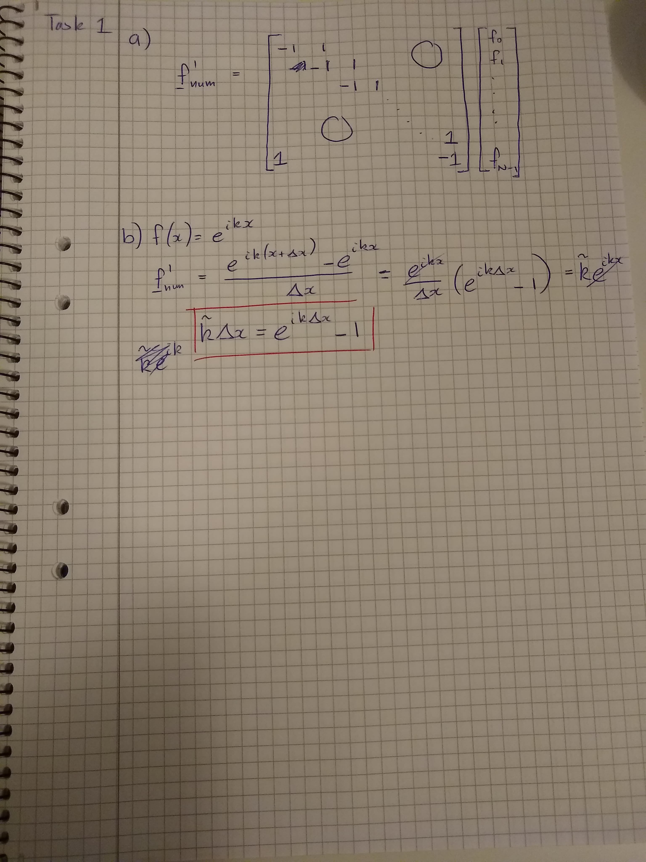
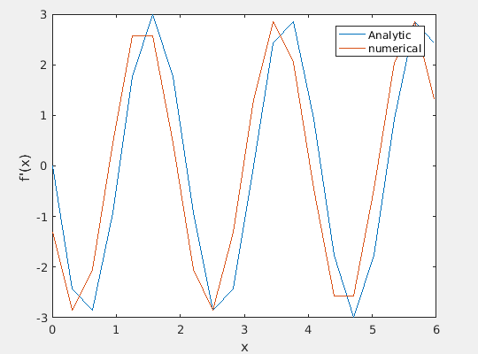
c)

d) mu =

-1.3121 + 2.5752i
From the output we can see that ikf = Df for the current case.
Analytically this makes sense as well!
-1.3121 + 2.5752i
-1.3121 + 2.5752i
-1.3121 + 2.5752i
-1.3121 + 2.5752i
-1.3121 + 2.5752i
-1.3121 + 2.5752i
-1.3121 + 2.5752i
-1.3121 + 2.5752i
-1.3121 + 2.5752i
-1.3121 + 2.5752i
-1.3121 + 2.5752i
-1.3121 + 2.5752i
-1.3121 + 2.5752i
-1.3121 + 2.5752i
-1.3121 + 2.5752i
-1.3121 + 2.5752i
-1.3121 + 2.5752i
-1.3121 + 2.5752i
-1.3121 + 2.5752i

k_mod =

-1.3121 + 2.5752i
