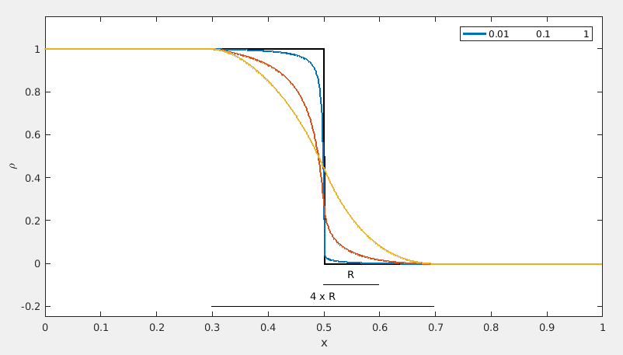

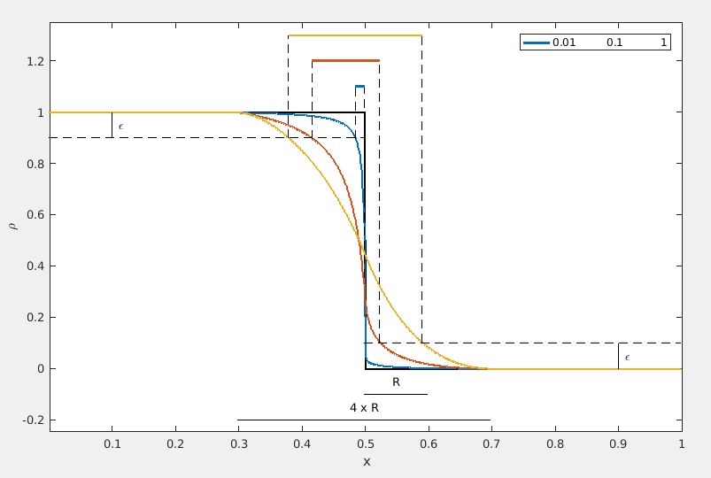

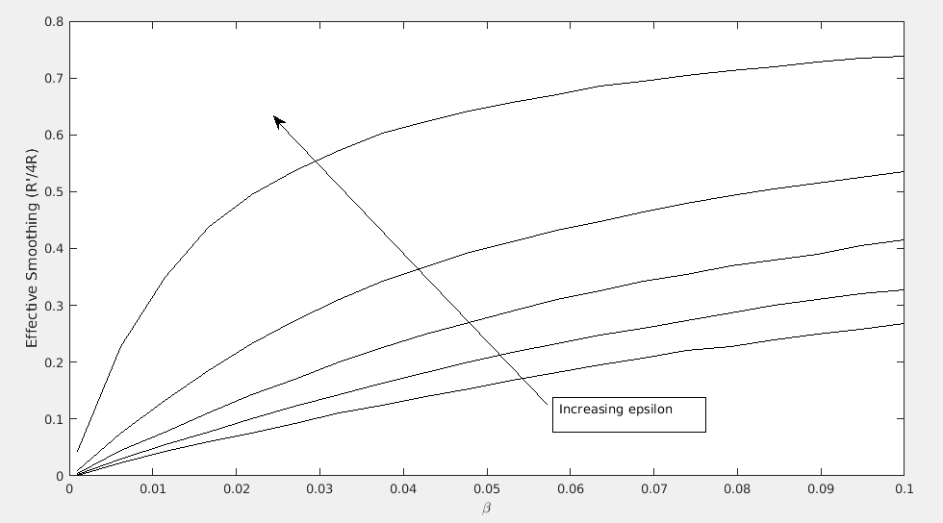
Scaled filter radius = 2
penalty parameter always incremented from 1:0.5:3
β

1E1
Obj = 6.2397E-2

1E0
Obj = 6.6844E-2

1E-1
Obj = 9.322E-2

1E-4
Obj = 8.5748E-1
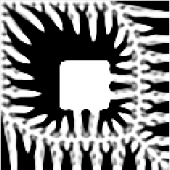
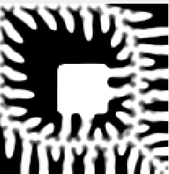
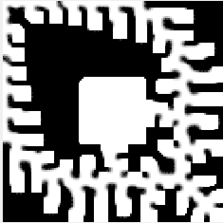
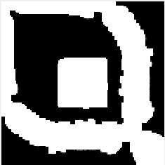
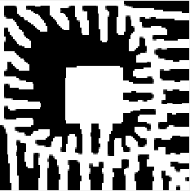
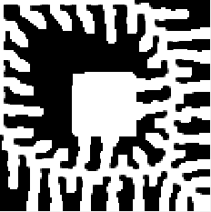
Obj = 1.2278E-1
Obj = 1.1935E-1
Scaled filter radius = 4
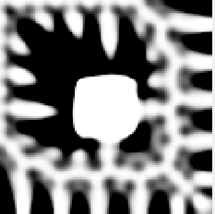
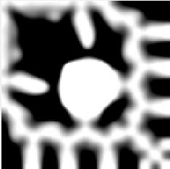

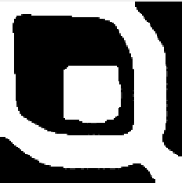


penalty parameter always incremented from 1:0.5:3
β

1E1
Obj = 7.6194E-2

1E0
Obj = 8.8622E-2

1E-1
Obj = 1.9210E-1

1E-4
Obj = 1.0868E-0
Obj = 1.1935E-1
Obj = 1.2278E-1

