Customer Churn Prediction
Week 2 Report: Exploratory Data Analysis & Feature Engineering
NexAfrica Machine Learning Internship
Prepared by: BabyLast

1. Overview
This report covers Week 2 of the Customer Churn Prediction project: exploratory data analysis (EDA), identification of key churn drivers, feature engineering, and feature preprocessing. All analysis builds on the cleaned dataset produced in Week 1 (7,043 customers, 21 columns, no missing values or duplicates).

2. Descriptive Statistics
Summary statistics for the core numerical variables:
Variable | Mean | Median | Min | Max
Tenure (months) | 32.4 | 29 | 0 | 72
Monthly Charges ($) | 64.76 | 70.35 | 18.25 | 118.75
Total Charges ($) | 2,279.73 | 1,394.55 | 0 | 8,684.80

A sanity check confirmed TotalCharges is internally consistent with tenure × MonthlyCharges (median difference of $0, with natural variation from pricing changes over time).
16.2% of customers are senior citizens. Contract types are split: 55.0% Month-to-month, 24.1% Two year, 20.9% One year.

3. Key Churn Drivers
Six key insights were identified by analyzing churn rates across customer segments.

Insight 1: Contract Type
Month-to-month customers churn at 42.7%, compared to 11.3% for one-year contracts and just 2.8% for two-year contracts — a roughly 15x difference between the least and most committed contract types. Contract length appears to function as a proxy for switching cost: customers without a lock-in period face no friction to leaving.
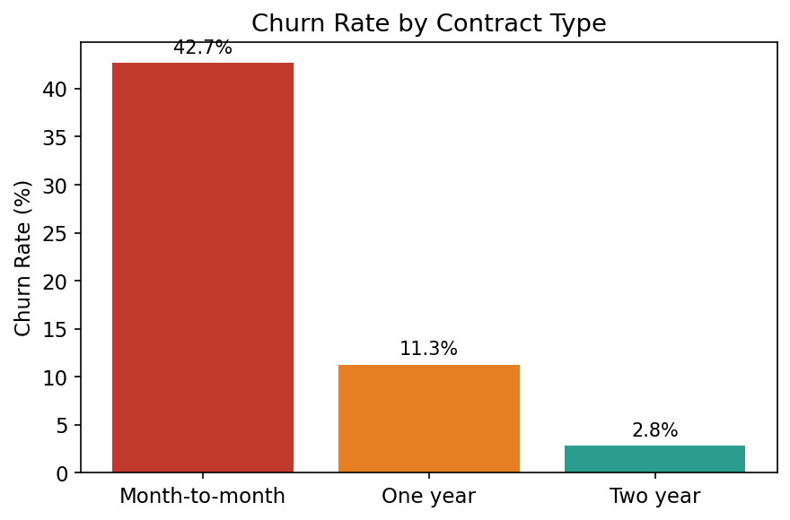
Figure 1: Churn rate by contract type

Insight 2: Tenure
Churned customers had an average tenure of 18.0 months, compared to 37.6 months for retained customers — roughly half the tenure. Churn risk is concentrated in a customer's first year or two, likely reflecting an early evaluation period combined with a lack of long-term contract commitment.
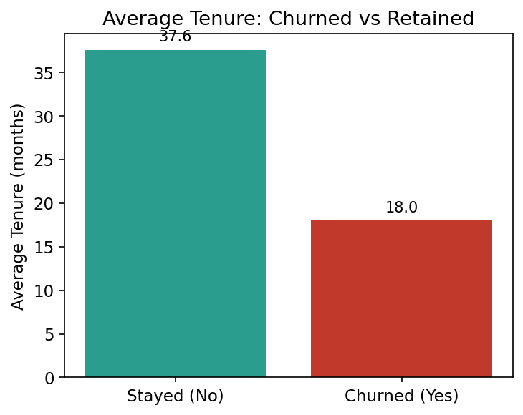
Figure 2: Average tenure, churned vs retained customers

Insight 3: Monthly Charges
Churned customers paid an average of $74.44/month, versus $61.27/month for retained customers — a gap of roughly $13. This may reflect price sensitivity among higher-paying customers, or may be a downstream effect of service type (see Insight 4).
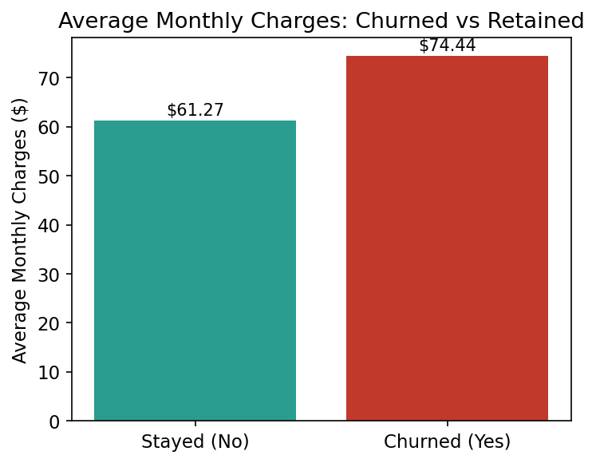
Figure 3: Average monthly charges, churned vs retained customers

Insight 4: Internet Service Type
Fiber optic customers churn at 41.9%, compared to 19.0% for DSL and 7.4% for customers with no internet service — more than double the DSL rate. This connects directly to Insight 3, since fiber optic is the highest-priced tier. Despite being the technically superior product, fiber optic shows the highest churn of any service type, possibly reflecting higher customer expectations or greater availability of competing providers in fiber-serviceable areas.
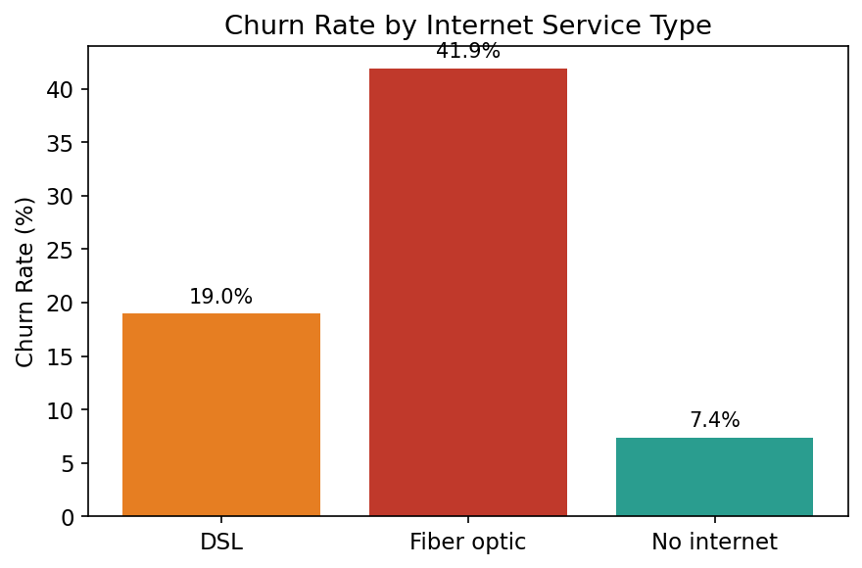
Figure 4: Churn rate by internet service type

Insight 5: Payment Method
Customers paying via electronic check churn at 45.3%, roughly 3x the rate of all other payment methods (15-19%). Automatic payment methods (bank transfer, credit card) show the lowest churn, suggesting payment friction — or the lack of it — discourages cancellation. This likely overlaps with contract type and tenure rather than acting as a fully independent driver.
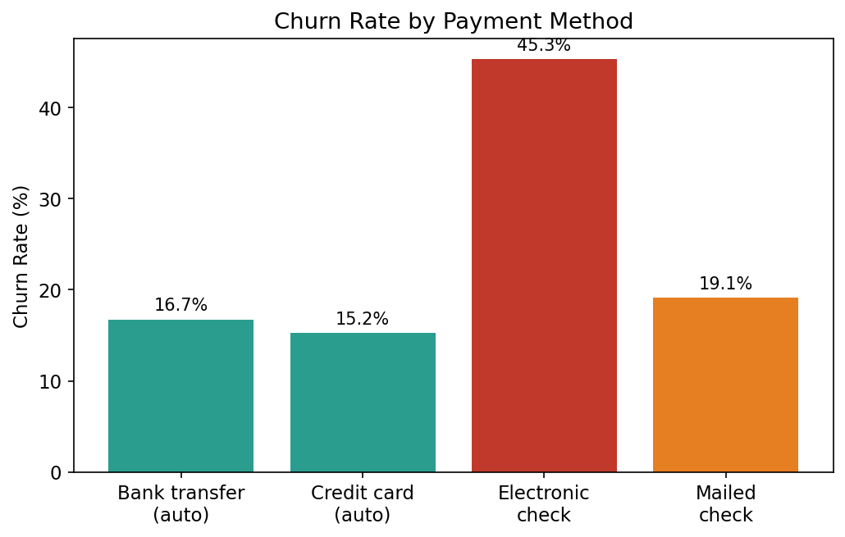
Figure 5: Churn rate by payment method

Insight 6: Demographics — Gender vs. Senior Citizen Status
Gender shows no meaningful effect on churn (26.9% female vs 26.2% male) and can likely be deprioritized as a predictor. Senior citizens, by contrast, churn at nearly double the rate of non-seniors (41.7% vs 23.6%), despite making up only 16.2% of the customer base — a real and substantial gap worth further investigation.
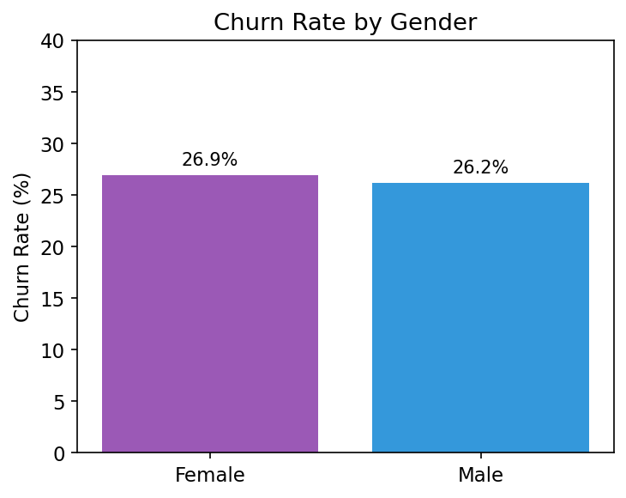
Figure 6: Churn rate by gender
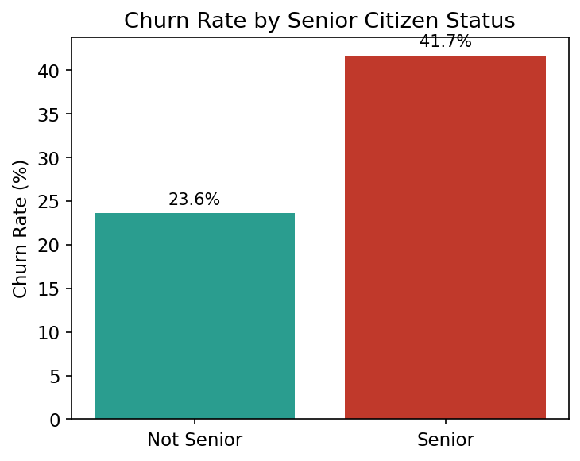
Figure 7: Churn rate by senior citizen status

Supplementary: Correlation Heatmap
Numeric features show tenure and TotalCharges are strongly correlated (0.83), as expected since charges accumulate over time. MonthlyCharges and TotalCharges are moderately correlated (0.65). SeniorCitizen shows weak correlation with all numeric variables.
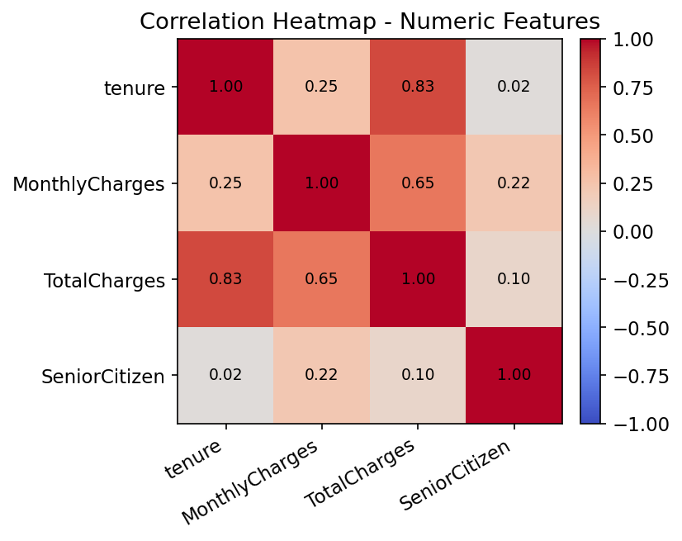
Figure 8: Correlation heatmap of numeric features

4. Feature Engineering
Three new features were engineered based on the patterns identified above, each validated by checking its relationship with churn before inclusion in the final dataset.

TenureGroup
Tenure was bucketed into four ranges (0-1 year, 1-2 years, 2-4 years, 4+ years) to make the churn relationship more interpretable and to help tree-based models split more effectively than on a raw continuous value. Churn drops sharply and consistently across groups: 47.4% → 28.7% → 20.4% → 9.5%.
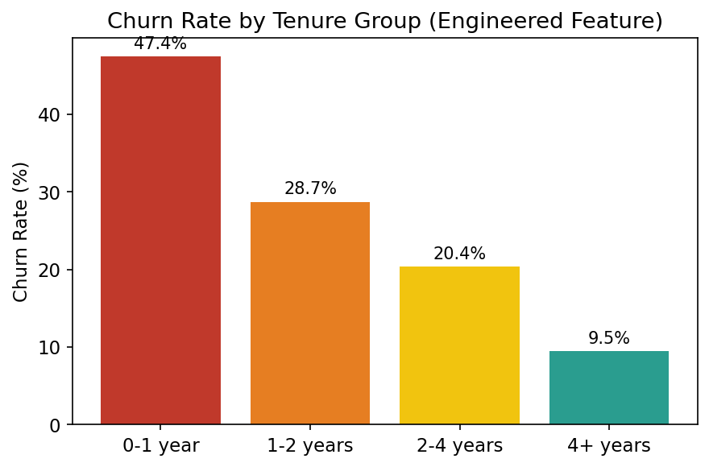
Figure 9: Churn rate by engineered TenureGroup feature

NumServices
A count of how many of 8 possible add-on services (phone, security, backup, protection, tech support, streaming TV/movies) each customer subscribes to, used as a proxy for ecosystem engagement. The relationship with churn is non-monotonic: churn is highest for customers with 0 services (43.8%) or 2-4 services (33-37%), and lowest for fully bundled customers with 7-8 services (12.4%, 5.3%). This suggests deep service adoption strongly correlates with retention, while customers still building out their service set (often newer customers) remain at elevated risk.

SpendingTier
MonthlyCharges was split into three equal-sized tiers (Low, Medium, High) using quantile binning, complementing the InternetService and NumServices findings. Churn increases monotonically across tiers: 15.9% (Low) → 29.7% (Medium) → 34.1% (High).
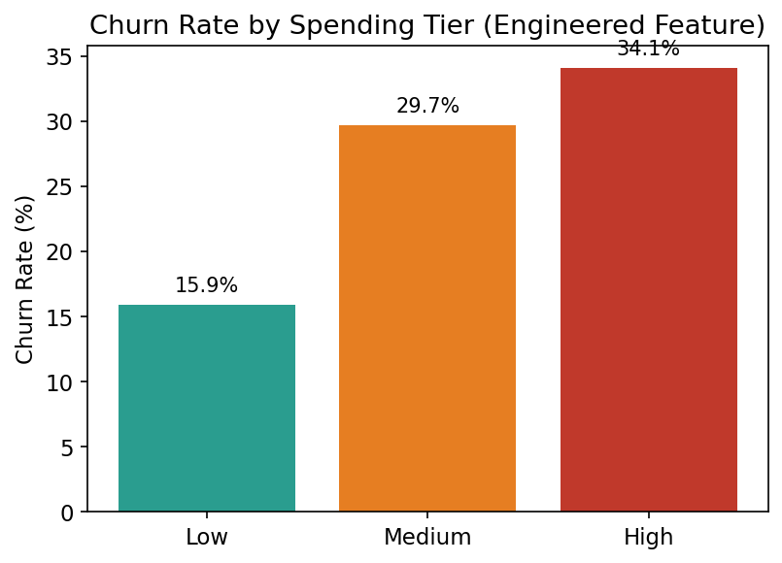
Figure 10: Churn rate by engineered SpendingTier feature

5. Feature Preprocessing
To prepare the dataset for machine learning, the following steps were applied:
- Dropped customerID (non-predictive identifier)
- Encoded the target variable Churn as binary (Yes = 1, No = 0)
- One-hot encoded all categorical features (drop_first=True to avoid redundant columns)
- Standardized numerical features (tenure, MonthlyCharges, TotalCharges, NumServices) using StandardScaler
- Split the dataset into features (X) and target (y): final shape (7,043 rows × 36 feature columns)
The resulting dataset, telco_churn_feature_engineered.csv, is fully machine-learning-ready and will be used as the starting point for model development in Week 3.

6. Summary
This week's analysis identified six substantiated churn drivers — contract type, tenure, monthly charges, internet service type, payment method, and senior citizen status — while confirming gender has no meaningful effect. Three engineered features (TenureGroup, NumServices, SpendingTier) were created, validated against churn, and incorporated into a final preprocessed dataset ready for model training.
Deliverables completed: EDA notebook, 10 visualizations, 6 documented insights, 3 engineered features with justification, and a machine-learning-ready dataset.

