中南大学

Web应用开发技术
实验报告

姓 名： | 陈佳祺
学 号： | 8209180420
班 级： | 软件工程1902
指导老师： | 宋 铁
完成时间： | 2021/02/08
分 数：
批阅日期：
实验一 基于MVC用JSP/Servlet实现JPetStore

- 实验内容——基本任务。
- 商品展示业务模块，包括大类Category、小类Product和具体商品Item的展示和搜索功能。
界面截图：
Category界面：
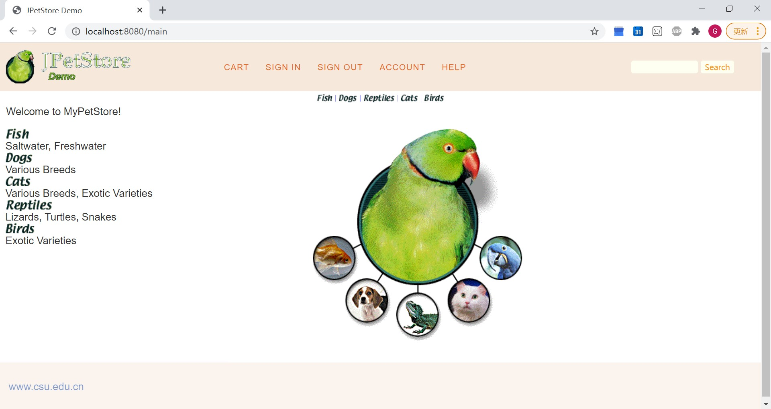
Product界面：
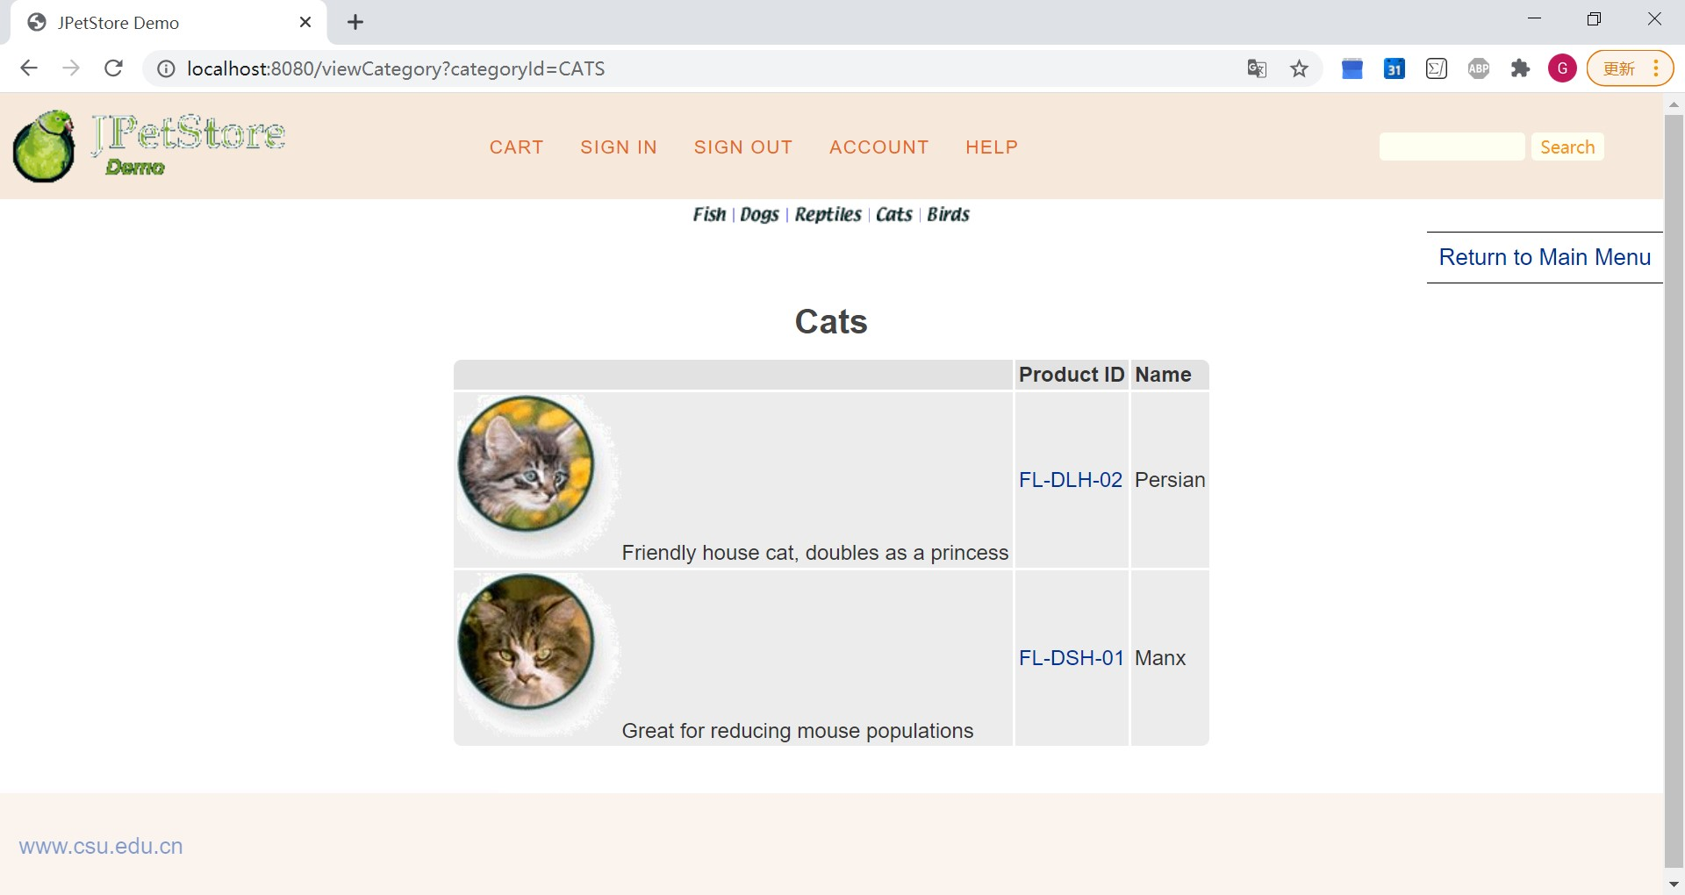
Item界面：
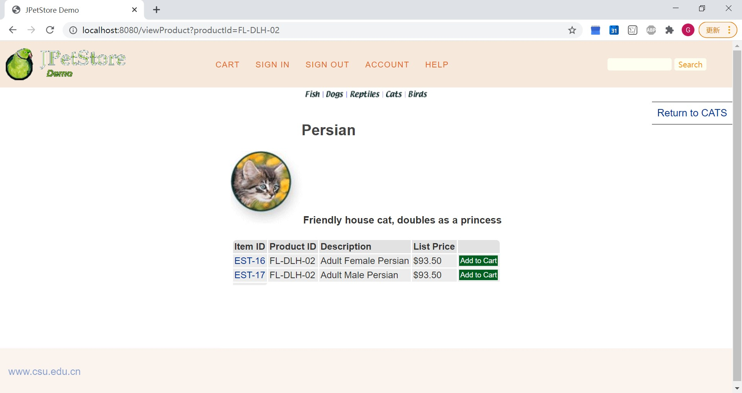
Item详情界面：
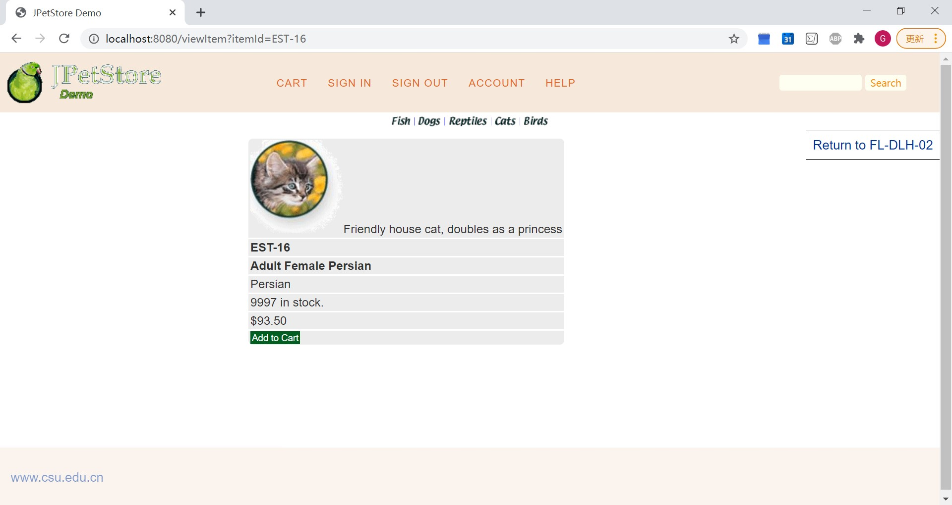
搜索“Retriever”结果：
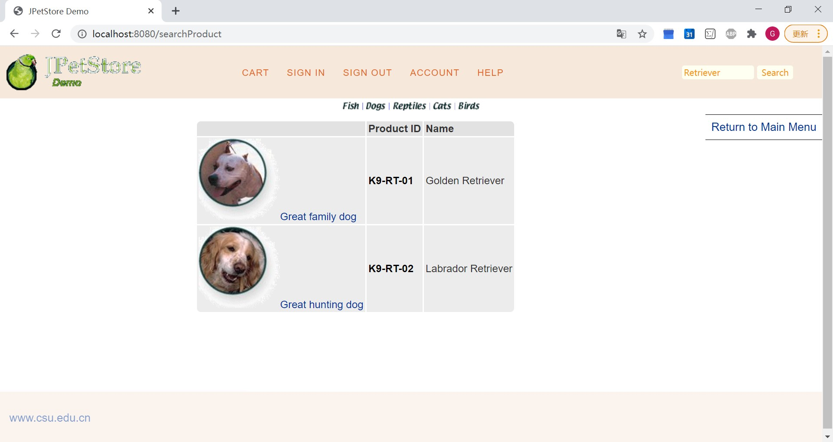
核心代码：
DAO类接口：
public interface CategoryDAO {
List<Category> getCategoryList();
Category getCategory(String categoryId);
}

public interface ProductDAO {
List<Product> getProductListByCategory(String categoryId);
Product getProduct(String productId);
List<Product> searchProductList(String keywords);
}

public interface ItemDAO {
void updateInventoryQuantity(Map<String, Object> param);
int getInventoryQuantity(String itemId);
List<Item> getItemListByProduct(String productId);
Item getItem(String itemId);
}
CatalogService类：
public class CatalogService {
private CategoryDAO categoryDAO;
private ProductDAO productDAO;
private ItemDAO itemDAO;
public CatalogService() {
categoryDAO = new CategoryDAOImpl();
productDAO = new ProductDAOImpl();
itemDAO = new ItemDAOImpl();
}
public List<Category> getCategoryList() {
return categoryDAO.getCategoryList();
}
public Category getCategory(String categoryId) {
return categoryDAO.getCategory(categoryId);
}
public Product getProduct(String productId) {
return productDAO.getProduct(productId);
}
public List<Product> getProductListByCategory(String categoryId) {
return productDAO.getProductListByCategory(categoryId);
}
public List<Product> searchProductList(String keyword) {
return productDAO.searchProductList("%" + keyword.toLowerCase() + "%");
}
public List<Item> getItemListByProduct(String productId) {
return itemDAO.getItemListByProduct(productId);
}
public Item getItem(String itemId) {
return itemDAO.getItem(itemId);
}
public boolean isItemInStock(String itemId) {
return itemDAO.getInventoryQuantity(itemId) > 0;
}
}
Servlet：
public class ViewCategoryServlet extends HttpServlet {
private static final String VIEW_CATEGORY = "/WEB-INF/jsp/catalog/Category.jsp";
private String categoryId;
protected void doPost(HttpServletRequest request, HttpServletResponse response) throws ServletException, IOException {
doGet(request, response);
}
protected void doGet(HttpServletRequest request, HttpServletResponse response) throws ServletException, IOException {
categoryId = request.getParameter("categoryId");
CatalogService service = new CatalogService();
Category category = service.getCategory(categoryId);
List<Product> productList = service.getProductListByCategory(categoryId);
HttpSession session = request.getSession();
session.setAttribute("category" , category);
session.setAttribute("productList" , productList);
request.getRequestDispatcher(VIEW_CATEGORY).forward(request,response);
}
}

public class ViewProductServlet extends HttpServlet {
private static final String VIEW_PRODUCT = "/WEB-INF/jsp/catalog/Product.jsp";
private String productId;
protected void doPost(HttpServletRequest request, HttpServletResponse response) throws ServletException, IOException {
doGet(request, response);
}
protected void doGet(HttpServletRequest request, HttpServletResponse response) throws ServletException, IOException {
productId = request.getParameter("productId");
CatalogService service = new CatalogService();
Product product = service.getProduct(productId);
List<Item> itemList = service.getItemListByProduct(productId);
HttpSession session = request.getSession();
session.setAttribute("product", product);
session.setAttribute("itemList", itemList);
request.getRequestDispatcher(VIEW_PRODUCT).forward(request,response);
}
}

public class ViewItemServlet extends HttpServlet {
private static final String VIEW_ITEM = "/WEB-INF/jsp/catalog/Item.jsp";
private String itemId;
protected void doPost(HttpServletRequest request, HttpServletResponse response) throws ServletException, IOException {
doGet(request,response);
}
protected void doGet(HttpServletRequest request, HttpServletResponse response) throws ServletException, IOException {
itemId = request.getParameter("itemId");
CatalogService service = new CatalogService();
Item item = service.getItem(itemId);
HttpSession session = request.getSession();
session.setAttribute("item",item);
session.setAttribute("product", item.getProduct());
request.getRequestDispatcher(VIEW_ITEM).forward(request,response);
}
}

public class SearchProductServlet extends HttpServlet {
private static final String SEARCH_PRODUCT = "/WEB-INF/jsp/catalog/SearchProducts.jsp";
private String keyword;
protected void doPost(HttpServletRequest request, HttpServletResponse response) throws ServletException, IOException {
doGet(request,response);
}
protected void doGet(HttpServletRequest request, HttpServletResponse response) throws ServletException, IOException {
keyword = request.getParameter("keyword");
CatalogService service = new CatalogService();
List<Product> productList = service.searchProductList(keyword);
HttpSession session = request.getSession();
session.setAttribute("productList",productList);
request.getRequestDispatcher(SEARCH_PRODUCT).forward(request,response);
}
}

- 用户管理业务模块，包括用户注册、登录、修改用户信息、查询用户相关订单等业务功能。
界面截图：
用户注册界面：
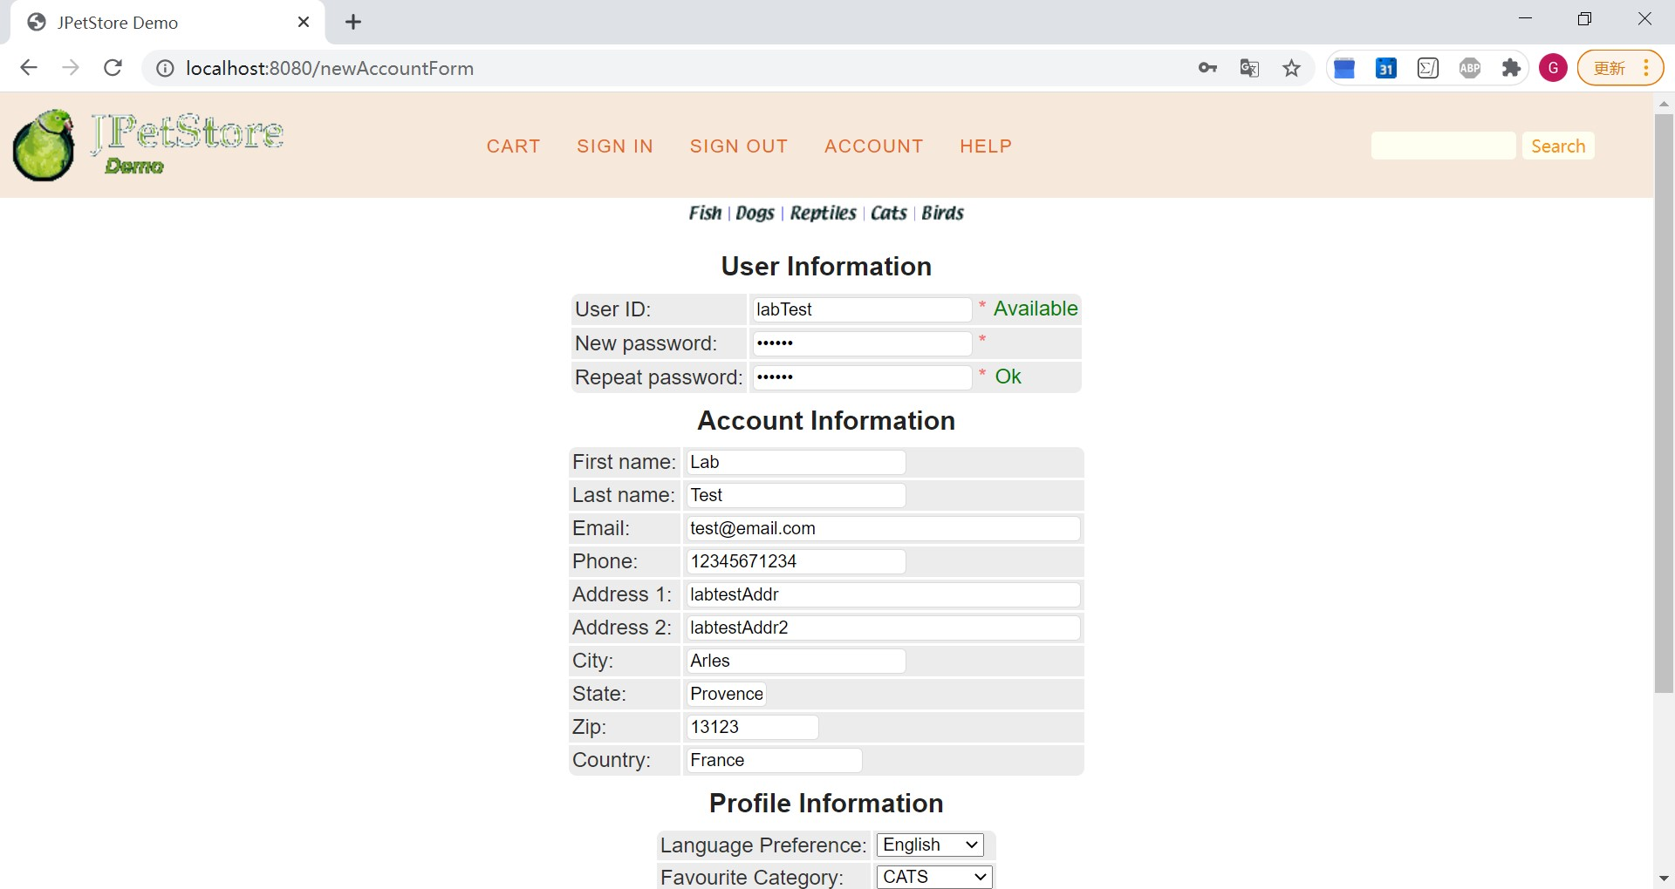
用户登录界面：
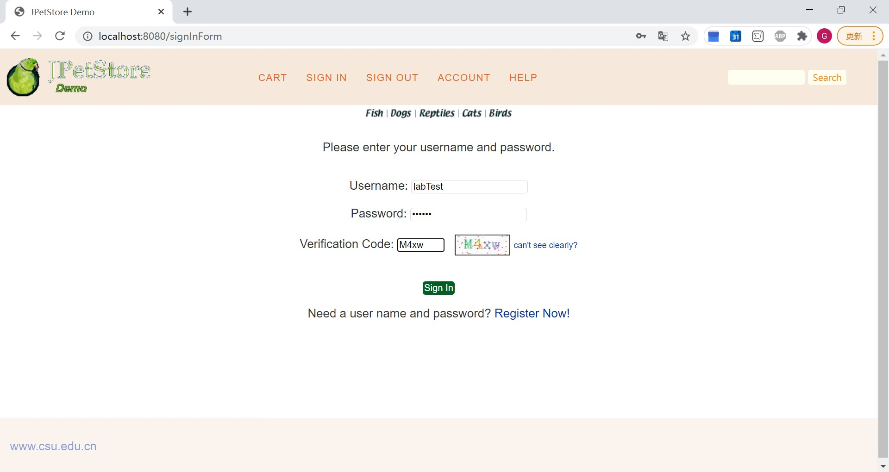
修改用户信息界面：（此处取消广告选项）
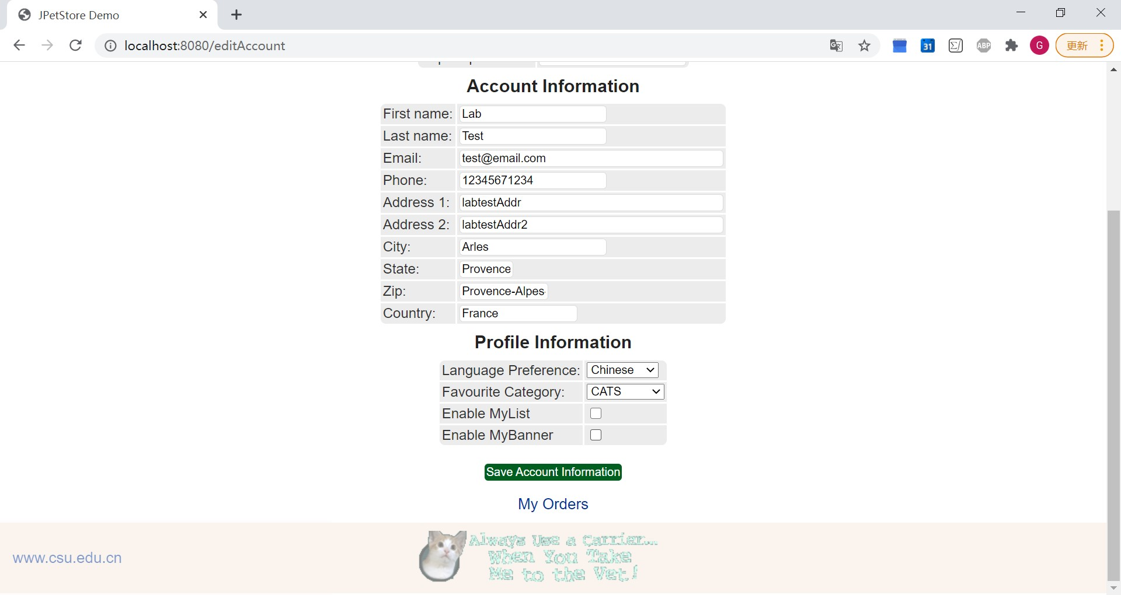
保存设置后底边栏不显示广告：
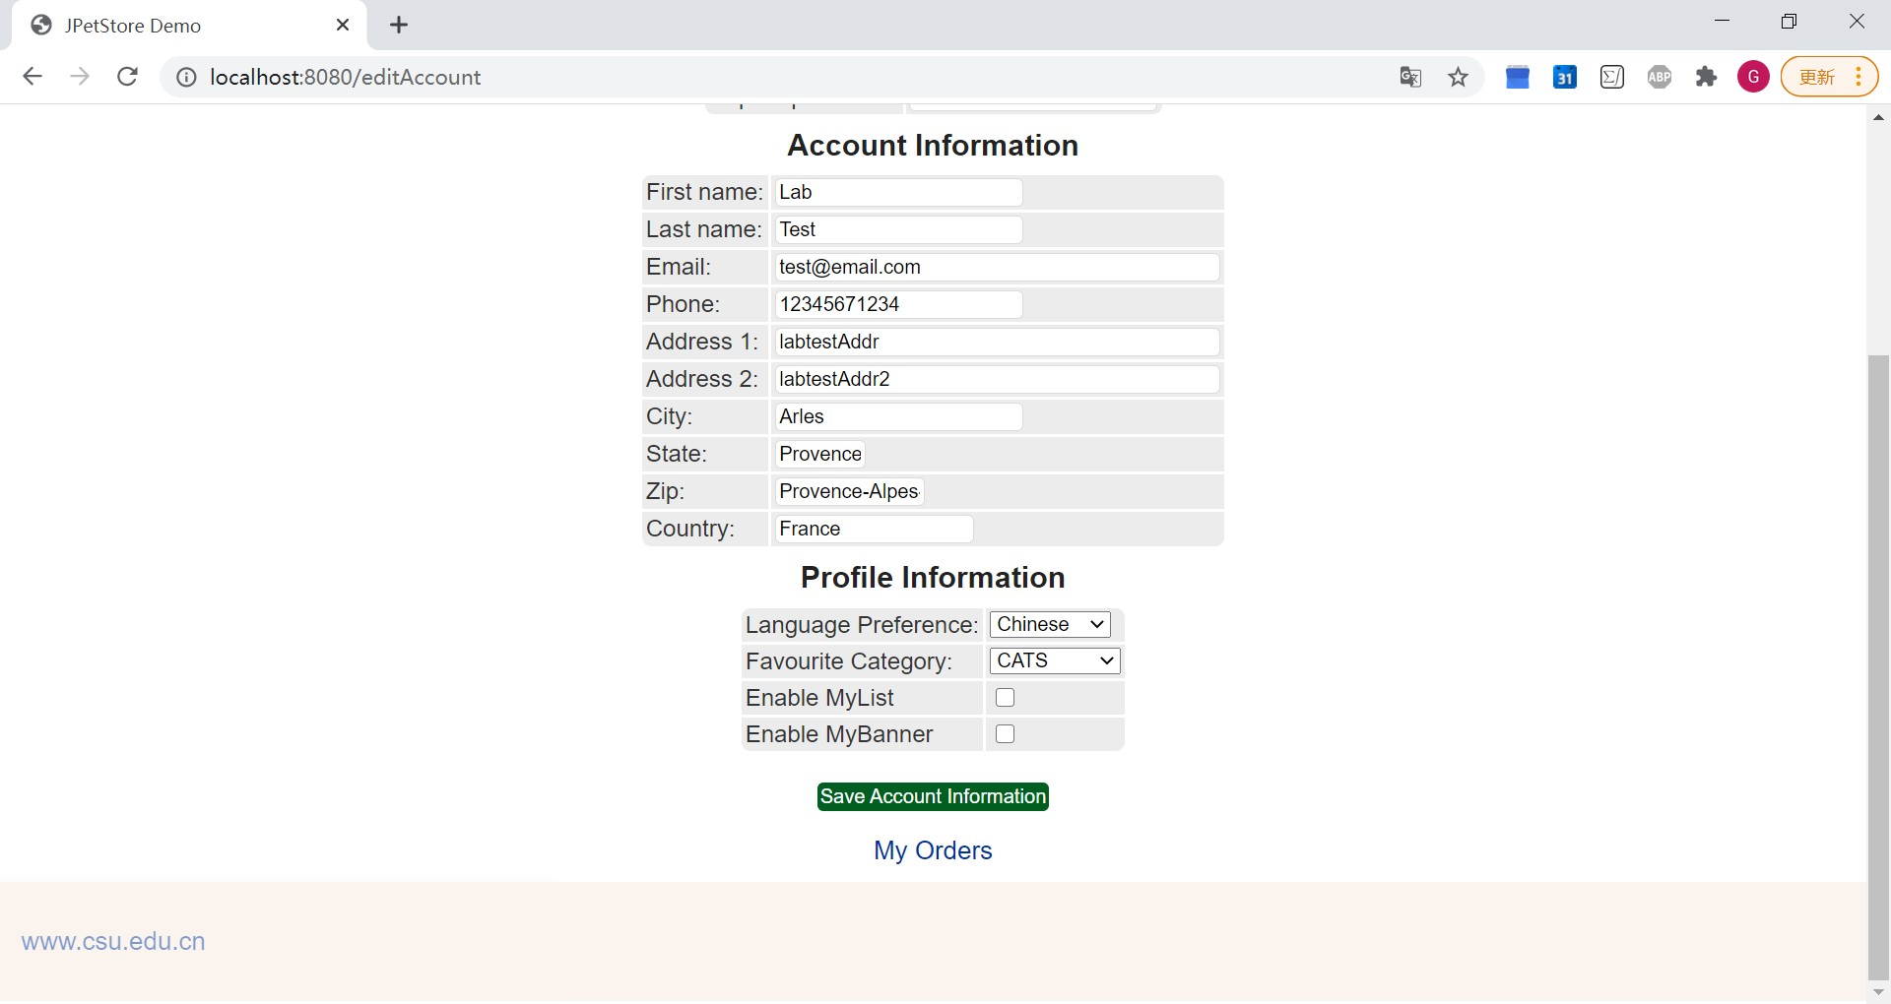
核心代码：
AccountDAO类接口：
public interface AccountDAO {
Account getAccountByUsername(String username);
Account getAccountByUsernameAndPassword(String username, String password);
void insertAccount(Account account);
void insertProfile(Account account);
void insertSignon(Account account);
void updateAccount(Account account);
void updateProfile(Account account);
void updateSignon(Account account);
}
AccountService类：
public class AccountService {
private AccountDAO accountDAO;
public AccountService(){
accountDAO = new AccountDAOImpl();
}
public Account getAccount(String username) {
return accountDAO.getAccountByUsername(username);
}
public Account getAccount(String username, String password) {
return accountDAO.getAccountByUsernameAndPassword(username, password);
}
public void insertAccount(Account account) {
accountDAO.insertAccount(account);
accountDAO.insertProfile(account);
accountDAO.insertSignon(account);
}
public void updateAccount(Account account) {
accountDAO.updateAccount(account);
accountDAO.updateProfile(account);
if (account.getPassword() != null && account.getPassword().length() > 0) {
accountDAO.updateSignon(account);
}
}
}
注册Servlet：
public class NewAccountServlet extends HttpServlet {
private static final String NEW_ACCOUNT_FORM = "/WEB-INF/jsp/account/NewAccountForm.jsp";
private static final String MAIN = "/WEB-INF/jsp/catalog/Main.jsp";
private Account account;
private AccountService accountService;
private Cart cart;
private CartService cartService;
protected void doPost(HttpServletRequest request, HttpServletResponse response) throws ServletException, IOException {
doGet(request, response);
}
protected void doGet(HttpServletRequest request, HttpServletResponse response) throws ServletException, IOException {
HttpSession session = request.getSession();
if(!request.getParameter("password").equals(request.getParameter("repeatedPassword"))) {
String pwdMessage = "password validation failed, please enter again";
session.setAttribute("pwdMessage",pwdMessage);
request.getRequestDispatcher(NEW_ACCOUNT_FORM).forward(request, response);
}else{
session.setAttribute("pwdMessage", null);
account = new Account();
account.setUsername(request.getParameter("username"));
account.setPassword(request.getParameter("password"));
account.setFirstName(request.getParameter("firstName"));
account.setLastName(request.getParameter("lastName"));
account.setEmail(request.getParameter("email"));
account.setPhone(request.getParameter("phone"));
account.setAddress1(request.getParameter("address1"));
account.setAddress2(request.getParameter("address2"));
account.setCity(request.getParameter("city"));
account.setState(request.getParameter("state"));
account.setZip(request.getParameter("zip"));
account.setCountry(request.getParameter("country"));
account.setLanguagePreference(request.getParameter("languagePreference"));
account.setFavouriteCategoryId(request.getParameter("favouriteCategoryId"));
account.setListOption(request.getParameter("listOption") != null);
account.setBannerOption(request.getParameter("bannerOption") != null);
accountService = new AccountService();
accountService.insertAccount(account);
cartService = new CartService();
cartService.createCart(account.getUsername());
cartService.mergeCart((Cart)session.getAttribute("cart"),cartService.getCart(account.getUsername()));
session.setAttribute("account", account);
session.setAttribute("cart", cartService.getCart(account.getUsername()));
session.setAttribute("signInMessage", " Welcome, "+ account.getUsername());
request.getRequestDispatcher(MAIN).forward(request, response);
}
}
}
登录Servlet：
public class SignInServlet extends HttpServlet {
private static final String SIGN_IN_FORM = "/WEB-INF/jsp/account/SignInForm.jsp";
private static final String MAIN = "/WEB-INF/jsp/catalog/Main.jsp";
private AccountService accountService;
private CartService cartService;
private Account account;
private String username;
private String password;
private Cart cart;
protected void doPost(HttpServletRequest request, HttpServletResponse response) throws ServletException, IOException {
doGet(request, response);
}
protected void doGet(HttpServletRequest request, HttpServletResponse response) throws ServletException, IOException {
username = request.getParameter("username");
password = request.getParameter("password");
//验证码验证
//用户登录
accountService = new AccountService();
account = accountService.getAccount(username, password);
HttpSession session = request.getSession();
if(account == null){
String signInFailedMessage = "Invalid username or password. Please try again";
request.setAttribute("signInFailedMessage", signInFailedMessage);
request.setAttribute("username", username);
request.getRequestDispatcher(SIGN_IN_FORM).forward(request, response);
}else{
cartService = new CartService();
if(session.getAttribute("cart") == null){
cart = cartService.getCart(username);
}else {
cart = (Cart)session.getAttribute("cart");
cart = cartService.mergeCart(cartService.getCart(username), cart);
}
String signInMessage = "Welcome, " + username;
session.setAttribute("signInMessage", signInMessage);
session.setAttribute("account", account);
session.setAttribute("cart", cart);
response.sendRedirect("/main");
}
}
}
修改用户信息Servlet：
public class EditAccountServlet extends HttpServlet {
private static final String EDIT_ACCOUNT_FORM = "/WEB-INF/jsp/account/EditAccountForm.jsp";
private Account account;
private AccountService accountService;
protected void doPost(HttpServletRequest request, HttpServletResponse response) throws ServletException, IOException {
doGet(request, response);
}
protected void doGet(HttpServletRequest request, HttpServletResponse response) throws ServletException, IOException {
HttpSession session = request.getSession();
if(!request.getParameter("password").equals(request.getParameter("repeatedPassword"))) {
String pwdMessage = "password validation failed, please enter again";
session.setAttribute("pwdMessage", pwdMessage);
request.getRequestDispatcher(EDIT_ACCOUNT_FORM).forward(request, response);
}else{
session.setAttribute("pwdMessage", null);
account = (Account)session.getAttribute("account");
account.setUsername(request.getParameter("username"));
account.setPassword(request.getParameter("password") != null ? request.getParameter("password") : account.getPassword());
account.setFirstName(request.getParameter("firstName"));
account.setLastName(request.getParameter("lastName"));
account.setEmail(request.getParameter("email"));
account.setPhone(request.getParameter("phone"));
account.setAddress1(request.getParameter("address1"));
account.setAddress2(request.getParameter("address2"));
account.setCity(request.getParameter("city"));
account.setState(request.getParameter("state"));
account.setZip(request.getParameter("zip"));
account.setCountry(request.getParameter("country"));
account.setLanguagePreference(request.getParameter("languagePreference"));
account.setFavouriteCategoryId(request.getParameter("favouriteCategoryId"));
account.setListOption(request.getParameter("listOption") != null);
account.setBannerOption(request.getParameter("bannerOption") != null);
accountService = new AccountService();
accountService.updateAccount(account);
session.setAttribute("account", account);
session.setAttribute("signInMessage", "welcome, "+ account.getUsername());
request.getRequestDispatcher(EDIT_ACCOUNT_FORM).forward(request, response);
}
}
}
查询用户订单Servlet：
public class ViewListOrdersServlet extends HttpServlet {
private static final String VIEW_LIST_ORDERS = "/WEB-INF/jsp/order/ListOrders.jsp";
private Account account;
private OrderService orderService;
private List<Order> orderList;
protected void doPost(HttpServletRequest request, HttpServletResponse response) throws ServletException, IOException {
doGet(request, response);
}
protected void doGet(HttpServletRequest request, HttpServletResponse response) throws ServletException, IOException {
orderService = new OrderService();
HttpSession session = request.getSession();
account = (Account)session.getAttribute("account");
orderList = orderService.getOrdersByUsername(account.getUsername());
session.setAttribute("orderList", orderList);
request.getRequestDispatcher(VIEW_LIST_ORDERS).forward(request, response);
}
}

- 订单管理模块，包括购物车管理、新增订单、地址信息等业务功能。
界面截图：
购物车界面：
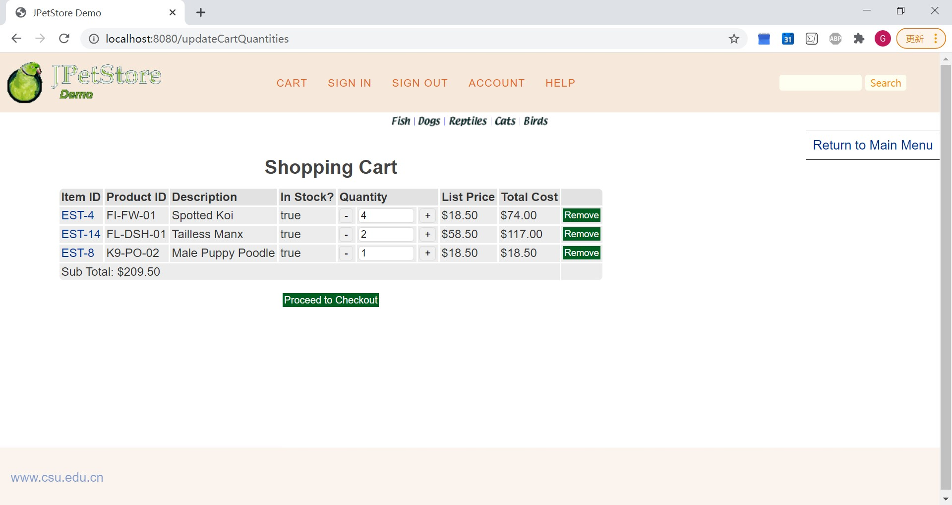
订单确认界面：
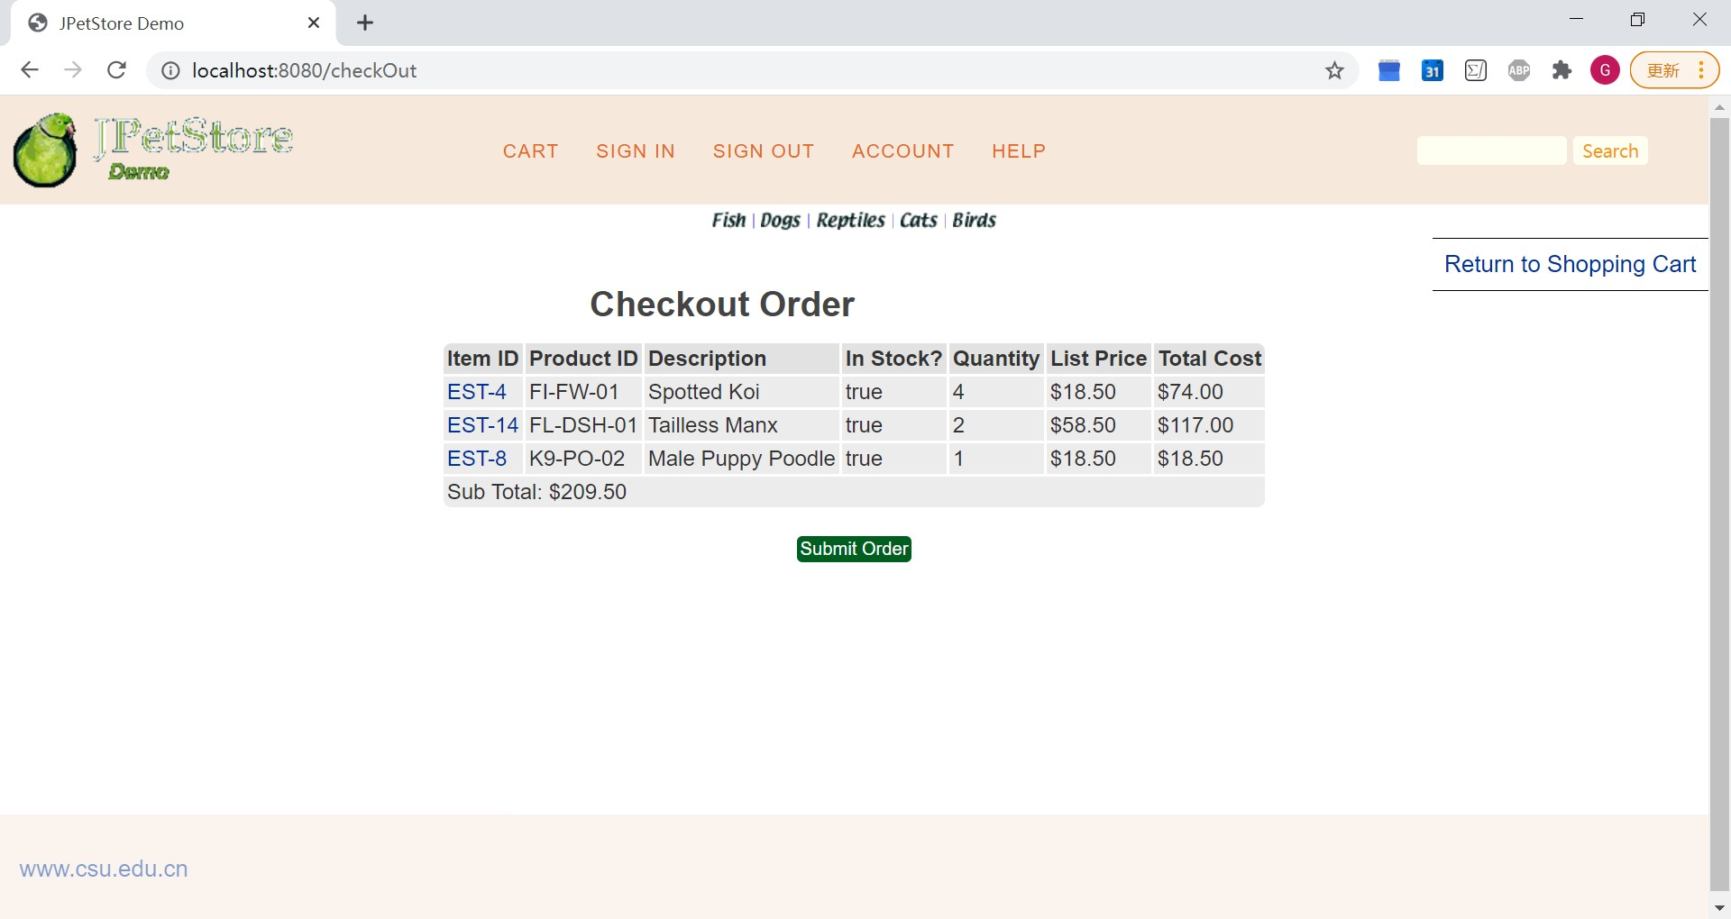
填写订单信息界面：
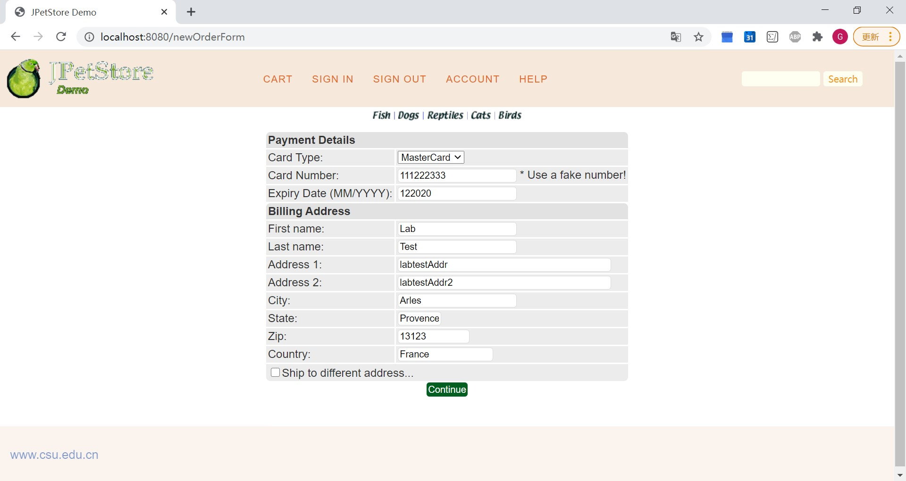
订单地址信息确认界面：
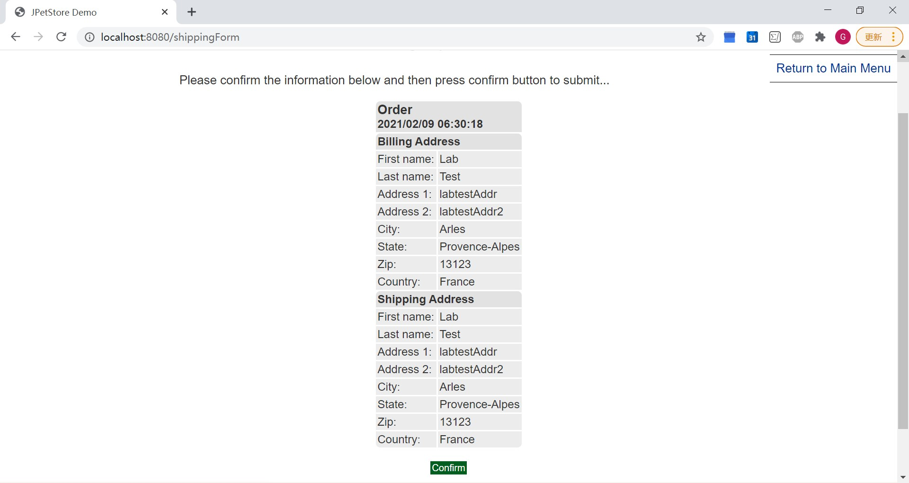
提交订单成功界面：
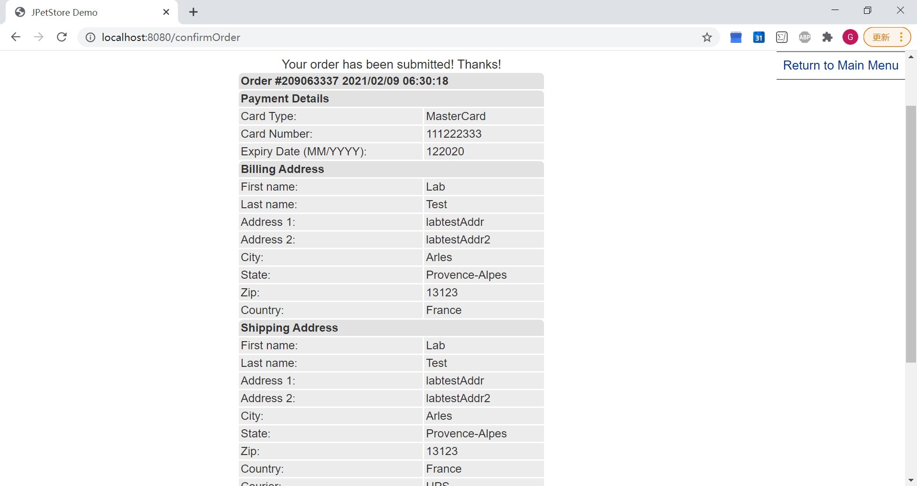
账号历史订单界面：
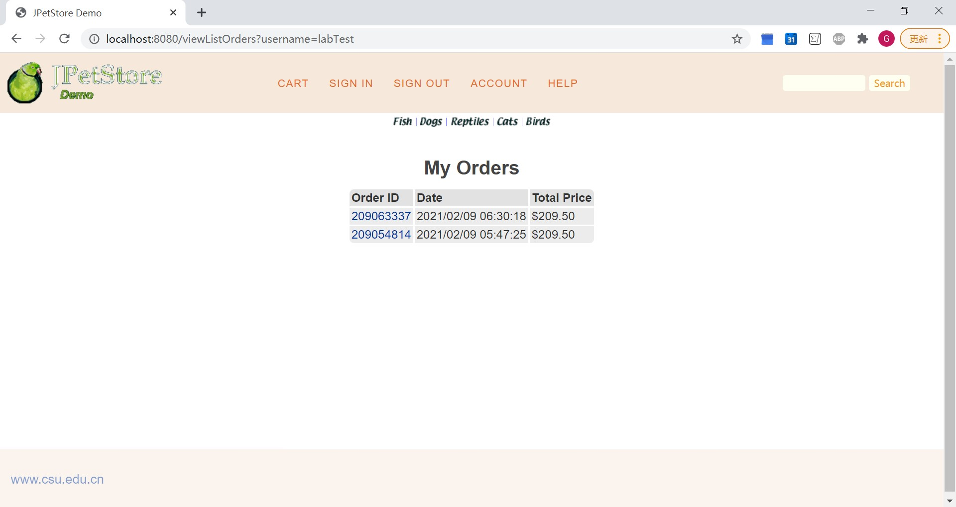
核心代码：
OrderDAO类接口：
public interface OrderDAO {
List<Order> getOrdersByUsername(String username);
Order getOrder(int orderId);
void insertOrder(Order order);
}
OrderService类：
public class OrderService {
private ItemDAO itemDAO;
private OrderDAO orderDAO;
private OrderStatusDAO orderStatusDAO;
private LineItemDAO lineItemDAO;
public OrderService(){
itemDAO = new ItemDAOImpl();
orderDAO = new OrderDAOImpl();
orderStatusDAO = new OrderStatusDAOImpl();
lineItemDAO = new LineItemDAOImpl();
}
public Order getOrder(int orderId) {
Order order = orderDAO.getOrder(orderId);
order.setLineItems(lineItemDAO.getLineItemsByOrderId(orderId));
for (int i = 0; i < order.getLineItems().size(); i++) {
LineItem lineItem = (LineItem) order.getLineItems().get(i);
Item item = itemDAO.getItem(lineItem.getItemId());
item.setQuantity(itemDAO.getInventoryQuantity(lineItem.getItemId()));
lineItem.setItem(item);
}
return order;
}
public List<Order> getOrdersByUsername(String username) {
return orderDAO.getOrdersByUsername(username);
}
public void insertOrder(Order order) {
order.setOrderId(getOrderId());
Map<String, Object> param = new HashMap<String, Object>();
for (int i = 0; i < order.getLineItems().size(); i++) {
LineItem lineItem = (LineItem) order.getLineItems().get(i);
String itemId = lineItem.getItemId();
Integer increment = lineItem.getQuantity();
param.put(itemId, increment);
lineItem.setOrderId(order.getOrderId());
lineItemDAO.insertLineItem(lineItem);
}
itemDAO.updateInventoryQuantity(param);
orderDAO.insertOrder(order);
orderStatusDAO.insertOrderStatus(order);
}
public int getOrderId(){
SimpleDateFormat dateFormat = new SimpleDateFormat("MMddHHmmss");
return Integer.parseInt(dateFormat.format(new Date().getTime()));
}
}
Servlet：
获取购物车商品：
public class NewOrderFormServlet extends HttpServlet {
private static final String NEW_ORDER_FORM = "/WEB-INF/jsp/order/NewOrderForm.jsp";
private static final String SIGN_IN_FORM = "/WEB-INF/jsp/account/SignInForm.jsp";
private static final String ERROR = "/WEB-INF/jsp/common/Error.jsp";
private Account account;
private Order order;
private Cart cart;
protected void doPost(HttpServletRequest request, HttpServletResponse response) throws ServletException, IOException {
doGet(request, response);
}
protected void doGet(HttpServletRequest request, HttpServletResponse response) throws ServletException, IOException {
HttpSession session = request.getSession();
account = (Account)session.getAttribute("account");
cart = (Cart)session.getAttribute("cart");
if (account == null){
session.setAttribute("message", "You must sign in before attempting to check out. Please sign in and try checking out again.");
request.getRequestDispatcher(SIGN_IN_FORM).forward(request, response);
}else if(cart != null){
order = new Order();
order.orderInit(account, cart);
session.setAttribute("order", order);
request.getRequestDispatcher(NEW_ORDER_FORM).forward(request, response);
}else{
session.setAttribute("message", "Order fails to be created because the cart is not found.");
Account account = (Account)session.getAttribute("account");
request.getRequestDispatcher(ERROR).forward(request, response);
}
}
}
获取地址信息：
public class NewOrderServlet extends HttpServlet {
private static final String CONFIRM_ORDER = "/WEB-INF/jsp/order/ConfirmOrder.jsp";
private Account account;
private Order order;
private Cart cart;
protected void doPost(HttpServletRequest request, HttpServletResponse response) throws ServletException, IOException {
doGet(request, response);
}
protected void doGet(HttpServletRequest request, HttpServletResponse response) throws ServletException, IOException {
HttpSession session = request.getSession();
account = (Account) session.getAttribute("account");
order = (Order) session.getAttribute("order");
order.setUsername(account.getUsername());
order.setOrderDate(new Date());
if(request.getParameter("shipToFirstName") != null) {
order.setShipToFirstName(request.getParameter("shipToFirstName"));
order.setShipToLastName(request.getParameter("shipToLastName"));
order.setShipAddress1(request.getParameter("shipAddress1"));
order.setShipAddress2(request.getParameter("shipAddress2"));
order.setShipCity(request.getParameter("shipCity"));
order.setShipState(request.getParameter("shipState"));
order.setShipZip(request.getParameter("shipZip"));
order.setShipCountry(request.getParameter("shipCountry"));
}else{
order.setShipToFirstName(order.getBillToFirstName());
order.setShipToLastName(order.getBillToLastName());
order.setShipAddress1(order.getBillAddress1());
order.setShipAddress2(order.getBillAddress2());
order.setShipCity(order.getBillCity());
order.setShipState(order.getBillState());
order.setShipZip(order.getBillZip());
order.setShipCountry(order.getBillCountry());
}
session.setAttribute("order", order);
request.getRequestDispatcher(CONFIRM_ORDER).forward(request, response);
}
}
生成订单：
public class ConfirmOrderServlet extends HttpServlet {
private static final String VIEW_ORDER = "/WEB-INF/jsp/order/ViewOrder.jsp";
private OrderService orderService;
private CartService cartService;
private LogService logService;
private Order order;
protected void doPost(HttpServletRequest request, HttpServletResponse response) throws ServletException, IOException {
doGet(request, response);
}
protected void doGet(HttpServletRequest request, HttpServletResponse response) throws ServletException, IOException {
HttpSession session = request.getSession();
orderService = new OrderService();
cartService = new CartService();
logService = new LogService();
order = (Order)session.getAttribute("order");
orderService.insertOrder(order);
cartService.clearCart((Cart)session.getAttribute("cart"));
session.setAttribute("cart", null);
String confirmMessage = "Your order has been submitted! Thanks!";
request.setAttribute("confirmMessage", confirmMessage);
request.getRequestDispatcher(VIEW_ORDER).forward(request, response);
}
}

//以上三个业务模块，用运行界面截图和核心代码展示功能完成情况。
- 实验内容——扩展任务。
- 添加验证码功能：在用户注册和用户登录模块中添加验证码功能。
界面截图：
验证码为空：
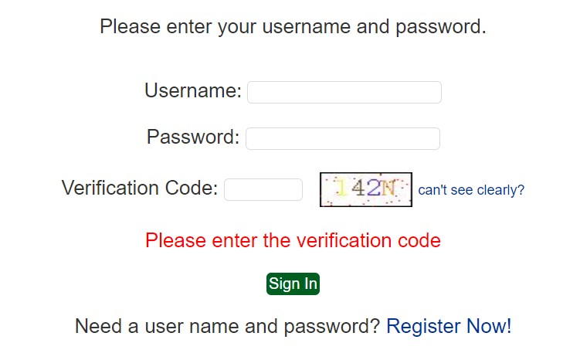
验证码输入错误：
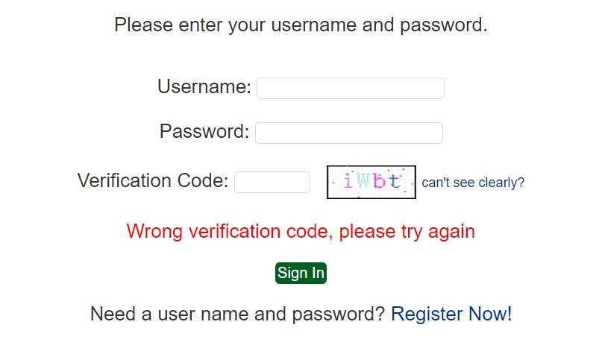
核心代码：
生成验证码：
public class VerificationCodeServlet extends HttpServlet {
@Override
protected void doPost(HttpServletRequest request, HttpServletResponse response) throws ServletException, IOException {
doGet(request, response);
}
@Override
protected void doGet(HttpServletRequest request, HttpServletResponse response) throws ServletException, IOException {
int width = 60;
int height = 30;
//随机字符字典，去掉了0，o，1，I 等易混淆字符
String data = "ABCDEFGHJKLMNPQRSTUVWXYZ23456789abcdefghijklmnpqrstuvwxyz";
Random random = new Random();
//1 创建图片数据缓存区域
BufferedImage image = new BufferedImage(width, height, BufferedImage.TYPE_INT_RGB);//创建一个彩色的图片
//2 获得画板(图片，ps图层)，创建绘制对象
Graphics g = image.getGraphics();
//3 绘制黑色外边框
g.setColor(Color.BLACK);
g.fillRect(0, 0, width, height);
//4 绘制白色内边框
g.setColor(Color.WHITE);
g.fillRect(1, 1, width-2, height-2);
/* 1 提供缓存区域，为了存放4个随机字符，以便存入session */
StringBuilder builder = new StringBuilder();
//5 随机生成4个字符
//设置字体颜色
g.setFont(new Font("宋体", Font.BOLD&Font.ITALIC, 20));
for(int i = 0 ; i < 4 ;i ++){
//随机颜色
g.setColor(new Color(random.nextInt(255),random.nextInt(255), random.nextInt(255)));
//随机字符
int index = random.nextInt(data.length());
String str = data.substring(index, index + 1);
/*2 缓存*/
builder.append(str);
//写入
g.drawString(str, (width / 6) * (i + 1) , 20);
}
//给图中绘制噪音点，让图片不那么好辨别
for(int j=0,n=random.nextInt(100);j<n;j++){
g.setColor(Color.RED);
g.fillRect(random.nextInt(width),random.nextInt(height),1,1);//随机噪音点
}
/*3 获得随机数据，保存至session*/
String tempStr = builder.toString();
request.getSession().setAttribute("sessionCacheData",tempStr);
// 将图片写至浏览器
ImageIO.write(image, "jpg", response.getOutputStream());
}
}
验证码验证（仅截取关键代码）：
//1 获得用户输入的验证码
String verifyCode = request.getParameter("verifyCode");
//2 获得服务器session 存放数据 ,如果没有返回null
String sessionCacheData = (String) request.getSession().getAttribute("sessionCacheData");
// *将服务器缓存session数据移除
request.getSession().removeAttribute("sessionCacheData");
// ** 判断服务器是否存在
if(sessionCacheData == null){
request.setAttribute("msg", "请不要重复提交");
request.getRequestDispatcher(SIGN_IN_FORM).forward(request, response);
return;
}
//3 比较
if(verifyCode == ""){
request.setAttribute("username", username);
request.setAttribute("msg", "Please enter the verification code");
request.getRequestDispatcher(SIGN_IN_FORM).forward(request, response);
return;
}else if(! sessionCacheData.equalsIgnoreCase(verifyCode)){
//用户输入错误
// * 存放request作用域
request.setAttribute("username", username);
request.setAttribute("msg", "Wrong verification code, please try again");
// * 请求转发
request.getRequestDispatcher(SIGN_IN_FORM).forward(request, response);
return;
}
前端验证码显示：
Verification Code: <input type="text" name="verifyCode" size="5"/>
<img id="verificationImg" src="/verificationCode"/>
<a id="verificationTips">can't see clearly?</a> <br /><br />
验证码刷新（verificationImgRefresh.js）：
$(function () {
$("#verificationImg").on("click", reloadImg);
$("#verificationTips").on("click", reloadImg);
})
function reloadImg() {
var verify = document.getElementById("verificationImg");
verify.setAttribute("src", "/verificationCode?" + Math.random());
}

基本原理及实现方案：
1) 登录界面请求servlet生成验证码：
2) 验证码以绘制图片方式生成：为图片绘制边框，从自定义字符字典中随机选取四个字符并以随机颜色绘制，绘制随机干扰点。
3) 生成图片后通过ImageIO的write方法写入浏览器。
4) 通过js绑定图片和提示信息点击事件，点击时重新发起请求，生成随机对象并传入servlet，以生成新的验证码。

- 购物车功能：原项目中购物车为内存购物车，即将用户相关的购物车存储在session中；在数据库中添加购物车表，将购物车数据持久化，以便用户下次登录时可查看或修改自己的购物车数据。
界面截图：
数据库中cart表格：
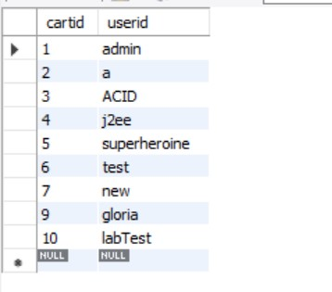
数据库中cartitem表格：
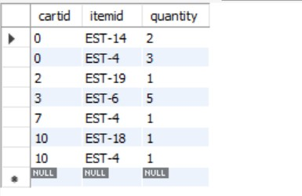
核心代码：
DAO类接口：
public interface CartDAO {
Cart getCartByUsername(String username);
void insertCart(Cart cart);
}

public interface CartItemDAO {
List<CartItem> getCartItemsByCartId(int cartId);
void insertCartItem(CartItem cartItem);
void deleteCartItem(int cartId, String itemId);
void updateCartItemQuantity(int cartId, String itemId, int quantity);
void clearCartItemsByCartId(Cart cart);
}
CartService类：
public class CartService {
private CartDAO cartDAO;
private CartItemDAO cartItemDAO;
public CartService(){
cartDAO = new CartDAOImpl();
cartItemDAO = new CartItemDAOImpl();
}
public Cart getCart(String username){
Cart cart = cartDAO.getCartByUsername(username);
CatalogService catalogService = new CatalogService();
List<CartItem> itemList = cartItemDAO.getCartItemsByCartId(cart.getCartId());
for (CartItem cartitem : itemList) {
boolean isInStock = catalogService.isItemInStock(cartitem.getItemId());
Item item = catalogService.getItem(cartitem.getItemId());
cart.addItem(item, isInStock);
cart.setQuantityByItemId(item.getItemId(), cartitem.getQuantity());
}
return cart;
}
public void updateCart(Cart cart){
List<CartItem> itemList = cart.getCartItemList();
for (CartItem cartItem : itemList) {
//cartItem.setCartId();
cartItemDAO.insertCartItem(cartItem);
}
}
public Cart mergeCart(Cart usercart, Cart cart){
List<CartItem> itemList = cart.getCartItemList();
//CatalogService catalogService = new CatalogService();
for (CartItem cartItem : itemList) {
String itemId = cartItem.getItemId();
if(usercart.containsItemId(itemId)){
cartItemDAO.updateCartItemQuantity(usercart.getCartId(), itemId,
usercart.getCartItem(itemId).getQuantity() + cartItem.getQuantity());
}else{
cartItem.setCartId(usercart.getCartId());
cartItemDAO.insertCartItem(cartItem);
}
usercart.addCartItem(cartItem);
}
return usercart;
}
public void addItem(Cart cart, CartItem item){
//item.setCartId(cart.getCartId());
cartItemDAO.insertCartItem(item);
}
public void updateItem(Cart cart, String itemId, int quantity){
cartItemDAO.updateCartItemQuantity(cart.getCartId(), itemId, quantity);
}
public void deleteItem(Cart cart, String itemId) {
try {
cartItemDAO.deleteCartItem(cart.getCartId(), itemId);
} catch (Exception ex) {
ex.printStackTrace();
}
}
public void clearCart(Cart cart){
cartItemDAO.clearCartItemsByCartId(cart);
}
public void createCart(String username){
Cart cart = new Cart();
cart.setUsername(username);
cartDAO.insertCart(cart);
}
}
Servlet：
添加商品：
public class AddItemToCartServlet extends HttpServlet {
private static final String VIEW_CART = "/WEB-INF/jsp/cart/Cart.jsp";
private String workingItemId;
private Cart cart;
private CatalogService catalogService;
private CartService cartService;
protected void doPost(HttpServletRequest request, HttpServletResponse response) throws ServletException, IOException {
doGet(request, response);
}
protected void doGet(HttpServletRequest request, HttpServletResponse response) throws ServletException, IOException {
workingItemId = request.getParameter("workingItemId");
HttpSession session = request.getSession();
cart = (Cart)session.getAttribute("cart");
if (cart == null) {
cart = new Cart();
}
if (cart.containsItemId(workingItemId)) {
cart.incrementQuantityByItemId(workingItemId);
if(session.getAttribute("account") != null){
cartService = new CartService();
cartService.updateItem(cart, workingItemId, cart.getCartItem(workingItemId).getQuantity());
}
} else {
catalogService = new CatalogService();
boolean isInStock = catalogService.isItemInStock(workingItemId);
Item item = catalogService.getItem(workingItemId);
cart.addItem(item, isInStock);
if(session.getAttribute("account") != null){
cartService = new CartService();
cartService.addItem(cart, cart.getCartItem(item.getItemId()));
}
}
session.setAttribute("cart", cart);
request.getRequestDispatcher(VIEW_CART).forward(request, response);
}
}
更改商品数量：
public class UpdateCartQuantitiesServlet extends HttpServlet {
private static final String VIEW_CART = "/WEB-INF/jsp/cart/Cart.jsp";
private static final String ERROR = "/WEB-INF/jsp/common/Error.jsp";
private Cart cart;
private CartService cartService;
protected void doPost(HttpServletRequest request, HttpServletResponse response) throws ServletException, IOException {
doGet(request, response);
}
protected void doGet(HttpServletRequest request, HttpServletResponse response) throws ServletException, IOException {
HttpSession session = request.getSession();
cart = (Cart) session.getAttribute("cart");
cartService = new CartService();
Iterator<CartItem> cartItems = cart.getAllCartItems();
while (cartItems.hasNext()) {
CartItem cartItem = cartItems.next();
String itemId = cartItem.getItem().getItemId();
try {
int quantity = Integer.parseInt(request.getParameter(itemId));
cart.setQuantityByItemId(itemId, quantity);
if (quantity < 1) {
cartItems.remove();
if(session.getAttribute("account") != null){
cartService.deleteItem(cart, itemId);
}
}else{
if(session.getAttribute("account") != null){
cartService.updateItem(cart, itemId, quantity);
}
}
} catch (Exception e) {
session.setAttribute("message", "The Quantities of Item must be Integer!");
request.getRequestDispatcher(ERROR).forward(request, response);
}
}
request.getRequestDispatcher(VIEW_CART).forward(request, response);
}
}

- 日志功能：数据库中添加日志信息表，给项目添加日志功能，用户登录后记录用户行为，比如浏览了哪些商品、将商品添加进购物车、生成订单等。
界面截图：
数据库中log表格，记录时间、用户、操作详情：
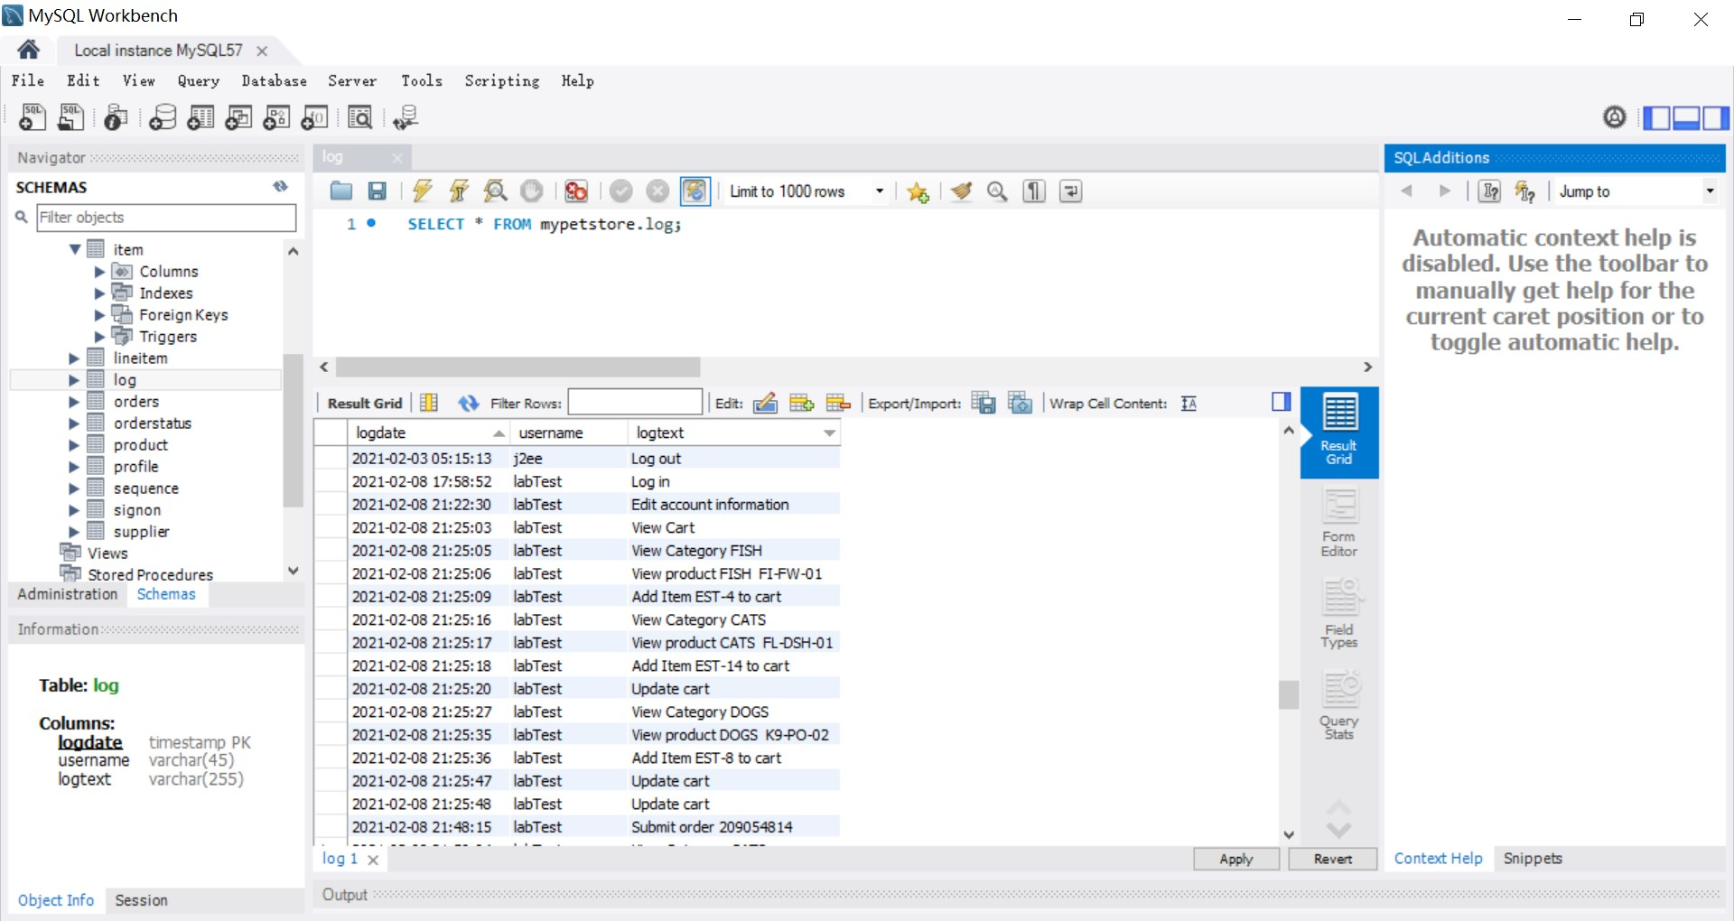

核心代码：
LogDAO类接口：
public interface LogDAO {
void insertLog(Date date, String username, String log);
}
LogService类：
public class LogService {
private LogDAO logDAO;
public LogService(){
logDAO = new LogDAOImpl();
}
public void insertLog(String username, String logText){
logDAO.insertLog(new Date(), username, logText);
}
}
功能情况：
1) 记录方式：
通过在需要记录操作的servlet中实例化LogService对象，使用LogDAO类向数据库的log表格中插入日志记录。一条日志包括时间戳、用户名、具体操作内容三项。
2) 可记录内容：
登录、登出、修改用户信息、查看商品、添加商品、修改购物车商品信息、生成订单。

- 小组成员分工及实验总结
- 小组分工：
一人组，无分工，陈佳祺负责所有开发和测试工作。
- 实验总结
问题一：
问题描述：
网页测试过程中产生各种404。
解决办法：
查看调试信息发现都是路径问题，修改相应路径即可。
详细内容：
web.xml中的url配置和jsp中的要一致。
数据库的图片路径与web文件夹中的图片路径要一致。
a标签的href内容不加http则默认是相对路径，要访问服务器外网址应使用带有http等协议字段的完整路径。

问题二：
问题描述：
JSP编写过程中对html标签的使用不熟悉，出现一些取值或判断无效。
解决办法：
利用搜索引擎，边查边写，并另外编写文档记录遇到的标签使用问题。
详细内容：
checkbox默认勾选返回值是on，未勾选的默认返回值是null。
<c:if>字符串相等用eq。
<a>标签中使用 target="_blank"，在新标签页打开链接。

问题三：
问题描述：
订单提交时显示的时间准确，但是退出后再次查看订单，发现时间出错，所有的时分秒都变成了08:00:00。
解决办法：
思考后发现问题出现的原因大概是Java环境的时间和数据库中的时间类型不一致，转换时会出错，查询相关资料，发现使用sql.date中的timestamp可以完成java和数据库中保留时分秒的时间转换，解决了问题。

心得体会：
这次实验中遇到的问题很多都是路径不对、标签使用不熟悉、数据转换出错，靠查看调试信息和搜索错误提示基本都能解决。写sql语句也很容易出错，可以用之前写好的确认无误的语句作为参考，对照着写，需要非常细心。

实验二 使用AJAX和jQuery改善用户体验
- 实验内容——基本任务。
- 账号管理模块。在新建账号和修改账号信息页面上用AJAX技术进行表单验证，如“判断用户名是否已存在”等功能。
界面截图：
Id已被注册：
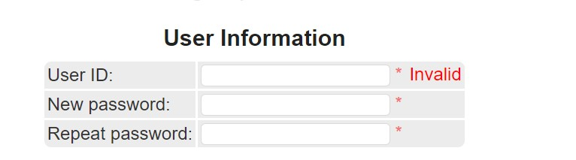
Id可用，重复密码验证失败：
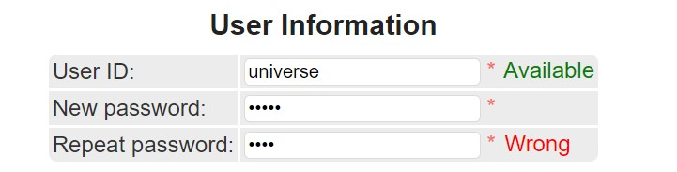
核心代码：
checkUsername.js
$(function () {
$("#username").on("blur", function () {
$.ajax({
type : "GET",
url : "usernameExist?username="+this.value,
success : function (data){
if(data.msg === "Exist"){
$("#usernameTips").attr("class", "errorTips").text("Invalid");
}else if(data.msg === "Not Exist"){
$("#usernameTips").attr("class", "okTips").text("Available");
}
}
});
})
})
NewAccountForm.jsp（仅截取部分）
<input type="text" name="username" id="username" required/>
<span class="star">*</span>
<span id="usernameTips"></span>
<script type="text/javascript" src="js/checkUsername.js"></script>
CSS样式：
.okTips{
color: green;
}
.errorTips{
color: red;
}

.star{
color: #f56c6c;
margin-right: 2px;
}

- 查询商品模块。在主页面右上角的查询商品功能中添加自动补全功能。
界面截图：
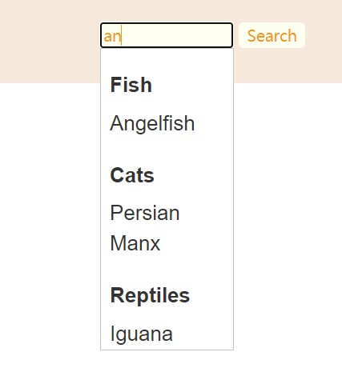
核心代码：
autoComplete.js
$( function() {
$.widget( "custom.catcomplete", $.ui.autocomplete, {
_create: function() {
this._super();
this.widget().menu( "option", "items", "> :not(.ui-autocomplete-category)" );
},
_renderMenu: function( ul, items ) {
var that = this,
currentCategory = "";
$.each( items, function( index, item ) {
var li;
if ( item.category !== currentCategory ) {
ul.append( "<li class='ui-autocomplete-category'>" + item.category + "</li>" );
currentCategory = item.category;
}
li = that._renderItemData( ul, item );
if ( item.category ) {
li.attr( "aria-label", item.category + " : " + item.label );
}
});
}
});
var data = [
{ label: "Koi", category: "Fish" },
{ label: "Goldfish", category: "Fish" },
{ label: "Angelfish", category: "Fish" },
{ label: "Tiger Shark", category: "Fish" },
{ label: "Bulldog", category: "Dogs" },
{ label: "Chihuahua", category: "Dogs" },
{ label: "Dalmation", category: "Dogs" },
{ label: "Poodle", category: "Dogs" },
{ label: "Golden Retriever", category: "Dogs" },
{ label: "Labrador Retriever", category: "Dogs" },
{ label: "Persian", category: "Cats" },
{ label: "Manx", category: "Cats" },
{ label: "Iguana", category: "Reptiles" },
{ label: "Rattlesnake", category: "Reptiles" },
{ label: "Amazon Parrot", category: "Birds" },
{ label: "Finch", category: "Birds" }
];
$( "#searchKeyword" ).catcomplete({
delay: 0,
source: data
});
} )
IncludeTop.jsp
<form action="searchProduct" method="post" onsubmit="return checkSearch()">
<div class="ui-widget">
<input id="searchKeyword" name = "keyword" size="14">
<input type="submit" name="searchProducts" value="Search" />
<script type="text/javascript" src="js/checkSearch.js"></script>
</div>
</form>

- 购物车模块。在购物车模块中修改购买数量时，通过AJAX修改购物车信息。
界面截图：
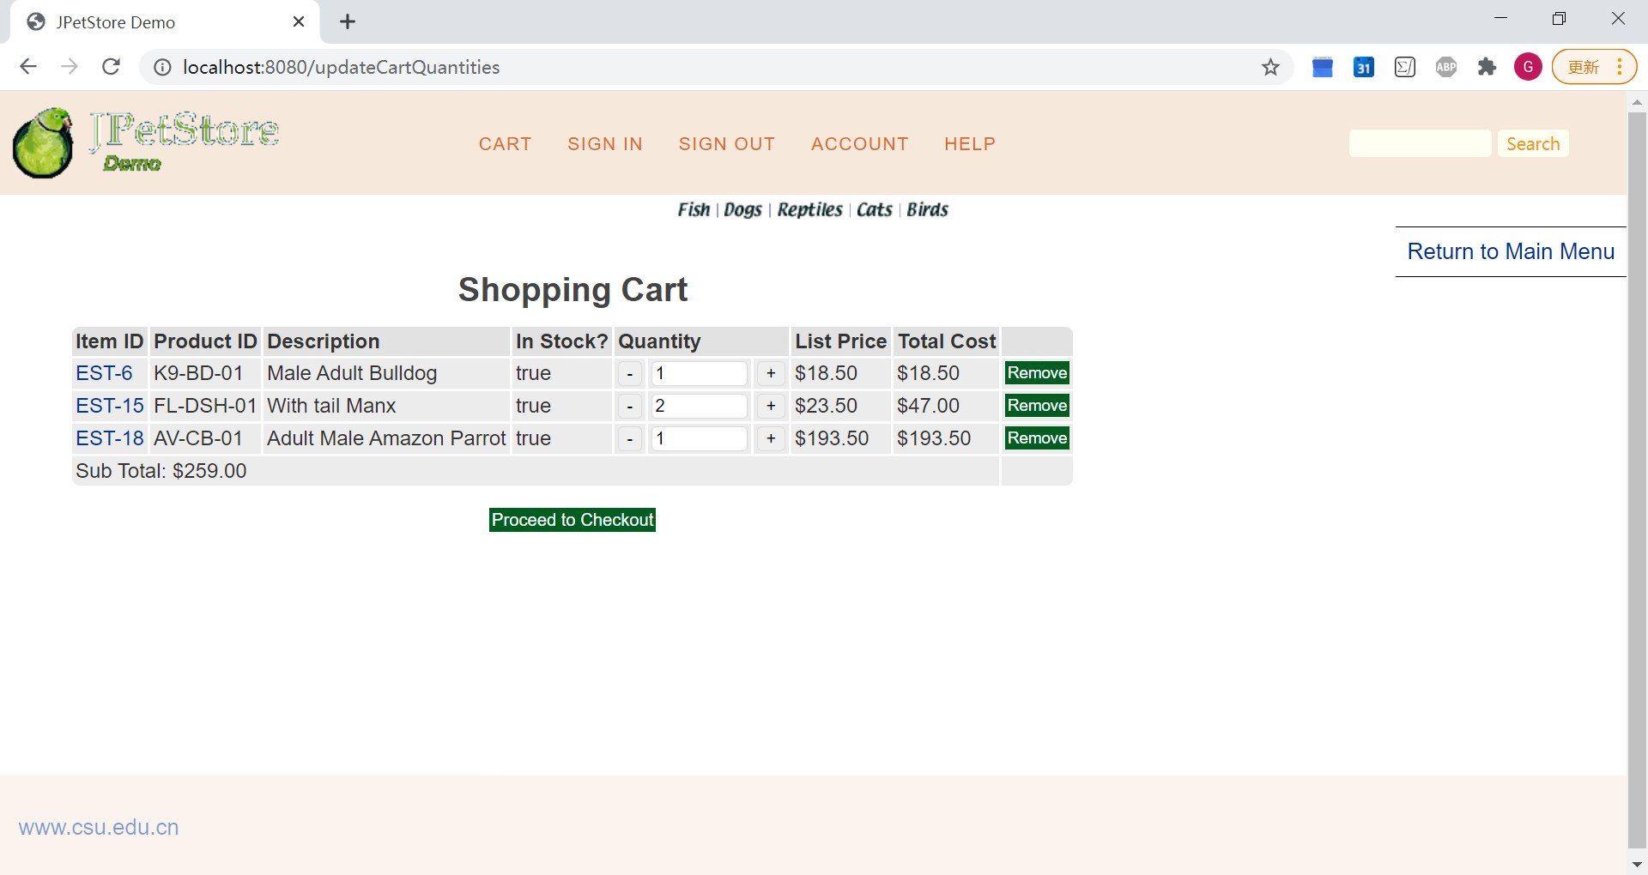
核心代码：
updateCart.js（部分）
$(function() {
$(".cartItemQuantity").focus(function () {
$(this).attr("data-oval", $(this).val()); //将当前值存入自定义属性
}).on("blur", function () {
var oldVal = ($(this).attr("data-oval")); //获取原值
var newVal = ($(this).val()); //获取当前值
if (oldVal != newVal) {
$("#cartForm").submit();
}
})
})
Cart.jsp (仅截取部分代码)
<script type="text/javascript" src="js/updateCart.js"></script>
<input class="cartItemQuantity" type="text" name="${cartItem.item.itemId}" value="${cartItem.quantity}" size="6px"/>

- 实验内容——选做任务。
- 商品展示模块。在首页展示商品的图片上添加AJAX效果，即当鼠标移到某个商品图片上时，用悬浮窗展示该类型商品的信息。（未完成）
- 订单模块。通过选项卡或模版内容实现订单多个信息部分的录入，不需要页面跳转，在一个页面完成订单所有内容的录入。（未完成）
- 其他效果：可自行选择其他UI模版，或选择其他功能点进行用户体验的优化。
1) 搜索判空
界面截图：
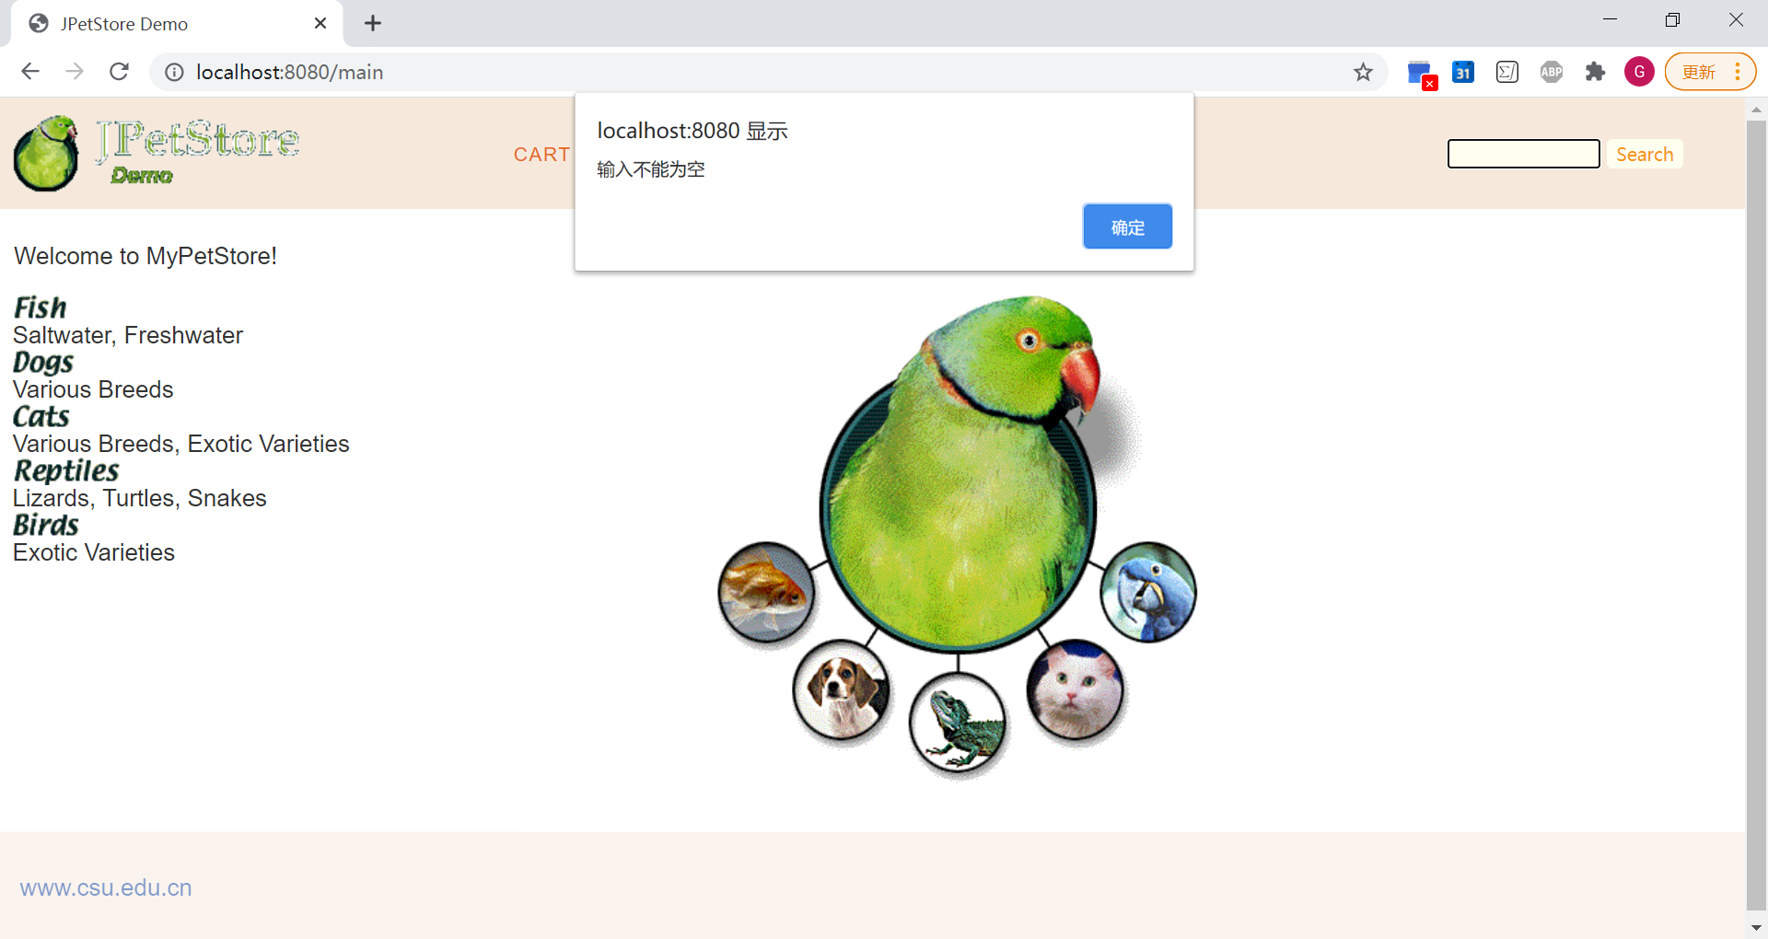
核心代码：
checkSearch.js
function checkSearch(){
if(document.getElementsByName("keyword")[0].value.match(/^[ ]*$/)){
alert('输入不能为空');
document.getElementsByName("keyword")[0].value = "";
document.getElementsByName("keyword")[0].focus();
return false;
}
}
基本原理：
JS实现，获取表单内容，若为空则alert弹窗提示。

2) 密码验证
界面截图：
核心代码：
$(function () {
$("#rptSignUpPwd").on("blur", function () {
if($("#signUpPwd").val() !== $("#rptSignUpPwd").val()){
$("#passwordTips").attr("class", "errorTips").text("Wrong");
}else if($("#signUpPwd").val() == $("#rptSignUpPwd").val()){
$("#passwordTips").attr("class", "okTips").text("Ok");
}
});
})
基本原理：
AJAX绑定事件，鼠标离开输入框时判断两密码框输入是否相同，设置对应提示信息。

3) 购物车加减按钮修改商品数量
界面截图：
核心代码：
updateCart.js（部分）
$(function() {
var t;
$(".add").click(function () {
t = $(this).parent().prev().find("input");
t.val(parseInt(t.val()) + 1);
$("#cartForm").submit();
});
$(".min").click(function () {
t = $(this).parent().next().find("input");
if(t.val() > 1) {
t.val(parseInt(t.val()) - 1);
$("#cartForm").submit();
}
})
})
基本原理：
AJAX绑定事件，点击按钮时修改商品数量输入框内容，最低为1，然后提交表单，持久化至数据库。

- 小组成员分工及实验总结
- 小组分工：
一人组，无分工，陈佳祺负责所有开发和测试工作。
- 实验总结
1) 遇到的问题：
问题描述：
CSS修改未生效。
解决办法：
查看网页信息，删除本地项目中out文件夹内的war包，重新部署项目更新资源。
详细内容：
Chrome F12打开调试界面，查看修改部分的style信息，发现样式未改变，查看sources一栏中的资源，发现css文件内容未更改。搜索后发现是因为服务器更新时未更新css资源至war包，查看out文件夹中的war包内容，css文件还是原来的版本，删除该文件夹，重新部署项目，再次运行发现更改成功。

2) 心得体会：
关于实验：
这次的实验做得非常仓促，一夜速成，UI没能做很多更改，有很多关于完善用户体验的想法也没来得及实现，后续会再花时间写一写。
整个Web实验的过程中遇到的问题基本都可以靠网络搜索来解决，有很多博客和教程可以找到详细解答和拓展，越来越觉得学习的过程基本就是踩坑的过程，要及时记录并不断练习，还可以学习别人的代码（读懂并复现），业务型的代码大多是熟能生巧的事情。

关于课程：
在本学期的学习过程中，我发现自己的兴趣好像并不在Web开发上。就我个人而言，CG带给我的惊喜和兴奋感会更多，在Linux上对着黑框做CSAPP的lab也更有趣，但是上这门课的过程中写代码很快乐，废寝忘食debug也很爽，课堂上那些关于技术的故事和细节都很有意思，不管怎样选Web不亏。
课程暂告一段落，尝试并学到了一些东西，解决问题的能力得到了提高，看到了很多同学优秀的课程作业，学无止境，多试错。

