**Plan de seguimiento y control del proyecto**

**Sprint #______________**

|  |  |  |  |  |  |
| --- | --- | --- | --- | --- | --- |
| Factor | | Comunicación | | | |
| Objetivo | Mejorar la formalidad de la comunicación entre el equipo de desarrollo y la empresa (Product Owner, clientes y usuarios) con el fin de asegurar digitalmente la información y que se respeten los acuerdos de privacidad de la información en cada negocio. Este objetivo se establece ya que los colaboradores de equipo llevan la comunicación de manera informal por medio de WhatsApp y Facebook. | | | | |
|  | | | | | |
| Actividades | | | Duración | Responsable | Progreso |
| Buscar la (s) herramientas digitales disponibles y acordes con el proyecto | | | 2 horas | Jaime Restrepo | 10% |
| Definir una política de uso del canal de comunicación definido | | | 3 horas | Sofía Correa | 0% |
| Sensibilizar al equipo de desarrollo sobre la importancia del uso y la participación por medio del canal de comunicación definido | | | 45 minutos | Mariana Espinosa | 0% |
| Revisar los comentarios realizados por medio del canal de comunicación y generar un mecanismo de respuesta oportuna | | | 1 Sprint | Equipo Scrum | 0% |

**Evidencia de la realización de la Retrospectiva en equipo**

1. Evidencia 1. Material generado

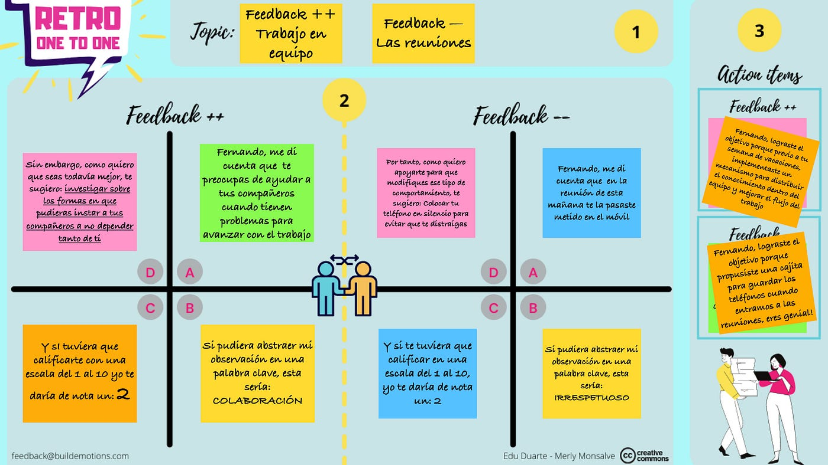

1. Evidencia 2. Reunión del equipo tanto presencial como virtual

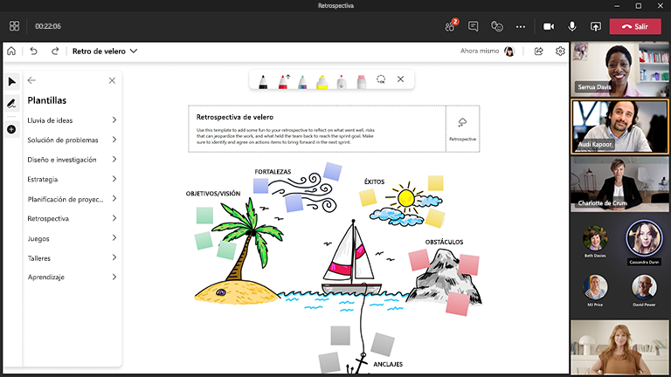

Anexo 2. Insumos externos

1. Lista de factores que influyen en la productividad de un equipo de desarrollo

|  |  |
| --- | --- |
| Factor | Definición |
| Communicación | La comunicación y la colaboración capturan cómo las personas y los equipos se comunican y trabajan juntos. Los miembros del equipo se basan en las ideas de los demás y trabajan para desarrollar un entendimiento conjunto. La comunicación de circuito cerrado se define como "el intercambio de información entre un emisor y un receptor independientemente del medio". |
| Liderazgo | Capacidad para influir y guiar, motivar e inspirar a otros miembros de un equipo, organización o comunidad, incluido el liderazgo de proyectos, negocios, prácticas y tecnología. “El liderazgo de equipo se define como la 'capacidad para dirigir y coordinar las actividades de otros miembros del equipo, evaluar la eficacia del equipo, asignar tareas, desarrollar conocimientos, habilidades y capacidades del equipo, motivar a los miembros del equipo, planificar y organizar, y establecer una atmósfera positiva'. |
| Trabajo en equipo | Capacidad para trabajar bien con otros durante conversaciones, proyectos, reuniones u otras colaboraciones. Es un vínculo compartido que impulsa a los miembros del equipo a permanecer juntos y querer trabajar juntos. La cohesión del equipo se define como “la tendencia de un grupo a permanecer unido en la búsqueda de sus metas y objetivos”. Es un conjunto de individuos interdependientes que se ven a sí mismos como un grupo y realizan una tarea definida por la organización. |

1. Otros factores a considerar

|  |  |
| --- | --- |
| Factor | Definition |
| Communication | Communication is the method that allows a human to link with another human [21]. It is the bridge that channels the transmission of thoughts, emotions, and information [28]. The valid forms of communications (verbal, written, gestural) are the ones that take into account the relevance of the messages, the correct use of the language, the adequate moment to transmit the information, the method used, and the interpretation of the perception of the interlocutor.  In the work teams, the forms of communication ease the adequate flux of information, promoting dynamics that influx the outcome of software development projects [7] [29]. That can be seen in the clarity of instructions and objectives, the preventions of reprocessing, improvement of tasks and activities, and assertive conflict solving. |
| Collaboration | The collaboration is related to the sentiment of feeling supported by others, a tendency of working together in a solidarity environment. In teamwork, collaboration arises when various members work together for a mutual benefit [30]. The capacity to share knowledge, information, and know-how to achieve a common goal is also essential. Collaboration is related to trust, friend relationships, or cordiality between team members to create a proper environment and achieve goals.  Collaboration is opposed to competition even though the possibility of achieving personal or collective progress can be a source of conflicts, frustration, envy, and aggressiveness [21]. |
| Commitment | It is the level of responsibility a team member is willing to assume in his/her tasks inside the work team. In the same way, the team is responsible for the goals of the project. A responsible person is consequent with his/her actions, achieves his/her tasks, and can assume his/her mistakes [21]. |
| Motivation | Motivation is the factor that moves the team member into action [21]. The motivation is inherent to every individual, has an intensity, force, and duration. It varies according to the objective and determines part of human behavior [31]. The motivations can be uncountable and, according to Herzberg [32], cited by [33], are classified in:  Intrinsic motivations: they surge of the pleasure of doing the job. Imply desire to do the task because they matter, like are exciting or are part of something valuable (autonomy, mastery, and purpose) [34]. They are related to the position and the tasks of the position. It produces a long-lasting satisfaction effect, an increase of productivity reaching excellence, way better than normal levels. It also includes feelings of realization, growth, and professional recognition. These are evidenced in the execution of tasks and challenging activities that are important for the job. When the motivation factors are optimal, the satisfaction is substantially improved; when not, satisfaction is lost [33].  Extrinsic motivations are related to the job's external factors, like the physical conditions that surround the individual when he/she is working. Comprehend the physical and environmental conditions of the job, the salary, the social benefits, the corporate policies, the type of supervision, the status of the relationships between directors and employees, the rules of procedure, the opportunities, etc. These aspects influxes in a limited way, the workers' behavior because, when optimal, they only prevent dissatisfaction [33]. |
| Work satisfaction | Work satisfaction is determined by the discrepancy between what he/she wants and what he/she has in the job [35]. It relates to the content or the challenging and stimulant activities of the position. The expectations, personal and professional growth, recognition, opportunities, salary, work environment, and others are the aspects that measure work satisfaction [21]. |
| Leadership | Leadership is the capacity that some people have to influence others inside the team focused on achieving goals and objectives [36]. The leader exalts in the team because he/she has a group of qualities and characteristics: Important security in himself/herself and his/her convictions and ability to take decisions and risks. He/she also stands out in three dimensions: His/her activity, the capacity to perform tasks and objectives, and the affection he/she receives. Teamwork requires a collaboration attitude and a high integration capacity, which depends on a good leader and his/her capacity to coordinate the team members’ functions. This way, high efficacy levels can be achieved in comparison with individualized work [21]. |
| Innovation  (creativity) | The innovation manifest in an individual or teamwork with creative thinking as the capacity to establish a new relationship between facts or to integrate them originally or innovatively. The innovation is related to the creativity needed to elaborate new, different, valuable trough experiences and know-how [21]. |
| Emotional  Intelligence | The ability that an individual has to identify and process adequately his/her emotions. That implies not getting dominated by the emotions, instead of control his/her behavior. Emotional intelligence relies on the quality of the interpersonal relationships with the team members. It will let him/her recognize the emotional state of his/her teammates and act empathetically, forging ties of friendship and confidence. Although it is an individual factor, the adequate management of emotions in complex group situations, like conflict solution, has a significative influx (positive or negative) in the work environment [37][38]. |
| Autonomy | It is defined as the capacity to take workable decisions independently from the management. It directly relates to the liberty the employee and the team have to take decisions related to the project and the tasks in it [9]. Could include the decisions: what should be done first, which projects to investigate, which ideas to develop, how to solve problems, and how to adapt the job without external interference.  Autonomy impulses creativity and improves intrinsic motivation. Additionally, it is related to auto efficacy and how individuals trust his/her abilities and capacities [39]. |
| Empathy and Interpersonal Relationship | Empathy is the mental state in which an individual relates to another individual or a group sharing the same mood. It needs a disposition of openness to the other, so the feelings that they are feeling can be understood. In social interaction, values like respect are necessary. This implies a consensus in the group rules, establishing limits, and a margin that everybody gives and receives [21]. This way, good personal relationships are promoted as the social nature of the human being inside the socialization dynamics with his/her teamwork.  Empathy used to be a bridge to build social relationships. Nevertheless, empathy does not happen without processes like admiration or proximity with the other. This allows a step-by-step sociocultural knowledge in which every person appropriates the stimuli he/she receives from others and the environment. With the stimuli, the behavior is molded according to the needs [21]. Inside these processes, aspects like attitudes and partiality exist. These aspects act upon the decisions an individual takes based on value judgments according to the received stimuli allowing him/her to do a quick (and unconscious) global evaluation relatively stable that determines his/her conduct. |
| Team Cohesion | The identity of the team is an essential aspect of cohesion. To this end, the individual should feel parts of the team acting motivated and autonomically. Additionally, the team's objectives must be consistent with the objective of the individual and his/her goals. The cohesion of a work team refers to the level of integration of its members so that all efforts are focused on the same common goal. This integration eases teamwork due to the ability to distribute responsibilities between team members for decision-making and to have different points of view to avoid biases and wrongdoings in the work process [21]. In teamwork, a social characteristic where the dynamics that meddle social relationships, empathy, and collaboration prevails. This makes an individual feel an active and positive part of a team and makes him/her a potentiator of the team's performance. Likewise, the definition of clear objectives allows team members to focus on the achievement of the tasks planted by the group. |
| Capabilities and Experiences in software development process | It is the knowledge and experience in the analysis, design, and development of a software product according to every member of the team's goal. Demands familiarity with the dominance of the application, the hardware and software platform and the tools and languages of programming. |
| Capabilities and Experiences in software project management | It is the knowledge application, abilities, tools, and techniques directed at the project activities to achieve the requisites of it [40]. These capacities and experiences are directed to functions like planning, dynamic of resources organization (human, economic and materials), decision making, procedures elaboration and achieving that team members do the tasks they are responsible for [21]. |

* Para efectos del ejercicio no se han presentado las referencias, pero se pueden solicitar de ser necesario.