Daily Bible

Project Proposal

Gloria Kim

Devoted

# Project Overview

## Background

As Psalm states that “Blessed is the one whose delight is in the law of the Lord and…meditates on his law day and night,” a Christian should read the Bible whenever s/he can. To encourage reading the Bible, I plan to create an app that can repeatedly alarm the app users to read a certain number of pages and share their notes to others (if they want) to motivate each other.

The current similar apps are as follows:

1. Daily Bible Verse

(<https://play.google.com/store/apps/details?id=com.adepture.dailybibleverse&hl=en_US>)

Disadvantage: The app can set an alarm daily only (no options to choose specific days). The app does not provide to choose the number of pages to read.

1. Daily Bible: Audio, Reading Plans, Devos

(<https://play.google.com/store/apps/details?id=joansoft.dailybible&hl=en_US>)

Disadvantage: Although the app provides a reading plan, it does not let users to set an alarm.

1. Bible Alarm

(<https://play.google.com/store/apps/details?id=com.bible.malayalees.en&hl=en_US>)

Disadvantage: The app does not allow users to share their prayers or notes with others.

Provide any background information or motivation as to why you selected this project topic? Are there any similar projects or products that exist?

1. Daily Devotional Bible – Morning & Evening Offline

(<https://play.google.com/store/apps/details?id=daily.devotional.apps.bible.morning.evening&hl=en_US>)

Disadvantage: The app does not allow users to share their prayers or notes with others in the app.

To compensate such disadvantage, I plan to develop an app to share the notes and set a more flexible alarm.

## Project Description

This project is about developing an app to encourage people to read the Bible by sharing their notes and having a frequent alarm.

The problem that this project wants to solve is to provide motivation for Christians to read more Bible so that they can know more about God and become more like Him.

This project offers the following services:

* Set an alarm
* Set a number of pages to read
* Set the reading method (either chronologically or historically)
* Show the total number of reading the entire Bible
* Show the user’s note
* Show every user’s shared note

The first draft of the app design looks as below:

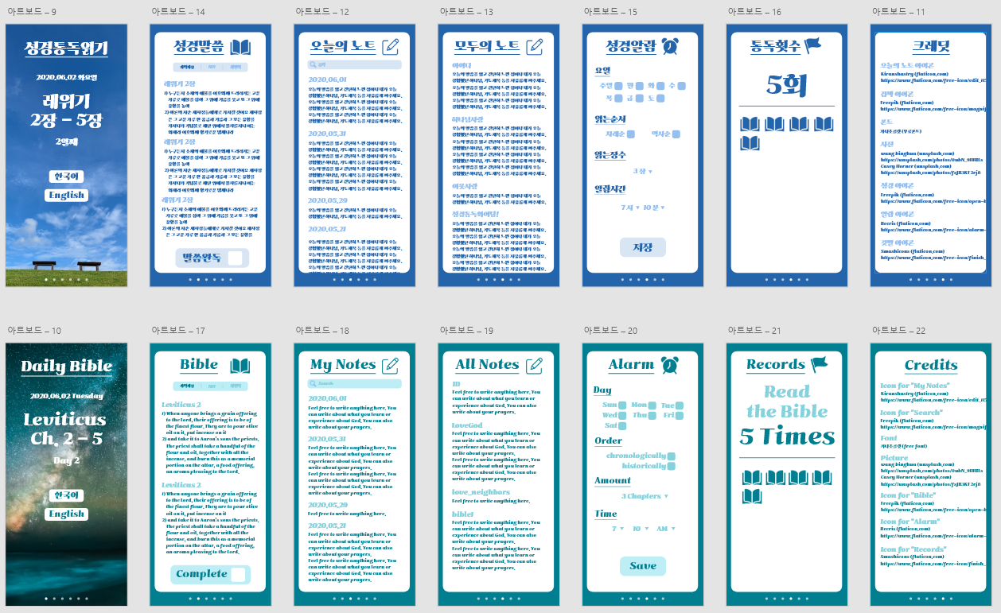

I plan to implement the project using the waterfall model.

## Tools and Technologies

Mention all the tools and technologies you will need to implement your project. What development environment (IDEs) would you be using? What programming languages? What software applications? What Server? What Database? What APIs? What operating system would you be using?

* IDEs: Android Studio
* Programming language: Java
* Software application: Adobe XD, online PNG tool (<https://onlinepngtools.com/change-png-color>)
* APIs: Firebase
* OS: Windows

# Project Plan

## Project cost and effort estimates

Describe your project plan, detailing what resources would you need in this project and how much they would cost (money and time).

The project is expected to cost $25 to purchase a developer account of Google Play Console. There is no other monetary cost to this project.

The project is an individual project, and it is expected to spend about two months to develop an app (excluding the days to wait the reviewing process by Google App). During the planning process, I will plan the project, such as timeline and associated costs. During the design process, I will design the app using Adobe XD (which is attached to Section 1.2). During the coding process, I will code the app, both xml and java files, using Android Studio. I will also implement Firebase, which will require some time to learn. (I plan to learn Firebase using YouTube, just like I learned to use Android Studio.) This process may contain errors, but I will ignore all minor errors to fix during the testing and editing process. This is because I want to finish the full app and be ready to turn it in just in case an emergency happens in my life that I am out of time to complete the project. Then, during the testing and editing process, I will edit all possible errors that I can find. Lastly, I will post the app on Google App, which will take about seven days to publish. The publishing process will require to add some images and write Terms of Services, which may require to communicate with student legal services.

## Project Timeline

|  |  |  |  |  |  |  |  |  |  |
| --- | --- | --- | --- | --- | --- | --- | --- | --- | --- |
| **Task Name** | **June** | | | | **July** | | | | **August** |
| **Week1** | **Week2** | **Week3** | **Week4** | **Week1** | **Week2** | **Week3** | **Week4** | **Week1** |
| Plan |  |  |  |  |  |  |  |  |  |
| Design |  |  |  |  |  |  |  |  |  |
| Code |  |  |  |  |  |  |  |  |  |
| Test |  |  |  |  |  |  |  |  |  |
| Edit |  |  |  |  |  |  |  |  |  |
| Publish |  |  |  |  |  |  |  |  |  |

# Risk Analysis

## Generic Risk

1. It is common that app has sensitive data leakage. I may learn about app security, but it may take too much time and possibly make the app too heavy. Since the app does not associate with any private data (other than personal notes), I will simply state that the app does not provide a full protection of your data in Terms of Services.
2. I may have a logic error for the app, which may impact the app to crash. In order to prevent such happening, I will briefly design the app structure as well before I start coding.
3. The app should be able to fit in to all different sizes of screens. In order to do so, I will design the app using the smallest possible screen and put my design based on inches from the screen (e.g., four inches down from the top to place the title). This way, I can assure that all app content appears in the screen.
4. The app may not run on a certain android phone. I will specify the recommended environment when I publish the app (e.g., The app runs on Jellybean 14.0 and above). Also, I will test the app using different emulators.
5. The app development may take more time than expected. As stated above, I will try to ignore all minor errors and fully develop the app first just in case I am out of time to turn in the full app. As soon as I have a full app, I will upload on the App Store and updates the app once I fix the errors.

## Project Specific Risks

1. Because this is a waterfall project, it is difficult to change the design once it is all complete. To reduce such risk, I created an app design using Adobe XD.
2. The project may associate additional costs when there are too many users. In that case, I will update the app stating that the shared notes will be deleted from the shared space (not from the personal space) after a certain number of days.
3. The app has two versions: Korean and English. However, people who speak English only may think the Korean button as a weird symbol without an appropriate sign. To resolve the problem, I will modify the current design with two buttons of Korean and English to one button of Language to choose.
4. Some people may not want to share their notes or prayers, so I will modify the current design to add a button to make their notes or prayers private.
5. Since this is an individual project, I may not as productive as other teams. In order to increase my productivity, I will set time to work on my project (specifically, two hours right after our regular classes to work on the project).

# Member Roles

I, Gloria Kim, is the only member in this group, and I will be completing all portions alone.