RECEIPT

Most receipts are made of two types: paper and thermal. Paper receipts are recyclable just like other papers, but thermal receipts are BPA-coated, an industrial chemical that’s used to produce specific kinds of plastic. This chemical is linked to cancer, pre-mature puberty, obesity, type 2 diabetes, and more, so for the (recycling employees), it is discrouaged to place in recycling bins.

<https://wastelandrebel.com/en/why-you-shouldnt-recycle-receipts/#:~:text=Well%2C%20yes%2C%20it%20is%2C,as%20much%20as%20you%20can.&text=Thing%20is%2C%20receipts%20are%20actually,other%20papers%2C%20or%20compost%20them.>

REFRIGERATOR

`commonBulk`

RIBBONS & BOWS

3.

Facilities that accept commingled recyclables and sort out the cardboard use a large piece of equipment called disc screens, or sets of spinning discs with spaces in between. Large flat items like cardboard are carried up and over the screen, while smaller items fall through the spaces between the discs.

Unfortunately, ribbons (as well as plastic bags, twine and anything else that’s long and stringy) end up wrapping around the spinning shafts that hold the discs. It's kind of like hair wrapping around the roller brush of a vacuum cleaner.

Over the space of just a few hours, the gaps between the discs can fill up until the smaller items that were supposed to fall through the spaces no longer can.

To fix the problem "the facility then needs to shut down all the equipment so they can get in and cut out all the junk that has wrapped around the shafts holding the discs,” said Peter Spendelow, a materials management specialist for Oregon's Department of Environmental Quality.

<https://www.usatoday.com/story/tech/news/2017/12/20/dont-recycle-bow-sloppy-christmas-recycling-can-send-all-your-efforts-landfill/963415001/>

RUG

3.

~~Carpets are full of complex fibers that make them impossible to break down in landfills. And, because~~ carpet is made from multiple components with different chemical makeups, it’s tough to recycle properly. In addition to its disposal woes, carpet’s bulkiness burdens the sanitation workers tasked with picking it up.

4.

CARE (Carpet America Recovery Effort) is a nonprofit organization working to develop the infrastructure needed to recycle carpet efficiently across the U.S. In the meantime, find a carpet recycling facility near you with our [recycle center locator](https://search.earth911.com/?what=Carpet&where=zip+code&list_filter=all&max_distance=25&family_id=&latitude=&longitude=&country=&province=&city=&sponsor=).

<https://earth911.com/recycling-guide/how-to-recycle-carpet/#:~:text=Despite%20complications%2C%20nearly%20all%20types,of%20and%20where%20you%20live.>

SANITIZING WIPE

3.

Disinfectant wipes are made up of synthetic fibers that prevent them from being compostable or recyclable. So, after just one use, they are thrown away and head to the landfill.

<https://www.greenmatters.com/p/are-disinfectant-wipes-compostable#:~:text=Disinfectant%20wipes%20are%20mostly%20not,and%20head%20to%20the%20landfill.>

SATELLITE DISH

3.

Every satellite dish is made up of plastic, metal and a circuit board/hardware. Those materials put satellite dishes in the electronic waste category, which means they can be recycled, but just like iPhones and laptops they need to be recycled at the right facility.

<https://godish.com/can-satellite-dishes-be-recycled/#:~:text=Every%20satellite%20dish%20is%20made,recycled%20at%20the%20right%20facility.>

SAUCE BOTTLE (PLASTIC)

`plasticBottle`?

SAUCE & SYRUP

`food`

SCISSORS

(trash preparation0

1. Wrap your scissors or kitchen or other small knife securely in cardboard.
2. Tape the cardboard closed.
3. Place the taped cardboard package into your regular trash.

<https://www2.montgomerycountymd.gov/DepHowDoI/material.aspx?tag=knives&material_key=56>

SHELLFISH

`food`

SHOE BOX

`cardboard`

2.

1. Wet each box, chop and make into pulp.
2. Then it is cleaned and bleached.
3. The pulp is pressed and rolled into paper.
4. The paper is designed into a new shoe box.

<https://www.youtube.com/watch?v=Bx0ozMweqoU&feature=emb_logo>

3. Shoe boxes are **made from** a variety of materials, including corrugated and non-corrugated card, fabric and plastic.is shoe box

<https://www.satra.com/bulletin/article.php?id=2193#:~:text=Today%2C%20shoe%20boxes%20are%20available,different%20stacking%20and%20storage%20options.>

SHOES (PAIRED)

Maybe 2 & 4

Nike's [Reuse a Shoe](https://www.nike.com/help/a/recycle-shoes) program, running [since 1993](https://s3-us-west-2.amazonaws.com/purpose-cms-preprod01/wp-content/uploads/2019/08/14041729/Reuse-a-Shoe_Store_List_8.13.19.pdf), recycles worn out sneakers by any brand. They've processed 33 million pairs of shoes to date. After separating the shoes into leather, foam, plastic and rubber, the pieces are ground down and [reused as surfacing](https://www.nikegrind.com/materials/) for playgrounds, track tops, carpet padding and even new Nike gear, like maybe the soles of your Air Jordans. You can get in on the action by dropping your shoes at participating Nike and Converse Factory stores (here's [a list](https://www.nike.com/retail/?features%5B%5D=Reuse%20-%20A%20-%20Shoe&page=1&storesPerPage=15) of them).

<https://fashionista.com/2020/02/how-to-recycle-shoes-sneakers-heels#:~:text=If%20your%20shoes%20are%20truly,bin%20instead%20of%20the%20trash.>

SHUTTLECOCK

3.

Because these products contain so many components (leather, plastic, cork, rubber, etc) it takes a long time is decompose especially the leather, plastic, and rubber seeing as they are not composed of decomposable material. Therefore, it can not be **recycled**.

<https://prezi.com/rjeynljd607k/the-life-cycle-of-a-badminton-shuttlecock/#:~:text=Because%20these%20products%20contain%20so,it%20can%20not%20be%20recycled.>

SILVERWARE

4??3??2??? `scrapMetal`

At the bare minimum, do a magnet test on your cutlery. If it’s attracted to your magnet, the metal is ferrous; if not, it’s non-ferrous. This will be important information if you take your items to a scrap metal recycler, as we’ll discuss in a moment. Also keep in mind that any additional elements in your cutlery, such as wooden or plastic handles or special coatings, will [complicate the recycling process](https://livegreen.recyclebank.com/because-you-asked-how-are-mixed-material-items-recycled).

Find out which scrap metal recyclers are available in your area. Each will accept different types of metal, and some may specialize exclusively in ferrous or non-ferrous metals, or even a particular type of metal. Depending on market rates, you may actually make some money for your old cutlery!

<https://livegreen.recyclebank.com/column/the-list/because-you-asked-is-my-old-cutlery-recyclable>

SIX PACK PLASTIC RINGS

3?

The rings are made of plastic #4 (LDPE) and can be recycled in programs that accept low-density polyethylene resin

<https://earth911.com/home/wow-you-can-recycle-that/#:~:text=Six%2DPack%20Beverage%20Rings&text=The%20rings%20are%20made%20of,accept%20low%2Ddensity%20polyethylene%20resin.&text=Federal%20law%20has%20required%20the,the%20plastic%20into%20tiny%20pieces.>

SLEEPING BAG

3. `commonBulk` A sleeping bag is a voluminous piece of gear that requires large swaths of polyester or nylon. I

SMOKE DETECTOR

3.

Most smoke detectors are either photoelectric alarms or ionization alarms. Ionization alarms contain an extremely small amount of radiation, so they cannot be placed both in trashcans and recycling bins. Instead, contact the manufacturer for recycling. Most of the major companies will take their products back.

If you have a photoelectric smoke detector, you may not be able to recycle most of the device.

Ionization alarms contain an extremely small amount of radiation, and some municipalities will not accept them in the waste stream.

<https://recyclenation.com/2015/06/how-to-recycle-smoke-detectors/>

SOAP BOTTLE (PLASTIC)

`plasticBottle` ?

SOUP BOX

Like `aseptic container`

`carton`

STEEL --> STEEL CAN?

1.

Most steel cans will have a paper label, which does not need to be removed. The paper will be removed during the recycling process, and since it’s a low quality of paper, it won’t be worth your time to remove and recycle it with other paper.

You should rinse your cans to remove any leftover food. This will prevent your recycling bin from smelling and reduce the risk of animals attacking your recycling.

Completely remove the lid (also made of steel) and insert into the can, then pinch the top so it closes. This will also prevent birds or cats from getting their heads stuck in the cans.

2 `steel`

<https://www.monterreyiron.com/the-steel-recycling-process>

3

**NO DEGRADATION**

Steel is a metallurgical wonder in that the material does not degrade upon recycling. The steel you put in is the same steel you recycle and reuse. The same durability, the same properties, the same material. Steel can be recycled and reused endlessly. Two of every three tons of steel produced is recycled material.

**RECYCLING STEEL IS EASY**

Scrap metal is cut up into little chunks and magnets easily separate iron and steel from the mix. This leaves other metals and non-metallic materials behind so only the pure steel is melted down and recast.

The primary method of steel recycling is oxygen basic. This reduces the amount of iron ore required to create steel. The secondary method is known as electric arc furnace where 100% scrap metal is used to make new product.

**RECYCLING IS LESS EXPENSIVE**

When you consider what goes into mining iron ore plus the other metals and materials that go into making virgin steel, recycling steel makes keen economic sense. Mining is a hazardous profession and hard on the environment. Processing the iron ore into steel introduces another step into production.

Scrap metal, on the other hand, is readily available and merely needs to be separated, melted down, and reused.

STERNO

3.

**Sterno** and other gel fuels are hazardous waste, and banned from trash disposal. Empty hazardous waste containers should not be placed in your **recycling** bin.

<https://cswd.net/a-to-z/sterno-canned-gel-fuel/#:~:text=Sterno%20and%20other%20gel%20fuels,placed%20in%20your%20recycling%20bin.>

STICKY NOTE

`paper`

STORAGE CONTAINER +++ ADD PLASTIC FOOD STORAGE CONTAINERS??? <https://www.keeptruckeegreen.org/guide/plastic-food-storage-containers/>

3.

Regardless of size or composition, most plastic storage bins have one thing in common: they are hard to recycle. Plastic storage bins cannot go in your curbside recycling bin. For one thing, large ones will not fit. It is also highly unlikely that your curbside recycling program is set up to recycle these items.

<https://recyclenation.com/2015/11/how-to-recycle-plastic-storage-bins/#:~:text=from%20getting%20trapped.-,Regardless%20of%20size%20or%20composition%2C%20most%20plastic%20storage%20bins%20have,in%20your%20curbside%20recycling%20bin.&text=They%20are%20typically%20much%20more,soap%20bottles%20and%20milk%20cartons.>

STRAW (METAL)

3.

They are extremely durable and 100% **recyclable**! You have to take it to a designated local **metal recycling** facility to do so.

<https://www.solunacollective.com/blogs/explore/reusable-straws-eco-tips#:~:text=From%20an%20aesthetic%20standpoint%2C%20stainless,stainless%20steel%20does%20not%20biodegrade.>

STRAW (RUBBER)

`rubber` or `eraser`

STRAW (PLASTIC)

3. Although the **plastic** they are made from is technically **recyclable**, they are not accepted in curbside **recycling** programs. **Plastic straws** are too lightweight to make it through the mechanical **recycling** sorter.

<https://www.mydisposal.com/plastic-straws#:~:text=Although%20the%20plastic%20they%20are,through%20the%20mechanical%20recycling%20sorter.&text=Because%20straws%20are%20non%2Drecyclable%2C%20they%20end%20up%20landfills>.

STRING, TWINE

Stuck in the machine??

STYROFOAM

`Styrofoam`

SUITCASE

3. `commonBulk`

SUNSCREEN

METAL -> `aerosol can`

Plastic ->

SURGE PROTECTOR

TABLE

* Plastic, wood, etc.

TABLE FAN // ADD CEILING FANS?

TABLET

`electronics`

TAKE-OUT CONTAINER (PLASTIC)

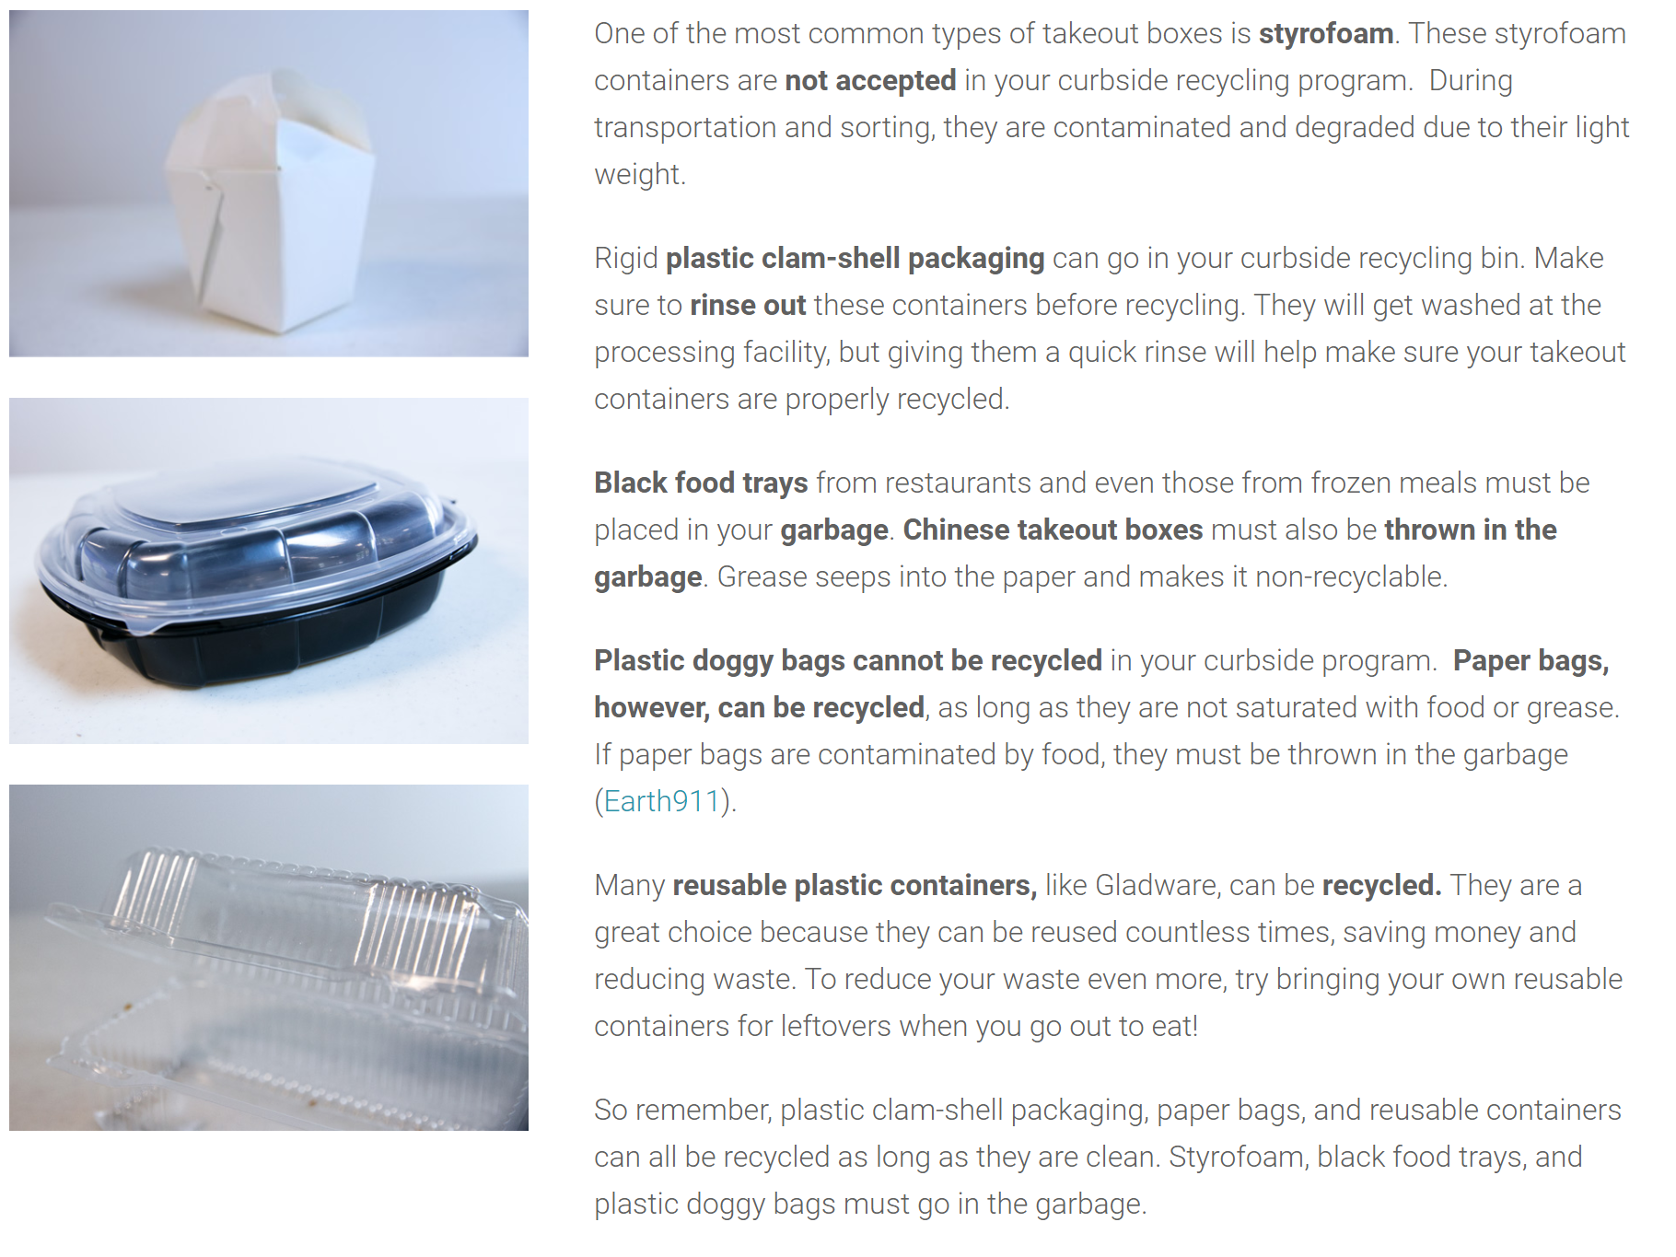 <https://www.mydisposal.com/taking-confusion-takeout-container-recycling#:~:text=Many%20reusable%20plastic%20containers%2C%20like,you%20go%20out%20to%20eat>!

TEABAGS

3. Paper **tea bag** wrappers are often plastic coated, making them not **recyclable**. And even if they were truly only plain paper, they are too small to be captured in the sorting process and end up in the “fines” at the end and go to the landfill anyway.

<https://kanecountyconnects.com/2020/01/recycling-qa-can-i-recycle-tea-bag-wrappers/#:~:text=A%3A%20Tea%20Bag%20Wrappers%20Are%20NOT%20Recyclable%20Because%20%E2%80%A6&text=The%20ones%20you%20describe%20are,coated%2C%20making%20them%20not%20recyclable>.

TELEVISION

`electronics`

TEXTILE

2.

When recycling textiles, natural and synthetic fibers must be [**recycled**](https://www.thebalancesmb.com/the-basics-of-recycling-clothing-and-other-textiles-2877780) differently. This is why after donations are collected, sorting textiles is a crucial part of the process. extiles are sorted by type (clothing versus linens, towels, etc.), by fabric (synthetic versus natural fibers), and by color (some material needs to be re-dyed, while other material does not). Once the textiles are properly sorted, they are then pulled into fibers or shredded, which results in yarn. Next, the yarn is processed and cleaned. It then is re-spun so that it can be reused, either by being knitted or woven.

Any fiber that cannot be spun into yards is compressed into filling, such as insulation or textile filling inside of mattresses.

3.

**Textiles** can be **recycled**, which refers to the process of turning old clothing, fabrics, and other **textiles** into materials that can be reused. BUT NO TIN DENTON!!

<https://www.greenmatters.com/p/how-fabric-gets-recycled#:~:text=Textiles%20can%20be%20recycled%2C%20which,then%20transformed%20into%20recovered%20materials>.

TIRE

1.

### Tire Recycling Preparation

1. Before disposing of tires, ask an auto shop if your old tires can be retreaded or repaired. Either option prolongs the life of your tires and is cheaper than buying new tires.
2. If you are having tires replaced at an auto shop, ask if the shop will recycle the old tires for you. Depending on where you live, the cost of new tires [may include a tax that funds the disposal](https://www.amazon.com/gp/help/customer/display.html?nodeId=200989080) of your old tires, or disposal may be included in the service charge.
3. If recycling tires yourself, you’ll need to remove the rim and wheel weights first. Luckily, the rim is made of aluminum and the weights are made of steel — both valuable metals you can recycle as scrap. **Warning:** You should have experience using power tools if you’re going to cut the tire off the rim yourself. Please exercise caution.
4. Before recycling tires, consider a reuse project for them. Besides the obvious option of making a tire swing, they make [great planters in your garden](https://www.thespruce.com/are-tire-gardens-safe-growing-veggies-848043) or [compost bins](http://www.doityourself.com/stry/making-a-compost-bin-out-of-old-tires).

<https://earth911.com/recycling-guide/how-to-recycle-tires/>

2.

<https://www.youtube.com/watch?v=ldE-mam2rq8>

3.

<https://en.wikipedia.org/wiki/Tire_recycling#:~:text=Tires%20can%20be%20reclaimed%20into,may%20integrate%20recycled%20materials%20no>

TISSUE PAPER

3.

**Tissue paper** is hard to **recycle** because it's already been recycled: it's made from recycled **paper**, so the fibers are shortened to the point where it cannot feasibly go through the **recycling** process again.

<https://www.keeptruckeegreen.org/guide/tissue-paper/>

TOILET

3.

Most **toilet** bowls are made of porcelain, and while we wouldn't want them **recycled** into dinner plates they can be crushed and mixed into concrete, footpaths and roads.

<https://ecocycle.com.au/blog/5-gross-things-probably-didnt-know-can-recycle/#:~:text=Most%20toilet%20bowls%20are%20made,bowls%2C%20so%20check%20with%20yours>.

TOILET PAPER

3.

Because **they** usually come in contact with food wastes, greases, and possibly bodily fluids, **they** are not able to **be** "**cleaned**" during the **recycling** process and should not **be** with other "**clean**" **paper** waste like magazines and copy **paper**

<https://www.mesacc.edu/recycling-sustainability/do-not-recycle>

TOILET PAPER ROLL

3.

Empty rolls are recycled with cardboard.

<https://www.keeptruckeegreen.org/guide/paper-towel-toilet-paper-rolls/>