# Epigenetic profile around exon boundaries

Gloria Li  
Tue Jun 17 16:38:48 2014

1. Profile epigenetic signals (DNA methylation, H3K4me3, H3K4me1, H3K9me3, H3K27me3, H3K36me3) around exon boundaries, i.e. exon 3-prime/5-prime +/- 200bp.

* WGBS: lumRM066 and myoRM045 bismark fractional methylation calls.
* MeDIP: lumRM035 and myoRM035 signals from wig files.
* H3K4me3: myoRM080 wig file, no libraries for lum available.
* H3K4me1, H3K9me3, H3K27me3, H3K36me3: lumRM080 and myoRM080 wig files.

1. Use exon expression and isoform analysis in RM084 lum and Rm084 myo to divide exons into four categories:

* exons expressed in both cell types: positive control
* lum-specific exons: only expressed in lum cells
* myo-specific exons: only expressed in myo cells
* exons not expressed in either cell types: negative control

1. If the epigenetic mark is associated with the isoform event, we would expect in lum cells, its signal profile for lum-specific exons is similar to expressed in both exons, and myo-specific exons similar to not expressed exons, and a reversed pattern in myo cells.

### DNA methylation profile with WGBS at exon boundaries

* Exons expressed in both cell types and exons not expressed in either cell type have distinct DNA methylation profiles.
* Profiles for isoform exons are close to exons expressed in both, without obvious distinction between two cell types.

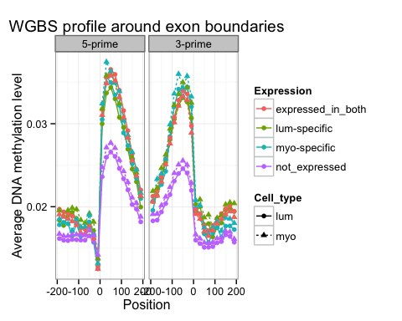

### DNA methylation profile with MeDIP at exon boundaries

* DNA methylation profiles are similar to results from WGBS, but the dip at exon 5-prime end is not as clear.
* Again no distinction between cell types for isoform exons.

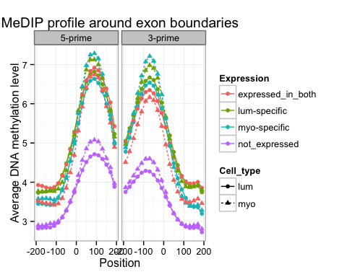

### H3K4me3 profile at exon boundaries

* No H3K4me3 libraries available for lum cells.
* H3K4me3 profiles match DNA methylation profile well.
* For myo H3K4me3 signals, expressed in both and not expressed in either exons have different profiles, but no obvious differences are observed between lum-specific and myo-specific exons.

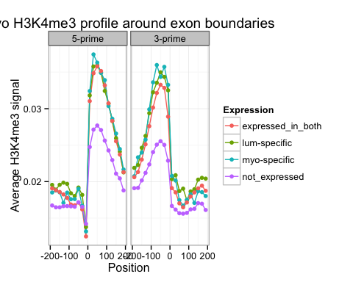

### H3K4me1 profile at exon boundaries

* myo and lum cells have different levels of H3K4me1 signals: normalize?
* For each cell type, profiles for the two types of isoform exons are similar.

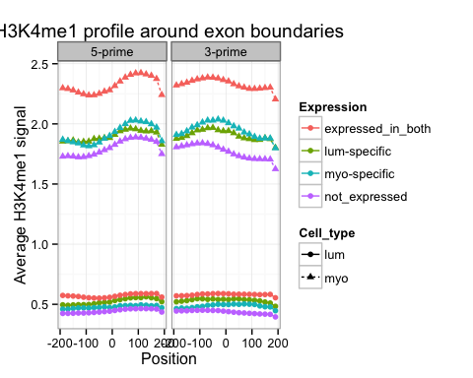

### H3K9me3 profile at exon boundaries

* myo and lum cells also have different levels of H3K9me3 signals.
* In lum cells, profiles for the two types of isoform exons are similar.
* In myo cells, we do see expected pattern, i.e. lum-specific exons closer to not expressed exons and myo-specific exons closer to expressed in both exons, but the differences are small and not present in lum cells.

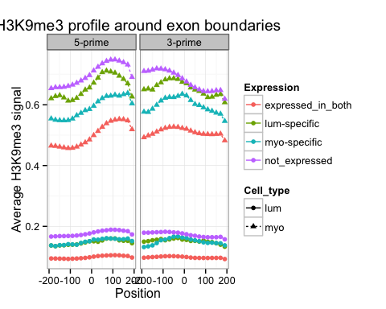

### H3K27me3 profile at exon boundaries

* myo and lum cells still have different levels of H3K27me3 signals.
* In both cell types, isoform exons have higher signal level than both not expressed and expressed in both exons.

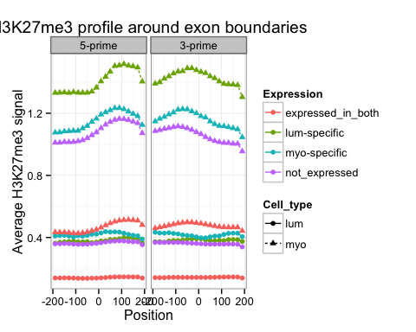

### H3K36me3 profile at exon boundaries

* myo and lum cells still have different levels of H3K36me3 signals.
* Exons expressed in both cell types have a distinct profile than the rest of exons. Isoform exons have similar profile as not expressed exons.

