**Software engineering report 2**

**Group 11**

|  |  |  |  |
| --- | --- | --- | --- |
| ID | Team Member | Group | Mail |
| 149037 | Anas Mohamed | A2 | **anas149037@bue.edu.eg** |
| 139974 | Lorina Medhat | A3 | **lorina139974@bue.edu.eg** |
| 139394 | Engy Samir | A3 | **engy139394@bue.edu.eg** |
| 150753 | Gloria Ezzat | A3 | **gloria150753@bue.edu.eg** |

Notes:

1. We used files instead of Derby.
2. When you withdraw cash, you deal with dollars but when you deposit cash you deal with cents as it’s required in the description.
3. We made some changes in the use case scenarios and use case event decompositions depending on the feedback.
4. The system scenario starts with the user logging in with “valid” card number and pin or it will display an error message then he would choose whatever transaction he needs so if he choose withdraw he will enter the money he wants in dollar and it will automatically be subtracted from his balance, if he enters amount of money greater than what already is in his balance it will display an error message, so now if he choose to check balance it will display a message with his new balance, as for the deposit he needs to enter money in cents as it’s required in the description, then if he choose print receipt it will print all the client’s data from the database.

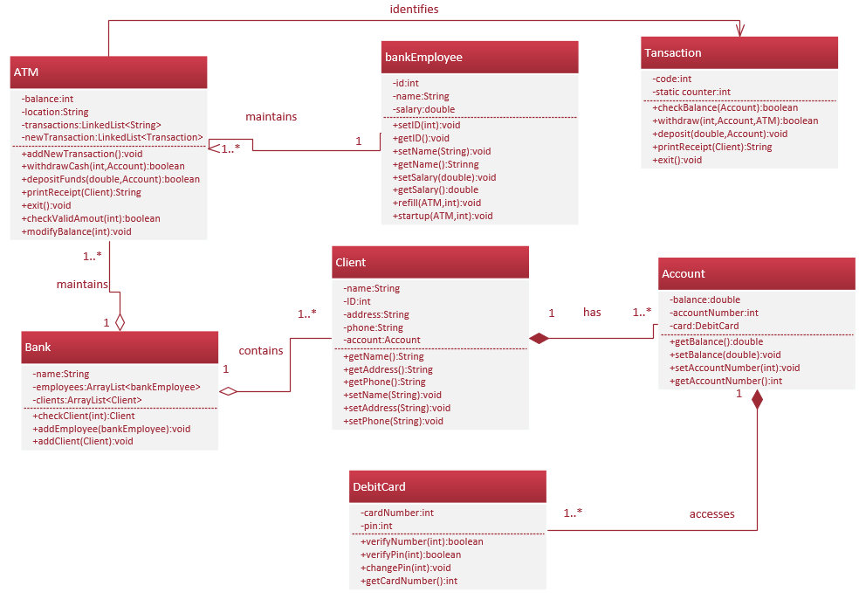

**Use Case Event Decomposition:**

|  |  |  |  |  |  |
| --- | --- | --- | --- | --- | --- |
| **Event** | **Trigger** | **Source** | **Use Case** | **Response** | **Destination** |
| Client needs to enter the system | Search for the client’s card number and pin in the database. | Client | Login | Display the transaction form | Client |
| Client need to withdraw cash | Subtract the cash from the client’s balance. | Client | Withdraw cash | Display a message “Transaction Successful”. | Client |
| Client need to deposit funds | Add the cash to the client’s balance. | Client | Deposit funds | Display a message “Transaction Successful”. | Client |
| Client needs to print receipt | Search for the client’s data in the database. | Client | Print receipt | Display the client’s receipt in a text field. | Client |
| Client needs to check his balance | Search for the client’s balance in the database. | Client | Check balance | Display the client’s balance in a text field. | Client |
| Employee needs to refill the machine | Check the machine balance. | Employee | Refill machine | Add 10000$ to the machine balance | ATM |
| Employee needs to start-up the machine | Exchange the existed startup money by the new one. | Employee | Start-up machine | Change the start-up amount of money of the machine | ATM |
| Employee maintains the system to get all the transactions happened during each day | Check the transactions made during the day | Employee | Maintain system | Show the transactions happened during all the day | Employee |

**Use Cases Scenarios:**

**Login Use Case:**

|  |  |
| --- | --- |
| **ID** | 1 |
| **Title** | Login |
| **Description** | A registered user can login to their account at any time by entering their account number and pin to check their balance, withdraw an amount of money or deposit funds. |
| **Priority** | High |
| **Primary actor** | Client |
| **Secondary actor** | Bank |
| **Pre-condition** | Registered account  Right user name and pin |
| **Post-condition** | Logged in |
| **Main success scenario** | 1. The user enters account number and pin   2- The user clicks submit  3- The system verifies the client’s account number and pin  4- Login successful |
| **Extensions** | 1. Enter wrong account number or pin   2- Click submit  3- Display error message |

**Withdraw Cash Use Case:**

|  |  |
| --- | --- |
| **ID** | 2 |
| **Title** | Withdraw |
| **Description** | A registered user can withdraw money at any time by logging in. if the withdrawal amount of money is greater than the client’s or machine’s balance, an error message is displayed. If the money is available, the client is asked to re-enter his pin |
| **Priority** | Medium |
| **Primary actor** | Client |
| **Secondary actor** | Bank |
| **Pre-condition** | Logged in |
| **Post-condition** | Subtract the amount of money from the client’s balance. |
| **Main success scenario** | 1. Login 2. Choose withdraw process 3. Enter the amount of money 4. Enter the pin 5. The amount of money is subtracted from client’s balance |
| **Extensions** | 1- Enter unavailable amount of money  2- Display error message  1- Enter wrong pin  2- Display error message |

**Deposit Funds Use Case:**

|  |  |
| --- | --- |
| **ID** | 3 |
| **Title** | Deposit |
| **Description** | A registered user can deposit their funds by logging in. if the user did not enter the money within 2 minutes, the process will not complete. |
| **Priority** | Medium |
| **Primary actor** | Client |
| **Secondary actor** | Database |
| **Pre-condition** | Logged in |
| **Post-condition** | Add the amount of money to the client’s balance |
| **Main success scenario** | 1. Log in 2. Choose deposit process 3. Enter the amount of money 4. Put the money within 2 minutes 5. The amount of money is successfully added to the user’s balance |
| **Extensions** | 1. Enter the amount of money 2. Does not put the money within 2 minutes 3. Stop the process and ask the user to exit or to go back to the choices |

**Check Balance Use Case:**

|  |  |
| --- | --- |
| **ID** | 4 |
| **Title** | Check balance |
| **Description** | A registered user can check his balance at any time by logging in. |
| **Priority** | Medium |
| **Primary actor** | Client |
| **Secondary actor** | Bank |
| **Pre-condition** | Logged in |
| **Post-condition** | Get the balance |
| **Main success scenario** | 1. Log in 2. Choose check balance process 3. View the balance |
| **Extensions** | 1. Enter wrong account number or pin 2. Click submit   3- Display error message |

**Print Receipt Use Case:**

|  |  |
| --- | --- |
| **ID** | 5 |
| **Title** | Print receipt |
| **Description** | A registered user can print a receipt after doing any transaction such as withdrawing cash, deposit funds or checking their account’s balance. |
| **Priority** | Low |
| **Primary actor** | Client |
| **Secondary actor** | Bank |
| **Pre-condition** | Doing any of the transactions. |
| **Post-condition** | Get a printed receipt |
| **Main success scenario** | 1. Log in 2. Choose a specific transaction 3. Ask for the receipt 4. Get a printed receipt |
| **Extensions** | 1. Enter wrong account number or pin 2. Click submit   3- Display error message |

**Make Transaction Use Case:**

|  |  |
| --- | --- |
| **ID** | 6 |
| **Title** | Make transaction |
| **Description** | A registered user can do whatever transaction he wants by logging in. |
| **Priority** | High |
| **Primary actor** | Client |
| **Secondary actor** | Bank |
| **Pre-condition** | Registered account |
| **Post-condition** | A specific transaction is chosen. |
| **Main success scenario** | 1. Login 2. Choose a specific transaction |
| **Extensions** | 1. Enter wrong account number or pin 2. Click submit   3- Display error message |

**Maintain System Use Case:**

|  |  |
| --- | --- |
| **ID** | 7 |
| **Title** | Maintain system |
| **Description** | Accessing the ATM transactions. |
| **Priority** | High |
| **Primary actor** | Bank Employee |
| **Secondary actor** | Database |
| **Pre-condition** | The ATM needs to be refilled. |
| **Post-condition** | The number of transactions during the day is displayed |
| **Main success scenario** | 1. Login 2. Access the ATM transactions |
| **Extensions** | 1. Enter wrong account number or pin 2. Click submit   3- Display error message |

**Refill Machine Use Case:**

|  |  |
| --- | --- |
| **ID** | 8 |
| **Title** | Refill machine |
| **Description** | A machine is refilled daily to 10000$ |
| **Priority** | Low |
| **Primary actor** | Bank Employee |
| **Secondary actor** | Database |
| **Pre-condition** | Machine is empty |
| **Post-condition** | Machine is refilled |
| **Main success scenario** | 1. Login 2. Access the ATM 3. Refill the machine |
| **Extensions** | 1. Enter wrong account number or pin 2. Click submit   3- Display error message |

**Start-Up Machine Use Case:**

|  |  |
| --- | --- |
| **ID** | 9 |
| **Title** | Start-up machine |
| **Description** | Change the amount of money the ATM will start with. |
| **Priority** | Medium |
| **Primary actor** | Bank Employee |
| **Secondary actor** | Bank |
| **Pre-condition** | Determines the amount of money the ATM will start with. |
| **Post-condition** | The amount of money is determined. |
| **Main success scenario** | 1. Login 2. Access the ATM 3. Change the amount of money the ATM will start with. |
| **Extensions** | 1. Enter wrong account number or pin 2. Click submit   3- Display error message |

**Test Cases Templates:**

|  |  |
| --- | --- |
| ID | 1 |
| Test Case Name | Verify login with valid card number and pin. |
| Objective | To ensure that the logging operation is working successfully as desired. |
| Name of tested Module | Login form/ ATM screen. |
| Test Scenario | 1. Enter card number 2. Enter pin 3. Press submit button |
| Input | Card number & Pin (89797984,25728) |
| Expected Output | Move to Transactions Form. |
| Actual Output | Move to Transactions Form. |
| Pass/Fail | Pass. |

|  |  |
| --- | --- |
| ID | 1 |
| Test Case Name | Verify login with valid card number and pin. |
| Objective | To ensure that the logging operation is working successfully as desired. |
| Name of tested Module | Login form/ ATM screen. |
| Test Scenario | 1. Enter card number 2. Enter pin 3. Press submit button |
| Input | Card number & Pin (89797984,2572) ‘wrong pin’ |
| Expected Output | Move to Transactions Form. |
| Actual Output | Invalid Number or password |
| Pass/Fail | Fail. |

|  |  |
| --- | --- |
| ID | 2 |
| Test Case Name | Verify choosing one of the transactions. |
| Objective | To ensure that choosing any of the operations is working successfully as desired. |
| Name of tested Module | Form/ ATM screen |
| Test Scenario | 1. Choose Withdraw cash 2. Press submit button |
| Input | 1. Press Withdraw cash 2. Press Submit button |
| Expected Output | Move to Withdraw Form. |
| Actual Output | Move to Withdraw Form. |
| Pass/Fail | Pass. |

|  |  |
| --- | --- |
| ID | 3 |
| Test Case Name | Verify withdrawing cash. |
| Objective | To ensure that withdrawing amount of cash is working successfully as desired. |
| Name of tested Module | Form/ ATM screen |
| Test Scenario | 1. Enter amount of money 2. Enter pin 3. Press submit button |
| Input | Enter the amount of money you want to withdraw (1000) |
| Expected Output | Display a message “Transaction successful” |
| Actual Output | Display a message “Transaction successful” |
| Pass/Fail | Pass. |

|  |  |
| --- | --- |
| ID | 3 |
| Test Case Name | Verify withdrawing cash. |
| Objective | To ensure that withdrawing amount of cash is working successfully as desired. |
| Name of tested Module | Form/ ATM screen |
| Test Scenario | 1. Enter amount of money 2. Enter pin 3. Press submit button |
| Input | Money in Dollars (30000) pin (25728) |
| Expected Output | Display a message “Transaction successful” |
| Actual Output | Display a message “invalid amount” |
| Pass/Fail | Fail |

|  |  |
| --- | --- |
| ID | 3 |
| Test Case Name | Verify withdrawing cash. |
| Objective | To ensure that withdrawing amount of cash is working successfully as desired. |
| Name of tested Module | Form/ ATM screen |
| Test Scenario | 1. Enter amount of money 2. Enter pin 3. Press submit button |
| Input | Money in Dollars (1000) pin (2572) |
| Expected Output | Display a message “Transaction successful” |
| Actual Output | Display a message “Wrong pin” |
| Pass/Fail | Fail |

|  |  |
| --- | --- |
| ID | 4 |
| Test Case Name | Verify deposing funds. |
| Objective | To ensure that deposing amount of money is working successfully as desired. |
| Name of tested Module | form/ ATM screen |
| Test Scenario | 1. Enter amount of money 2. Press submit button |
| Input | Enter the amount of money you want to deposit (100) |
| Expected Output | Display a message “Transaction successful” |
| Actual Output | Display a message “Transaction successful” |
| Pass/Fail | Pass. |

|  |  |
| --- | --- |
| ID | 5 |
| Test Case Name | Verify printing client’s receipt. |
| Objective | To ensure that printing client’s balance is working successfully as desired. |
| Name of tested Module | form/ ATM screen |
| Test Scenario | 1. Press print receipt. |
| Input | Press print receipt. |
| Expected Output | Display client’s receipt in the text field. |
| Actual Output | Display client’s receipt in the text field. |
| Pass/Fail | Pass. |