Final Project_Happiness

Gloria P Moore

3/1/2020

## How Much Happy?

Be happy, is not all that every person wants? Expressed maybe in words, like, needs, desires, goals, peace, etc. Human being is always looking to be happier, is what life is about it, happiness, that state of mind that makes us feel good, complete, exited, so many words. If we are aware that state of mind, is the ideal state. How can society, governments, us, can do to increase that level every day? Governments and other organizations are giving every day more importer to the use of happiness index as part of their indicators to inform their policy-decision making process, describes how measurements of well-being can be used effectively to assess the progress of nations. What can governments and society improve to get a happier population? At the end, happy people, happy country. • What factors are the ones who significantly affect the most the happiness index in the United States? • Which of these factors are affecting negatively and which ones positively? • What factors can be improved in the United Stated to improve the level of happiness? • Is the United States becoming a happier country in the future? • What factors are significantly positive affecting the country with higher happiness index in the last year of the report? • Are the factors found in the last question, the same that are affecting the happiness index in the United States? A little of benchmarking in not a bad idea.

## Data Set

The data set is available in [**https://worldhappiness.report/**](https://worldhappiness.report/)

## Variables

## [1] "Happiness.Rank" "Country" "Happiness.Score" "GDP"   
## [5] "Family" "Life.exp" "Freedom" "Generosity"   
## [9] "Corruption" "Year"

In this study, we will work with 4 data sets, 1 for each year from 2015 till 2018.

## How has been the the Happiness score for the United Stated from 2015 till 2018?

## Warning: package 'dplyr' was built under R version 3.6.2

## Warning in bind_rows_(x, .id): Unequal factor levels: coercing to character

## Warning in bind_rows_(x, .id): binding character and factor vector, coercing  
## into character vector  
  
## Warning in bind_rows_(x, .id): binding character and factor vector, coercing  
## into character vector  
  
## Warning in bind_rows_(x, .id): binding character and factor vector, coercing  
## into character vector  
  
## Warning in bind_rows_(x, .id): binding character and factor vector, coercing  
## into character vector

## ID Country Hapiness.Rank Happiness.Score GDP Family Life.exp  
## 1 1 United States 15 7.119 1.394510 1.247110 0.8617900  
## 2 2 United States 13 7.104 1.507960 1.047820 0.7790000  
## 3 3 United States NA 6.993 1.546259 1.419921 0.7742866  
## 4 4 United States NA 6.886 1.398000 1.471000 0.8190000  
## Freedom Corruption Generosity Year Happiness.Rank  
## 1 0.5460400 0.1589000 0.4010500 2015 NA  
## 2 0.4816300 0.1486800 0.4107700 2016 NA  
## 3 0.5057405 0.1356388 0.3925788 2017 14  
## 4 0.5470000 0.1300000 0.2910000 2018 18

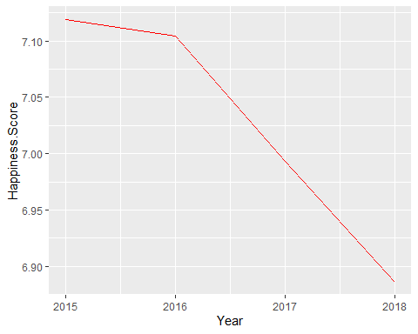

From this plot, The United States has been having a constant decrease in its Happiness Score, let’s see by year, what is afecting

## Let’s see how the 6 factors has been scoring during the 4 years in anaylsis

## ID Year Happiness.Score GDP Family Life.exp Freedom Corruption  
## 1 1 2015 7.119 1.394510 1.247110 0.8617900 0.5460400 0.1589000  
## 2 2 2016 7.104 1.507960 1.047820 0.7790000 0.4816300 0.1486800  
## 3 3 2017 6.993 1.546259 1.419921 0.7742866 0.5057405 0.1356388  
## 4 4 2018 6.886 1.398000 1.471000 0.8190000 0.5470000 0.1300000  
## Generosity  
## 1 0.4010500  
## 2 0.4107700  
## 3 0.3925788  
## 4 0.2910000

## ID Year Happiness.Score Fact Scores  
## 1 1 2015 7.119 GDP 1.3945100  
## 2 2 2016 7.104 GDP 1.5079600  
## 3 3 2017 6.993 GDP 1.5462593  
## 4 4 2018 6.886 GDP 1.3980000  
## 5 1 2015 7.119 Family 1.2471100  
## 6 2 2016 7.104 Family 1.0478200  
## 7 3 2017 6.993 Family 1.4199206  
## 8 4 2018 6.886 Family 1.4710000  
## 9 1 2015 7.119 Life.exp 0.8617900  
## 10 2 2016 7.104 Life.exp 0.7790000  
## 11 3 2017 6.993 Life.exp 0.7742866  
## 12 4 2018 6.886 Life.exp 0.8190000  
## 13 1 2015 7.119 Freedom 0.5460400  
## 14 2 2016 7.104 Freedom 0.4816300  
## 15 3 2017 6.993 Freedom 0.5057405  
## 16 4 2018 6.886 Freedom 0.5470000  
## 17 1 2015 7.119 Corruption 0.1589000  
## 18 2 2016 7.104 Corruption 0.1486800  
## 19 3 2017 6.993 Corruption 0.1356388  
## 20 4 2018 6.886 Corruption 0.1300000  
## 21 1 2015 7.119 Generosity 0.4010500  
## 22 2 2016 7.104 Generosity 0.4107700  
## 23 3 2017 6.993 Generosity 0.3925788  
## 24 4 2018 6.886 Generosity 0.2910000

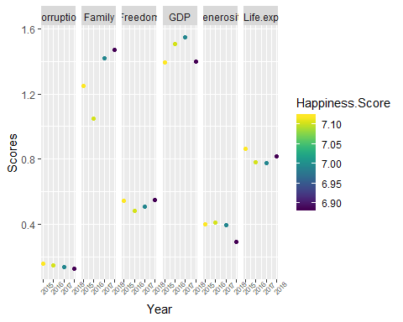 From this chart we can see how the The GDP has decreased from 2018 till 2018, also the Generosity. We are going to check the relationship between these factors with the Happiness Score, what of these factors are correlated with the Hapiness Score

## Analysin correlations

## [1] 0.1386329

## [1] -0.8411005

## [1] -0.3713491

## [1] 0.1740418

## [1] 0.9396002

## [1] 0.9021935

From the vallues calculated, the correlation between the Happiness Score in the United States and the Family (Social Support), has been negative correlated during the past 4 years = -0.84 The correlation between the Perception of corruption and the Happinness score in the United States in the past 4 years is positive correlated = 0.93, as the Generosity is positive correlated = 0.90

Let’s have clear that our Happinness Score has been decreasing, so if we have this concept clear, the correlations make sense. The perception of curruption has been increasing in the past 4 years, what makes us less happy, The family, or Social Support has been increasing but as our Happiness Score has been decreasing, this result in a negative correlatio = -0.84

What If we make this analysis for the entire data set? How about how these factores affect to the rest of the countries including us

## [1] 0.7962319

## [1] 0.7386767

## [1] 0.5281273

## [1] 0.7701664

## [1] 0.4061443

## [1] 0.1333373

### Correlation between factors and Happiness Scores in 2018

GDP = 0.7962319 Family = 0.7386767 Freedom = 0.5281273 Life.exp = 0.7701664 Corruption = 0.4061443 Generosity = 0.1333373

## Let’s see Happiness in function of each factor in 2018

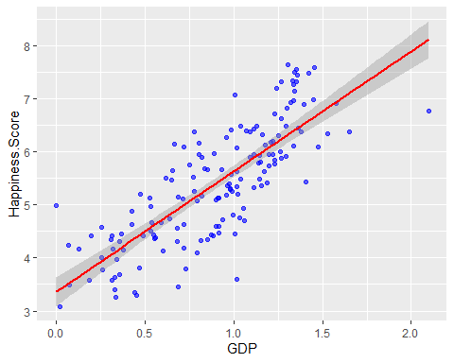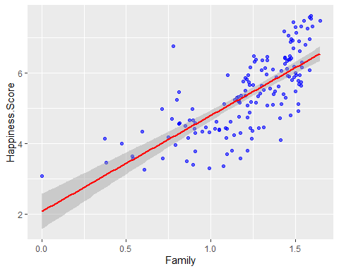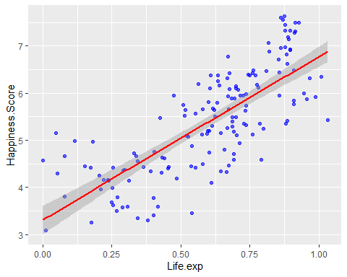

## Warning: Removed 1 rows containing non-finite values (stat_smooth).

## Warning: Removed 1 rows containing missing values (geom_point).

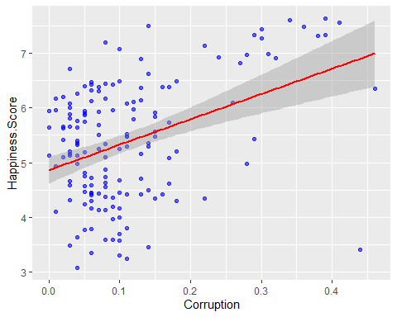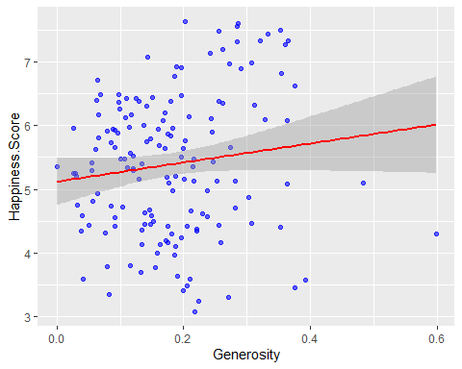 Each factor shows a tendency to be possitive correlated with the Happiness Score Worldwide in 2018. But which ones are significantly correlated?

##   
## Pearson's product-moment correlation  
##   
## data: data2018$Happiness.Score and data2018$GDP  
## t = 16.279, df = 153, p-value < 2.2e-16  
## alternative hypothesis: true correlation is not equal to 0  
## 95 percent confidence interval:  
## 0.7302477 0.8474983  
## sample estimates:  
## cor   
## 0.7962319

##   
## Pearson's product-moment correlation  
##   
## data: data2018$Happiness.Score and data2018$Family  
## t = 13.555, df = 153, p-value < 2.2e-16  
## alternative hypothesis: true correlation is not equal to 0  
## 95 percent confidence interval:  
## 0.6576076 0.8028341  
## sample estimates:  
## cor   
## 0.7386767

##   
## Pearson's product-moment correlation  
##   
## data: data2018$Happiness.Score and data2018$Freedom  
## t = 7.6929, df = 153, p-value = 1.641e-12  
## alternative hypothesis: true correlation is not equal to 0  
## 95 percent confidence interval:  
## 0.4041259 0.6330674  
## sample estimates:  
## cor   
## 0.5281273

##   
## Pearson's product-moment correlation  
##   
## data: data2018$Happiness.Score and data2018$Life.exp  
## t = 14.935, df = 153, p-value < 2.2e-16  
## alternative hypothesis: true correlation is not equal to 0  
## 95 percent confidence interval:  
## 0.6971647 0.8273604  
## sample estimates:  
## cor   
## 0.7701664

##   
## Pearson's product-moment correlation  
##   
## data: data2018$Happiness.Score and data2018$Corruption  
## t = 5.4796, df = 152, p-value = 1.731e-07  
## alternative hypothesis: true correlation is not equal to 0  
## 95 percent confidence interval:  
## 0.2650066 0.5302442  
## sample estimates:  
## cor   
## 0.4061443

##   
## Pearson's product-moment correlation  
##   
## data: data2018$Happiness.Score and data2018$Generosity  
## t = 1.6642, df = 153, p-value = 0.09813  
## alternative hypothesis: true correlation is not equal to 0  
## 95 percent confidence interval:  
## -0.02483293 0.28499484  
## sample estimates:  
## cor   
## 0.1333373

From all the analysis of the correlation test applied to each factor, all of them result as significantly correlated, but Generositym The p-value of the test is 0.098 which is greater than the significance level = 0.05. Is concluded that the percepcion of Generosity and the Happiness Score are not significantly correlatedwith a correlation coefficient of 0.13.

It is the same for the U.S?

##   
## Pearson's product-moment correlation  
##   
## data: us_2015.1$Happiness.Score and us_2015.1$GDP  
## t = 0.19797, df = 2, p-value = 0.8614  
## alternative hypothesis: true correlation is not equal to 0  
## 95 percent confidence interval:  
## -0.9488815 0.9704225  
## sample estimates:  
## cor   
## 0.1386329

##   
## Pearson's product-moment correlation  
##   
## data: us_2015.1$Happiness.Score and us_2015.1$Family  
## t = -2.1992, df = 2, p-value = 0.1589  
## alternative hypothesis: true correlation is not equal to 0  
## 95 percent confidence interval:  
## -0.9965808 0.6261394  
## sample estimates:  
## cor   
## -0.8411005

##   
## Pearson's product-moment correlation  
##   
## data: us_2015.1$Happiness.Score and us_2015.1$Freedom  
## t = -0.56561, df = 2, p-value = 0.6287  
## alternative hypothesis: true correlation is not equal to 0  
## 95 percent confidence interval:  
## -0.9819717 0.9170221  
## sample estimates:  
## cor   
## -0.3713491

##   
## Pearson's product-moment correlation  
##   
## data: us_2015.1$Happiness.Score and us_2015.1$Life.exp  
## t = 0.24995, df = 2, p-value = 0.826  
## alternative hypothesis: true correlation is not equal to 0  
## 95 percent confidence interval:  
## -0.9451379 0.9724653  
## sample estimates:  
## cor   
## 0.1740418

##   
## Pearson's product-moment correlation  
##   
## data: us_2015.1$Happiness.Score and us_2015.1$Corruption  
## t = 3.8823, df = 2, p-value = 0.0604  
## alternative hypothesis: true correlation is not equal to 0  
## 95 percent confidence interval:  
## -0.2216006 0.9987650  
## sample estimates:  
## cor   
## 0.9396002

##   
## Pearson's product-moment correlation  
##   
## data: us_2015.1$Happiness.Score and us_2015.1$Generosity  
## t = 2.958, df = 2, p-value = 0.09781  
## alternative hypothesis: true correlation is not equal to 0  
## 95 percent confidence interval:  
## -0.4430970 0.9979616  
## sample estimates:  
## cor   
## 0.9021935

The rsult sof these tests, indicates that my analysis is not significant, this can be related to the few values that I have just for the United States in the last 4 Years.

## Conclusion

from all the analysis presented, We as a country could turn our focus in the most significant factores that Affect Happiness World Wide, GDP, Life Expectancy and Family support or Social Support. Goverments are using these reports to increase actions on those factors to get a happier society, happy society, happy and better results