**DOKUZ EYLUL UNIVERSITY**

**ENGINEERING FACULTY**

**DEPARTMENT OF COMPUTER ENGINEERING**

**CME2204**

**ALGORITHM ANALYSIS**

**2019-2020 Spring**

**ASSIGNMENT – II**

**0-1 Knapsack and Fractional Knapsack Problem**

**by**

**Mehmet Hamdi Uslu 2400000145**

**28.05.2020**

# INTRODUCTION

In this assignment, we are expected to implement dynamic and greedy approach solution for a problem. Which is a car company that produces given amount of cars every month with investments, profits costs etc. Profits are from car sales and investments. Costs are from car production that can’t fulfill the demands and garage costs of those cars are production surplus. In 0/1 knapsack problem you can either take the whole object. whereas in Fractional Knapsack you can take some part of it.

To understand the problem: Your current employees can produce p=5 cars in a month, for the

three month (x=3), m[ ] = { 7, 3, 6 } and G(1) = 5, G(2)= 7, G(3)=10, G(4)=12, G(5)=13, etc...

and d=5 TL.

For the first month, your employees can produce 5 cars, however, the demand is 7. You can

hire interns with the cost of d*(7-5) TL.

For the second month, the demand is 3, will you produce 5 and keep 2 cars in the garage for

the next months for not paying intern costs? Or will you just produce 3 cars?

With these explanations we must create system that will take each limitations we are assigned to and maximize the profit. Which are:

int x = 30; // month

int p = 5; // produce rate

int d = 5; // intern fee

int B = 150; // cost of car

int t = 3; // tax rate

int c = 6; // number of investment companies

for example. After these variable assigned we need to read from txt documents we are presented that have demands , garage costs and company txts. Company txt has six individual companies system can use maximum.

# IMPLEMENTATIONS

## 

Firstly I started to read documents after initializing limiting variables with 3 functions. Which are

quite simple.

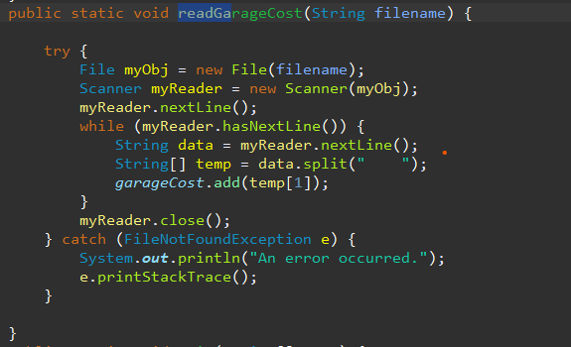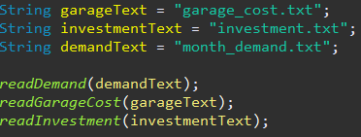

Reading demand is similar to reading garage cost but for reading investments I implemented an investment class. That can take max 6 and minimum 2 investment company and holds every month’s max investment rate on a variable and read accordingly.

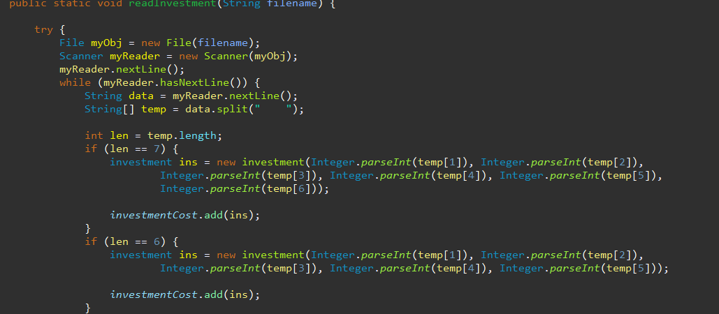

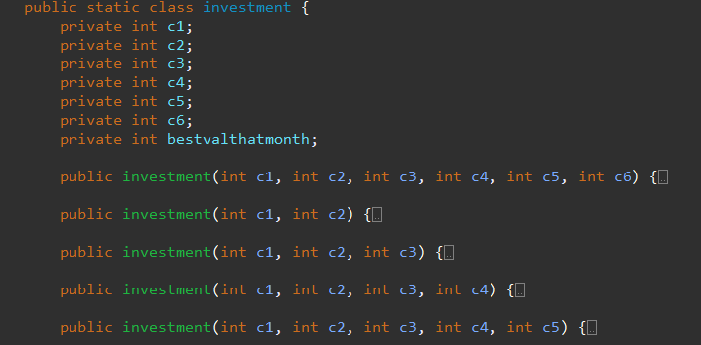

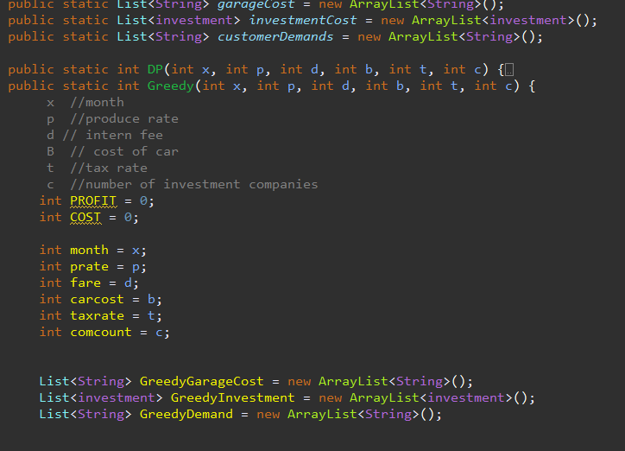Every txt read is then send to a global list to carried over to DP and Greedy functions likewise

After these implementations of greedy approach and dynamic approach main difference between these two approaches are greedy decides what is best in that moment without looking back or doing different work. On Dynamic we decide what is best with looking back to one step back and create a path to use for ourselves follow and solve whole question in one go and print outcomes.

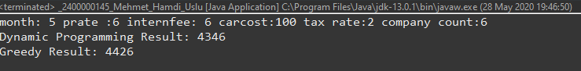

# CONCLUSION

In conclusion my homework is almost done yet it’s not complete in some test cases my results get wobble-y and sometimes over estimates profits but sometimes gets it %100 corretly. So I would rate my homework a failure yet I worked on it but I don’t count working half of the time success which is the reason. However, I believe I managed to learn a lot from it that I am happy to obtain those knowledge.