Fictional dashboard report
The dashboard shows weekly sign-ups.
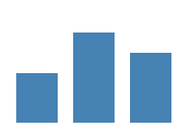
Figure 1 shows the trend.
A bullet icon:
Chart | 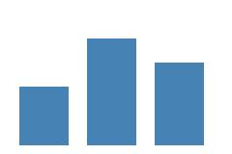
The end of the report.

