Appendix A：穩健性檢驗：OLS 與負二項迴歸模型比較
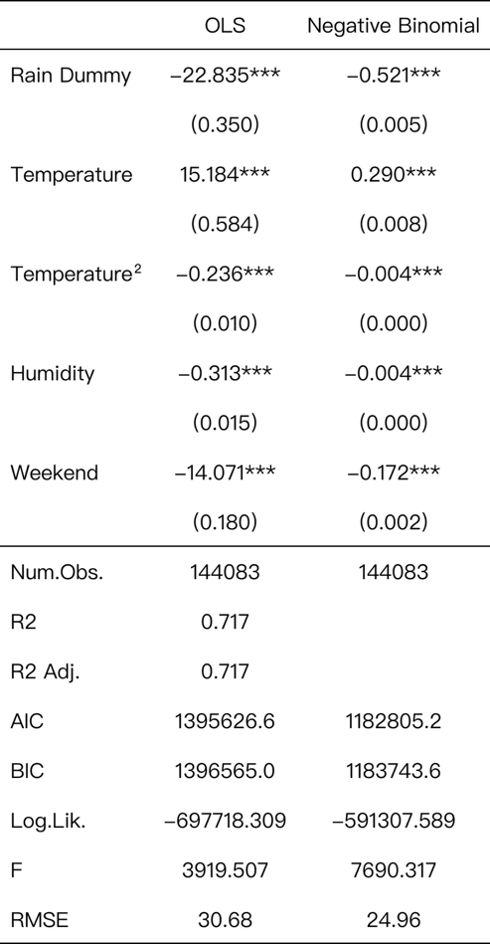
為檢驗研究結果是否受到模型設定方式影響，本研究進一步以適用於計數資料的 Negative Binomial Regression 重新估計模型。結果顯示，降雨、溫度、溫度平方項、濕度與週末效果之估計方向及統計顯著性均與 OLS 模型一致。其中，降雨仍為影響 YouBike 需求最重要的負向因素，而溫度則呈現倒 U 型關係。整體而言，主要研究發現不因模型選擇而改變，顯示本文結果具有良好的穩健性（robustness）。
表A1 OLS與負二項迴歸模型比較

Appendix B：騎乘距離分析與借還車分析
圖B1顯示捷運周邊 YouBike 騎乘距離呈現明顯右偏（right-skewed）分布，大部分騎乘集中於短距離區間。樣本騎乘距離中位數約為 0.73 公里，表示有一半以上的騎乘旅次距離不到 1 公里；此外，90% 的旅次距離低於 1.87 公里。雖然少數旅次可達 4 至 5 公里以上，但其比例相當有限。此結果顯示，本研究所識別之捷運周邊 YouBike 使用行為確實以短程移動為主，符合接駁運輸的特徵。換言之，多數使用者是利用 YouBike 完成捷運站與目的地之間的短距離移動，而非將 YouBike 作為長距離主要運輸工具。
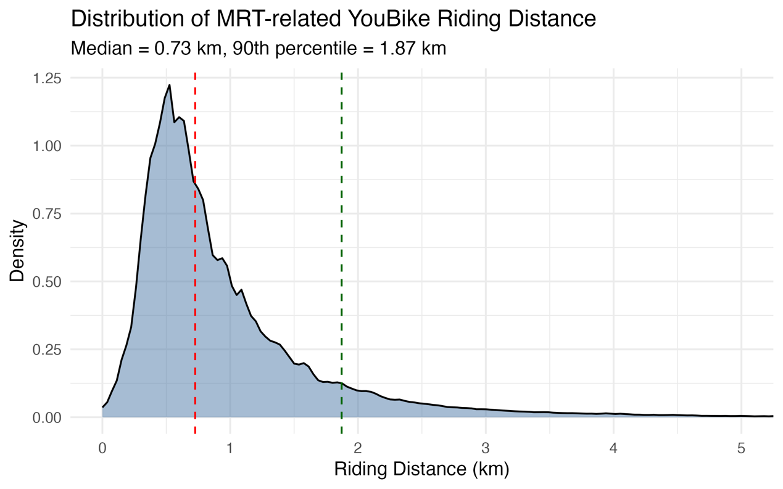
圖B 1 捷運周邊Youbike騎乘距離分布
圖 B2 比較各時段之借車（Borrow）與還車（Return）需求，兩者皆呈現明顯的雙峰型態。第一波高峰出現在上午 7–8 時，第二波高峰則出現在下午 17–18 時，與一般通勤族上下班時段高度一致。
此外，借車與還車曲線整體走勢相當接近，顯示捷運周邊 YouBike 系統大致維持供需平衡。然而，在晚間尖峰時段（18–21 時）借車需求略高於還車需求，而上午通勤時段（6–7 時）則觀察到還車需求略高於借車需求，反映部分站點可能具有單向通勤流動特徵。
整體而言，此圖進一步支持捷運周邊 YouBike 主要扮演通勤接駁工具的角色，其需求型態與都市居民的日常通勤作息高度一致。
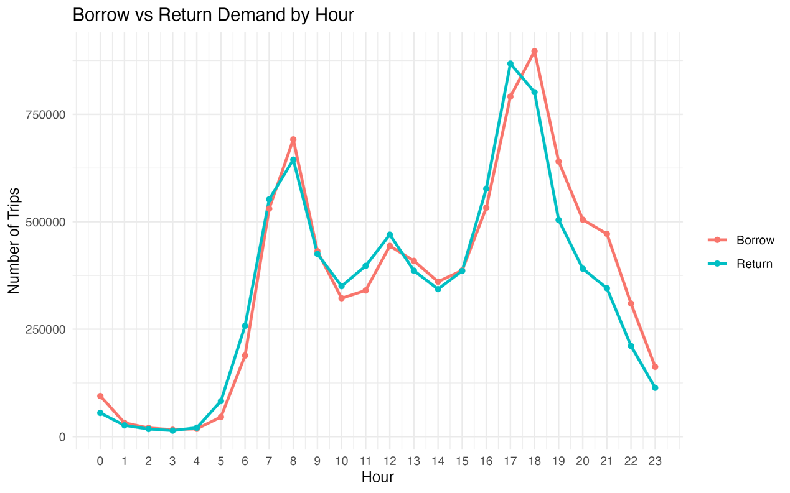
圖B 2 Youbike借還車需求之小時分布

Appendix C : R script
C.1 : Weather data

library(jsonlite)
library(dplyr)
library(sf)
library(stringr)
library(tidyr)
library(lubridate)
library(purrr)

#讀天氣資料
temp_files <- list.files(
"Data/weather/temp",
pattern = "AirTemperature-hour.csv",
full.names = TRUE
)

read_temp_file <- function(file_path) {
temp_raw <- read.csv(file_path)
file_name <- basename(file_path)
file_parts <- str_split(
file_name,
"-",
simplify = TRUE
)
station_id <- file_parts[1]
year_month <- paste0(
file_parts[2],
"-",
file_parts[3]
)
message(
"reading: ", file_name,
" | station_id = ", station_id,
" | year_month = ", year_month
)
temp_long <- temp_raw %>%
mutate(
across(
starts_with("X"),
as.character
),
日.時 = as.character(日.時),
day = str_extract(日.時, "\\d+"),
day = as.numeric(day)
) %>%
filter(
!is.na(day),
day >= 1,
day <= 31
) %>%
pivot_longer(
cols = starts_with("X"),
names_to = "hour",
values_to = "temperature"
) %>%
mutate(
hour = as.numeric(
gsub("X", "", hour)
),
date_str = paste0(
year_month,
"-",
sprintf("%02d", day)
),
date = suppressWarnings(
ymd(date_str)
),
temperature = str_trim(temperature),
temperature = case_when(
temperature %in% c(
"&",
"X",
"/",
"-",
"",
"NA"
) ~ NA_character_,
temperature == "T" ~ "0",
TRUE ~ temperature
),
temperature = as.numeric(temperature),
weather_station_id = station_id
) %>%
filter(!is.na(date)) %>%
select(
weather_station_id,
date,
hour,
temperature
)
return(temp_long)
}

temp_panel <- temp_files %>%
map_dfr(read_temp_file)
saveRDS(temp_panel, "Output/temp_panel.rds")

#讀雨量資料
rain_files <- list.files(
"Data/weather/rain",
pattern = "Precipitation-hour.csv",
full.names = TRUE
)

read_rain_file <- function(file_path) {
rain_raw <- read.csv(file_path)
file_name <- basename(file_path)
file_parts <- str_split(
file_name,
"-",
simplify = TRUE
)
station_id <- file_parts[1]
year_month <- paste0(
file_parts[2],
"-",
file_parts[3]
)
message(
"reading: ", file_name,
" | station_id = ", station_id,
" | year_month = ", year_month
)
rain_long <- rain_raw %>%
mutate(
across(
starts_with("X"),
as.character
),
日.時 = as.character(日.時),
day = str_extract(日.時, "\\d+"),
day = as.numeric(day)
) %>%
filter(
!is.na(day),
day >= 1,
day <= 31
) %>%
pivot_longer(
cols = starts_with("X"),
names_to = "hour",
values_to = "rain"
) %>%
mutate(
hour = as.numeric(
gsub("X", "", hour)
),
date_str = paste0(
year_month,
"-",
sprintf("%02d", day)
),
date = suppressWarnings(
ymd(date_str)
),
rain = str_trim(rain),
rain = case_when(
rain %in% c(
"&",
"X",
"/",
"-",
"",
"NA"
) ~ NA_character_,
rain == "T" ~ "0",
TRUE ~ rain
),
rain = as.numeric(rain),
weather_station_id = station_id
) %>%
# 去掉日期
filter(!is.na(date)) %>%
select(
weather_station_id,
date,
hour,
rain
)

return(rain_long)
}

library(purrr)

rain_panel <- rain_files %>%
map_dfr(read_rain_file)
saveRDS(rain_panel, "Output/rain_panel.rds")

#讀濕度資料
humidity_files <- list.files(
"Data/weather/humidity",
pattern = "RelativeHumidity-hour",
full.names = TRUE
)

read_humidity_file <- function(file_path) {
humidity_raw <- read.csv(file_path)
file_name <- basename(file_path)
file_parts <- str_split(
file_name,
"-",
simplify = TRUE
)
station_id <- file_parts[1]
year_month <- paste0(
file_parts[2],
"-",
file_parts[3]
)
message(
"reading: ", file_name,
" | station_id = ", station_id,
" | year_month = ", year_month
)
humidity_long <- humidity_raw %>%
mutate(
across(
starts_with("X"),
as.character
),
日.時 = as.character(日.時),
day = str_extract(日.時, "\\d+"),
day = as.numeric(day)
) %>%
filter(
!is.na(day),
day >= 1,
day <= 31
) %>%
pivot_longer(
cols = starts_with("X"),
names_to = "hour",
values_to = "humidity"
) %>%
mutate(
hour = as.numeric(
gsub("X", "", hour)
),
date_str = paste0(
year_month,
"-",
sprintf("%02d", day)
),
date = suppressWarnings(
ymd(date_str)
),
humidity = str_trim(humidity),
humidity = case_when(
humidity %in% c(
"&",
"X",
"/",
"-",
"",
"NA",
"..."
) ~ NA_character_,
TRUE ~ humidity
),
humidity = as.numeric(humidity),
weather_station_id = station_id
) %>%
filter(!is.na(date)) %>%
select(
weather_station_id,
date,
hour,
humidity
)
return(humidity_long)
}

humidity_panel <- humidity_files %>%
map_dfr(read_humidity_file)

saveRDS(humidity_panel, "Output/RelativeHumidity.rds")

C.2 : Data-cleaning

library(jsonlite)
library(dplyr)
library(sf)
library(stringr)
library(tidyr)
library(lubridate)
library(geosphere)

## cleaning pipeline
#1. 讀資料
#2. 建立 YouBike ↔ MRT 對照表
#3. 建立 YouBike ↔ 氣象站對照表
#4. 讀 6–9 月騎乘資料
#5. 篩 MRT-substitution trips
#6. aggregate 成 MRT × date × hour
#7. 讀天氣資料
#8. merge 天氣
#9. 輸出 final data

#捷運出入口資料
mrt <- read.csv("Data/MRT.csv", fileEncoding = "Big5")

#Youbike站點資料
url <- "https://tcgbusfs.blob.core.windows.net/dotapp/youbike/v2/youbike_immediate.json"
bike <- fromJSON(url)
bike_station <- bike %>% select(sno, sna, sarea, latitude, longitude)
head(bike_station)
bike_sf <- st_as_sf(
bike_station,
coords = c("longitude", "latitude"),
crs = 4326
)
bike_sf <- st_transform(bike_sf, 3826)

#配對200公尺內有Youbike站的捷運站
mrt_sf <- st_as_sf(mrt, coords = c("經度", "緯度"), crs = 4326) #WGS84 全球經緯度系統
mrt_sf <- st_transform(mrt_sf, 3826) #轉成：「台灣的公尺座標系」TM2
mrt_buffer <- st_buffer(mrt_sf, dist = 200)
nearby <- st_join(bike_sf, mrt_buffer, join = st_within)
mrt_bike_station <- nearby %>%
filter(!is.na(出入口名稱)) %>% distinct(sna) #選定在捷運站入口附近兩百公尺的站點
#mrt_bike_station <- mrt_bike_station %>%
# mutate(
# sna = gsub("YouBike2.0_", "", sna)
# )

#將youbike站配對到最近捷運站
mrt_bike_station_map <- nearby %>%
filter(!is.na(出入口名稱)) %>%
st_drop_geometry() %>%
mutate(
sna = gsub("YouBike2.0_", "", sna),
mrt_station = str_extract(出入口名稱, ".*?站")
) %>%
select(
sna,
mrt_station,
出入口名稱
) %>%
distinct()

#騎乘資料
trip_files <- list.files(
"Data/票證資料",
pattern = "YouBike2.0票證刷卡資料.csv",
full.names = TRUE
)

read_youbike_trip <- function(file_path) {
trip <- read.csv(
file_path,
header = FALSE
)
names(trip) <- c(
"start_time",
"start_station",
"end_time",
"end_station",
"duration",
"bike_type",
"date"
)
trip <- trip %>%
mutate(
start_station = trimws(start_station),
end_station = trimws(end_station),
start_time = ymd_hms(start_time),
date = as.Date(start_time),
hour = hour(start_time)
)
return(trip)
}

Youbike_all <- trip_files %>%
lapply(read_youbike_trip) %>%
bind_rows()

Youbike_all <- Youbike_all %>%
mutate(
start_station = trimws(start_station),
end_station = trimws(end_station)
) #讓站名字串統一

#篩選出符合騎乘起站以及終站都在捷運站附近的站點
Youbike_all <- Youbike_all %>%
mutate(
start_near_mrt = start_station %in% mrt_bike_station_map$sna
)

mrt_sub_Youbike_all <- Youbike_all %>%
filter(
(start_near_mrt) & (start_station != end_station)
)

#配對youbike到捷運站
nearest_mrt_idx <- st_nearest_feature(bike_sf, mrt_sf)
bike_mrt_map <- bike_sf %>%
mutate(
nearest_mrt_exit = mrt_sf$出入口名稱[nearest_mrt_idx],
sna = gsub("YouBike2.0_", "", sna),
mrt_station = str_extract(nearest_mrt_exit, ".*?站")
) %>%
st_drop_geometry() %>%
select(sna, mrt_station, nearest_mrt_exit) %>%
distinct(sna, .keep_all = TRUE)

# Borrow / Return 分開 + 騎乘距離
# 建立 YouBike 站點座標表
clean_station_name <- function(x) {
x %>%
str_replace("^YouBike2.0_", "") %>%
str_replace("_\\d+$", "") %>%
str_trim()
}

bike_coord <- bike_station %>%
mutate(
sna_clean = clean_station_name(sna)
) %>%
group_by(sna_clean) %>%
summarise(
latitude = first(latitude),
longitude = first(longitude),
.groups = "drop"
)

mrt_sub_Youbike_all <- mrt_sub_Youbike_all %>%
mutate(
start_station_clean = clean_station_name(start_station),
end_station_clean = clean_station_name(end_station)
)

# 加入起點與終點座標
mrt_sub_Youbike_all <- mrt_sub_Youbike_all %>%
left_join(
bike_coord %>%
rename(
start_lat = latitude,
start_lng = longitude
),
by = c("start_station_clean" = "sna_clean")
) %>%
left_join(
bike_coord %>%
rename(
end_lat = latitude,
end_lng = longitude
),
by = c("end_station_clean" = "sna_clean")
)

# 計算起訖站直線距離，單位為 km
mrt_sub_Youbike_all <- mrt_sub_Youbike_all %>%
mutate(
ride_distance_km =
distHaversine(
cbind(start_lng, start_lat),
cbind(end_lng, end_lat)
) / 1000,
)

mrt_sub_Youbike_all <- mrt_sub_Youbike_all %>%
left_join(
bike_mrt_map %>% select(sna, mrt_station),
by = c("start_station" = "sna")
)

# 3. 讀取氣象站清單
weather_sta <- read.csv(
"Data/weather_sta_list_2025-06-09.csv",
fileEncoding = "UTF-8"
)
weather_north <- weather_sta %>%
filter(
城市 %in% c("臺北市", "新北市"),
!is.na(經度),
!is.na(緯度),
撤站日期 == ""
)
weather_sf <- st_as_sf(
weather_north,
coords = c("經度", "緯度"),
crs = 4326
) %>%
st_transform(3826)
# 讀入已整理好的 weather panel

rain_panel <- readRDS("Output/rain_panel.rds")

temp_panel <- readRDS("Output/temp_panel.rds")

humidity_panel <- readRDS("Output/RelativeHumidity.rds")

# 1. rain 最近測站
rain_station_ids <- unique(rain_panel$weather_station_id)
weather_rain_sf <- weather_sf %>%
filter(站號 %in% rain_station_ids)
nearest_rain_idx <- st_nearest_feature(
bike_sf,
weather_rain_sf
)
bike_sf$nearest_rain_station <- weather_rain_sf$站名[nearest_rain_idx]
bike_sf$nearest_rain_id <- weather_rain_sf$站號[nearest_rain_idx]
# 2. temperature 最近測站
temp_station_ids <- unique(temp_panel$weather_station_id)
weather_temp_sf <- weather_sf %>%
filter(站號 %in% temp_station_ids)
nearest_temp_idx <- st_nearest_feature(
bike_sf,
weather_temp_sf
)
bike_sf$nearest_temp_station <- weather_temp_sf$站名[nearest_temp_idx]
bike_sf$nearest_temp_id <- weather_temp_sf$站號[nearest_temp_idx]

# 3. humidity 最近測站
humidity_station_ids <- unique(humidity_panel$weather_station_id)
weather_humidity_sf <- weather_sf %>%
filter(站號 %in% humidity_station_ids)
nearest_humidity_idx <- st_nearest_feature(
bike_sf,
weather_humidity_sf
)

bike_sf$nearest_humidity_station <- weather_humidity_sf$站名[nearest_humidity_idx]

bike_sf$nearest_humidity_id <- weather_humidity_sf$站號[nearest_humidity_idx]

# 建立 YouBike station ↔ weather station 對照表

bike_weather_map <- bike_sf %>%
st_drop_geometry() %>%
mutate(
sna = gsub("YouBike2.0_", "", sna)
) %>%
select(
sno,
sna,
sarea,
nearest_rain_station,
nearest_rain_id,
nearest_temp_station,
nearest_temp_id,
nearest_humidity_station,
nearest_humidity_id
)

mrt_sub_Youbike_all <- mrt_sub_Youbike_all %>%
left_join(
bike_weather_map %>%
select(
sna,
nearest_rain_station,
nearest_rain_id,
nearest_temp_station,
nearest_temp_id,
nearest_humidity_station,
nearest_humidity_id
),
by = c(
"start_station" = "sna"
)
)

mrt_hourly <- mrt_sub_Youbike_all %>%
filter(
hour %in% c(6:23)
) %>%
mutate(weekday = weekdays(date), weekend = ifelse(weekday %in% c("Saturday", "Sunday"), 1, 0)
) %>%
group_by(
mrt_station,
date,
hour
) %>%
summarise(
trip_count = n(),
weekday = first(weekday),
weekend = first(weekend),
nearest_rain_station = first(nearest_rain_station),
nearest_rain_id = first(nearest_rain_id),
nearest_temp_station = first(nearest_temp_station),
nearest_temp_id = first(nearest_temp_id),
nearest_humidity_station = first(nearest_humidity_station),
nearest_humidity_id = first(nearest_humidity_id),
.groups = "drop"
)

mrt_weather <- mrt_hourly %>%
left_join(
rain_panel,
by = c("nearest_rain_id" = "weather_station_id", "date", "hour"))

# merge temperature

mrt_weather <- mrt_weather %>%
left_join(
temp_panel,
by = c(
"nearest_temp_id" =
"weather_station_id",
"date",
"hour"
)

)

# merge humidity

mrt_weather <- mrt_weather %>%
left_join(
humidity_panel,
by = c(
"nearest_humidity_id" =
"weather_station_id",
"date",
"hour"
)
)

mrt_weather_clean <- mrt_weather %>% drop_na()

#建立一個rain_dummy
mrt_weather_clean <- mrt_weather_clean %>%
mutate(rain_dummy = ifelse(rain > 0, 1, 0))

#borrow
borrow_data <- Youbike_all %>%
mutate(
near_mrt = start_station %in% mrt_bike_station_map$sna,
hour = hour(start_time)
) %>%
filter(
near_mrt,
start_station != end_station
)
return_data <- Youbike_all %>%
mutate(
near_mrt = end_station %in% mrt_bike_station_map$sna,
hour = hour(start_time)
) %>%
filter(
near_mrt,
start_station != end_station
)
borrow_hourly <- borrow_data %>%
count(hour) %>%
rename(count = n) %>%
mutate(type = "Borrow")
return_hourly <- return_data %>%
count(hour) %>%
rename(count = n) %>%
mutate(type = "Return")
borrow_return_hourly <- bind_rows(
borrow_hourly,
return_hourly
)

saveRDS(mrt_weather_clean, "Output/mrt_weather_clean.rds")
saveRDS(borrow_return_hourly, "Output/borrow_return_hourly.rds")

C.3 : EDA
library(ggplot2)
library(dplyr)
library(tidyr)
library(scales)
library(gt)

mrt_weather_clean <- readRDS("Output/mrt_weather_clean.rds")
#1. trip_count
mrt_weather_clean %>% ggplot(aes(trip_count)) + geom_histogram()
mrt_weather_clean %>% ggplot(aes(x = log(trip_count+1))) + geom_histogram()

# 不同站點平均需求
station_mean <- mrt_weather_clean %>%
group_by(mrt_station) %>%
summarise(
avg_trip = mean(trip_count, na.rm = TRUE),
sd_trip = sd(trip_count, na.rm = TRUE),
n = n()
) %>%
arrange(desc(avg_trip))

f1 <-
station_mean %>%
slice_head(n = 20) %>%
ggplot(
aes(
x = reorder(mrt_station, avg_trip),
y = avg_trip
)
) +
geom_col() +
coord_flip() +
labs(
title = "Top 20 MRT Stations by Average YouBike Demand",
x = "MRT Station",
y = "Average Trip Count"
) +
theme_minimal(base_family = "PingFang TC")

ggsave(
"Figures/figure1.png",
plot = f1,
width = 8,
height = 5,
dpi = 300
)

# YouBike 使用量的日內變化
hourly_pattern <- mrt_weather_clean %>%
group_by(hour) %>%
summarise(
avg_trip = mean(trip_count, na.rm = TRUE)
)

f2 <-
hourly_pattern %>% ggplot(aes(x = hour, y = avg_trip))+
geom_line(size = 1) +
geom_point(size = 2) +
scale_x_continuous(breaks = 6:23) +
labs(
title = "Hourly Pattern of YouBike Usage",
x = "Hour of Day",
y = "Average Trip Count"
) + theme_minimal()
ggsave(
"Figures/figure2.png",
plot = f2,
width = 8,
height = 5,
dpi = 300
)

# 假日與平日的變化
hourly_weekend <- mrt_weather_clean %>% group_by(hour, weekend) %>%
summarise(avg_trip = mean(trip_count), .groups = 'drop')

f3 <-
hourly_weekend %>%
ggplot(aes(x = hour, y = avg_trip, color = factor(weekend))) +
geom_line(size = 1.2) +
scale_x_continuous(
breaks = 0:23
) +
labs(
title = "Hourly YouBike Demand",
x = "Hour",
y = "Average Trip Count",
color = "Weekend"
) + theme_minimal()
ggsave(
"Figures/figure3.png",
plot = f3,
width = 8,
height = 5,
dpi = 300
)

# 雨量
rain_hour <- mrt_weather_clean %>%
group_by(hour, rain_dummy) %>%
summarise(
avg_trip = mean(trip_count, na.rm = TRUE),
.groups = "drop"
)

rain_hour <- rain_hour %>%
mutate(
rain_label = ifelse(rain_dummy == 1, "Rain", "No Rain")
)

f4 <- rain_hour %>%
ggplot(aes(x = hour,y = avg_trip, color = rain_label, group = rain_label)) +
geom_line(linewidth = 1.2) +
geom_point() +
scale_x_continuous(breaks = 0:23) +
labs(
x = "Hour",
y = "Average Trip Count",
color = "Rain Condition",
title = "Hourly YouBike Demand by Rain Condition"
) +
theme_minimal() +
theme(
legend.position = "right"
)
ggsave(
"Figures/figure4.png",
plot = f4,
width = 8,
height = 5,
dpi = 300
)

#溫度
temp_pattern <- mrt_weather_clean %>%
group_by(temperature) %>%
summarise(avg_trip = mean(trip_count), .groups = "drop")

f5 <- temp_pattern %>% ggplot(aes(x = temperature, y = avg_trip)) +
geom_point(alpha = .5) +
geom_smooth()
ggsave(
"Figures/figure5.png",
plot = f5,
width = 8,
height = 5,
dpi = 300
)

#晴天與雨天的溫度差異
temp_rain <- mrt_weather_clean %>%
group_by(temperature, rain_dummy) %>%
summarise(
avg_trip = mean(trip_count),
.groups = "drop"
)

f6 <- temp_rain %>%
ggplot(aes(temperature, avg_trip, color = factor(rain_dummy,labels = c("No Rain", "Rain")
)
)
) +
geom_smooth(se = FALSE) +
labs(
color = "Weather Condition"
)

ggsave(
"Figures/figure6.png",
plot = f6,
width = 8,
height = 5,
dpi = 300
)

#濕度
humidity_pattern <- mrt_weather_clean %>%
group_by(humidity) %>%
summarise(
avg_trip = mean(trip_count)
)

f7 <- humidity_pattern %>%
ggplot(aes(x = humidity, y = avg_trip)) +
geom_point(
alpha = 0.5,
size = 2
) +
geom_smooth(
method = "loess",
se = TRUE,
linewidth = 1.2
) +
labs(
title = "Relationship Between Humidity and YouBike Demand",
x = "Humidity (%)",
y = "Average Trip Count"
) +
theme_minimal(base_family = "PingFang TC") +
theme(
plot.title = element_text(
hjust = 0.5,
face = "bold"
)
)
ggsave(
"Figures/figure7.png",
plot = f7,
width = 8,
height = 5,
dpi = 300
)

#
station_rain <- mrt_weather_clean %>%
group_by(mrt_station, rain_dummy) %>%
summarise(
avg_trip = mean(trip_count),
.groups = "drop"
) %>%
pivot_wider(
names_from = rain_dummy,
values_from = avg_trip
) %>%
mutate(
rain_effect = (`1`-`0`)/`0`
)

head(station_rain[order(station_rain$rain_effect),], 20)

t1 <- station_rain %>%
arrange(rain_effect) %>%
slice_head(n = 20) %>%
gt() %>%
cols_label(
mrt_station = "MRT Station",
`0` = "Mean Demand (No Rain)",
`1` = "Mean Demand (Rain)",
rain_effect = "Percentage Change"
) %>%
fmt_percent(
columns = rain_effect,
decimals = 1
)

gtsave(
t1,
"Tables/table1.png"
)

#borrow and return
readRDS("Output/borrow_return_hourly.rds")
library(ggplot2)

f10 <- ggplot(
borrow_return_hourly,
aes(
x = hour,
y = count,
color = type
)
) +
geom_line(size = 1) +
geom_point() +
scale_x_continuous(
breaks = 0:23
) +
labs(
title = "Borrow vs Return Demand by Hour",
x = "Hour",
y = "Number of Trips",
color = ""
) +
theme_minimal()
ggsave(
"Figures/figure10.png",
plot = f10,
width = 8,
height = 5,
dpi = 300
)

# 騎乘距離比例
distance_data <- mrt_sub_Youbike_all %>%
filter(!is.na(ride_distance_km))
f9 <- ggplot(
distance_data,
aes(x = ride_distance_km)
) +
geom_density(
fill = "#4E79A7",
alpha = .5
) +
geom_vline(
xintercept = 0.726,
color = "red",
linetype = 2
) +
geom_vline(
xintercept = 1.872,
color = "darkgreen",
linetype = 2
) +
coord_cartesian(xlim = c(0, 5)) +
labs(
title = "Distribution of MRT-related YouBike Riding Distance",
subtitle = "Median = 0.73 km, 90th percentile = 1.87 km",
x = "Riding Distance (km)",
y = "Density"
) +
theme_minimal(base_size = 14)
ggsave(
"Figures/figure9.png",
plot = f9,
width = 8,
height = 5,
dpi = 300
)

C.4 : Model

library(dplyr)
library(modelsummary)
library(performance)
library(broom)
library(ggplot2)
mrt_weather_clean <- readRDS("Output/mrt_weather_clean.rds")

#檢查相關問題
mrt_weather_clean %>%
select(rain_dummy,
temperature,
humidity,
weekend) %>%
cor(use = "complete.obs")

# Model0: Weather only
m0 <- lm(
trip_count ~
rain_dummy +
temperature +
I(temperature^2) +
humidity,
data = mrt_weather_clean
)
summary(m0)

# Model 1: Weather + Time
m1 <- lm(
trip_count ~
rain_dummy +
temperature +
I(temperature^2) +
humidity +
weekend +
factor(hour),
data = mrt_weather_clean
)
summary(m1)

# Model 2: Weekend × Hour
#檢查平日與假日的日內需求型態是否不同

m2 <- lm(
trip_count ~
rain_dummy +
temperature +
I(temperature^2) +
humidity +
weekend * factor(hour),
data = mrt_weather_clean
)
summary(m2)
# Model 3: Rain × Hour
# 檢查雨天效果是否因時段不同而異

m3 <- lm(
trip_count ~
rain_dummy * factor(hour) +
temperature +
I(temperature^2) +
humidity +
weekend,
data = mrt_weather_clean
)
summary(m3)

# Model 4: Full model with MRT station fixed effects
#控制不同捷運站本身的需求差異

m4 <- lm(
trip_count ~
rain_dummy +
temperature +
I(temperature^2) +
humidity +
weekend +
factor(hour) +
factor(mrt_station),
data = mrt_weather_clean
)
summary(m4)

# Model 5: Rain × Weekend
m5 <- lm(
trip_count ~
rain_dummy * weekend +
temperature +
I(temperature^2) +
humidity +
factor(hour) +
factor(mrt_station),
data = mrt_weather_clean
)
summary(m5)

# Model performance comparison
model_performance <- compare_performance(
m0, m1, m2, m3, m4, m5
)
model_performance

# 4. Export model comparison table
modelsummary(
list(
"M0" = m0,
"M1" = m1,
"M2" = m2,
"M3" = m3,
"M4" = m4,
"M5" = m5
),
coef_omit = "factor\\(hour\\)|factor\\(mrt_station\\)",
output = "Tables/regression.png"
)

#
station_fe <- tidy(m4) %>%
filter(grepl("factor\\(mrt_station\\)", term)) %>%
mutate(
station = gsub("factor\\(mrt_station\\)", "", term)
) %>%
select(station, estimate)

anova(m0, m1)
anova(m1, m2)
anova(m1, m3)
anova(m1, m4)

# Top 10
top10 <- station_fe %>%
arrange(desc(estimate)) %>%
slice(1:10)

# Bottom 10
bottom10 <- station_fe %>%
arrange(estimate) %>%
slice(1:10)

plot_station <- bind_rows(
top10,
bottom10
)

f8 <- ggplot(plot_station,
aes(x = reorder(station, estimate),
y = estimate)) +
geom_col() +
coord_flip() +
labs(
title = "Top and Bottom MRT Station Fixed Effects",
subtitle = "Controlling for weather and time factors",
x = NULL,
y = "Station Fixed Effect"
) +
theme_minimal(base_family = "PingFang TC")
ggsave("Figures/figure8.png", f8, width = 8, height = 5, dpi = 300)

C.4 : Appendix

## nb model
library(MASS)
mrt_weather_clean <- readRDS("Output/mrt_weather_clean.rds")

model_nb <- glm.nb(
trip_count ~ rain_dummy + temperature + I(temperature^2) +
humidity + weekend + factor(hour) + factor(mrt_station),
data = mrt_weather_clean
)
summary(model_nb)
modelsummary(
list(
"OLS" = m4,
"Negative Binomial" = model_nb
),
coef_omit = "factor\\(",
coef_map = c(
rain_dummy = "Rain Dummy",
temperature = "Temperature",
"I(temperature^2)" = "Temperature²",
humidity = "Humidity",
weekend = "Weekend"
),
estimate = "{estimate}{stars}",
statistic = "({std.error})",
stars = c('*' = .05, '**' = .01, '***' = .001),
output = "Appendix_Robustness.png"
)

