Admin Login Credentials for the Admin Panel :-

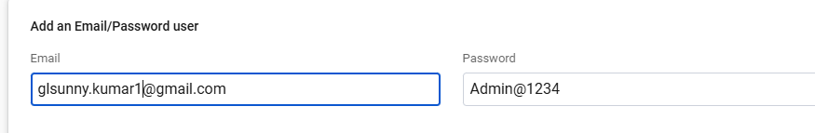

To Deploy the Website to the firebase we need two commands so that it can be directly pushed to firebase hosting where the go daddy Domain is Mapped .These command misses the assest pasted in the assest folder .

1. ng build --configuration production
2. firebase deploy