Setting up SFTP with your Code Editor:
VS Code:
1) Dedicate a folder somewhere on your computer for your C programs.
- This is the folder that will link all programs you save in that folder onto Thoth.
2) Install the extension: SFTP by liximomo
3) Enter the following: CTRL + SHIFT + P (Windows) or CMD + SHIFT + P (Mac)
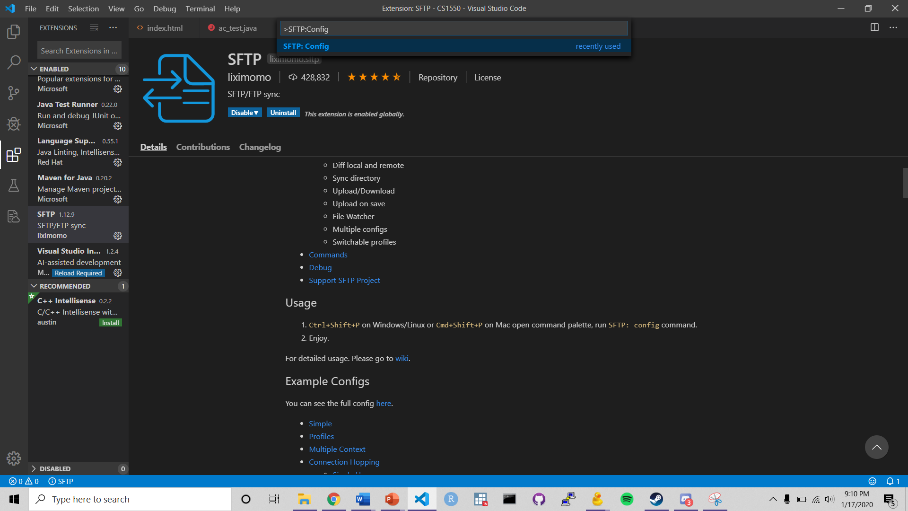
4) Run the SFTP: config command

5) You will be prompted to select a folder, use the same folder from Step 1.
6) You will be asked to create a config file, for your purposes please utilize the following code, and name the file sftp.json:
{
"name": "private",
"protocol": "sftp",
"host": "unixs.cssd.pitt.edu",
"port": 22,
"username": "gol6",
"remotePath": "/afs/pitt.edu/home/g/o/gol6/private/cs1550",
"connectTimeout": 10000,
"uploadOnSave": true,
"downloadOnOpen": true,
"syncMode": "full",
"algorithms": {
"kex": [
"ecdh-sha2-nistp256",
"ecdh-sha2-nistp384",
"ecdh-sha2-nistp521",
"diffie-hellman-group-exchange-sha256",
"diffie-hellman-group-exchange-sha1",
"diffie-hellman-group1-sha1",
"diffie-hellman-group14-sha1"
],
"cipher": [
"aes128-ctr",
"aes192-ctr",
"aes256-ctr",
"aes128-gcm",
"aes128-gcm@openssh.com",
"aes256-gcm",
"aes256-gcm@openssh.com",
"aes128-cbc",
"blowfish-cbc",
"3des-cbc"
],
"serverHostKey": [
"ssh-rsa",
"ecdsa-sha2-nistp256",
"ecdsa-sha2-nistp384",
"ecdsa-sha2-nistp521"
],
"hmac": [
"hmac-sha2-256",
"hmac-sha2-512",
"hmac-sha1"
]
}
}
Note: You will need to replace the username to your Pitt username
- You will also need to replace the remote_path to wherever you want to save your files onto thoth. (You can find the path using Cyberduck, or Filezilla)
- For example, this .json file will save into a subdirectory in private called cs1550
- Make sure the directory you want to save into exists!

8) You’re done. To test whether this worked, make a file Hello.c, and paste the following code in:
#include <stdio.h>
int main(){
printf(“Hello! I’ve linked my local files correctly onto Thoth!!!\n”);
return 0;
}
9) Once you save the file, you will be prompted to enter your password.
- Periodically, you will be prompted to enter your password.
- Once you do, the file should show up in Thoth.
10) Once the file is in the desired directory in Thoth, compile and run it!
11) If you get the following output, you’ve done it
Hello! I’ve linked my local files correctly onto Thoth!!!

Atom:
1) Install the package “remote-ftp”
- Install a package by navigating to Settings > Install > Search Packages

2) Now, let’s dedicate a folder to 449.
- Navigate to File > Add Project Folder and select your desired folder.

3) Now we need to configure the SFTP file.
- Navigate to Packages > Remote FTP > Create SFTP Config File

4) Now we need to modify the default .json file that it generated:
{
{
"protocol": "sftp",
"host": "thoth.cs.pitt.edu",
"port": 22,
"user": "gol6",
"pass": "pass",
"promptForPass": true,
"remote": "/afs/pitt.edu/home/g/o/gol6/private",
"local": "",
"agent": "",
"privatekey": "",
"passphrase": "",
"hosthash": "",
"ignorehost": true,
"connTimeout": 10000,
"keepalive": 10000,
"keyboardInteractive": false,
"keyboardInteractiveForPass": false,
"remoteCommand": "",
"remoteShell": "",
"watch": [],
"watchTimeout": 500
}
- You need to modify the user field to be your Pitt Username.
- You need to set the remote directory to be where you want to store your files.
- In order to get the directory where you want to store files:
a) Log onto thoth
b) pwd when you’re in the directory you want to store files in.
c) Copy that path, this is the path that you want to put into the remote field.
- Personally, I would recommend just doing /afs/pitt.edu/home/g/o/gol6, this way we can access all the files that are on thoth.

Most importantly, remember to save the file!

5) Now navigate to Packages > Remote FTP > Toggle

6) Then navigate to the Remote window, click Connect, and enter your password!


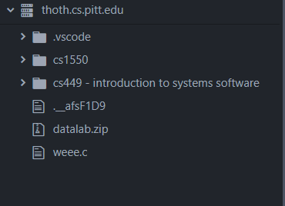
7) Once we’re in:

This will be different for you, but this lists all of the files that we can see from the designated remote path we entered for the remote field.
- We can access the files locally on our computer by simply navigating to where the file is located, opening the file on Atom, and editing it!
- Now, when we save the file, the changes will be reflected!

8) Now, we can add our local files to thoth as well!
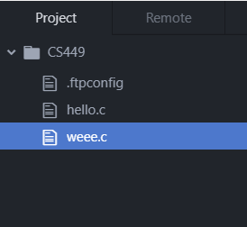

If we create a new file here, the moment we save it, it will appear right at the directory where we specified our remote path!!

9) We’re done, we did it!!

