This implementation this OO File System is meant to be run off of a console. I am using Eclipse’s console to do my testing. This is what the console should look like after you compile and run.

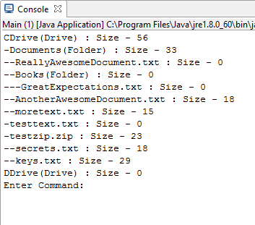

Every dash on the left signifies a level in the file hierarchy. For example, Books is in Documents which is in CDrive. Sizes of files are defined to the right.

Now on the console you should be able to run various commands that correspond to the functions defined in the spec. Here is the syntax for the commands on the console.

create [type](“drive”, “folder”, “text”, or “zip”) [name] [parentPath] [content](optional)

example: “create text MyAwesomeBook CDrive\Documents\Books\ thisIsTheContent”

delete [pathToBeDeleted]

example: “delete CDrive\Documents\Books”

move [sourcePath] [destinationPath]

example: :move CDrive\Documents DDrive\”

write [path] [content]

example: “write CDrive\testtext hereIsSomeContent”

print (This just prints out the file hierarchy)

The spec asks to show a sketch of implementation of the Move operation. Here is what the code looks like.

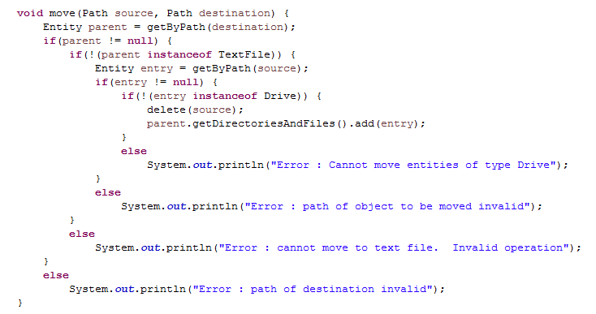

It simply obtains the future parent entity,

Obtains the child entry,

Deletes the previous occurrence of the child

Adds the child to the parent’s directories.

There are lots of checks here to make sure that illegal operations are not being performed. For example, if the child to be moved is a Drive, it is illegal to move it as the subdirectory of something else.

That’s the main idea! Most of the functionality is coded into the FileSystem class.

Thanks for your time and attention. I hope to hear back from you soon.

-Grant Lubeck