**RABID ASSAULT MECH**

**FOR UNITY3D DOCUMENTATION**

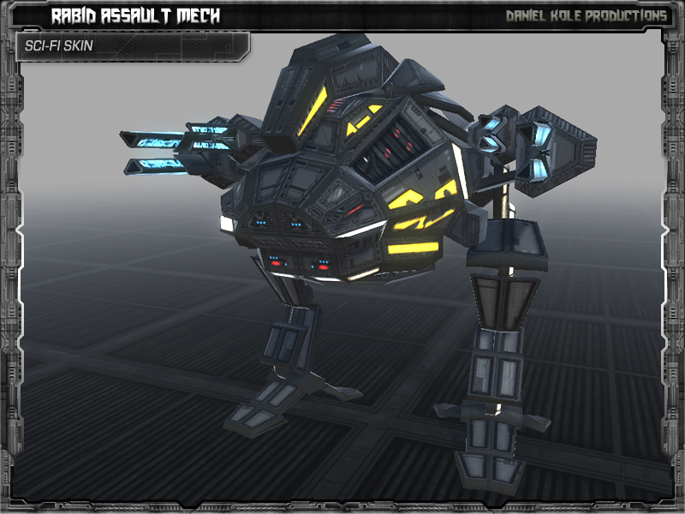

**RELEASE VERSION 1.0**

***CREATED BY: DANIEL KOLE***

*Copywrite 2014 - Daniel Kole Productions*

***Rabid Assault Mech - Overview:***

Requires Unity 5.1.2 or higher.

***Rabid Assault Mech***, is a 2-legged, assault mech. The model has the following animations: idle, strafe right, strafe left, walk forward, walk backward, turn right, turn left, attack, jump, hit from front, hit from back, die backward, and die forward. There are 5 full skins included: Sci-fi, Desert, Green Camo, Snow Camo, and Red Black. A simple movement/animation script is included.

***Rabid Assault Mech - Usage and Version History:***

***Usage and Installation:***

To use this package:

- Start a new project and import the Rabid Assault Mech Asset Package into the project.

- Open the ***AssaultMechDemo.unity*** scene located in the **RabidAssaultMech/Scenes** folder. This scene contains a Rabid Assault Mech generic prefab with instructions for moving the model. This is the demo setup scene.

***Version History:***

***Version 1.0 -***

**- First Release Version of Rabid Assault Mech.**

**- Includes a demo scene with a Rabid Assault Mech setup with scripts and ready to use.**