1.1 Introduction about the Lipid Bilayer

In general, biological components are “soft”, meaning that they are fluid-like (or viscoelastic),

have bond energies comparable to room temperature thermal energies, and exhibit diverse phases with long-range order. These properties result in interesting behaviors such as self-assembly, dynamic heterogeneity, and phase separation (or phase transitions). In this thesis, we would be focusing on lipid bilayers, a form of soft matter which exhibits all the above-mentioned properties.

The lipid bilayer is primarily composed of phospholipids, sterols, and an assortment of membrane proteins. They are the membranes that surround all cells and many sub-cellular structures. Their primary function is to isolate the interior of the cell from the exterior of the cell. As such, the lipid bilayer is impermeable to nearly all water-soluble molecules, despite it being only a few nanometers in width [1]. The membrane proteins present on the lipid bilayer serve to selectively transport ions and molecules across the bilayer. Additionally, they can also function as membrane receptors and relay signals between the cell’s internal and external environments. Since processes such as signal relaying and ion transport have to occur at specific sites in the cell, their execution is highly dependent on the dynamics of the surrounding lipid matrix and the very controversial concept of lipid rafts. Despite its importance in frequent biological processes, the dynamic behavior of the lipid bilayer is not well understood [1].

(1.1.2 Introduction about Cholesterol)

Cholesterol is molecule that has significant impact on the dynamics of the lipid bilayer. Studies have shown that regions in the lipid bilayer enriched with a higher concentration of cholesterol are associated with less fluidity than its surrounding regions [2,3,6]. Additionally, whilst medical researchers have acknowledged that abnormalities in the lipid bilayer is one of the pathological hallmarks of Alzheimer’s Disease [7], they are beginning to discover cholesterol’s significance in the pathways of this disease [5]. Thus, in order to better understand the heterogeneous dynamics of the lipid bilayer, it would pay dividends to understand the effects cholesterol has on the lipid bilayer. 

Cholesterol, whilst still a lipid, differs significantly from typical phospholipids. Cholesterol is composed of a rigid and flat hydrocarbon head group and flexible fatty acid tail. Within a lipid bilayer, cholesterol interrupts the interactions between neighboring phospholipids and thus inhibits crystallization [4?]. Additionally, the bulky and rigid head group of the molecule enhances the mechanical stability of the bilayer. In fact, the absence of cholesterol in primitive bacterial cell membranes is posited as the reason for the evolution of cell walls in plant cells.

Apart from influencing structure, the unique makeup of cholesterol also influences the dynamics and fluidity of the lipid bilayer. The bulky, planar, and polar hydrocarbon head of cholesterol inhibits the motion of the top part of the fatty acid chains. The reduces the fluidity of the intermediate portion of the bilayer. In contrast, the flexible tails of cholesterol molecules allow for more motion in the phospholipids, thus making that region, the central portion of the bilayer, more fluid.



1.2 Dynamic Heterogeneity in Lipid Bilayer

Dynamic Heterogeneity is a common phenomenon in a variety of soft condensed matter systems where intermolecular forces are strong relative to the effects of thermal energy, such as fluids approaching glass transitions [8]. “It is characterized by the distinction between mesoscopic regions of varying mobility and frequently occurs without any significant change in the overall structure of these systems [19]. Dynamical heterogeneity arises from the transient caging of individual molecules and particles within these systems, allowing domains of molecules and particles to display cooperative, rather than random motion, leading to mesoscopic clustering. The figure shows how single particle displacements of a two-dimensional system have segregated regions of either limited or enhanced mobility, consistent with dynamical heterogeneity [20].” (from kiley’s thesis)

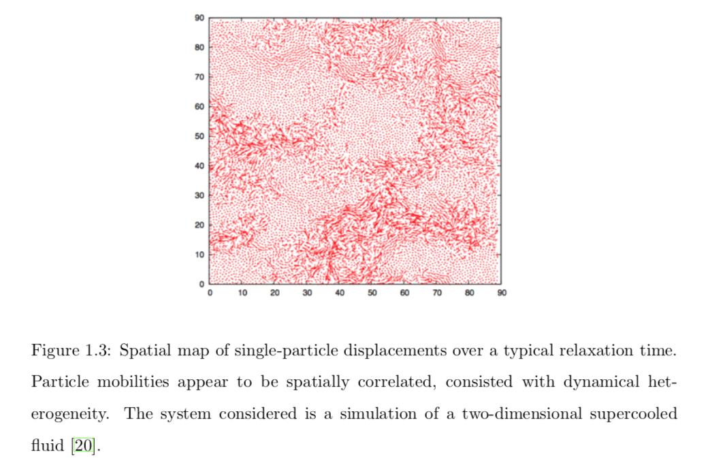

While glass-forming fluids and lipid bilayers are by no means identical systems, they both share the characteristically strong intermolecular forces.

This thesis is based on Neha’s.

1.3 Approach to Problem

1.4 Thesis Overview

No outline yet. I was told this was one of the last sections of the thesis to write along with the abstract.

This relationship has not gone unnoticed in the literature, as previous studies have mentioned qualitative similarities between the observations of dynamic heterogeneity between lipid membranes and glass forming fluids [12, 13]. While glass-forming fluids and lipid bilayers are clearly distinct systems, strong intermolecular interactions could lead to a similar tendency to cluster and move collectively. Simulation studies have lready stressed that a single lipid and its neighbors appear to move in loosely defined clusters which themselves are a manifestation of concerted motions of lipids at much longer time scales [12], much like glass-forming fluids.

As these qualitative similarities are acknowledged, we can take advantage of previ- ously un-utilized quantitative methods and the existing knowledge base in soft condensed- matter systems. Fortunately, the theoretical tools to quantify collective motion in glassy materials have long been established, and can now be put to use to further our under- standing of the intrinsic dynamic properties of lipid membranes. A previous study has demonstrated that such an approach is potentially productive [14]. That study was per- formed with a very simple coarse-grained model that represents a single lipid by three beads, with one head-bead and two tail-beads [15]. This thesis builds on that previous work by utilizing both the computational tools and theoretical ideas developed in the field of glassy materials and a more biologically representative lipid model.

Recent research on single-component lipid bilayers shows substantial evidence that lipid rafts may be a manifestation of dynamic heterogeneity [21, 22]. One research study, which this thesis closely builds on, showed how domains of lipid clusters arise naturally as a result of the inherent dynamics of bilayer systems—on the same size- and time-scales expected for lipid rafts [21, 22]. This dynamically heterogeneous clustering

Perhaps useful paragraphs:

Such behaviors are challenging to determine from the atomic or molecular composition of the biological system and often require a diverse set of analytical and experimental techniques. In tackling such problems, it is often useful to borrow concepts and ideas from soft matter physics which have been traditionally focused on polymers, gels, self-assembled surfactant structures, and many other complex fluids. Using such ideas, new perspectives on phenomena as diverse as DNA condensation, protein and peptide fibrillization, lipid partitioning in rafts, vesicle fusion and budding, and others can be obtained.

References:

1. Andersen, Olaf S.; Koeppe, II, Roger E. (June 2007). [*"Bilayer Thickness and Membrane Protein Function: An Energetic Perspective"*](http://www.annualreviews.org/doi/abs/10.1146/annurev.biophys.36.040306.132643). Annual Review of Biophysics and Biomolecular Structure. **36** (1): 107–130. [*doi*](https://en.wikipedia.org/wiki/Digital_object_identifier):[*10.1146/annurev.biophys.36.040306.132643*](https://doi.org/10.1146%2Fannurev.biophys.36.040306.132643)*. Retrieved 12 December 2014*.
2. <http://www.jlr.org/content/44/4/655.full>
3. <https://pubs.acs.org/doi/full/10.1021/la302620t>
4. <https://courses.washington.edu/conj/membrane/bilayer.htm>
5. <https://www.sciencedirect.com/science/article/pii/S0005273608002216> (alzeimer’s disease link to lipid bilayer and cholesterol)
6. K. Simons and D. Toomre, Nature Reviews. Molecular Cell Biology 1, 31 (2000).
7. <https://www.ncbi.nlm.nih.gov/pmc/articles/PMC3565322/>
8. R. Richert, Journal of Physics: Condensed Matter 14, R703 (2002).
9. J. P. Garrahan, Proceedings of the National Academy of Sciences 108, 4701 (2011).
10. K. Jacobson, O. G. Mouritsen, and R. G. W. Anderson, Nature Cell Biology 9, 7  (2007).