1.1.1 Lipid Bilayers and Membranes

Many biological components are “soft”, meaning that they are fluid-like (or viscoelastic),

have bond energies comparable to room temperature thermal energies, and exhibit diverse phases with long-range order. These properties result in interesting behaviors such as self-assembly, dynamic heterogeneity, and phase separation (or phase transitions). In this thesis, we would be focusing on lipid bilayers, a form of soft matter which exhibits all the above-mentioned properties.

The lipid bilayer is primarily composed of phospholipids, sterols, and an assortment of membrane proteins. They are the membranes that surround all cells and many sub-cellular structures. Their primary function is to isolate the interior of the cell from the exterior of the cell, and regulate the flow of material across the membrane. As such, the lipid bilayer is impermeable to nearly all water-soluble molecules, despite it being only a few nanometers in width [1]. The membrane proteins present on the lipid bilayer serve to selectively transport ions and molecules across the bilayer. Additionally, they can also function as membrane receptors and relay signals between the cell’s internal and external environments. Since processes such as signal relaying and ion transport have to occur at specific sites in the cell, their execution is highly dependent on the dynamics of the surrounding lipid matrix. Unfortunately, despite its importance in frequent biological processes, the dynamic behavior of the lipid bilayer is not well understood [1].

1.1.2 Introduction about Cholesterol

Cholesterol is one of the most abundant molecules in lipid layers and has a significant impact on the dynamics of the lipid bilayer. Studies have shown that regions in the lipid bilayer enriched with a higher concentration of cholesterol are associated with less fluidity than its surrounding regions [2-4]. Additionally, whilst medical researchers have acknowledged that abnormalities in the lipid bilayer is one of the pathological hallmarks of Alzheimer’s Disease [5], they are beginning to discover cholesterol’s significance in the pathways of this disease [6]. Thus, in order to better understand the heterogeneous dynamics of the lipid bilayer, it would pay dividends to understand the effects cholesterol has on the lipid bilayer. 

Cholesterol, itself also a lipid, differs significantly from typical phospholipids. Cholesterol is composed of a rigid and flat hydrocarbon head group and flexible fatty acid tail. Within a lipid bilayer, cholesterol interrupts the interactions between neighboring phospholipids and thus inhibits crystallization [do I need a ref?]. Additionally, the bulky and rigid head group of the molecule enhances the mechanical stability of the bilayer. In fact, the absence of cholesterol in primitive bacterial cell membranes is posited as the reason for the evolution of cell walls in plant cells.

Apart from influencing structure, the unique makeup of cholesterol also influences the dynamics and fluidity of the lipid bilayer. The bulky, planar, and polar hydrocarbon head of cholesterol inhibits the motion of the top part of the fatty acid chains. The reduces the fluidity of the intermediate portion of the bilayer. In contrast, the flexible tails of cholesterol molecules allow for more motion in the phospholipids, thus making that region, the central portion of the bilayer, more fluid.



1.2 Dynamic Heterogeneity in Lipid Bilayer

Dynamic Heterogeneity is a common phenomenon in a variety of soft condensed matter systems where intermolecular forces are strong relative to the effects of thermal energy, such as fluids approaching glass transitions [7]. “It is characterized by the distinction between mesoscopic regions of varying mobility and frequently occurs without any significant change in the overall structure of these systems [19]. Dynamical heterogeneity often arises from the transient caging of individual molecules and particles within these systems, allowing domains of molecules and particles to display cooperative, rather than random motion, leading to mesoscopic clustering. The figure shows how single particle displacements of a two-dimensional system have segregated regions of either limited or enhanced mobility, consistent with dynamical heterogeneity [20].” (from kiley’s thesis)

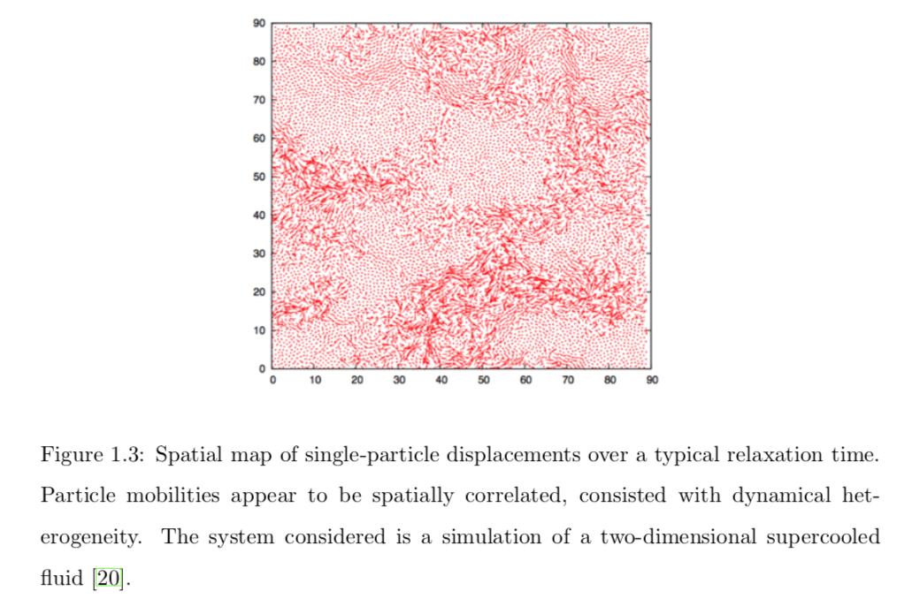

While glass-forming fluids and lipid bilayers are by no means identical systems, they both share the characteristically strong intermolecular forces.

Random Links:

1. <https://courses.washington.edu/conj/membrane/bilayer.htm>
2. J. P. Garrahan, Proceedings of the National Academy of Sciences 108, 4701 (2011).
3. K. Jacobson, O. G. Mouritsen, and R. G. W. Anderson, Nature Cell Biology 9, 7  (2007).
4. <https://www.ncbi.nlm.nih.gov/books/NBK26871/> (thefigures)

References:

1. Andersen, O.S. and R.E. Koeppe, *Bilayer thickness and membrane protein function: an energetic perspective.* Annual review of biophysics and biomolecular structure, 2007. **36**: p. 107.

2. Pike, L.J., *Lipid rafts: bringing order to chaos.* Journal of lipid research, 2003. **44**(4): p. 655.

3. Redondo-Morata, L., M.I. Giannotti, and F. Sanz, *Influence of cholesterol on the phase transition of lipid bilayers: a temperature-controlled force spectroscopy study.* Langmuir : the ACS journal of surfaces and colloids, 2012. **28**(35): p. 12851.

4. Simons, K. and D. Toomre, *Lipid rafts and signal transduction.* Nature Reviews Molecular Cell Biology, 2000. **1**(1): p. 31.

5. Kosicek, M. and S. Hecimovic, *Phospholipids and Alzheimer’s Disease: Alterations, Mechanisms and Potential Biomarkers*, in *Int. J. Mol. Sci.* 2013. p. 1310-1322.

6. Errico, G., et al., *Interaction between Alzheimer’s Aβ(25–35) peptide and phospholipid bilayers: The role of cholesterol.* BBA - Biomembranes, 2008. **1778**(12): p. 2710-2716.

7. Ranko, R., *Heterogeneous dynamics in liquids: fluctuations in space and time*. 2002. p. R703-R738.