Chemical Geology – Exam 3

George Lu

I chose to do Exercise 3: H2O-CO2 geobarometry and degassing calculations.

**1. Instructions for use**

*1.a. Running the program (same program for either calculation)*

1. Make sure python version 3.8.1 or later is installed.
2. Ensure that the following libraries are installed: ﻿numpy, scipy, matplotlib
3. To run the program, open a terminal window and type: python h2o_co2_calc.py
4. The program will prompt which kind of calculation you would like to perform. For calculating the equilibrium pressure (Part 1), type 0 and press enter. For calculating water and carbon dioxide solubilities (Part 2), type 1 and press enter.

*1.b. Part 1: Calculate the equilibrium pressure*

1. You will be prompted to enter the compositions one at a time, by wt. The exception is with CO2, which is in ppm.
2. You will be also prompted to enter temperature, in Celsius.
3. After entering everything and pressing the enter key, the program will return the equilibrium pressure, in bar.
4. To run again, re-enter python h2o_co2_calc.py.
5. It should be noted that the equations used in the solution are rearranged such that the left-hand side is zero. This is just to better fit to the format required for the solver. This also applies to the compositions function.

*1.c. Part 1 example with screenshots*

We will try to recreate the same equilibrium pressure as the default values from <https://calcul-isto.cnrs-orleans.fr/apps/thermodynamics/#/home>, the site based off of the same Iacono-Marziano et al., (2012) paper that my script is also based off of. Note that their a, b, B and C coefficients for H2O are different than the paper’s (and therefore different than mine). Here is their calculation:

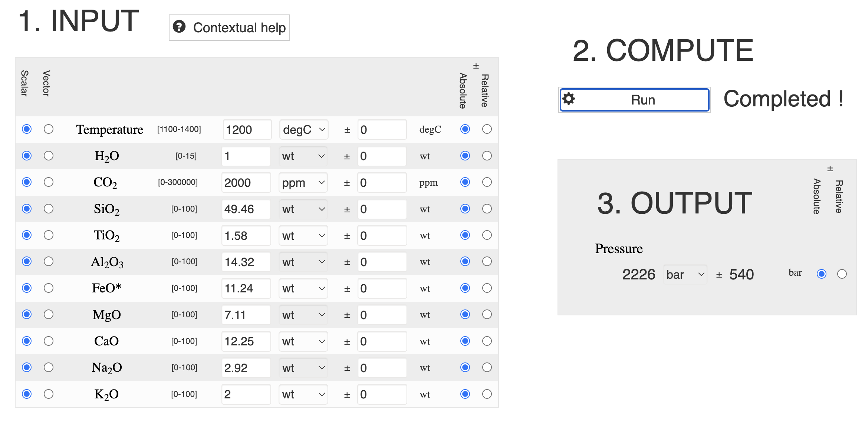

Now, let us enter the relevant values into my script, and see if our calculated result lies near theirs:

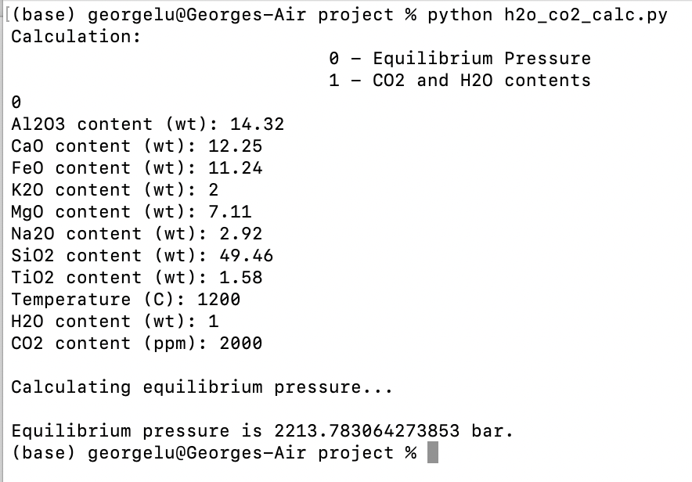

From the terminal window screenshot, you can see that my calculated 2214 bar equilibrium pressure is very close to their 2226 bar, and well within their error range.

*1.d. Part 2: Calculate the H2O and CO2 content from initial pressure to 0.1MPa (1 bar)*

1. You will be prompted to enter the compositions one at a time, by wt.
2. You will also be prompted to enter the initial pressure (in bar), the temperature (in Celsius), and the ﻿carbon dioxide gas mole fraction.
3. After entering everything, the program will return a plot showing the calculated H2O and CO2 contents ranging from the specified pressure down to 1 bar. Note that the calculation has trouble working with very small pressures, so the pressures around 1 bar and less may not be accurate.

*1.e. Part 2 example with screenshots*

Again, this is compared with the default example from the web-app, screenshot below:

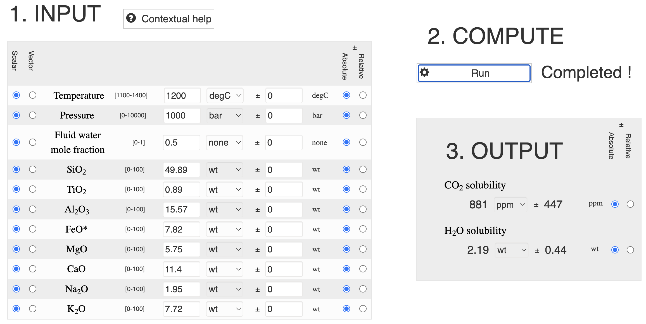

Now this only calculates it with a single pressure, not a range like my script, so we will just use this pressure as an initial pressure in our calculations, and see if that aligns with their output. The screenshot from my script is below:

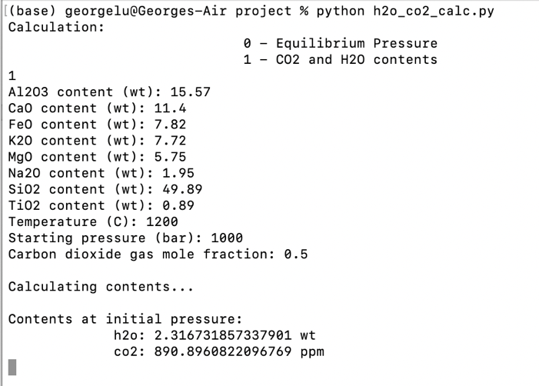

Note that my code uses the CO2 mole fraction (because later on, we see in their Mt. Etna data tables, that’s what they provide). Regardless, my results are quite similar to theirs, and again within their error ranges. Furthermore, my script outputs the plot below, which shows the evolution of solubilities as the pressure decreases down to 0.1 MPa (1 bar). Note that this plot changes a bit in formatting depending on what shell is running the script.

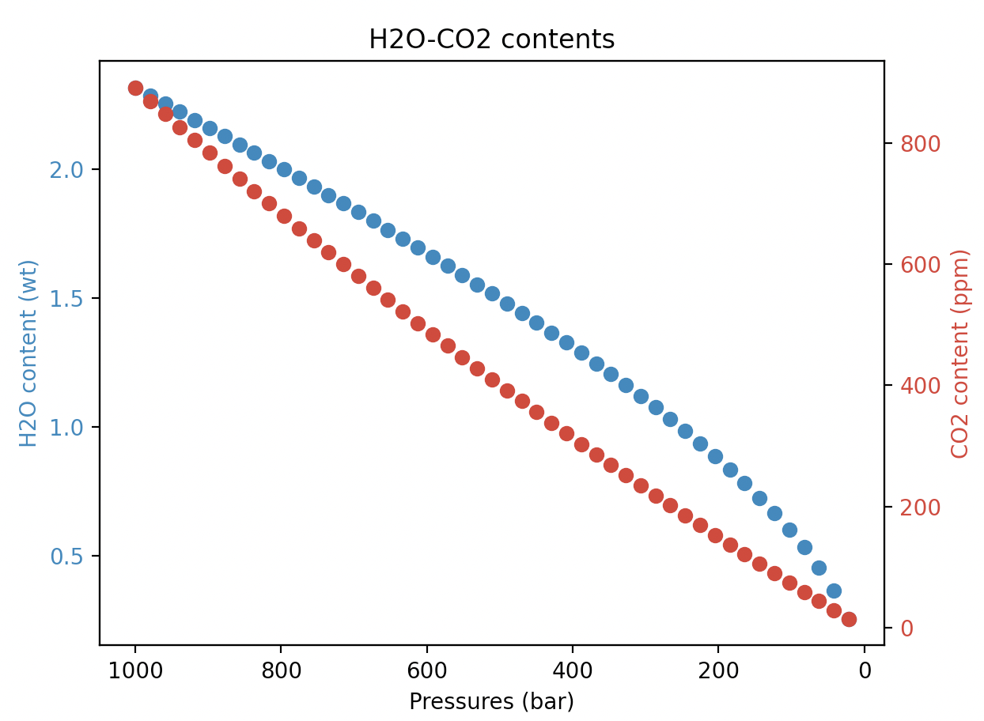

**2. Evaluating the program with real data from literature**

To evaluate the program, I had some test scripts (commented out in final script – lines 214 onwards). These scripts copied over all the experiment conditions and results for the H2O-CO2 experiments with Mt. Etna basalt from Tables 1 and 2 in Iacono-Marziano et al., (2012). This includes the set equilibrium pressures and the measured compositions. We then compare our calculated results with their settings/results to determine if our script works.

*2.a. Evaluating equilibrium pressure calculations*

To test the equilibrium pressure, I put in the measured compositions into my script to see if I can get the same pressures as the pressures used for each experiment. Then I compare my calculated pressures with their experimental pressures. If my calculations are correct, then it should be a perfect 1 to 1 fit with their experiments. Figure 1 on the next page shows the relation, and we can see that the fit is quite well, especially for the lower pressures. The blue line represents the 1 to 1 fit.

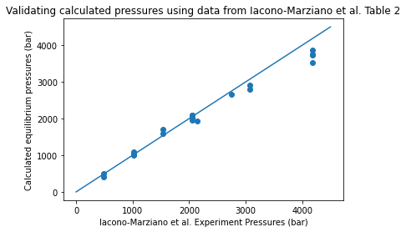

Figure 1: Comparing my program pressures with those in the experiments of in Iacono-Marziano et al., (2012)

*2.b. Evaluating H2O-CO2 composition calculations*

For the compositions/solubilities, we do the same thing as with the equilibrium pressures, except we put in the pressures and the mole fractions from the experiments, and see if we get the same compositions. These are shown in Figures 2 (CO2 content) and 3 (H2O content). These also have a general linear relationship except for 2 outlier points. Upon closer inspection, these were experiments where there was no H2O added, so the CO2 mole fractions were 0.94 and 0.93. I believe that this very small amount of water caused some inaccuracies in my solver which propagated into a large underestimate in CO2 solubility and an overestimate in H2O solubility.

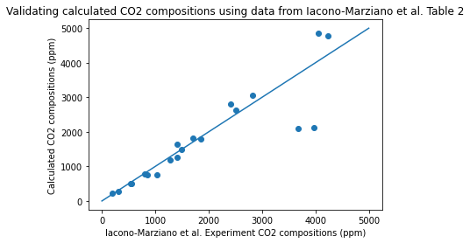

Figure 2: Comparing my program CO2 compositions with those in the experiments of in Iacono-Marziano et al., (2012)

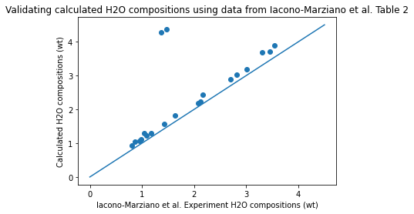

Figure 3: Comparing my program H2O compositions with those in the experiments of in Iacono-Marziano et al., (2012)

**3. Comments/Future work**

Overall, from the example scripts and from comparing results with real world data from Mt. Etna basalts, we can see that this method can generally follow the correct trends for H2O-CO2 solubilities and equilibrium pressures. However, we do see some limitations: in the boundaries of low H2O starting conditions, the solver does not perform well. This could be due to the initial guess of the solver being too far from the solution, so the solution diverges. Consequently, to improve this script, one would need to explore the boundaries of this solver further to identify within what ranges it can accurately reflect the system. Then, some guardrails can be put in place to make sure that users only put in values within the reasonable ranges. Furthermore, due to uncertainties in how error was incorporated/propagated in the model described in the paper and time limitations, error bars were not included in this script. This would be another important next step to add in to better the rigor of our calculations.

**4. References**

Iacono-Marziano, G., Morizet, Y., Le Trong, E., Gaillard, F., 2012. New experimental data and semi-empirical parameterization of H2O–CO2 solubility in mafic melts. Geochimica et Cosmochimica Acta 97, 1–23. https://doi.org/10.1016/j.gca.2012.08.035