**PROGRAM-5**

### 5a) Write a Python program to demonstrate how to draw a Histogram using Matplotlib

# import the necessary libraries # Pandas library for data frames import pandas as pd

# numpy library to do numerical operations import numpy as np

import matplotlib.pyplot as plt cars_data = pd.read_csv("cars.csv")

plt.title('Histogram for distance travelled in KiloMeter') plt.hist(cars_data ['KM'], color='green', edgecolor='white', bins=5) plt.xlabel('Kilometer')

plt.ylabel('Frequency') plt.show()

## OUTPUT:

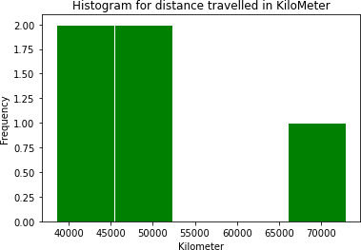



### 5b) Write a Python program to demonstrate how to draw a Pie chart using Matplotlib

# Import libraries

import matplotlib.pyplot as plt import pandas as pd

# Creating dataset

cars_data = pd.read_csv("Cars_Barplot.csv") cars = cars_data["Car"]

data = cars_data["Sales"] # Creating plot

fig = plt.figure(figsize =(10, 7)) plt.pie(data, labels = cars)

# show plot plt.show()

## OUTPUT:

