SARGUN SINGH - FreeRADIUS server with MySQL Database guide

Phase 1: VM Creation (Performed on GCP)

1. Create a VM
gcloud compute instances create freeradius-server \
--machine-type=n1-standard-4 \
--zone=us-central1-a \
--boot-disk-size=20GB \
--image-family=ubuntu-2004-lts \
--image-project=ubuntu-os-cloud \
--scopes=https://www.googleapis.com/auth/cloud-platform \
--tags=http-server,https-server,radius-server

2. Allow SSH Traffic (if not already allowed)
gcloud compute firewall-rules create allow-ssh --allow=tcp:22 –source-ranges=0.0.0.0/0

3. Allow RADIUS Traffic
gcloud compute firewall-rules create allow-radius --allow=udp:1812,udp:1813 –target-tags=radius-server

Phase 2: VM Initialization

1. Install necessary modules:
brew install mysql
brew install freeradius-server
brew install freeradius-server-mysql

2. Secure the MySQL Installation as per requirements:
sudo mysql_secure_installation

3. Start the sql Service, FreeRADIUS and enable necessary modules
brew services start mysql
sudo radiusd -X
sudo ln -s /usr/local/etc/freeradius-server/mods-available/sql /usr/local/etc/freeradius-server/mods-enabled/sql

4. Configure the Default Authentication Method:
sudo nano /etc/freeradius/3.0/sites-enabled/default

Phase 3:Creating and configuring the user

1. Log in to the MySQL Server and update the root password

mysql> sudo mysql -u root -p

mysql> ALTER USER 'root'@'localhost' IDENTIFIED WITH mysql_native_password BY 'password';

mysql> FLUSH PRIVILEGES;

2. Create a new user (sargun) in this case and grant privelages

mysql> CREATE USER 'sargun'@'localhost' IDENTIFIED BY 'Free@Radius789';

mysql> GRANT ALL PRIVILEGES ON radiusdb.* TO 'sargun'@'localhost';

mysql> FLUSH PRIVILEGES;

mysql> EXIT;
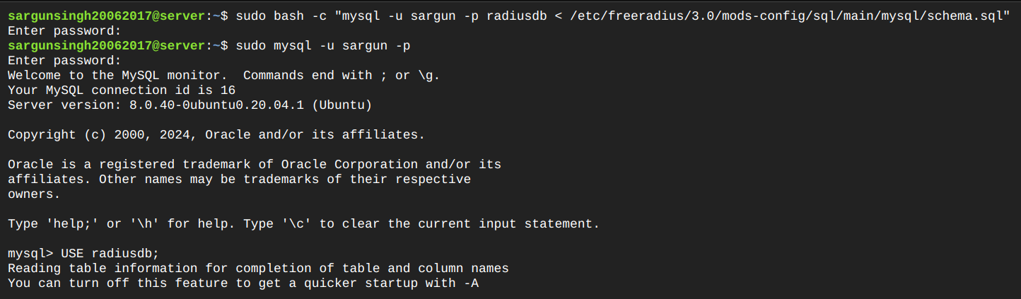

Phase 4: Using a default schema and updating the table

1. Importing the schema:
sudo bash -c "mysql -u sargun -p radiusdb </usr/local/etc/freeradius-server/mods-config/sql/main/mysql/schema.sql"

2. Login as the user
sudo mysql -u sargun -p

3. Inserting Values:

mysql> INSERT INTO radcheck (UserName, Attribute, op, Value) VALUES ('testuser', 'User- Password', ':=', 'testing123');

mysql> INSERT INTO radcheck (UserName, Attribute, op, Value) VALUES ('sargun', 'User- Password', ':=', 'securePass123');

mysql> INSERT INTO radcheck (UserName, Attribute, op, Value) VALUES ('testuser2', 'User- Password', ':=', 'anotherPassword');

mysql> SELECT * FROM radcheck;

mysql> EXIT;
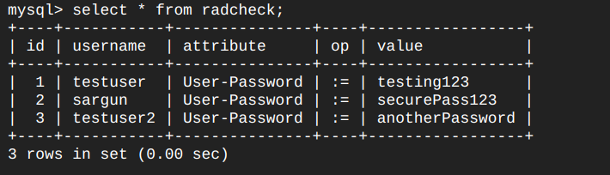

Phase 5: Modiying files for running a simple FreeRADIUS server

File 1: /usr/local/etc/freeradius-server/mods-available/sql:

1. Driver Changed:
  - Original: driver = "rlm_sql_null" (or potentially rlm_sql_sqlite)
  - Changed to: driver = "rlm_sql_mysql"
  - Purpose: To enable the MySQL driver for database interaction.

2. Dialect changed:
  - Original: dialect = "sqlite"
  - Changed to : dialect = "mysql"

3.TLS Configuration Removed:
  - Original: A tls block was present within the mysql section
  - Changed to: The entire tls block was removed or commented out.
  - Purpose: To disable TLS for the MySQL connection, as it wasn't necessary for a basic setup

4.MySQL Connection Details:
server = "localhost"
port = 3306
login = "sargun"
password = "Free@Radius789"
radius_db = "radiusdb"

5. Set read_clients property equal to yes
read_clients = yes

File 2: /usr/local/etc/freeradius-server/sites-enabled/default

authorize Section Module
Original: -sql
Changed to: sql

File 3: /usr/local/etc/freeradius-server/clients.conf
Shared Secret:
  - Changed to: secret = testing123
  - Purpose: To set a shared secret for the localhost client, matching the secret used in the radtest command.

Phase 6: Testing the FreeRadius server with different users but same keys in files

1. Start the server
sudo systemctl start freeradius

2. Run the radtest command
radtest <username> <password> <server-ip> <port> <shared-secret>

- <username> : The username for testing
- <password> : The password for the user
- <server-ip> : The RADIUS server is running locally
- <port> : The default RADIUS authentication port.
- <shared-secret> : The shared secret between the RADIUS client (radtest) and the server

3. Testing Cases
Case 1: radtest testuser testing123 127.0.0.1 1812 testing123

Case 2: radtest testuser2 anotherPassword 127.0.0.1 1812 testing123

Case 3: radtest sargun securePass123 127.0.0.1 1812 testing123

Case 1 & 2 Output

Case 1: Sent Access-Request Id 153 from 0.0.0.0:40057 to 127.0.0.1:1812 length 78
User-Name = "testuser"
User-Password = "testing123"
NAS-IP-Address = 10.128.0.5
NAS-Port = 1812
Cleartext-Password = "testing123"
Received Access-Reject Id 153 from 127.0.0.1:1812 to 127.0.0.1:40057 length 38
Message-Authenticator = 0x7bc698590bbc6c7aad73032d669a71d0
(0) -: Expected Access-Accept got Access-Reject

Case 2: Sent Access-Request Id 47 from 0.0.0.0:33643 to 127.0.0.1:1812 length 79
User-Name = "testuser2"
User-Password = "anotherPassword"
NAS-IP-Address = 10.128.0.5
NAS-Port = 1812
Cleartext-Password = "anotherPassword"
Received Access-Reject Id 47 from 127.0.0.1:1812 to 127.0.0.1:33643 length 38
Message-Authenticator = 0xfca6fa2a6bccd67f052f80ec1f19705a
(0) -: Expected Access-Accept got Access-Reject

Why It Happens
- The RADIUS server is configured for sargun, and the database credentials are set for this user (login = "sargun", password = "Free@Radius789").
- The shared secret testing123 configured in /etc/freeradius/3.0/clients.conf is only valid for requests that come from a client identified as sargun.
  - When a request from testuser arrives, the server cannot authenticate it because testuser isn't configured in the RADIUS database.
  - No match = Access-Reject: The server replies with an Access-Reject message.
Technical Aspect
- When a request is sent by radtest for testuser, the server attempts to authenticate by checking the radcheck table in the MySQL database. If it doesn’t find a matching entry for testuser (or the password doesn't match), it sends an Access-Reject.
- The RADIUS server uses the shared secret (testing123) to verify that the request is coming from a trusted source. If the client’s shared secret does not match what's in clients.conf, the server rejects the request regardless of user credentials.

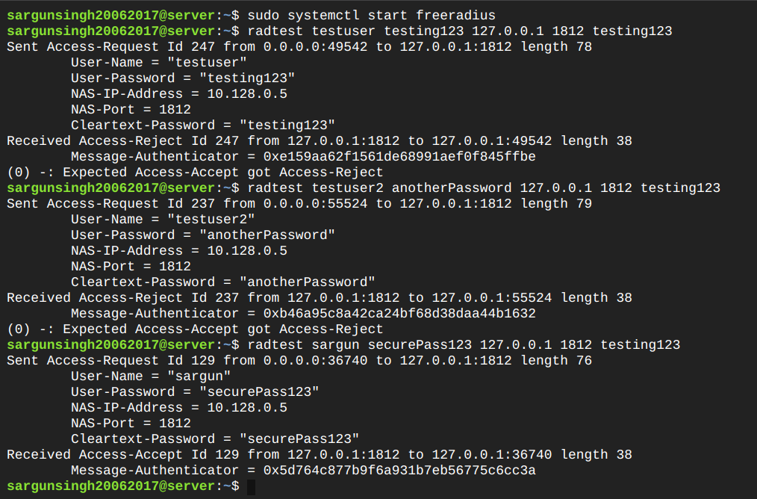
Case 3 Output
Sent Access-Request Id 208 from 0.0.0.0:44884 to 127.0.0.1:1812 length 76
User-Name = "sargun"
User-Password = "securePass123"
NAS-IP-Address = 10.128.0.5
NAS-Port = 1812
Cleartext-Password = "securePass123"
Received Access-Accept Id 208 from 127.0.0.1:1812 to 127.0.0.1:44884 length 38
Message-Authenticator = 0x5aba46d7f3768943ea011127e5a58b70

Why It Happens:
- The RADIUS server is specifically configured for sargun. The database entry for sargun exists in radcheck, and the password (securePass123) matches the stored value.
- The shared secret testing123 is correct for the server-client authentication, so the server recognizes the request as valid.
- Successful Authentication: Because the username (sargun) exists in the radcheck table, the password matches, and the shared secret is correct, the server sends an Access-Accept message.
Technical Aspect:
- When the radtest command sends a request with the username sargun, the server first checks the radcheck table in the MySQL database. It finds sargun with the correct password (securePass123) and authenticates the user.
- Shared Secret Verification: The server then checks that the shared secret (testing123) in clients.conf matches the one used by radtest. Since the secrets match, the server accepts the request, returning an Access-Accept response.

