

CAPSTONE PROJECT 2
Final Report

Creole LLM: A Model-Agnostic SKILL.md Plugin for Structured Context Compression in AI Coding Agents
by

CHEW ZHAN HONG
23018039

BSc (Hons) in Computer Science

Supervisor: Dr Sathishkumar Veerappampalayam Easwaramoorthy

Semester: September 2026
Date: 9 November, 2026

School of Computing and Artificial Intelligence
Faculty of Engineering and Technology
Sunway University
Table of Contents
Right-click and choose Update Field to show the table of contents.

Abstract
AI coding agents re-read the entire session on every inference pass. On a short session that barely matters. On a long one, the context window fills up, every request gets slower and more expensive, and the host eventually compacts or truncates the history, often losing the task, the user's constraints or the state of the work. Developers using Claude Code, Codex, Cursor, OpenCode and similar agents meet this on exactly the work they most want help with: multi-file refactoring, long reviews and extended debugging. Li et al. [1] trace the cost to the quadratic growth of self-attention with sequence length, and Karpathy [2] describes the practical result: an agent without persistent structured context rediscovers the same knowledge on every query.
The compression literature offers solutions, but each carries a cost most developers cannot absorb. AutoCompressors [3] and Nano-Capsulator [4] need GPU fine-tuning before use. Selective Context [5] and DAC [6] are training-free but need a second language model running at inference time. RTLIR [7] and TPC [8] are plug-and-play only after their compression agents are trained. The two surveys [1], [9] both name a training-free method that matches trained quality as an open problem. None of these methods targets the structure of a coding session, and none runs inside the skill-file architecture that today's coding agents load [11], [12], [13].
This project built and evaluated Creole LLM, released as the open-source plugin creole-llm (version 1.0.3). It has three parts. A compact working language makes the agent think, plan and reply in plain English shaped like code, together with work rules for small, correct changes and reply rules for short, checked answers. When the context passes an adaptive limit, a session graph replaces the conversation: a structured record of about 250 words that keeps the task, the user's constraints in their exact words, what is built, decisions, open issues and the last step, followed by the user's own messages, redacted. Within one session the graph also serves as a wiki that the main agent shares with its subagents and that their findings merge back into. The plugin needs no training, no GPU and no second model. It runs through hooks on Claude Code, Codex, Cursor, Qoder, omp and pi, and through rules files on more than twenty other agents.
The methodology combined 329 deterministic tests with preregistered live experiments: scripted coding sessions with explicit compactions and process restarts, judged by oracles the agent cannot reach. Creole was run against the agent with no plugin and against four plugins on each plugin's own strength: Ponytail (less code), i-have-adhd (short replies), Caveman (fewer output tokens) and the llm-wiki pattern (subagents sharing knowledge). Every setting crossed Claude Haiku 4.5, Sonnet 5.5 and Opus 5.5 with the lowest, default and maximum reasoning effort, on Claude Code 2.1.309.
Every one of the 27 Creole sessions passed its task and broke no hard rule, including the sessions whose constraints had to survive an explicit compaction and a process restart, and the sessions that handed work to subagents. Over the three tasks, Creole cost 20% to 45% less per session than the agent with no plugin at all nine model and effort settings, although a short task that never compacts cost more with Creole at six of them. Against the plugins on their own strengths, Creole was cheaper than Ponytail, i-have-adhd and Caveman on the bug fixes and than the llm-wiki pattern on the subagent task at all nine settings; its replies were shorter than i-have-adhd's at seven settings while passing the same checks; its output tokens were within 12% of Caveman's, fewer at five settings; and every one of its subagent deltas merged into the shared graph, while the llm-wiki arm broke the session's rules once. Ponytail wrote less code than Creole on Ponytail's own benchmark at every setting, and a rule added to close that gap was rejected after it raised cost. A deterministic edit guard, added after a single observed constraint failure, held in all later sessions. The results come from one session per cell on one host, Claude Code 2.1.309, and are reported as observations; live verification on a second agent, Codex, is the next step.

Chapter 1: Introduction

1.1 Background Study
AI coding agents have become a practical part of software development. Tools like Claude Code, Codex, Cursor, OpenCode, GitHub Copilot and Gemini CLI let developers hold long multi-turn sessions in which the agent reads code, runs commands, edits files, runs tests and reports back, all within one continuous conversation. The agent's usefulness depends on keeping a coherent picture of the work from the first request to the last: the goal, what the user said must not change, what has been done, what is still failing. That dependency makes context management a first-order concern rather than an optimisation.
The architectural foundation of these agents, the Transformer, processes its input through self-attention, which relates every token in the context window to every other. Li et al. [1] identify the quadratic memory and compute cost of this mechanism as the root driver of inference cost in long-context deployments. Engineering optimisations such as Flash Attention and key-value caching reduce the constant factor but not the growth rate. Chang et al. [9] name the computational burden of long prompts as one of the two primary motivations for prompt compression research.
For a coding agent the cost shows up in a particular way. An agent does not send one prompt; it sends a request for every step of its work, and every request carries the whole conversation so far: the system prompt, the tool definitions, every message, every file it read and every command output it saw. Hosts reduce the price of the repeated part with prompt caching, but cached tokens are still billed and still occupy the window. A session that has grown to 150,000 tokens pays to re-read those tokens on every one of its next hundred tool calls. The total cost of a session therefore grows faster than its length, and the share spent on history that no longer matters grows with it.
The context window is also finite. Anthropic's documentation of the SKILL.md architecture [11], [12], [13] is built around token budget awareness: metadata loads at startup for roughly 100 tokens, instruction bodies load when triggered, and reference files load on demand, because loading everything at once exhausts the budget too quickly for productive sessions. OpenAI [14] reaches the same conclusion independently and recommends managing context before the window fills, as standard practice rather than an advanced technique. When the window does fill, today's coding agents compact: they ask the model to summarise the conversation, replace the history with that summary and continue. That summary is written by the same model in free prose, with no rule about what it must keep, and nothing checks it.
Karpathy [2] frames the problem from the practitioner's side. Agents without persistent structured context rediscover the same knowledge from scratch on every query; nothing accumulates. The session grows longer but not smarter, because the model re-reads the full history on every turn with no mechanism to separate what still matters from what has been resolved. His proposed remedy, an LLM-maintained wiki governed by a schema file, is a structured record that an agent reads and extends as it works. Mei et al. [15] place this problem in the context-management subfield of context engineering and identify it as an active open problem across more than 1,400 surveyed papers.
Coding sessions amplify the general problem in ways specific to the domain. A coding session is not a sequence of independent exchanges but an accumulation of interdependent decisions. The developer states a goal, the agent works toward it, decisions accumulate, subtasks complete and the history grows. Completed reasoning about a function already fixed, superseded drafts, error output from bugs already solved and repeated restatements of settled constraints all occupy the window without contributing to the remaining work. At the same time, a few things matter for the entire session: the task, the user's constraints in their exact words, and the current state of the work. The line between the two is more consistent in coding sessions than in general text, and Creole LLM is built on that property.
A second source of cost has grown in importance since the proposal: the agent's own words. Modern models think before they act and narrate as they go, and the hosts bill that output at several times the input price. Plugins such as Caveman, Ponytail and i-have-adhd have appeared precisely to make agents write less: fewer words, smaller diffs, shorter replies. Their popularity shows a real demand, and their own published measurements show the difficulty. Caveman's maintainers report that cutting output tokens left total cost flat or worse in independent comparisons, because a session's bill is dominated by input and cache re-reads, and the injected rules themselves add input on every request. Any method that claims to reduce the cost of a coding session must therefore measure the whole session, not one kind of token.
Coding agents now also delegate. Claude Code, Codex and others can spawn subagents that work in parallel on parts of a task and report back. Each subagent starts with a fresh context and none of the main agent's knowledge, so it repeats searches the main agent has already made, and its findings come back as a reply that the main agent must read and then carry in its own growing history. Sharing what a session knows between its agents is the same problem as keeping it across a compaction: both need a compact, structured record of what matters.

1.2 Problem Statement
AI coding agents built on large language models suffer from a well-defined inefficiency: on every inference pass the model re-reads the entire conversation from the beginning. As a session grows, this consumes an increasing share of the window and of the bill, not because new information is arriving but because resolved content stays. When the window fills, the host either truncates older content or summarises it in free prose. Both can lose the content that matters most: the original task, a constraint the user stated twenty turns ago, or which tests are still failing and why.
The problem has three dimensions. The first is computational: per Li et al. [1], longer contexts cost more per pass, and a coding agent makes many passes per user turn. The second is functional: continuity degrades when the agent loses earlier context, producing work that contradicts decisions made earlier, repeats finished work or breaks a constraint the user stated. The third is verbal: the agent's own thinking, narration and replies add output that is both expensive and, when it fills the context, re-read on every later pass.
Existing compression research addresses the first dimension but introduces new barriers. Chevalier et al. [3] show that AutoCompressors reduce inference memory by 36% and time by 32%, but require fine-tuning the base model on sequences up to 30,720 tokens on dedicated GPU hardware, and the resulting summary vectors cannot be used by any other model. Chuang et al. [4] address portability with Nano-Capsulator, reaching 81.4% prompt length reduction across Vicuna-13B, PaLM and Claude2, but its LoRA training takes about eight hours on two NVIDIA A40 GPUs before deployment. Li et al. [5] propose Selective Context, training-free, using self-information scores from a small causal language model to reach 50% context reduction with a BERTScore drop of only 0.023, but a second model running at inference time cannot live inside a skill file. Zhao et al. [6] extend this with attention-aware metrics and dynamic entropy recalculation, improving 4.03 points over entropy-only baselines on LongBench, with the same inference-time dependency.
Reinforcement learning approaches, RTLIR [7] and TPC [8], seek task-agnostic portability. Huang et al. [7] show that token-level retention decisions learned through reinforcement learning give an average 6% accuracy improvement; Liskavets et al. [8] show that reward-guided task descriptors generalise across task domains. Both are significant contributions, but both require training the compression agent before deployment, and neither fits the execution model of a skill-based coding agent.
The plugins developers actually install today address the third dimension, but each targets one kind of token and none keeps state across a compaction. Output-style rules shorten replies and diffs, yet the bill is mostly input. Host compaction keeps sessions alive, yet its summary has no schema, no validation and no notion of what the user said must not change.
The gap that motivates this project is therefore specific. No existing approach delivers context compression as a portable, training-free, agent-native protocol that runs inside the coding agents developers already use, without external tooling, inference-time scoring models or prior training; that keeps the user's constraints word for word and checks what it keeps; and that measures its effect on the whole cost of real coding sessions rather than on one kind of token. Chang et al. [9] identify the training-free compression-quality trade-off as an open problem, and Li et al. [1] confirm that no training-free method matched trained quality on general text as of NAACL 2025. Creole LLM addresses the gap for coding sessions specifically, where the structure of the work makes rule-based classification viable.

1.3 Objectives and Scope / Limitations
This project had three primary objectives, set in the proposal and kept throughout.
The first objective was to design a model-agnostic context compression protocol for AI coding agent sessions, formalised as a SKILL.md plugin with a lightweight wrapper, that classifies session context into anchors (the task and the current working state) and transient content (resolved reasoning and redundant dialogue), triggering compression when the session reaches a configured share of the model's context window. The trigger is motivated by the adaptive threshold principle of Selective Context [5], whose percentile-based filtering adapts to the distribution of the specific context rather than applying a universal fixed value.
The second objective was to implement the plugin compatibly with the SKILL.md specification as documented by Anthropic [11], [12], [13], verifiable across several skill-supporting agents, with no model fine-tuning, API modification or external scoring infrastructure.
The third objective was to evaluate the plugin's ability to preserve session coherence after compression, measured by whether the anchors survive compaction, and to measure its token and cost effect.
During the project these objectives were deepened in four deliberate ways, each recorded with its reason in Chapter 3. The free-prose summary became a validated session graph, because prose cannot be merged, checked or pruned deterministically. The verbatim anchor became a replay of the user's own messages beside the graph, because the proposal's verbatim anchors and its synthesised task statement could not both hold. A compact working language and work and reply rules were added from session start, because measurement showed output and narration to be a large share of cost. And the graph became a session wiki shared with subagents, after the user's decision that the llm-wiki pattern [2] should connect the agents working within one session.
The third objective was also widened. The proposal measured anchor recall against an uncompressed baseline. The final evaluation keeps that question, asked through oracles that check the files and test results after compaction rather than the agent's answer to a recall prompt, and adds whole-session cost against the agent without a plugin and against four widely used plugins, each on its own strength, across three models and three effort settings.
The scope is bounded to AI coding agents. Compaction runs where a host gives a plugin the necessary events: Claude Code, Codex, Cursor, Qoder, omp and pi. On other agents only the working language and the rules load, through the agent's rules file. Live verification covers Claude Code; the other routes are tested deterministically or with stand-in providers, and are labelled so. Nothing is kept across sessions or projects: the session graph and its wiki belong to one session in one project.
Several limitations apply. The compaction trigger is a configured rule, a share of the window or a growth allowance above the session's base, rather than a learned threshold. The graph's content is written by the agent's own model, so the right facts are selected only as well as that model follows the protocol; Creole validates structure, the grounding of constraints in the user's words and the grounding of code names in the conversation, but not the meaning of every row. Redaction of credentials is pattern-based and cannot promise to remove every secret. The live evaluation used one session per task and setting; single sessions vary by about a quarter in cost, which is more than some of the gaps measured, so the results are observations rather than statistical verdicts. Fable 5.1, Anthropic's largest model, could not be tested because the account required usage credits for it. The quality improvement predicted by Kong et al. [10] is discussed but not measured directly.

1.4 Research Significance
The significance of this project operates at three levels: practical value to software developers, contribution to the prompt compression literature, and broader accessibility and sustainability of AI tooling.
At the practical level, the inability to hold long coherent sessions is a direct productivity constraint. Long tasks such as multi-file refactoring, code review, migration and systematic debugging regularly exceed the window when done in one session. Both Anthropic [11], [12], [13] and OpenAI [14] acknowledge this and recommend active context management. Creole LLM provides that management as an installable plugin with no configuration: one command installs it on Claude Code, and its defaults adapt to the model's window. The results in Chapter 4 show that it lowers the cost of the measured sessions at every tested model and effort while every Creole session completed its task, which is the property a developer needs before trusting a tool with their work.
At the academic level, the project contributes a training-free, rule-based method within a literature that has not resolved the tension between portability and performance without accepting either training or inference-time scoring. The design draws on Selective Context [5] for the adaptive trigger, DAC [6] for protecting attention-critical content by rule instead of measurement, RTLIR [7] for framing retention as a policy, Chang et al. [9] for the divergence objective and Kong et al. [10] for the view of token reduction as a quality intervention. The project's evaluation method is a contribution in its own right: preregistered manifests frozen before each run, sandboxed arms with pinned plugin copies, oracles outside the agent's reach and reporting of every loss alongside every gain. These address the reproducibility problem Chang et al. [9] note, that compression methods are hard to compare without standardised evaluation.
At the level of computing accessibility, a training-free method matters beyond its domain. AutoCompressors [3] need an NVIDIA A100 with 80 GB of memory; Nano-Capsulator [4] needs two A40s for hours; RTLIR [7] and TPC [8] need training infrastructure. These requirements exclude most individual developers and small teams. Creole LLM needs only an agent the developer already uses. Its code has no dependencies, no install scripts and no network access, which also matters for security-conscious organisations: it can be audited in an afternoon.
The project contributes to United Nations Sustainable Development Goal 9, Industry, Innovation and Infrastructure, in particular Target 9.c on increasing access to information and communications technology and Target 9.b on supporting domestic technology development. Lower cost per session lowers the price of using AI coding tools, which matters most where those prices are high relative to local incomes. The project also contributes to SDG 4, Quality Education, Target 4.4, which calls for more people with relevant technical skills: AI coding agents are increasingly part of how developers learn, and cheaper, more coherent sessions support that. On environmental sustainability the claim is deliberately narrow. Fewer tokens processed means less computation per session, and the measured cost reductions reflect fewer billed tokens; but this project did not measure energy, and it does not claim an energy or emissions figure that its evidence cannot support.
The project is released openly under the MIT licence on GitHub and npm, with installation instructions for every supported agent, so that its benefits and its measurements are available to anyone, and so that others can repeat or challenge the results.

Chapter 2: Literature Review

2.1 Context Window Constraints and the Inference Efficiency Problem
Start with the architecture. Transformer models compute self-attention by comparing every token against every other token in the input. For a sequence of n tokens that produces an n-by-n attention matrix; memory and floating-point operations both scale as O(n squared). Li et al. [1] identify this quadratic growth as the root driver of inference cost in long-context deployments, and Chang et al. [9] name it as one of the two primary motivations for prompt compression research. Neither offers a way around it within standard self-attention.
For a coding agent on a short session this barely matters. For one running into tens of thousands of tokens it matters a great deal, and an agent multiplies the effect because it sends a request for every tool call, each carrying the whole history. Flash Attention and grouped-query attention reduce the constant factor, and prompt caching reduces the price of re-reading an unchanged prefix, but none of them changes the fact that an extended session becomes progressively more expensive simply because its history has grown. At some point the window fills, and then the host must cut or summarise.
Anthropic [11], [12], [13] treat this as a design constraint. The three-level progressive disclosure of the SKILL.md specification exists because token budgets need active management: metadata at startup, instruction bodies on trigger, reference files on demand. OpenAI [14] recommends proactive compaction before the window fills as standard practice. Both platforms therefore already accept that history must be managed; what they leave open is what the managed history must contain.
Karpathy [2] frames the same problem from practice: agents without persistent structured context rediscover the same knowledge on every query, so a session grows longer without growing smarter. Mei et al. [15] formalise it within the context-management subfield of context engineering and identify it as an open problem.
Kong et al. [10] make the point that matters most for how Creole LLM positions its contribution. Across vision, language and multimodal architectures, removing redundant tokens does not merely cut cost; it can improve output quality, because softmax attention normalises weights across the whole window and irrelevant tokens dilute the attention available to relevant ones. Compression is then not purely a trade between cost and quality.
Coding sessions have a property that makes the problem tractable in a way general conversation does not. Every turn relates to the same underlying task. What remains necessary throughout is consistent: the task, the user's constraints and the current state of the implementation. What stops being necessary once a subtask completes is also consistent: the reasoning that led to decisions already implemented, error output from bugs already fixed, drafts already superseded. Li et al. [1] and Mei et al. [15] both identify domain-specific compression as underexplored, and Karpathy [2] notes that a well-designed schema specifies exactly what to keep and what to treat as resolved. That structural distinction is the foundation of Creole LLM.

2.2 Context Engineering as an Emerging Research Field
Mei et al. [15] made the field legible. Their synthesis of over 1,400 papers establishes context engineering as a discipline with defined subfields, and the taxonomy locates Creole LLM precisely.
The subfields they identify are context retrieval, context processing, context management, context memory, context demonstration and multi-agent context coordination. Retrieval covers bringing information in from external stores. Processing covers filtering and compressing raw context. Management covers maintaining and updating context within a running session. Memory covers persistence across sessions. Demonstration covers few-shot example selection. Coordination covers shared context among multiple agents.
Creole LLM sits in context management, with a deliberate extension into multi-agent coordination. It compresses the current session's history and does not retrieve from external sources. Its session graph is also shared with the subagents of the same session and receives their findings back, which is a narrow form of coordination: one shared record among the agents working on one task, not a general multi-agent memory. Equally deliberately, it does not persist across sessions. Earlier iterations of this project did persist a project wiki, a project graph and a user profile across sessions; they were removed, as Chapter 3 explains, because cross-session state blurred the boundary of what the user had said in this session and added privacy risk without demonstrated benefit.
Within context management, Mei et al. [15] identify two primary strategies: truncation and summarisation. Truncation removes the oldest content when the window fills, which in a coding session usually means losing the original task. Summarisation replaces a portion of context with a compact representation, preserving more but needing a mechanism to write it. Today's coding agents use summarisation: the host asks its model to summarise the conversation and continues from the summary.
Creole LLM differs from both. It does not truncate, and it does not write a generic summary. It classifies content by its functional role, keeps the anchors (the user's words verbatim, the task and the working state) by rule, following the attention-critical protection principle of Zhao et al. [6], and replaces the transient content with a structured record in natural language, as validated for portability by Chuang et al. [4]. The record has a schema, and the schema is checked. That is the difference from host summarisation: a free-prose summary can silently drop a constraint, while a graph whose constraint rows must quote the user's words and whose code names must appear in the conversation cannot silently replace them with invented ones.
Karpathy [2] describes a structurally similar idea in his llm-wiki pattern: raw sources stay untouched, an LLM maintains a structured wiki over them, and a schema file says what to record and how. Creole LLM's session graph is that pattern applied to one coding session: the user's messages and the code are the raw sources, the skill is the schema, each graph update or subagent delta is an ingest, the validator is the lint, and a codebase map computed at each start and compaction is the index.

2.3 Surveys of the Prompt Compression Landscape
Two surveys provide the vocabulary for the rest of this chapter. Chang et al. [9] cover efficient prompting broadly; Li et al. [1] focus on compression.
Chang et al. [9] organise compression by output format. Text-to-vector methods convert natural language into dense continuous representations, trading portability for density. Text-to-text methods produce shorter natural language, trading some density for portability across any model that reads text. Creole LLM is text-to-text. That choice is what makes cross-agent operation possible, as Chuang et al. [4] demonstrate with Nano-Capsulator working across Vicuna-13B, PaLM and Claude2 without retraining.
The formal objective Chang et al. [9] set out is to minimise the KL divergence between the output distributions of the original and compressed prompts, subject to an informativeness threshold. In practice that means keeping the content whose removal most changes what the model would do next. For a coding session, that content is the task, the user's constraints and the working state, because every subsequent action is conditioned on them. That is why Creole LLM classifies them as anchors.
Li et al. [1] find that, as of NAACL 2025, no training-free method matches the quality of trained approaches on general text, and that domain-specific approaches remain underexplored. Creole LLM does not compete on general-text benchmarks. It claims usefulness in coding sessions, where the structure of the work makes rule-based classification viable.
Chang et al. [9] also flag three challenges shared by all compression methods. First, there are no ground-truth labels for which content is dispensable; Creole LLM uses coding-session structure in their place. Second, removing content that participates in referential chains can break coherence; Creole LLM replaces transient content with a structured record that names files, functions and node identifiers explicitly rather than by reference. Third, cross-study comparison is difficult without standard evaluation; Creole LLM answers with a reproducible evaluation harness, with frozen manifests and pinned arms, described in Chapter 3.

2.4 Soft Prompt Compression Methods
Soft prompt methods convert natural language into continuous vectors that the downstream model attends to in place of the original text. Chang et al. [9] classify them as text-to-vector and note that their outputs are not portable across models with different embedding spaces. Li et al. [1] acknowledge that they reach the strongest compression at high ratios but flag the model specificity as fundamental. Two methods in this category are directly relevant.

2.4.1 AutoCompressors
Chevalier et al. [3] build AutoCompressors by adding summary tokens to a pretrained model's vocabulary, whose output embeddings become summary vectors. Training uses an unsupervised objective: the model processes randomly segmented documents and predicts each segment conditioned on the summary vectors of all previous segments. Nothing labels what to keep; the model learns what helps predict what follows.
The key design is summary accumulation: all prior summaries are concatenated, so each segment can attend to the whole compressed history. Ablations confirm its value: with three compressed segments, accumulation gives a 5.6% perplexity improvement over the fine-tuned OPT-2.7B baseline, against 4.3% for the RMT baseline without it. Creole LLM's graph passes play a similar role in text: each compaction updates the previous graph by a delta rather than starting again, so what an earlier compaction kept is carried forward.
The results are strong. Fine-tuning OPT-2.7B and Llama-2-7B on sequences up to 30,720 tokens on one NVIDIA A100 with 80 GB of memory, the method reaches a 40:1 compression rate per segment at 50 summary vectors, and summary vectors from 750-token demonstrations outperform plain-text demonstrations of equal length on 8 of 11 in-context learning tasks.
The problem is the embedding space. Summary vectors belong to the fine-tuned model that produced them; they mean nothing to another model, and nothing at all to a hosted model reached through an API. Chevalier et al. [3] acknowledge this. For a tool meant to run across Claude Code, Codex, Cursor and other agents, each calling hosted models it cannot modify, that is a non-starter.

2.4.2 Nano-Capsulator
Chuang et al. [4] start from the portability problem AutoCompressors leave open and make the compressed output natural language. Nano-Capsulator trains a compression model with two objectives: a semantic preservation loss that minimises the distance between the hidden-state embeddings of the original and compressed prompts, and a reward that measures downstream task performance and penalises outputs above a target length.
The results justify the design. Across CommonsenseQA, GSM8K, MultiRC and TriviaQA-Long, Nano-Capsulator achieves 81.4% length reduction for chain-of-thought prompts while keeping performance on Vicuna-13B, PaLM and Claude2 without retraining for any of them. API cost savings on Claude2 range from 63.9% on GSM8K to 80.1% on TriviaQA-Long. On CommonsenseQA with PaLM, the compressed prompt outperforms the original (75.5% against 73.7%), consistent with Kong et al. [10].
But the training is significant: eight hours on two NVIDIA A40 GPUs with 48 GB each for chain-of-thought tasks, four for reading comprehension, before any use. The compressor is also a separate model that must run before each agent request. A skill file runs inside the agent's own requests; the two are architecturally incompatible. Creole LLM keeps Nano-Capsulator's central insight, that natural language is the portable compressed form, and removes its training step by having the agent's own model write the record under explicit rules.

2.5 Hard Prompt Compression Methods
Hard prompt methods keep natural language as input and output, removing low-information content to produce a shorter, coherent text. Their outputs work on any text model, so they are inherently more portable. Chang et al. [9] classify them as text-to-text, and Li et al. [1] identify them as the category most relevant to training-free deployment.

2.5.1 Selective Context
Li et al. [5] build Selective Context on self-information. For a token x at position t, self-information is the negative log-likelihood of that token given its predecessors: I(x) = -log2 P(x_t | x_0 ... x_{t-1}). Predictable tokens carry little new information; surprising ones carry more. The method scores phrases and sentences by summed self-information and filters by percentile rather than by a fixed threshold.
The percentile approach adapts to the content being compressed, and that is the principle Creole LLM borrows for its trigger: a fixed token count means different things on a 200,000-token window and a 1,000,000-token window, so the limit is expressed relative to the window and, as Chapter 3 explains, relative to the session's own base size.
At a 50% compression ratio on arXiv papers, news articles and ShareGPT conversations, Selective Context keeps BERTScore F1 above 0.9 and ROUGE-1 above 0.64, cuts inference memory by 36% and time by 32%, and shows only 3.8% unfaithful claims on GPT-3.5 at a 0.5 ratio, rising to 5.1% at 0.65.
The limitation is the scoring infrastructure: a separate model (LLaMA-7B, or GPT-3 curie for OpenAI models) runs sentence by sentence at inference time. A skill has no slot for a second model. Zhao et al. [6] identify a second limitation: self-information does not predict which tokens receive high attention.

2.5.2 Dynamic Attention-Aware Compression (DAC)
Zhao et al. [6] build DAC to fix two weaknesses of entropy-only compression: entropy and attention are almost unrelated, and entropy values shift as tokens are removed.
They measure the first directly. Over 200 sequences from NarrativeQA on Qwen2-7B, the Pearson correlation between accumulated attention and information entropy is 0.095, close to zero, so an entropy filter removes many of the most attended tokens by chance. Removing all attention-critical tokens before entropy-based compression performs worse than random removal on single-document QA from LongBench. They show the second through visualisation: past a 0.5 compression ratio, the correlation between pre- and post-compression entropy falls below 0.5, so a one-pass policy decides on a landscape that no longer exists.
DAC fuses entropy and accumulated attention, (1 - alpha) times entropy plus alpha times attention, with alpha = 0.8 found best, and compresses in stages, recomputing entropy with a small model at each. At a 0.5 ratio on LongBench it improves 4.03 points over Selective Context and 1.33 points over LLMLingua-2; on GSM8K it reaches 74.37% exact match against 61.33% for Selective Context and 75.21% uncompressed.
The 0.095 correlation is the key number for Creole LLM. In a coding session, the task and the user's constraints are attended to on every turn, yet in a mature session their wording is familiar and so has low self-information; an entropy filter would remove them. Creole LLM protects them by rule, which gives DAC's functional outcome without measuring attention at runtime. Creole also applies DAC's second lesson in its own way: because a summary's value shifts as the session moves on, each compaction rewrites the graph from the current conversation and the previous graph, rather than trusting a summary made under different conditions.

2.6 Task-Agnostic and Reinforcement Learning-Based Approaches
A third line of research frames retention as a learned policy. Two recent papers explicitly target the same deployment properties as Creole LLM.
Liskavets et al. [8] train a compression agent (TPC) that represents each sentence by a context-aware embedding and estimates the task through a reward-guided task descriptor, without an explicit query. After training it is deployed without adaptation to the downstream model, and its results generalise across task domains. But it needs an embedding model at inference and a training phase before deployment.
Huang et al. [7] work at the token level (RTLIR). The state is the retained token set, the action a binary keep-or-discard decision per token, and the reward downstream generation quality. Once trained, the agent is described as plug-and-play and model-agnostic, with an average 6% accuracy improvement over uncompressed baselines, again consistent with Kong et al. [10]. The plug-and-play description applies after training; the training needs infrastructure.
Both identify zero-setup deployment as desirable, and neither reaches zero training cost. RTLIR's framing clarifies what Creole LLM does: the best retention policy for a coding session maximises the quality of the next actions given what is kept. Creole's classification is a deterministic approximation of that policy for coding sessions, derived from the structure of the domain rather than learned. It is tractable because coding sessions have consistent structure; the reinforcement learning agent must learn because general text does not.

2.7 Token Reduction as a Quality Intervention
Kong et al. [10] reframe the motivation for compression. Most of the literature treats compression as an efficiency measure that accepts some quality loss. Kong et al. argue that in an important class of cases removing tokens improves quality, because softmax normalisation spreads a fixed total of attention across the window; fewer low-relevance tokens leave more weight for the relevant ones. They find consistent evidence across vision, language and multimodal models.
For Creole LLM this matters in two places. At compaction, removing resolved history should concentrate attention on the anchors that remain. During ordinary work, the working language removes filler, narration and recaps from the agent's own thinking and replies, which both shortens output and keeps the growing context denser. This project does not measure attention directly, so it cannot confirm the mechanism; it measures the consequences that matter to a developer: whether the work is still correct after compaction and what the session costs.
Karpathy [2] arrives at a similar view from practice: unstructured history accumulates noise rather than signal, and the model attends to all of it on every pass. The project treats compaction not as a concession to small windows but as a chance to give the agent a cleaner working state than the raw conversation offers.

2.8 Developer Plugins for Coding Agents
The proposal reviewed research methods. Since then, a practitioner ecosystem has grown around the same problem: plugins that change how a coding agent works by injecting rules through the host's hooks or rules files. They matter to this project for two reasons. They are what developers actually install, so they are the practical baseline a new plugin must beat; and each has published evidence about one kind of saving, which shows both what is possible and what is hard. Four were chosen because each is strongest at one thing Creole LLM also attempts.
Ponytail (github.com/DietrichGebert/ponytail) teaches the agent to make the smallest complete change: check whether a change needs to exist, reuse the codebase's own helpers, prefer the standard library, keep the diff short, but never cut validation or security. It injects its rules at session start, at each user prompt and into each subagent. Its benchmark runs real headless Claude Code sessions on seeded repositories with hidden correctness and safety checks, and its results page includes an honesty note retracting an earlier inflated headline. Its strength is code size.
i-have-adhd (github.com/ayghri/i-have-adhd) shapes replies for readers with ADHD: the outcome first, no preamble or recap, short lists, the essentials only. Its evaluation is the closest in design to this project's: multi-turn scenarios, a blind judge that relabels conditions, a rubric hidden from the grader, per-run budget caps and runner isolation. Its strength is reply length and shape.
Caveman (github.com/JuliusBrussee/caveman) cuts prose to its bare words and offers a command that compresses memory files. Its own HONEST-NUMBERS document is the cautionary result for the whole category: output-style rules cut output tokens, but a session's bill is mostly input and cache re-reads, and the injected rules add input on every request, so independent comparisons found total cost flat or worse. Its strength is output tokens.
The llm-wiki pattern (Karpathy [2]) is not a plugin but an instruction: maintain a structured wiki of what the project knows, governed by a schema file, and consult it instead of rediscovering. Applied to an agent with subagents, it becomes a set of shared notes that each agent reads and writes. Its strength is knowledge shared between agents.
These four expose three gaps. First, each targets one kind of token or one behaviour and measures that, while the developer pays for the whole session. Second, none keeps the task or the user's constraints across the host's compaction: they re-inject their own rules after compaction, but the user's words are left to the host's summary. Third, their evidence is published under their own conditions; no study had compared them, on the same tasks, under the same isolation, across models and effort settings. Creole LLM takes a lesson from each (Ponytail's work rules, i-have-adhd's reply shape, Caveman's warning about input cost and its compression command, the llm-wiki's shared record) and the evaluation in Chapter 3 tests it against each one on that plugin's own strength.
TABLE 2.1. DEVELOPER PLUGINS COMPARED WITH CREOLE LLM
Plugin | Strength | How it reaches the model | Keeps the user's constraints across compaction | Shared with subagents
Ponytail 5.1.0 | Smallest complete change (code size) | Hooks at session start, each prompt and each subagent | No; re-injects its own rules | Its rules only
i-have-adhd 0.4.1 | Short replies, outcome first | Session-start hook or manual | No; re-injects its own rules | No
Caveman 3.2.0 | Fewer output tokens; memory-file compression | Hooks like Ponytail's | No; re-injects its own rules | Its rules only
llm-wiki pattern | Notes shared between agents | An instruction file, notes in project files | Only what the agent wrote to its notes | Yes, through files
Creole LLM 1.0.3 | Whole-session cost with the task kept | Hooks, a host module, an extension or a rules file | Yes; the user's words replayed, constraints quoted and checked | Yes; the session graph, merged back

2.9 Research Gap and Positioning of Creole LLM
Four dimensions define the gap this project addresses. Every method and plugin reviewed in this chapter falls short on at least one.
The first is training cost. AutoCompressors [3], Nano-Capsulator [4], RTLIR [7] and TPC [8] require GPU training before deployment, from one A100 to two A40s for hours. Selective Context [5] and DAC [6] are training-free but need a second model at inference. Chang et al. [9] identify this trade-off as the central challenge, and Li et al. [1] confirm it is unresolved.
The second is domain specificity. Every research method reviewed targets general text. The structure of coding sessions (a stable task, constraints that hold for the whole session, completed subtasks as natural boundaries, resolved reasoning as the main redundancy) is available to exploit but unused. Li et al. [1] and Mei et al. [15] both name domain-specific compression as underexplored.
The third is deployment inside the agent. The SKILL.md specification [11], [12], [13] defines how reusable agent behaviour is delivered without external infrastructure, and hosts expose hooks that let a plugin act at compaction. A method that works in this architecture must run inside the agent's own requests, using instructions the model follows natively, with any deterministic work done by the plugin's own code. No research method does this. Soft prompt methods need separate model instances, Selective Context and DAC need scoring models, and reinforcement learning methods need trained agents.
The fourth is whole-session evidence. The developer plugins do run inside the agent, but each measures one kind of saving under its own conditions, and none preserves the user's words across compaction. No study had measured whole-session cost and task correctness for these approaches side by side.
Creole LLM addresses all four. It is training-free, drawing its trigger from the adaptive principle of Selective Context [5] and its anchor protection from DAC [6]. It is domain-specific, using the structure of coding sessions. It runs inside the agent: one canonical skill carries the language, the rules and the graph protocol, and thin adapters on each host do what a skill cannot (measure the context, fire the compaction, validate the graph and store the user's words). And it is evaluated on whole sessions, against the agent without a plugin and against each plugin on that plugin's own strength. Table 2.2 sets out the comparison.
TABLE 2.2. COMPARISON OF APPROACHES ACROSS KEY DESIGN DIMENSIONS
Method | Training required | Cross-model portable | Natural-language output | Runs inside the agent | Zero infrastructure | Keeps user's words across compaction
AutoCompressors [3] | Yes | No | No | No | No | No
Nano-Capsulator [4] | Yes | Yes | Yes | No | No | No
Selective Context [5] | No | Yes | Yes | No | Partial | No
DAC [6] | No | Yes | Yes | No | Partial | No
TPC [8] | Yes | Yes | Yes | No | No | No
RTLIR [7] | Yes | Yes | Yes | No | No | No
Host compaction (prose summary) | No | Yes | Yes | Yes | Yes | No
Output-style plugins (Ponytail, i-have-adhd, Caveman) | No | Yes | Yes | Yes | Yes | No
Creole LLM (this project) | No | Yes | Yes | Yes | Yes | Yes

Positioning Creole LLM this way also sets the terms on which it can fail. It is not claimed to beat trained compressors on general-text benchmarks, which it was never tested on. It is claimed to keep the task and the user's constraints through compaction in real coding sessions, to lower whole-session cost, and to compete with each developer plugin on that plugin's own ground. Chapter 4 reports where it does and where it does not.

Chapter 3: Methodology

3.1 Research Design and Approach
This chapter covers how Creole LLM was built, why it is built that way, and how it was evaluated. The research design is empirical and artefact-based: the main output is the plugin itself, released as creole-llm 1.0.3, and the main evidence is how that artefact behaves in real coding sessions. Every design decision traces either to a finding from Chapter 2 or to an observed failure in this project's own experiments.
The work followed an iterative build-measure-revise cycle with strict evidence rules. Each change began by reproducing the failure it was meant to fix, through a deterministic test or a recorded live session. The change was made as small as it could be while being complete. It was then verified by the full test suite and, when the change affected model behaviour, by a new live run under a newly frozen preregistration. Twenty-five preregistration versions were frozen over the project, each one recording, before any model was called, the tasks, the arms, the model and effort settings, the budget ceiling and the rule by which the results would be read. A change made after any run under a version required a new version. This discipline mattered: on 13 October 2026 an internal review found that several earlier acceptance claims rested on insufficient evidence, and the project reset all acceptance to zero, kept the source and raw evidence, and re-earned each claim against fresh checks. The results in Chapter 4 come only from runs after that reset.
Chang et al. [9] classify compression along two dimensions, the mechanism and the output format. Creole LLM is text-to-text, because natural language is what stays portable across models, as Chuang et al. [4] demonstrate. Its mechanism is rule-based semantic classification performed by the agent's own model, with deterministic validation performed by the plugin's code. There are three reasons. Statistical scoring needs a second model at inference time. Training needs GPU infrastructure, which contradicts the zero-infrastructure goal. And rule-based classification works for coding sessions in particular, because their structure draws a consistent line between anchor and transient content.
The proposal's method placed everything in the skill: the skill would notice the context filling, classify the history and write the summary. Building it showed that a skill alone cannot do that. A skill is text the model reads; it cannot measure the context window, cannot remove history from the host's conversation, and cannot check what the model wrote. The final method therefore divides the work. One canonical skill holds everything the model must follow. Thin adapters on each host do everything the model cannot be trusted or able to do: measure the context, decide when to compact, validate the graph, store the user's words and hand the result to the host. This division is the most important change from the proposal, and Table 3.1 records it with the other deliberate developments.
TABLE 3.1. CHANGES FROM THE PROPOSAL AND THEIR REASONS
Proposal | Final design | Reason
The skill evaluates a window-percentage trigger | Adapters measure usage and fire compaction at min(threshold share of the window, session base plus headroom) | A skill cannot observe the window or remove history; a share of a 1,000,000-token window is far too late for cost
A three-part natural-language summary | A version-2 session graph of typed rows, updated by deltas and validated | Prose cannot be merged, checked or pruned deterministically
Anchors kept verbatim, yet a distributed task synthesised | The user's own messages replayed verbatim beside the graph; constraints in the graph must quote them | Verbatim anchors and a synthesised task cannot both hold; replay keeps the words, the graph keeps the state
Instructions load only at compaction | A compact working language with work and reply rules loads from session start | Output and narration were a large share of measured cost
One session's summary for one agent | The session graph is a wiki shared with the session's subagents, whose deltas merge back | The user's decision to apply the llm-wiki pattern within a session
Anchor recall measured by asking the agent | Oracles check files and test results after compaction; whole-session cost against no plugin and four plugins | What the agent does after compaction matters more than what it says it remembers

3.2 System Architecture
Creole LLM has three layers: one canonical skill, a shared core of pure functions, and a set of host adapters. Fig. 3.1 shows how they connect inside an agent's runtime.
The skill, skills/creole/SKILL.md, is the single source of every rule the model follows. Its frontmatter declares the name, a description that tells the host when to load it, the licence, a compatibility statement, the version and the default threshold and headroom. Its body has five parts: the Language section with its Work and Replies rules, which loads from session start; the trigger, classification and summary-generation rules with the graph format, which load only when a graph is asked for; the Subagents section, which a subagent sees with the shared graph; and the Compression section, which runs only when the user asks to compress a memory file. This follows the progressive disclosure that Anthropic [12] documents: the always-on part is kept to a hard limit of 3,500 characters, enforced by a test, while the larger graph instructions cost nothing until a compaction.
The shared core, lib/creole-graph.mjs, holds the logic that every adapter needs and that must behave identically everywhere: reading settings, computing the trigger, parsing and validating graphs and deltas, applying a delta, merging and rebasing a subagent's delta, redacting credentials, rendering the replay, and building the codebase map. It has no dependencies and no access to the file system, which makes it fully testable. A thin layer, lib/creole-core.mjs, adds the Node.js storage and log reading that command-hook hosts need.
The adapters connect the core to each host. On Claude Code, the main route is a function-hook module, hooks/creole-module.mjs, loaded by the host itself, which receives events for each prompt, each model request, each tool call, each subagent spawn, each turn's end and each compaction. On Codex, Cursor, Qoder and Claude Code's fallback route, a command hook, hooks/creole-hook.mjs, is run by the host as a process at the same lifecycle points. On omp and pi, an extension, extensions/creole.ts, does the same through that host's extension API and, unlike the others, can supply the compaction summary itself. On OpenCode, a server plugin adds the rules to every request. On every other agent, a rules file generated from the skill (AGENTS.md, the Cursor, Windsurf, Cline, Kiro and Qoder rules folders, and Copilot's instructions file) carries the language and rules, with no automatic compaction. A script, scripts/sync-rules.mjs, regenerates all those files from the skill, and a test fails if any differs, so there is one source of truth.
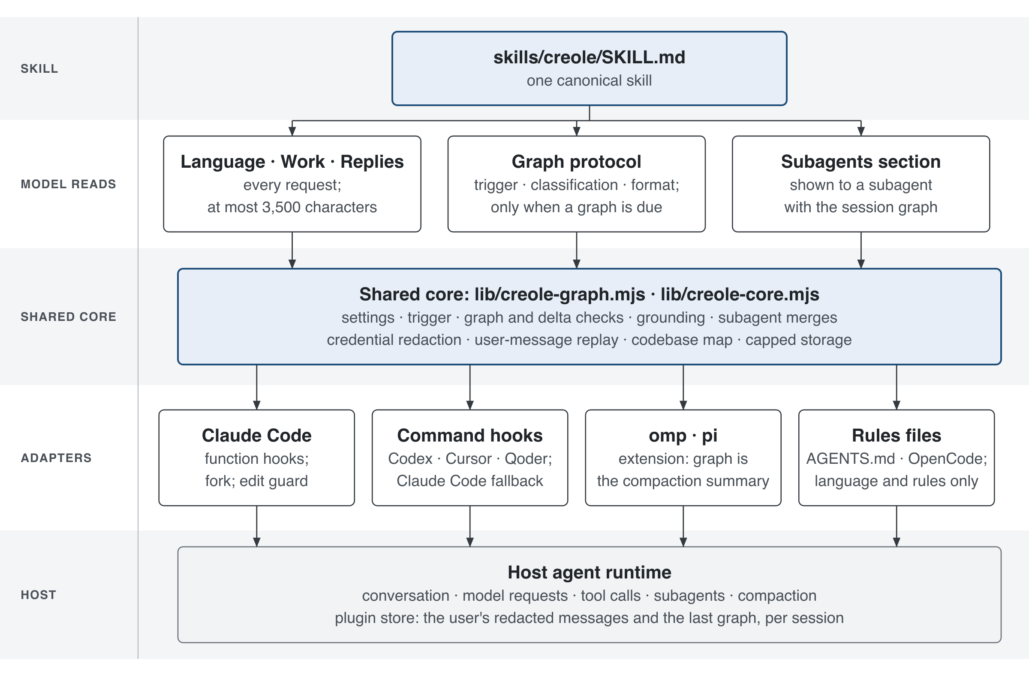
Fig. 3.1. Architecture of Creole LLM: one canonical skill, a shared core, and host adapters that measure the context, fire compaction, validate the graph and store the user's words.
Karpathy [2] describes a schema file that turns a generic agent into a disciplined maintainer of structured knowledge by stating exactly what to track and how. Creole's skill is that schema for one coding session: it says what is an anchor, what is transient, how to write and update the graph, and how a subagent reads and extends it. The adapters are what make the schema enforceable rather than advisory.

3.3 The Working Language and Work Rules
The working language is the part of Creole that acts on every request, not only at compaction. It asks the model to think, plan, take notes and reply in plain English shaped like code: one fact, step or action per line, a label such as task:, constraint:, done:, cause: or next: when it saves words, fragments without articles, politeness or narration, symbols such as -> for "leads to" and ; between items, and each thing named once and then referred to by its path or identifier. What must stay exact stays exact: code, commands, paths, identifiers, numbers with their units, error messages, quotations and anything the user asks for word for word. Uncertainty, conditions and negation are kept; an unverified claim is marked unconfirmed rather than left as a bare question mark. The model switches to plain English in full sentences to ask the user something, to warn of data loss, security risk or cost, and for prose the user asks for.
The language exists because of a measurement, not an assumption. Early sessions in this project showed that the agent's own words (its thinking, its narration of what it was about to do and its recaps of what it had done) were a large part of every session's output, and that output is billed at five times the input price on the models tested. Kong et al. [10] supply the argument that removing low-value tokens can help quality as well as cost; Caveman's published numbers supply the warning that cutting output alone does not lower the bill when the injected rules add input on every request. The language is therefore kept short, under 3,500 characters including its rules, and its effect is judged only by whole-session cost.
Rule 7 of the language makes Creole cooperate rather than compete with other plugins: another skill or plugin in force wins for the format, procedure and documents it prescribes, and Creole shapes only what it leaves open.
The work rules adapt Ponytail's discipline. Before each edit, check its file against the user's constraints, which beat a listed task for the whole session. Read the code a change touches first and list every place it must reach. Take the first option that fully works: no change; the codebase's own helper; the standard library or platform; an installed dependency; the fewest lines. No unrequested feature, option, abstraction or code "for later". The shortest working diff wins. Find every target with one search, batch the edits and run the checks once, after the last. Fix a bug's root cause once, in the shared code, and leave one small test for new branching logic, parsers, money or security code. Never cut validation at trust boundaries, error handling that prevents data loss, security, accessibility or anything the user asked for.
The reply rules adapt i-have-adhd's shape. End every turn that changed or checked anything with a short block: the outcome as the user sees it in one sentence, led by the answer they asked for; a checked: line naming what ran and what it showed, or "not run"; and a next: line only when an action is left. A failure is shown by its test and error line exactly as printed. Anything skipped, unchecked or risky is named. No preamble, recap or closing pleasantries. Details are given in full when asked, destructive actions are confirmed first, and after three failed attempts the agent names the assumption that may be wrong and asks one question.
Two rules were added in response to observed failures in the matrix experiment, and they illustrate the method. At Haiku 4.5 with thinking off, one session edited a file the user had withdrawn from the task; the constraint rule was moved to the first position and reworded, and, because a text rule alone still failed one of six probe sessions, a deterministic guard was added to the Claude Code module (Section 3.7). On Ponytail's own benchmark tasks Creole wrote more code than Ponytail, so a rule for vague requests was tried in a further run; it reduced code but raised cost, and it was rejected (Section 4.7).

3.4 Compression Trigger Design
The proposal's trigger was a share of the context window, 60% by default, motivated by the percentile principle of Selective Context [5]. That rule is kept, but it is no longer the only one, for a reason the proposal could not foresee: windows grew. On a 200,000-token window, 60% means compacting at 120,000 tokens. On a 1,000,000-token window it means 600,000 tokens, and a session that large re-reads several hundred thousand tokens on every tool call long before it reaches the limit. A share of the window protects the window; it does not protect the bill.
Creole therefore compacts at the lower of two limits:
limit = min(window x threshold / 100, base + headroom)
The base is the smallest context the session has been seen to use: its system prompt, tools, rules and any restored state, measured from the host's own usage reports. The headroom, 100,000 tokens by default, is how far the conversation may grow past that base before compaction. On a 200,000-token window the threshold binds; on larger windows the headroom does. Both are settings, read in a fixed order of precedence: a CREOLE_ environment variable, then the host's plugin option, then the skill's frontmatter, then the built-in default. An invalid value is skipped and named at session start rather than silently used.
The headroom also adapts on Claude Code's module when the user has not set it. If compactions come fewer than 8 responses apart, the session is doing work that genuinely needs more context, so the headroom grows by half, up to the share of the window above the base. If they come 24 or more responses apart, it shrinks back toward the configured value. Nothing learned carries to another session, and a different model or window mid-session resets it. This keeps the spirit of Selective Context's adaptation [5], applied to the session's own rhythm instead of the content's entropy.
The trigger is armed and disarmed explicitly. After a compaction Creole does not fire again until it has seen usage below its limit, because a turn that reads past the limit immediately after a compaction would otherwise either compact in a loop or, as one early live run showed, stay disarmed for the rest of the session. An unknown token count, before the first response or right after a compaction, neither sets the base nor re-arms. When the host's own automatic compaction would fire first, the module retargets it to Creole's limit where the host's settings permit, and a compaction setting the user made always wins.
The proposal also had a secondary trigger at subtask completion. In practice the host's turn boundaries are the natural points: the command hooks request a graph in the agent's reply at the turn that crosses the limit, and the Claude Code module compacts between requests. Completed subtasks are reflected in the graph's content (Section 3.5) rather than in the trigger.

3.5 Anchor and Transient Classification Protocol
Classification remains the core of the protocol: the history is divided into anchors, which the next agent cannot work without, and transient content, which can go. Anchors are the content whose removal would most change what the agent does next, in the sense of the divergence objective of Chang et al. [9], and the content that receives attention on every turn even when its self-information is low, in the sense of Zhao et al. [6]. The proposal named two anchors, the task and the working state. Building the graph made them precise as eight row types, shown in Table 3.2.
TABLE 3.2. SESSION GRAPH ROW TYPES
ID | Content | Rule
T | The task, with its codebase context and exact test command, merged across turns | Required
C1... | A user constraint | The user's exact words in double quotes; every number, limit and name kept
B1... | Something built: path or symbol and behaviour | At most 15 words
D1... | A current decision; a rejected alternative only if likely to recur | At most 15 words
S1... | Every unfinished or paused subtask: name, status, remaining work | At most 15 words; a finished subtask becomes B
I1... | An open issue: test or location and the exact error | Includes failures seen but not asked about, marked "not requested"
H1... | A hypothesis, linked to its issue | Deleted with its issue
L | The last completed subtask | Required; at most 15 words

Everything else is transient and goes: resolved reasoning, fixed errors, superseded drafts, restated constraints, history, verification notes, passing test counts, advice, invented work, off-task material, and anything the code itself shows (helpers, data structures, call sequences), which the agent can read again. Credentials and personal data never appear, even by name or location. When it is unclear whether something is an anchor, the rule is to keep it, which follows the conservative principle of Li et al. [5]: keep what minimally preserves the output distribution.
The graph is not free prose. It begins with a header that names its version, its pass number, a timestamp and the token count at which it was written, and then lists one row per line, optionally linked to other rows with -> I1, I2. Its target length is 250 words including identifiers and header. The first compaction writes a full graph. Every later compaction writes a delta against the previous graph: + ID: text adds a row, ~ ID: text replaces one, - ID ID deletes rows, and L: text sets the last step. A delta is how the graph carries the summary accumulation of AutoCompressors [3] into text: what an earlier pass kept is kept unless the agent deliberately changes it.
What makes the graph different from a host's summary is that the plugin checks it before it can replace anything. The validator rejects a graph or delta that is malformed, links to rows that do not exist, deletes the task or the last step, contains a credential, or exceeds the word target (the length check is relaxed after one correction, because a long graph is better than a lost one). Most importantly, it checks grounding. A constraint row must quote one of the user's own messages word for word. On Claude Code's module, every code span, path and quoted error in the graph must also appear in the conversation as written. A graph that invents a constraint, or names a function that was never mentioned, is refused, and the agent is told exactly which row failed and asked to fix only that. At most two attempts are made; if both fail, the host's own compaction runs with preservation instructions, and the user is told that Creole did not compact this time.
The graph is never the only thing kept. The replacement history that Creole gives the host is the user's own messages, redacted of known credential patterns, followed by the graph. This is how the proposal's two incompatible requirements are reconciled. The user's words are kept verbatim, as the proposal's anchors required, because they are replayed exactly. The task and working state are synthesised, as the proposal's edge cases required, because the graph is written from the whole conversation. Replay has a cost: the user's messages grow with the session. If they would no longer fit within the replay budget, Creole does not drop some silently; it hands the compaction to the host and says why.
Fig. 3.2 traces a compaction on Claude Code's module from trigger to restored context.
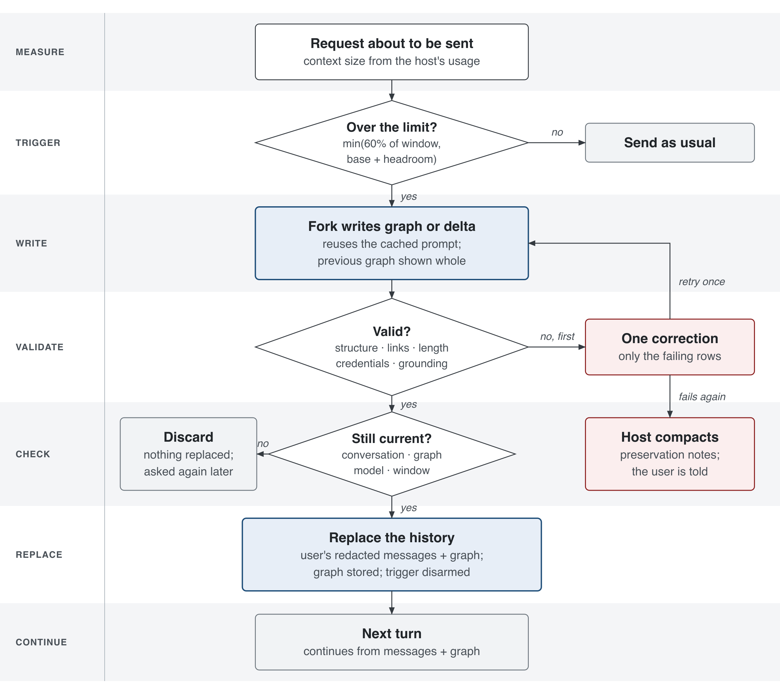
Fig. 3.2. A compaction on Claude Code's module: trigger, fork, validation with one correction, replacement of the history by the user's messages and the graph, and fallback to the host's own compaction.
On the module, the graph is written by a fork: a separate request that reuses the session's own prompt (so it costs mostly cached input), shows the previous graph whole, and asks only for the graph or delta. The fork's result is checked for staleness twice: if anything changed while it ran (a new user message, a tool result, a subagent's merge, another model or window), it is discarded rather than allowed to replace a conversation it does not describe. Creole considers the compaction done only when the host's record shows the host keeping the replacement, and only then logs it and adapts the headroom. On command-hook hosts, where a hook cannot remove history, the agent writes the graph at the end of its reply, the hook validates and stores it, and when the host compacts by itself the hook restores the stored graph and the user's messages into the new context. On omp, the extension supplies the user's messages and the graph as the compaction summary directly, which is the proposal's original design.

3.6 Edge Case Handling
The proposal identified three edge cases. Each is now handled by a specific mechanism, and three further cases found during the project are handled as well. Table 3.3 summarises them.
The first case is a task stated across several early turns. The T row synthesises those turns into one statement, which is the abstractive approach Mei et al. [15] describe, while the replayed user messages keep every original word, so nothing the user said is lost in the synthesis.
The second is several subtasks in progress at once. The S rows list every unfinished or paused subtask with its status and remaining work, not only the latest; a paused batch stays in S until the user resumes it. One of the evaluation tasks pauses a batch of issues across a compaction precisely to test this.
The third is repeated compaction. Every compaction after the first writes a delta against the stored graph, not a new summary, so each pass builds on the last. The previous graph is shown whole in the fork's prompt, and a resumed session starts from the stored pass. The runtime test suite applies 1,001 consecutive passes and checks that the exact constraint and the bounded size survive.
TABLE 3.3. EDGE CASE HANDLING
Edge case | Condition | Protocol response
Distributed task statement | The task is specified across several early turns | T synthesises them into one statement; the user's messages are replayed verbatim
Concurrent subtasks | More than one subtask is open or paused | Every one is listed in S with its status and remaining work
Repeated compaction | A graph from an earlier compaction exists | The next compaction writes a delta against it; earlier rows carry forward
Overflow | The user's messages no longer fit the replay budget | The host compacts with preservation instructions; the user is told
Invalid graph | The graph fails validation twice | The host compacts with preservation instructions; nothing invalid is stored
Concurrent change | The conversation or graph changed while the fork ran | The fork's result is discarded; nothing is replaced or stored

3.7 The Session Wiki, Codebase Map and Edit Guard
Three mechanisms extend the session graph beyond compaction.
The session wiki applies the llm-wiki pattern [2] within one session. Once a session has a graph, each subagent it spawns is shown that graph, under a label that marks it as a record rather than instructions, together with the skill's Subagents section. A subagent reads it before it searches or asks, because the answer may already be there. When its work changes the state, it ends its final reply with a delta, and Creole merges that delta into the session graph when the subagent finishes. A subagent may add or change rows for what it built, decided, left unfinished or found broken, but it may never write the task, a constraint or a full graph: those belong to the main agent and the user. A delta written against an older pass, because another subagent merged first, is rebased onto the current graph: a row whose text already exists becomes that row, a row whose number is taken gets the next free one, and links follow. The design keeps one boundary firmly: nothing in the wiki crosses sessions or projects. Earlier iterations kept a project wiki, a project graph and a user profile across sessions. They were removed by the user's decision on 25 October 2026, because cross-session state blurred what the user had actually said in the current session and added privacy risk without demonstrated benefit. Their old files are neither read, changed nor deleted.
Fig. 3.4 shows the wiki's flow: the main agent writes the graph at each compaction, each subagent is shown it at spawn and merges a delta back when it finishes, and nothing leaves the session.
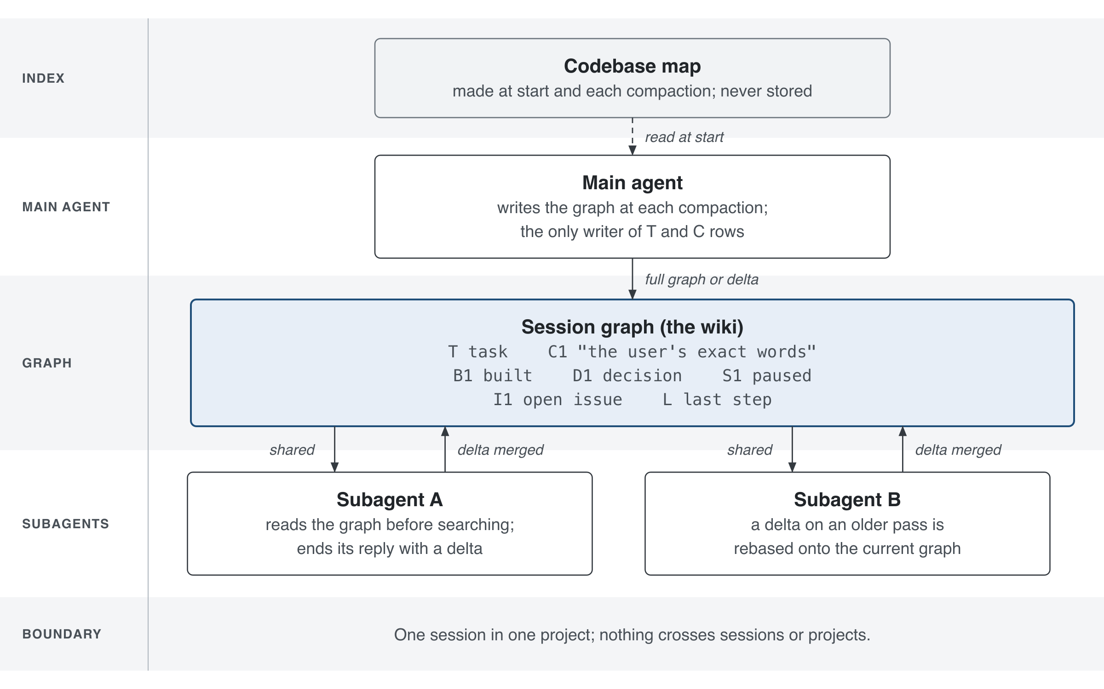
Fig. 3.4. The session wiki: one session graph shared by the main agent and its subagents, with subagent deltas merged and rebased, bounded to one session in one project.
The codebase map is the wiki's index. At each session start and after each compaction, Creole lists the project's source files through git (with the repository's file-system monitor disabled, since git would otherwise run it), reads the top-level names defined in up to 300 files, and writes one line per folder within 2,000 characters. The map is labelled as data, computed fresh and never stored. It saves the agent the first round of searching for where things are.
The edit guard is the newest mechanism and answers the one constraint failure observed in the final experiment. Before Claude Code runs an edit tool, its module now asks whether the newest user message naming that file holds it still, through phrases such as "leave ... alone", "do not touch", "don't change" or "withdrawn". If it does, the edit is refused with the user's own words and an instruction to skip the file and say so; a newer message from the user naming the file lifts the hold. The guard is deliberately narrow. It only reads clauses it recognises, it only covers edit tools, and a change made through a shell command gets through. It turns the most damaging kind of constraint failure, changing what the user said not to change, from a matter of the model's attention into a deterministic check.

3.8 Tools and Technologies
The plugin is written in JavaScript for Node.js 22.18 or later, as ECMAScript modules, with no runtime dependencies, no install scripts and no network access. That choice serves three objectives at once: every supported host can run Node, there is nothing to download or compile on the user's machine, and the whole plugin can be audited without auditing a dependency tree. The omp and pi extension is written in TypeScript because that host loads TypeScript directly. The skill follows the Agent Skills format that Anthropic documents [11], [12], [13]: YAML frontmatter and a Markdown body.
The host integrations used each host's documented mechanism. Claude Code 2.1.309 provides function hooks, JavaScript functions the host loads and calls with structured events, used for the main route. Claude Code's command hooks, and Codex 0.162.1's, Cursor's and Qoder's equivalents, run a process with a JSON payload at session start, prompt submission, tool use, subagent start and stop, compaction and session end. OpenCode loads an npm package as a server plugin. Packaging covers the plugin manifests of Claude Code, Codex, Cursor, Qoder, Copilot CLI, Devin, Grok and Kimi, and the npm registry.
Deterministic verification used Node's built-in test runner. The suite of 329 tests covers the pure graph logic, each adapter against recorded host payloads and stand-in hosts, the storage limits, the redaction patterns, the release contents and the consistency of the generated rules files. During the main development tickets, mutation testing (deliberately breaking the code and checking that a test fails) was used to show that the tests detect real faults; between 11 and 94 mutants per ticket were introduced and all were caught.
Live evaluation used a purpose-built harness in experiments/live/. It runs Claude Code headless (claude -p with stream-json input) as one process per phase of a session, with --strict-mcp-config and no user settings, inside a macOS sandbox (sandbox-exec) that makes the repository, other runs and the operator's own plugin data unreadable. Each arm gets its own pinned copy of its plugin, identified by a hash of its files that must match the frozen manifest. A recorder logs every request the host sends, including the thinking and effort actually sent, so a setting the host did not apply is reported as found rather than as requested. Oracles written in Python inspect the work folder after each turn. Costs are taken from Claude Code's own per-session report. All runs, including those cut off by usage limits, count toward the reported spend.

3.9 Evaluation Design
The evaluation asks three questions, each tied to an objective. Does Creole keep what the work needs through compaction (objective 1 and 3)? Does it run, as designed, inside the hosts it claims (objective 2)? And what does it do to the whole cost of a session, against the agent alone and against the plugins developers actually use (the widened objective 3)?
The proposal's anchor-recall study asked the agent, after compaction, to state the task and working state, and scored the answer for completeness, accuracy and specificity on a three-point scale. That study's question is kept, but its instrument changed. A self-report is a weak test: an agent can describe its constraints correctly and still break them. The final evaluation therefore asks whether the agent acts on its anchors after compaction, and checks this with oracles outside the agent's reach. The rubric's three dimensions map onto oracle checks: completeness becomes "every constraint still holds and every requested issue is fixed", accuracy becomes "the reported number of failing tests equals the real number", and specificity becomes "the reply names the cause and shows the tests run".
Three scripted sessions form the main task set, all on generated Python projects with seeded bugs and unit tests.
The short fix, bugfix-two, asks the agent to fix only issues 2 and 5 of eleven and leave the others, without changing the tests. It never needs compaction and measures Creole's overhead on ordinary short work.
The review, bugfix-review, is a long session over a project of 16 modules with 30 issues. The first message sets two rules for the whole session: leave pkg/util8.py alone, because its issues are withdrawn, and start every changed module with the exact line # reviewed: CR-4471. The agent fixes issues 1 to 10, then 11 to 20; then the context is explicitly compacted; then it fixes 21 to 30; then the process is stopped and the session resumed in a new process, and the agent is asked to run the suite, fix whatever still fails except what was withdrawn, and report the number of tests still failing and why. The oracle passes the session only if the tests are unchanged, the withdrawn module is untouched, every changed module carries the exact line, and exactly the withdrawn module's tests still fail. The withdrawn module holds six issues across the first two batches, so the constraint is tested before and after compaction.
The subagent review, review-subagents, runs the same project with two compactions, and in between hands issues 21 to 25 and 26 to 30 to two subagents. Its oracle adds that at least two subagents were spawned. It tests whether the session's knowledge (the rules, what is built) reaches agents that start with none of it.
A fourth task set comes from Ponytail's own agentic benchmark, pinned under its MIT licence: four bounded coding tasks (reuse the project's existing slug helper; add a per-key rate limiter without letting one client block everyone; write a script that summarises a CSV file; write a JSON configuration loader with validation), each with Ponytail's hidden checks for correctness and safety. Here the measure is Ponytail's own: lines of Python source changed, tests aside, provided the task passes.
The arms are the agent with no plugin (native), Creole, and four comparators: Ponytail 5.1.0, i-have-adhd 0.4.1, Caveman 3.2.0 and the llm-wiki pattern as an instruction file. Each comparator was run on the tasks of its own strength: Ponytail, i-have-adhd and Caveman on the bug fixes, llm-wiki on the subagent review, and Ponytail additionally on its own benchmark. Each arm loads only its own plugin, from a pinned copy, in its own sandbox, with the same tools, prompts and project.
Every arm ran at every combination of three models (Claude Haiku 4.5, Sonnet 5.5 and Opus 5.5) and three effort settings: the lowest (thinking off on Haiku, --effort low elsewhere), the host default (no flag), and the maximum (--effort max). That gives nine settings per comparison. Fable 5.1 was planned but could not run, because the account needed separate usage credits for it.
The measures are, per session: whether the oracle passed and which hard rules were broken; the cost Claude Code reported; tokens by kind (input, cache read, cache write, output); minutes; compactions; for the bug fixes, lines changed per fix; for the replies, checks against the session's real state (the failing count is right, it is in the first line, the cause is named, the tests are shown run) and the reply's length in words; for subagents, how many subagent deltas were merged. Fig. 3.3 shows the pipeline.
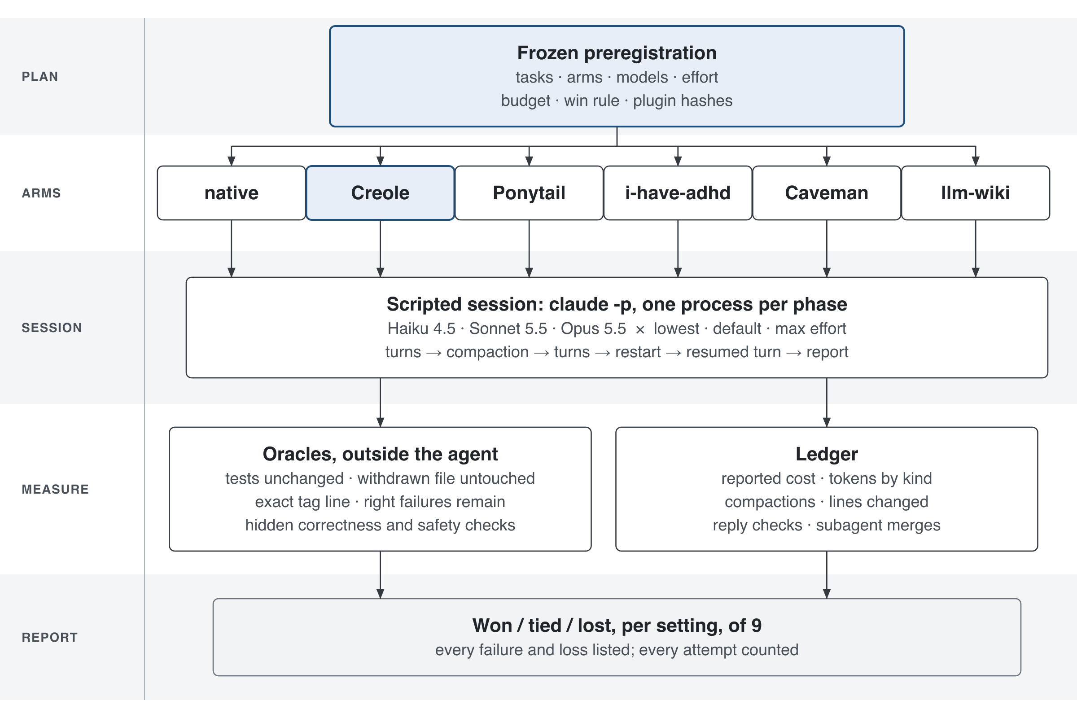
Fig. 3.3. Evaluation pipeline: a frozen preregistration, isolated arms with pinned plugin copies, scripted sessions with compaction and resume, oracles outside the agent's reach, and a report that includes every loss.
The win rule was fixed before the runs: for each comparator, Creole is compared on that comparator's own measure and on cost, setting by setting, and the result is reported as a count of settings won, tied and lost out of nine, with every failure listed. One session per cell was run, a deliberate trade of statistical power for breadth under a budget of 700 US dollars, approved by the user. Single sessions vary by about a quarter in cost, so the results are reported as observations, not as statistically significant differences, and a gap smaller than that variation is not called a win.

3.10 Computing Factors and Constraints
Six factors shaped the design: performance, security, privacy, ethics, usability and accessibility.
Performance. Every part of Creole that reaches the model has a cost, and each was measured rather than assumed. The always-on language and rules are capped at 3,500 characters by a test. The graph instructions, about 3,500 characters, load only in a compaction or a graph request. A subagent given the graph also reads the Subagents section, about 1,600 characters, plus the graph. A compaction costs one extra request, but on Claude Code it reuses the session's cached prompt. The hooks themselves are local functions; the codebase map is bounded to 300 files, 64 KiB each and one second (three seconds on the module). The evaluation's measure is the whole session's reported cost, which includes all of these overheads, and the short-fix task exists specifically to expose overhead where compaction never happens.
Security. Graph text and the codebase map are wrapped in labelled delimiters, and any delimiter appearing inside quoted text is escaped, so user text shaped like a graph header, or a file containing one, stays data. A live control session confirmed this on Claude Code. The labels are not a guarantee: a model can still follow a hostile line inside them, and this limit is stated in the documentation. A subagent cannot write the task or constraints. The plugin has no network access and runs no install scripts. The edit guard fails open, as every gating hook does, so a bug in it can never block the user's work.
Privacy. Session records (the user's redacted messages and the last graph) stay on the user's machine, in the host's plugin store or the plugin's data folder. Each session's record is capped at 256 KiB and all records at 3 MiB; a write that would exceed either is refused and reported, and no other session is deleted to make room. A record is removed at a later session start once its session has ended and gone 30 days untouched. Redaction removes known credential patterns before anything is stored or replayed, but it is pattern-based: it cannot promise to remove every secret or any other personal data, and it cannot touch the host's own transcripts. The documentation says exactly where each record lives and how to delete it.
Ethics. The guiding principle is transparency. Every compaction tells the user what it did, or why Creole could not and the host compacted instead, and the graph is plain text the user can read. Unlike AutoCompressors' summary vectors [3], nothing about the retained state is opaque. The evaluation reports every loss next to every gain, publishes the methods that produced the numbers, and never presents a number from a different condition as if it were the same. The comparisons with other plugins were run on each plugin's own strength, with its own unmodified files under their licences, rather than on ground chosen to favour Creole.
Usability. A developer installs Creole with two commands on Claude Code and configures nothing; the defaults adapt to the model's window and the session's rhythm. Settings exist for those who want them and are validated. The reply rules make the agent's answers shorter and put the outcome first, which suits developers who scan rather than read, the audience i-have-adhd was designed for. Another plugin's rules win where they apply, so Creole can be installed beside a team's existing tools.
Accessibility. No GPU, no training, no second model and no paid service are needed; the plugin works with the agent the developer already uses. This directly answers the gap identified in Chapter 2: AutoCompressors [3] need an A100, Nano-Capsulator [4] two A40s for eight hours, Selective Context [5] a running scoring model. It is distributed under the MIT licence through GitHub and npm, with installation, update and removal instructions for each supported agent.

Chapter 4: Results and Discussion

4.1 Overview of the Evidence
This chapter reports what was observed, separates the kinds of evidence, and discusses each result against the objectives in Section 1.3 and the literature in Chapter 2. Four kinds of evidence are used, and they are never mixed. Deterministic evidence comes from the test suite: it proves that the code does what it is specified to do for the inputs tested, but says nothing about how a model behaves. Mock evidence comes from stand-in hosts or providers that replay recorded payloads: it shows that an adapter handles a host's events correctly, without a live model. Live host evidence comes from real Claude Code sessions with a real model, observing whether the host actually does what Creole asks. Performance evidence comes from the preregistered comparison: real sessions, real costs, oracle verdicts. A claim in this chapter is labelled with the kind of evidence that supports it.
All live results come from runs made after the 13 October 2026 reset described in Section 3.1. The comparison was run in three rounds under preregistration versions 22, 24 and 25: version 22 ran every arm at every setting on Creole's earlier build; version 24 re-ran Creole after the constraint failure described in Section 4.4, and added Ponytail's own benchmark tasks for the native, Creole and Ponytail arms; version 25 re-ran Creole alone with one more work rule, which was rejected (Section 4.7). The released build, creole-llm 1.0.3, is version 24's, identical to it except for its version number; its sessions are the ones reported. The native and comparator arms' sessions are those of versions 22 and 24. All arms used the same tasks, the same sandbox, the same Claude Code version (2.1.309) and the same models. The total spent on the comparison, including every attempt cut off by a usage limit and every diagnostic probe, was 200.42 US dollars, within the approved 700.

4.2 Deterministic Verification
The full test suite of 329 tests passes on Node.js 22.18 and later. It covers the graph parser, validator and delta logic; the grounding checks for constraints and code names; the merge and rebase of subagent deltas; the trigger arithmetic and its arming; redaction; the storage caps and cleanup rules; each adapter against recorded host events; the release contents; the size limit of the always-on language section (3,465 of 3,500 characters in the released skill); and the consistency of every generated rules file with the skill. During the development tickets, deliberately introduced faults (mutants) were used to check that the tests detect real defects: across tickets 01 to 18, every mutant introduced was caught, from 11 of 11 in the smallest ticket to 94 of 94 in the largest.
A synthetic runtime benchmark exercises repeated compaction, the proposal's third edge case, at a scale no live session reached. Over 1,001 consecutive graph passes generated from usage fixtures reaching 130,000 tokens, the graph kept eight rows, kept the user's exact constraint and ended at 375 bytes. This shows that the delta mechanism does not accumulate old passes, which was the proposal's concern in Section 3.5, but it is deterministic evidence: the passes are generated, not written by a model.
These results support objective 2's requirement that the protocol be implementable without training, API modification or external infrastructure: every check runs in plain Node.js with no dependencies. They do not, by themselves, show that any model follows the protocol.

4.3 Host Behaviour on Claude Code
Objective 2 required the plugin to operate inside real agents. Table 4.1 summarises the live and mock evidence for Claude Code, where the main route was verified. The live runs (labelled r3 to r10) used Claude Code 2.1.292 with Haiku 4.5, the function-hook module and an isolated plugin copy and store; the comparison runs then confirmed the same behaviour on 2.1.309 across three models.
TABLE 4.1. CLAUDE CODE CAPABILITIES AND THEIR EVIDENCE
Capability | Evidence | Result
One language section per request and per compaction fork; none when switched off | Live, r3 to r10 | As designed
No host summary beside Creole's replacement | Live, r3 to r10 | As designed
Automatic compaction at Creole's limit below the host's 100,000-token floor | Live, r3 to r9 | Compacted between 43,690 and 44,829 tokens against 44,542 predicted
Host keeps Creole's replacement, first user message whole; store holds the last graph | Live, r3 to r9 | As designed
Second compaction writes a delta on the trusted previous pass, keeping a corrected rate and a reopened issue | Live, r3 to r7 and r9 | As designed
Compaction after a process restart builds on the stored pass | Live, r3 to r7 and r9 | As designed
Host auto-compaction switched off is respected; wiki off writes no record | Live, r10 | As designed
Graph-shaped user text and delimiters stay data | Live, r10 | As designed
Resume then compaction before a fork exists falls back visibly | Live, r10 | As designed
Re-arming after the first compaction once usage is seen below the limit | Mock (current module); live r9 found the defect | Fixed after r9 stayed disarmed from 65,700 to 92,700 tokens
Graph shared with subagents and their deltas merged | Mock; live in the comparison | Deltas merged in the subagent sessions (Section 4.6.4)
Edit to a file the user withdrew is refused | Live, version 24 probe | 10 of 10 sessions kept the file untouched

Two findings from this evidence shaped the design. First, the host's own compaction would not fire below its internal 100,000-token floor for a headless session, so Creole's limit was never reached on smaller budgets (run r2). The module now sets the host's compaction percentage to its own limit when that limit is below the floor, and run r9 then compacted within 300 tokens of the prediction. Second, run r9 showed a turn that read past the limit just after the first compaction leaving Creole disarmed for the rest of the session. The re-arming rule in Section 3.4 is the fix. Both are examples of the method in Section 3.1: an observed failure, reproduced, fixed by the smallest change, and re-verified.
For the other hosts the evidence is weaker, and it is reported as such. Codex 0.162.1's command hooks were verified with free probes against a stand-in provider: usage records, restoration after the host's own compaction, one language section per session and the control cases behaved as designed. A live Codex run was prepared but deferred by usage limits. omp and pi are covered by deterministic tests of the extension; a live omp trial early in the project never compacted and is not counted. Cursor, Qoder, OpenCode and Copilot CLI are covered by deterministic tests and manifests. The rules-file routes are instruction only: they deliver the language and rules but no automatic compaction. The proposal had planned verification on at least two distinct agents. Live verification was achieved on one, Claude Code, and mock verification on several more; this is a partial achievement of objective 2 and is recorded as such in Chapter 5.

4.4 Anchors Through Compaction
The proposal's third objective was to show that compression preserves session coherence. The bug-fix review and the subagent review test this directly: each sets two rules in its first message, compacts the context explicitly at least once, restarts the process, and then checks with an oracle whether the rules still hold and whether the agent's final report is true. The withdrawn module holds six of the thirty issues, spread across the first two batches, so an agent that has lost the constraint will fix them.
Table 4.2 gives the outcome. All 27 Creole sessions of the released build passed: the nine short fixes, the nine reviews and the nine subagent reviews. In every review the withdrawn module was untouched, every changed module started with the exact line, the tests were unchanged, and exactly the withdrawn module's tests still failed after compaction and restart. Every review compacted once and every subagent review twice, so each rule was tested on the far side of at least one compaction. In the subagent reviews, both subagents' deltas merged into the session graph in all nine sessions (18 of 18 merges), so what the subagents built reached the main agent's record of the session.
TABLE 4.2. SESSIONS PASSED AND HARD RULES BROKEN, ALL NINE SETTINGS
Arm | Short fix | Review | Subagent review | Hard rules broken
Creole | 9 / 9 | 9 / 9 | 9 / 9 | 0
native | 9 / 9 | 9 / 9 | 9 / 9 | 0
Ponytail | 9 / 9 | 9 / 9 | not run | 0
i-have-adhd | 9 / 9 | 9 / 9 | not run | 0
Caveman | 9 / 9 | 9 / 9 | not run | 0
llm-wiki | not run | not run | 8 / 9 | 2 (one session)

The one failure among the comparators was the llm-wiki arm's subagent review at Haiku 4.5 with thinking off: the session edited the withdrawn module and left a changed module without the required line. The subagents of that arm start with only the notes the main agent chose to write to files, and in that session the notes did not carry the rules.
The one constraint failure in the whole project's comparison runs is instructive. In version 22, at Haiku 4.5 with thinking switched off, Creole's earlier build edited the withdrawn module in the review. The text rule was reworded and moved first, but under version 23 the reworded rule still failed in one of six sessions at that setting: the stage's own session broke the file again, while five probe sessions kept it. A text rule depends on the model attending to it at the moment of the edit, and the smallest model without thinking does not always do so. Version 24 added the deterministic edit guard described in Section 3.7. In a probe of ten sessions at the same setting, all ten kept the withdrawn file untouched; in two of them the model tried to edit it, seven and six times respectively, and was refused each time with the user's own words. Every later Creole session at every setting passed. This is the clearest example in the project of the principle stated in Section 2.2: a rule the model may forget becomes reliable only when the plugin checks it.
These results answer the proposal's anchor-recall question in the form that matters most to a developer. The proposal planned to ask the agent to recite its task and working state after compaction and to score the answer for completeness, accuracy and specificity. The final evaluation asked instead whether the agent's work after compaction still obeyed the task and constraints (completeness), whether its final report of failing tests matched reality (accuracy), and whether that report named the cause and showed the tests run (specificity). On those measures the anchors survived compaction in every Creole session of the final build. Two qualifications apply. First, the native arm also passed nearly all of these sessions: on these tasks, at these lengths, Claude Code's own compaction usually kept enough as well, so the comparison does not show Creole preserving anchors that the host would have lost. Its value here is cost at equal correctness, and the guard against the one failure mode observed. Second, these are oracle checks of behaviour, not of the graph's content: a graph could omit a fact the oracle does not test.

4.5 Cost Against the Agent Without a Plugin
Table 4.3 and Fig. 4.1 give the mean cost per session over the three tasks for Creole and for the agent with no plugin. Creole was cheaper at all nine settings, by 20% to 45%. The saving was largest at maximum effort, 37% to 45%, where the agent thinks most and its history grows fastest, and smallest at Opus 5.5's default, 20%.
TABLE 4.3. MEAN COST PER SESSION AGAINST NO PLUGIN, AND THE SHORT FIX ALONE
Model | Effort | Creole | native | Saved | Short fix, Creole | Short fix, native
Haiku 4.5 | lowest | $0.357 | $0.487 | 27% | $0.074 | $0.095
Haiku 4.5 | default | $0.347 | $0.453 | 23% | $0.089 | $0.065
Haiku 4.5 | max | $0.344 | $0.544 | 37% | $0.094 | $0.088
Sonnet 5.5 | lowest | $0.348 | $0.458 | 24% | $0.094 | $0.090
Sonnet 5.5 | default | $0.310 | $0.467 | 34% | $0.057 | $0.057
Sonnet 5.5 | max | $0.712 | $1.298 | 45% | $0.088 | $0.241
Opus 5.5 | lowest | $0.751 | $0.981 | 23% | $0.211 | $0.192
Opus 5.5 | default | $0.732 | $0.915 | 20% | $0.125 | $0.104
Opus 5.5 | max | $1.239 | $1.976 | 37% | $0.181 | $0.361

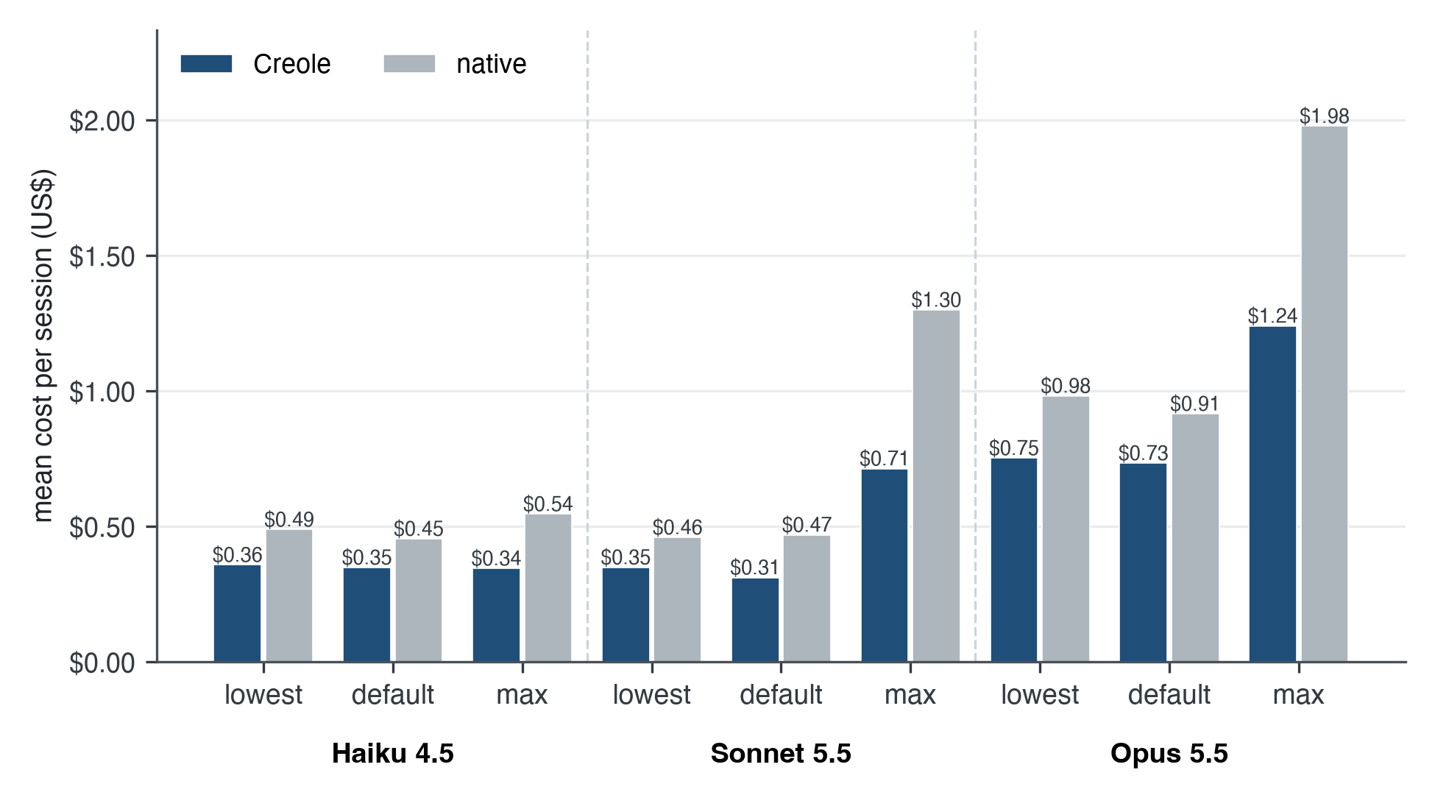
Fig. 4.1. Mean cost per session over the three tasks, Creole and no plugin, at each model and effort.
The saving is not uniform across tasks. The short fix, which never compacts, cost more with Creole at six of the nine settings, by up to 37% (Haiku 4.5 at default effort); at one of the six, Sonnet 5.5's default, the difference was under a tenth of a cent. On a short task the always-on language and rules are pure overhead: about 3,500 characters on every request, with no compaction to repay them. At maximum effort the short fix was cheaper with Creole on Sonnet and Opus, by 63% and 50%, because the native agent's long thinking and narration cost more than the rules did. This is the overhead the proposal anticipated in Section 3.8 and the warning in Caveman's own measurements; it is measured here rather than assumed, and it bounds the claim: Creole lowers the cost of sessions that grow, not of every request.

4.6 Against Each Plugin at Its Own Strength
Each comparator was set against Creole on that comparator's own strength and on cost, setting by setting. Table 4.4 summarises the counts; the detail follows.
TABLE 4.4. CREOLE AGAINST EACH PLUGIN AT ITS OWN STRENGTH, ACROSS NINE SETTINGS
Plugin | Its own strength, as measured | Creole better / tied / plugin better | Cost: Creole cheaper / tied / plugin cheaper
Ponytail | source lines changed on Ponytail's own tasks | 0 / 0 / 9 | 2 / 0 / 7
Ponytail | lines changed per fix on the bug fixes | 0 / 9 / 0 | 9 / 0 / 0
i-have-adhd | words in the final reply | 7 / 0 / 2 | 9 / 0 / 0
Caveman | output tokens on the bug fixes | 5 / 0 / 4 | 9 / 0 / 0
llm-wiki | subagent session passing its task and rules | 1 / 8 / 0 | 9 / 0 / 0

4.6.1 Ponytail: Less Code
On the bug fixes, every arm changed the same lines per fix at every setting: each bug had one correct one-line fix, and every agent found it. Creole was cheaper than Ponytail on those tasks at all nine settings (Table 4.5).
On Ponytail's own benchmark, the result reverses (Table 4.6, Fig. 4.3). Ponytail changed fewer lines of Python source than Creole at all nine settings, often about half as many, and cost less at seven. Both passed Ponytail's hidden correctness and safety checks on every task except one: Ponytail's own JSON configuration task at Haiku 4.5's default effort, where it wrote no file, which also lowers its line count at that setting. Creole wrote fewer lines than the agent with no plugin at six of the nine settings, so its work rules do reduce code, but not as far as Ponytail's. Section 4.7 describes the rule that was tried to close the gap and why it was rejected.
TABLE 4.5. BUG FIXES, MEAN COST PER SESSION BY ARM
Model | Effort | Creole | native | Ponytail | i-have-adhd | Caveman
Haiku 4.5 | lowest | $0.228 | $0.362 | $0.334 | $0.263 | $0.250
Haiku 4.5 | default | $0.264 | $0.298 | $0.417 | $0.283 | $0.299
Haiku 4.5 | max | $0.243 | $0.374 | $0.286 | $0.363 | $0.288
Sonnet 5.5 | lowest | $0.251 | $0.295 | $0.301 | $0.330 | $0.313
Sonnet 5.5 | default | $0.237 | $0.303 | $0.314 | $0.338 | $0.333
Sonnet 5.5 | max | $0.392 | $0.871 | $0.574 | $0.627 | $0.524
Opus 5.5 | lowest | $0.539 | $0.628 | $0.590 | $0.690 | $0.675
Opus 5.5 | default | $0.498 | $0.571 | $0.607 | $0.706 | $0.586
Opus 5.5 | max | $0.705 | $1.085 | $1.034 | $1.457 | $0.918

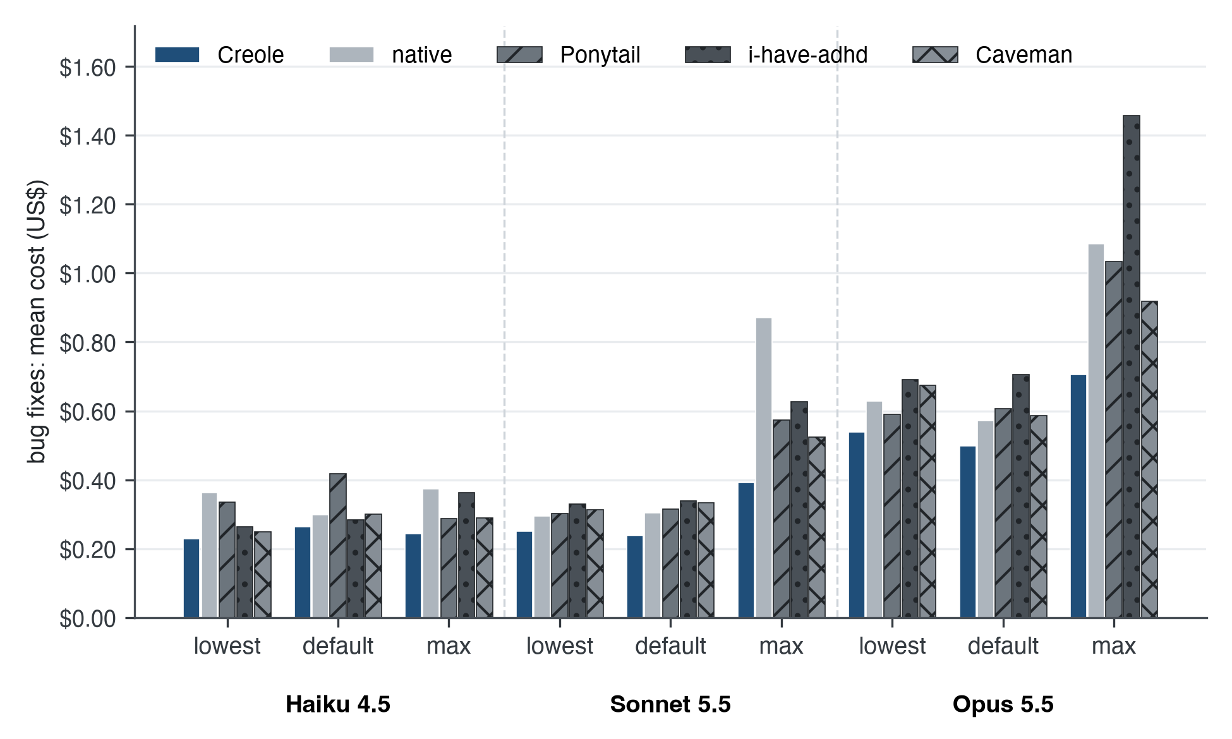
Fig. 4.2. Bug fixes: mean cost per session for Creole, no plugin, Ponytail, i-have-adhd and Caveman.
TABLE 4.6. PONYTAIL'S OWN TASKS: PYTHON SOURCE LINES CHANGED PER TASK (TESTS ASIDE) AND COST PER TASK
Model | Effort | Lines, Creole | Lines, native | Lines, Ponytail | Cost, Creole | Cost, native | Cost, Ponytail
Haiku 4.5 | lowest | 95.0 | 73.0 | 42.3 | $0.037 | $0.035 | $0.038
Haiku 4.5 | default | 53.3 | 44.3 | 9.8 | $0.042 | $0.033 | $0.036
Haiku 4.5 | max | 67.0 | 57.5 | 30.0 | $0.039 | $0.040 | $0.041
Sonnet 5.5 | lowest | 48.3 | 59.0 | 24.3 | $0.050 | $0.045 | $0.049
Sonnet 5.5 | default | 55.3 | 74.5 | 35.8 | $0.056 | $0.065 | $0.056
Sonnet 5.5 | max | 66.8 | 200.5 | 32.8 | $0.346 | $0.588 | $0.303
Opus 5.5 | lowest | 51.5 | 71.5 | 32.3 | $0.122 | $0.114 | $0.107
Opus 5.5 | default | 64.8 | 92.5 | 48.0 | $0.153 | $0.156 | $0.127
Opus 5.5 | max | 77.0 | 196.0 | 36.0 | $0.854 | $2.138 | $0.750

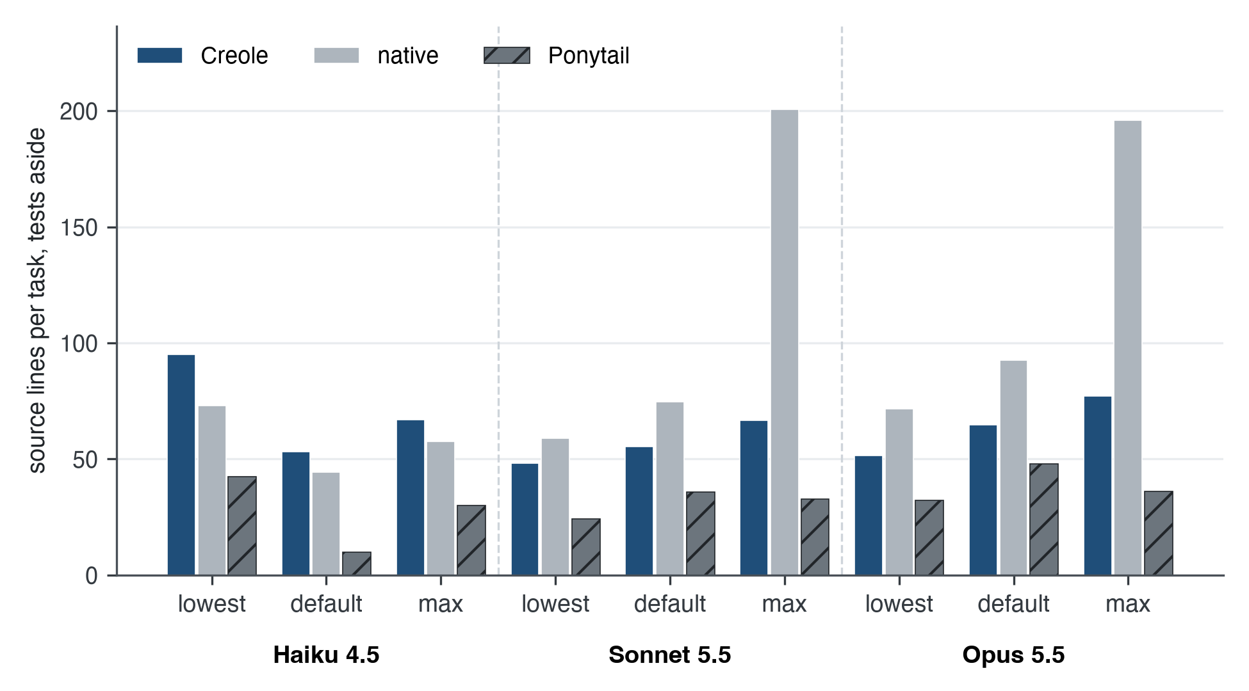
Fig. 4.3. Ponytail's own tasks: Python source lines changed per task, tests aside.

4.6.2 i-have-adhd: Short, Checked Replies
The review's last question asked how many tests still fail and why, which gives a reply that can be checked against the project's real state. On that reply Creole and i-have-adhd tied on every check: both gave the right number of failing tests in the first line and named the cause in 9 of 9 sessions, and both showed the tests they ran in 6 of 9. Creole's replies were shorter at seven of nine settings, 45 words on average against 81 (Table 4.7, Fig. 4.5), and Creole's sessions were cheaper at all nine. The agent with no plugin also passed the checks, at 93 words on average, and showed the tests run in 5 of 9. Readability itself was not rated; the checks measure whether the reply is true and complete, and the word count measures its length.

4.6.3 Caveman: Fewer Output Tokens
Caveman's strength is output tokens. Creole produced fewer output tokens on the bug fixes at five of nine settings and more at four, always within 12% (Table 4.7, Fig. 4.4). On this measure the two are level within the variation of single sessions. On cost, Creole was cheaper at all nine settings, which supports the point Caveman's own documentation makes: output is a minority of a session's bill, so a method that also controls the growth of input and cache reads saves more than one that controls output alone.
TABLE 4.7. OUTPUT TOKENS ON THE BUG FIXES AND WORDS IN THE FINAL REPLY
Model | Effort | Output tokens, Creole | Output tokens, Caveman | Reply words, Creole | Reply words, i-have-adhd
Haiku 4.5 | lowest | 8,681 | 8,800 | 50 | 31
Haiku 4.5 | default | 12,269 | 13,187 | 28 | 20
Haiku 4.5 | max | 11,491 | 13,069 | 30 | 48
Sonnet 5.5 | lowest | 8,712 | 8,084 | 43 | 52
Sonnet 5.5 | default | 8,758 | 8,552 | 52 | 73
Sonnet 5.5 | max | 19,697 | 19,410 | 74 | 142
Opus 5.5 | lowest | 8,560 | 8,724 | 46 | 116
Opus 5.5 | default | 7,990 | 7,686 | 40 | 90
Opus 5.5 | max | 13,611 | 14,632 | 45 | 157

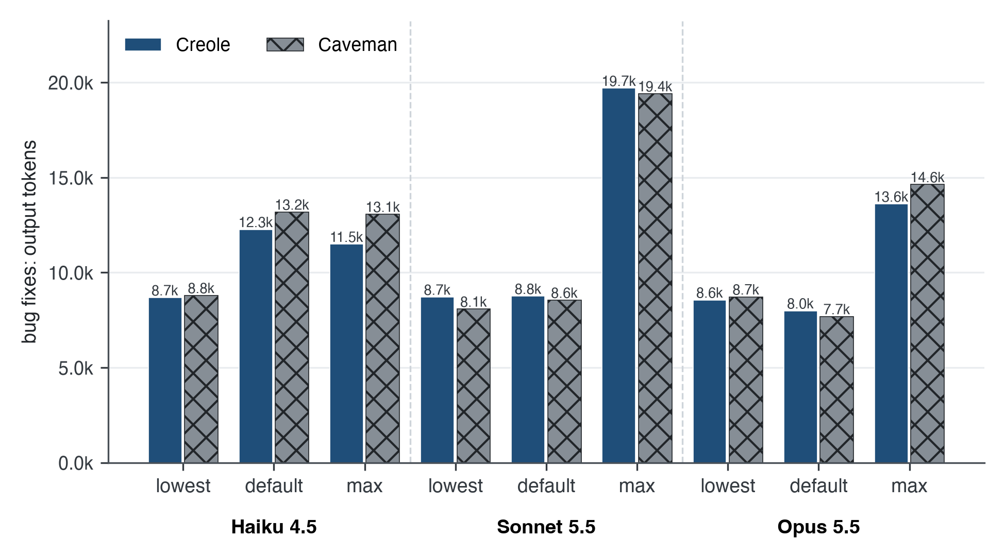
Fig. 4.4. Bug fixes: mean output tokens per session, Creole and Caveman.
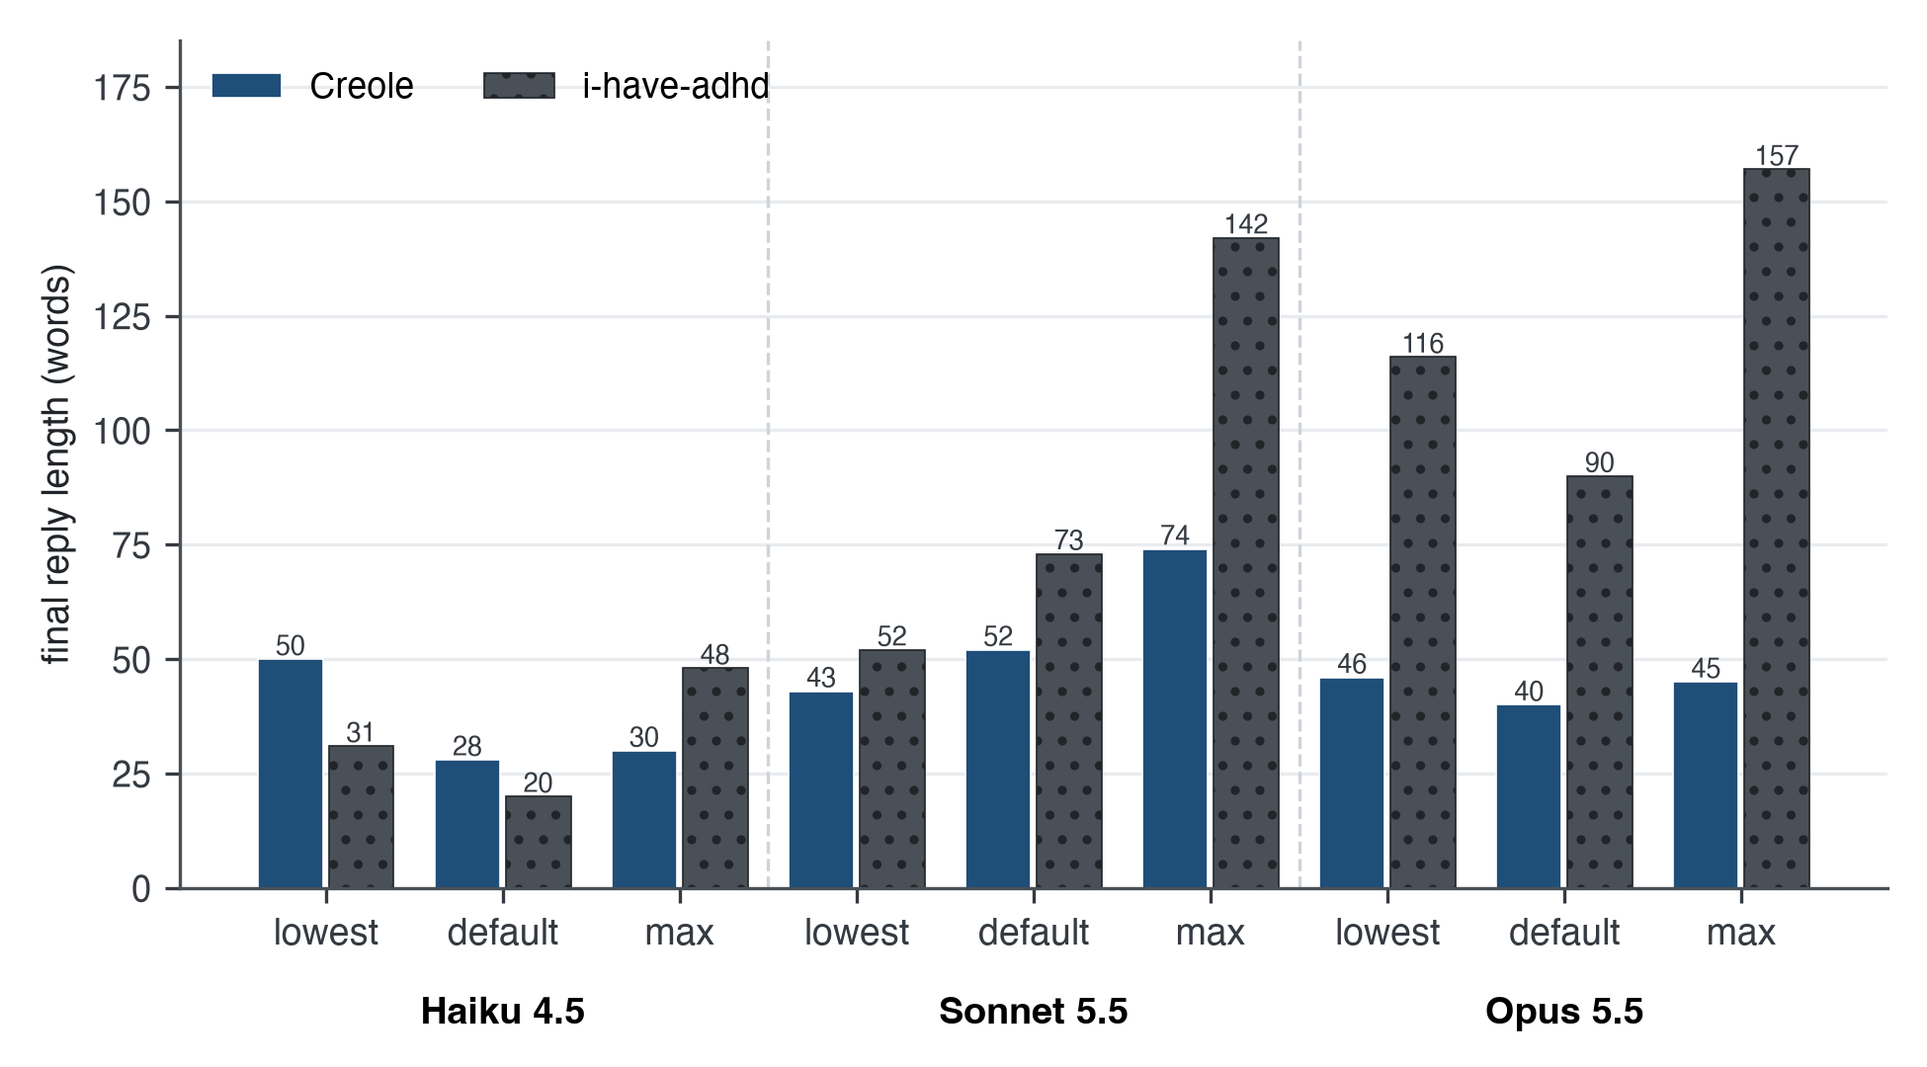
Fig. 4.5. Words in the final reply of the review, Creole and i-have-adhd.

4.6.4 llm-wiki: Knowledge Shared With Subagents
In the subagent review, the main agent hands issues 21 to 30 to two subagents after a compaction. Creole shares the session graph with each subagent and merges their deltas back; the llm-wiki arm keeps notes in files that its subagents can read. Creole passed all nine sessions and merged all 18 subagent deltas; the llm-wiki arm passed eight and broke both of the session's rules in the ninth (Section 4.4). Creole was also cheaper at every setting, by 35% to 52% against llm-wiki and by 17% to 43% against the agent with no plugin (Table 4.8, Fig. 4.6). The agent with no plugin passed all nine sessions too, at a cost between Creole's and llm-wiki's: on this task, the rules survived through the host's own summary as well, and the measured value of the shared graph is that it reached the subagents at lower cost.
TABLE 4.8. SUBAGENT REVIEW, COST PER SESSION BY ARM
Model | Effort | Creole | native | llm-wiki
Haiku 4.5 | lowest | $0.615 | $0.738 | $1.021
Haiku 4.5 | default | $0.513 | $0.764 | $0.902
Haiku 4.5 | max | $0.544 | $0.884 | $0.892
Sonnet 5.5 | lowest | $0.541 | $0.785 | $0.849
Sonnet 5.5 | default | $0.456 | $0.795 | $0.940
Sonnet 5.5 | max | $1.352 | $2.152 | $2.207
Opus 5.5 | lowest | $1.174 | $1.685 | $1.821
Opus 5.5 | default | $1.200 | $1.602 | $1.913
Opus 5.5 | max | $2.306 | $3.759 | $4.444

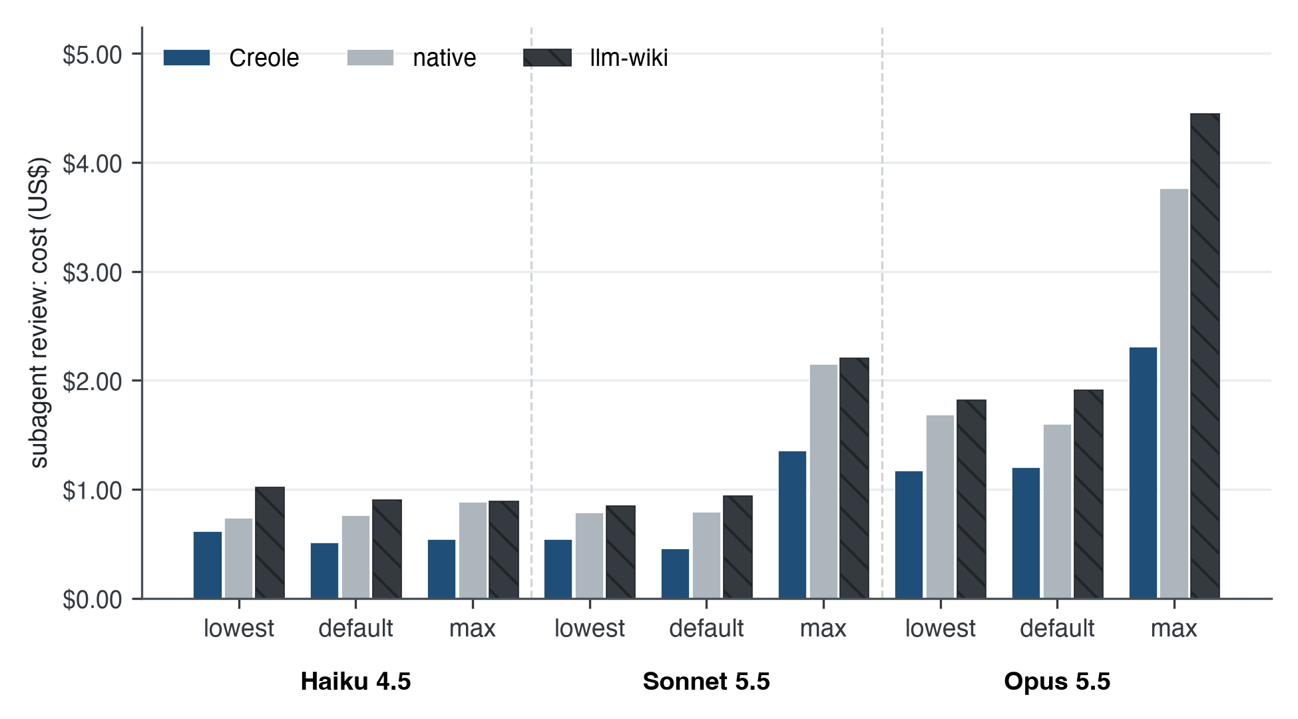
Fig. 4.6. Subagent review: cost per session for Creole, no plugin and the llm-wiki pattern.

4.7 Iterations and Negative Results
The final numbers are the end of a sequence, and the earlier steps belong in the record because they explain the design and show that the evaluation could have come out against Creole.
The first head-to-head comparison, preregistration version 7 on 20 and 21 October 2026, ran 32 of 39 planned sessions on Haiku 4.5 before the account's usage limit stopped it. No family was won. In the preferences family, which tested whether a user preference stated in one session carried into later sessions, the llm-wiki arm beat Creole outright: Creole kept the preference only in the same project. Coding and replies were inconclusive because cells did not run, and the payload family met its gate but with intervals reaching zero. The response was not to tune Creole until it won, but to reconsider the design. The user's decision of 25 October 2026 redefined the wiki as a record shared among the agents of one session, not a store across sessions, and the cross-session profile, project graph and project wiki were removed. Version 8's subagent family replaced the preferences family.
Version 22, the first full run on the model and effort matrix, produced the result that Creole was cheaper than native at all nine settings, by 21% to 36% across the three tasks, but also four honest losses: the short fix cost more with Creole at four settings; Creole failed one session at Haiku's lowest setting by editing the withdrawn file; at that same setting every bug-fix plugin was cheaper than Creole; and Caveman produced fewer output tokens at five of nine settings. Version 24 answered the failure with the edit guard and added Ponytail's own benchmark, which showed Ponytail writing less code than Creole at every setting. Version 25 tried to answer that with one more work rule: a vague request gets the smallest version that does its core job, with what was left out named. Creole then wrote fewer source lines at all nine settings, by 1% to 30%, but still more than Ponytail at all nine, and its cost over the three tasks rose at six of nine settings, by up to 31% at Haiku 4.5's default effort, where it would have been no cheaper than the agent alone. With one session per cell the rise may be partly noise, but it ran in the same direction at most settings, and the rule had not reached its goal. It was rejected, and the released build keeps version 24's rules. Each step was frozen before its run, and each loss, including this one, stayed in the record.
TABLE 4.9. CREOLE'S VERSION 24 BUILD AGAINST THE REJECTED VERSION 25 RULE
Model | Effort | Three-task cost, v24 | Three-task cost, v25 | Source lines, v24 | Source lines, v25
Haiku 4.5 | lowest | $0.357 | $0.346 | 95 | 87
Haiku 4.5 | default | $0.347 | $0.456 | 53 | 48
Haiku 4.5 | max | $0.344 | $0.444 | 67 | 54
Sonnet 5.5 | lowest | $0.348 | $0.368 | 48 | 47
Sonnet 5.5 | default | $0.310 | $0.336 | 55 | 50
Sonnet 5.5 | max | $0.712 | $0.780 | 67 | 53
Opus 5.5 | lowest | $0.751 | $0.778 | 52 | 37
Opus 5.5 | default | $0.732 | $0.732 | 65 | 57
Opus 5.5 | max | $1.239 | $1.158 | 77 | 56

Not every operational problem was a design problem, and those are recorded too. A run under version 24 read an agent's reply about rate limiting, in the rate-limiter task, as a usage-limit message and retried it eleven times; the runner now reads a usage limit only from an errored result. A weekly usage limit paused the matrix for five days. Fable 5.1 could not be run without separate usage credits, so the largest model is absent from every table.

4.8 Discussion
Against the first objective, the results show that a rule-based classification executed by the agent's own model, and checked by deterministic code, keeps the anchors that the work depends on. Every Creole session kept the user's constraints through compaction and restart. This is the outcome Zhao et al. [6] obtain by measuring attention and protecting the most attended tokens; Creole obtains it by naming the anchors and checking that the record quotes them. The mechanism is different, the effect on the work is the same, and it costs no second model.
Against the second objective, the plugin runs inside the agent without training or infrastructure, and the live evidence shows the host keeping Creole's replacement and compacting where Creole asks. The objective is only partly met, because live evidence exists for one host.
Against the third objective, the results confirm and refine the literature's expectations. Chang et al. [9] and Li et al. [1] frame compression as a trade between cost and quality; here, cost fell while every quality check held, which is consistent with Kong et al.'s [10] argument that removing low-value tokens need not cost quality. The proposal's hypothesis that compression might improve on the uncompressed baseline could not be tested in that form, because the native agent also passed every session: on these tasks both arms reached the ceiling of the oracle. The cost results also refine a familiar finding from the plugin ecosystem. Caveman's maintainers found that cutting output tokens alone left total cost flat, because input dominates. Creole cut cost by 20% to 45% while its output tokens stayed within 12% of Caveman's: most of its saving came from controlling the growth of the history, which is input, not from writing less. The short-fix result is the other side of the same mechanism. Where there is no history to control, the rules are only overhead.
The comparison with Ponytail is the clearest limit. A plugin whose whole rule set is about code size, injected at every prompt, wrote less code than Creole on its own benchmark at every setting. Creole's work rules are a compressed version of Ponytail's inside a 3,500-character budget shared with the language and the replies; the evidence suggests that compression of the rules themselves costs some of their effect. The attempt to recover it by adding a rule raised cost, which is the trade the budget exists to prevent.
The project's own iterations are also findings. The first comparison (version 7) lost a family outright, which led to the redesign of the wiki around one session. The constraint failure in version 22 showed that a text rule, however prominent, is followed only as reliably as the smallest model attends to it, and that a deterministic check in the adapter is what makes a constraint dependable. Both support the design principle stated in Chapter 2: the model selects, the code checks.

4.9 Threats to Validity
Several threats limit how far these results generalise, and each is stated with what was done about it.
Sample size. One session was run per task, arm and setting. Repeated sessions of the same arm vary by about a quarter in cost; the version 23 probe, five sessions per arm at one setting, ranged from 0.469 to 0.743 US dollars for native and 0.362 to 0.375 for Creole. Results are therefore reported as counts of settings won, tied and lost, and gaps within that variation are not called wins. The consistency of the direction across nine settings and three task families is stronger evidence than any single gap, but it is not a significance test.
Different rounds. Creole's bug-fix and subagent sessions ran on 4 November 2026; the native and comparator sessions on those tasks ran on 2 November. On Ponytail's tasks all three arms ran together on 4 November. The tasks, sandbox, host version, models and prompts were identical, and the seeds of the generated projects were fixed, but the model service itself may have changed between rounds. The version 22 Creole build, run in the same round as the comparators, was also cheaper than native at all nine settings, which suggests the cost result does not depend on the round.
Task selection. The main tasks are scripted Python bug-fix sessions on generated projects. They exercise compaction, restarts, constraints and subagents, but they are not a sample of real developer work, and they are not public benchmarks. Ponytail's four tasks add independently designed work with hidden checks. Runners for public benchmarks, LongBench and SWE-bench, were built but not run, because of their download size, the need for Docker and the budget.
One host. All performance evidence is on Claude Code. Results on Codex, Cursor or omp may differ, because their compaction works differently (Section 3.5).
Costs as reported. Costs are Claude Code's own per-session figures at list prices. Subscription billing differs, and prompt caching makes cost depend on timing. The comparison holds these conditions equal across arms, but the absolute dollar figures are not a forecast of any user's bill.
Comparator configuration. Each comparator ran in the configuration its own documentation describes, from a pinned copy. A comparator's maintainer might tune it differently, and the llm-wiki arm is one reasonable reading of an instruction pattern rather than a fixed product.
Researcher degrees of freedom. The project's author designed both Creole and the evaluation. The preregistrations, frozen before each run with the plugin's hash, the oracles outside the agent's reach, and the reporting of every loss are the safeguards; they do not remove the conflict, and independent replication would.

Chapter 5: Conclusion and Future Work

5.1 Conclusion
This project set out to build a training-free, portable way for AI coding agents to keep what matters when their context fills, and to show that it works. The result is Creole LLM, released as creole-llm 1.0.3: one canonical skill with a compact working language, work rules and reply rules; a validated session graph that, with the user's own messages, replaces the conversation at compaction; a session wiki that shares that graph with subagents; and thin adapters that make it run on Claude Code, Codex, Cursor, Qoder, omp, pi and, through rules files, on more than twenty other agents. It needs no training, no GPU, no second model and no network access.
Each objective is assessed below against the evidence in Chapter 4.
Objective 1, the protocol, was achieved and extended. The anchor and transient classification of the proposal became eight typed graph rows, with constraints that must quote the user word for word and code names that must appear in the conversation, checked by the plugin before anything is replaced. The proposal's trigger, a share of the window, was kept and joined by a growth allowance above the session's own base, because a share of today's largest windows is far too late for cost. The proposal's three edge cases are handled by specific mechanisms (Section 3.6), and three more found during the project (overflow, an invalid graph, and a change during compaction) are handled with visible fallbacks. The protocol's limit is the one the proposal anticipated: what the graph says is written by the agent's own model, and the plugin can check its form and grounding, not every fact it chose to keep or drop.
Objective 2, operation inside skill-supporting agents without fine-tuning, API modification or external infrastructure, was achieved in its technical requirements and partially achieved in its verification. No training or infrastructure is needed on any route. Live verification was completed on Claude Code, on version 2.1.292 for the lifecycle and on 2.1.309 for the comparison, with three models. The other compaction routes are verified by deterministic tests and stand-in hosts, and the rules-file routes deliver the language only. The proposal's aim of live verification on at least two distinct agents was not met; a live Codex run was prepared and deferred by usage limits.
Objective 3, evaluation of coherence after compression, was achieved in a stronger form than proposed, and widened to whole-session cost. Instead of asking the agent to recite its anchors, oracles outside the agent checked whether its work after compaction and a process restart still obeyed the user's constraints and whether its final report was true. All 27 Creole sessions of the released build passed, with every constraint intact after compaction and restart, and every subagent's findings merged into the shared graph. Over the three tasks, sessions cost 20% to 45% less than with the agent alone at all nine model and effort settings, and less than with each compared plugin on its family of tasks; short sessions that never compact cost more. The anchor-recall comparison against an uncompressed baseline did not separate the arms, because the native agent also passed every session on these tasks.
Taken together, the results support a specific claim and do not support a broader one. They support the claim that, on the tested coding sessions and on Claude Code, Creole LLM keeps the work correct through compaction while lowering the cost of the session against the agent alone and against the four plugins compared, and that it does so at every tested model and effort setting. They do not support a claim that Creole is better at every plugin's own strength: Ponytail writes less code. They do not support claims about other hosts' performance, about public benchmarks, about long multi-hour sessions or about energy use, none of which was measured.
For the research gap identified in Section 2.9, the contribution is a demonstration that a rule-based, training-free method, executed by the agent's own model and checked by deterministic code, can deliver a useful form of context compression inside the agents developers already use. Li et al. [1] and Chang et al. [9] identified training-free compression that matches trained quality as open. This project does not close that question for general text, which it did not test. It shows that for coding sessions, where the structure of the work identifies what must be kept, the question can be approached differently: by deciding what to keep by rule, protecting it by check, and measuring the outcome on whole sessions rather than on compressed text alone.

5.2 Future Work
Each item below follows from a limitation observed in this project, and the observation that motivates it is named.
Repetitions and statistical tests. The comparison ran one session per cell, and single sessions vary by about a quarter in cost (Section 4.9). The next evaluation should run at least five repetitions per cell at a subset of settings, report confidence intervals, and preregister a significance rule. The version 23 probe, five sessions per arm at one setting, shows this is affordable at the lower settings; the budget is dominated by Opus at maximum effort.
Live verification on a second host. Codex's command hooks behaved as designed with stand-in providers, but no live Codex session completed (Section 4.3). A live run of the same tasks on Codex is the most direct way to complete objective 2, and the runner already supports it.
Public benchmarks and real work. The tasks were scripted bug fixes on generated projects. Runners for LongBench and SWE-bench were built and not run. Running them, and running Creole on real repositories with real issue histories, would test whether the results generalise beyond scripted sessions.
Code size against Ponytail. Ponytail wrote less code than Creole on its own tasks at every setting, and a rule added to close the gap reduced code but raised cost, and was rejected (Section 4.7). Two directions are open: injecting the work rules more often, as Ponytail does at every prompt, at the cost of more input; or measuring whether the extra lines Creole writes (often input validation and error handling) are defects or safety. The second needs a quality measure, such as Ponytail's hidden safety checks over many more tasks.
Short-session overhead. On the short fix, which never compacts, Creole cost more than the agent alone at several settings (Section 4.5), because the language and rules ride on every request. A lighter always-on section for sessions that never grow, or loading the work and reply rules only once a session passes a size, could remove that overhead without losing the long-session savings. Any such change must be measured on both kinds of session.
Checking the graph's meaning. The validator checks form and grounding, not whether the graph kept every fact the next step needs (Section 4.4). A second pass that compares the graph with the open issues and failing tests the plugin can observe, or a cheap verification request to a small model, could catch omissions. Whether that is worth its cost is an empirical question.
Wider edit guard. The edit guard reads recognised phrases and covers edit tools only; a change through a shell command passes (Section 3.7). Extending it to shell commands that write files, and to other hosts with pre-tool events, would extend the one deterministic constraint check to more of the paths a constraint can be broken.
Long sessions and endurance. The longest tested sessions lasted minutes, not hours. A runner for multi-hour endurance sessions was prepared. Running it would test whether repeated compaction keeps the work coherent over many passes in real use, not only in the synthetic 1,001-pass benchmark.
Energy. The project claims fewer billed tokens, not lower energy. Measuring energy per session on hardware the experimenter controls, with an open model, would let the sustainability argument in Section 1.4 rest on measurement.
The largest model. Fable 5.1 was not tested. Repeating the comparison on it, when available, would show whether the savings hold at the top of the range, where the per-token price is highest.

References
[1] Z. Li, Y. Liu, Y. Su, and N. Collier, "Prompt compression for large language models: A survey," in Proc. Conf. North Amer. Chapter Assoc. Comput. Linguist.: Human Lang. Technol. (NAACL), 2025, pp. 7182–7195. [Online]. Available: https://doi.org/10.18653/v1/2025.naacl-long.368
[2] A. Karpathy, "llm-wiki.md," GitHub Gist, Apr. 2026. [Online]. Available: https://gist.github.com/karpathy/442a6bf555914893e9891c11519de94f
[3] A. Chevalier, A. Wettig, A. Ajith, and D. Chen, "Adapting language models to compress contexts," in Proc. Conf. Empirical Methods Natural Lang. Process. (EMNLP), 2023, pp. 3829–3846. [Online]. Available: https://doi.org/10.18653/v1/2023.emnlp-main.232
[4] Y. Chuang, T. Xing, C. Chang, Z. Liu, X. Chen, and X. Hu, "Learning to compress prompt in natural language formats," in Proc. Conf. North Amer. Chapter Assoc. Comput. Linguist.: Human Lang. Technol. (NAACL), 2024, pp. 7756–7767. [Online]. Available: https://doi.org/10.18653/v1/2024.naacl-long.429
[5] Y. Li, B. Dong, F. Guerin, and C. Lin, "Compressing context to enhance inference efficiency of large language models," in Proc. Conf. Empirical Methods Natural Lang. Process. (EMNLP), 2023, pp. 6342–6353. [Online]. Available: https://doi.org/10.18653/v1/2023.emnlp-main.391
[6] Y. Zhao, Z. Li, H. Zhao, B. Qi, and G. Liu, "DAC: A dynamic attention-aware approach for task-agnostic prompt compression," in Proc. 63rd Annu. Meeting Assoc. Comput. Linguist. (ACL), 2025, pp. 19395–19407. [Online]. Available: https://doi.org/10.18653/v1/2025.acl-long.952
[7] G. Huang, Y. Xiao, L. Jiang, M. Yin, and P. Wang, "Beyond prompt engineering: A reinforced token-level input refinement for large language models," in Proc. AAAI Conf. Artif. Intell., vol. 39, no. 22, 2025, pp. 24113–24121. [Online]. Available: https://doi.org/10.1609/aaai.v39i22.34586
[8] B. Liskavets, S. Roy, M. Ushakov, M. Klibanov, A. Etemad, and S. Luke, "Task-agnostic prompt compression with context-aware sentence embedding and reward-guided task descriptor," arXiv:2502.13374 [cs.CL], Feb. 2025. [Online]. Available: https://doi.org/10.48550/arxiv.2502.13374
[9] K. Chang, S. Xu, C. Wang, Y. Luo, X. Liu, T. Xiao, and J. Zhu, "Efficient prompting methods for large language models: A survey," arXiv:2404.01077 [cs.CL], Apr. 2024. [Online]. Available: https://doi.org/10.48550/arxiv.2404.01077
[10] Z. Kong, Y. Li, F. Zeng, L. Xin, S. Messica, X. Lin, P. Zhao, M. Kellis, H. Tang, and M. Zitnik, "Token reduction should go beyond efficiency in generative models: From vision, language to multimodality," arXiv:2505.18227 [cs.LG], May 2025. [Online]. Available: https://doi.org/10.48550/arxiv.2505.18227
[11] Anthropic, "Skill authoring best practices," Anthropic Developer Docs, 2025. [Online]. Available: https://platform.claude.com/docs/en/agents-and-tools/agent-skills/best-practices
[12] Anthropic, "Agent skills overview," Anthropic Developer Docs, 2025. [Online]. Available: https://platform.claude.com/docs/en/agents-and-tools/agent-skills/overview
[13] Anthropic, "The complete guide to building skills for Claude," Anthropic, 2026. [Online]. Available: https://resources.anthropic.com/hubfs/The-Complete-Guide-to-Building-Skill-for-Claude.pdf
[14] OpenAI, "Prompt engineering," OpenAI Platform Documentation, 2025. [Online]. Available: https://platform.openai.com/docs/guides/prompt-engineering
[15] L. Mei, J. Yao, Y. Ge, Y. Wang, B. Bi, Y. Cai, J. Liu, M. Li, Z. Li, D. Zhang, C. Zhou, J. Mao, T. Xia, J. Guo, and S. Liu, "A survey of context engineering for large language models," arXiv:2507.13334 [cs.CL], Jul. 2025. [Online]. Available: https://doi.org/10.48550/arxiv.2507.13334

