- Conduct an in-depth analysis of the Haircare category, as this category demonstrates the worst profitability. The negative financial performance may be related to pricing policy and high material costs, which requires further investigation.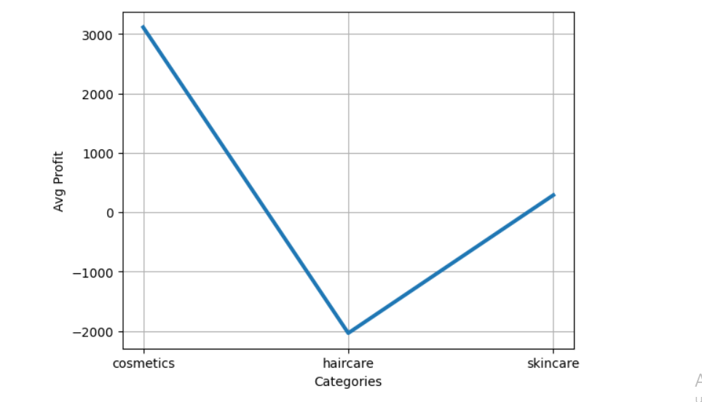
- The analysis indicates a lack of alignment between demand forecasting and warehouse replenishment planning. This misalignment contributes to prolonged Lead Times (20–30 days), reducing supply chain responsiveness and increasing the risk of customer dissatisfaction due to delayed order fulfillment.

- 75% of Lead Time is spent on product production, which takes a long time and can subsequently lead to negative customer reactions and an increase in the number of unsuccessful orders.

- The analysis revealed that for some SKUs (designated as Red and Yellow flags), the production cost is comparable to or exceeds the selling price, indicating potential pricing errors.

- Route A is associated with the highest number of operational failures and the greatest total losses. From a profitability perspective, this is most likely driven by the nature of the goods transported along this route, as it is predominantly used for products with low or negative margins. Consequently, the primary source of losses appears to be the characteristics of the transported goods rather than the route itself. With respect to delivery failures, Route A may be less effective due to its relatively long duration, as indicated by its average delivery time, or due to suboptimal combinations of transportation modes and carriers. These factors may contribute to operational issues and, in some cases, an inability to meet customer expectations.
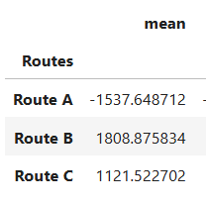

Recommendations:
- It is recommended to review the entire Haircare category, focusing on the product assortment, production conditions, supplier pricing for raw materials, market price analysis, and possible price revisions to improve overall profitability.

- Determine the reason for such a long manufacturing lead time in production; perhaps the reason is incorrect operational/aggregated planning, distribution of production capacities, and so on.

- Conduct a demand forecast for each SKU or category to determine the quantity of materials needed for stock. Provide more data to calculate the purchase point for a certain amount of materials for production.

- !Critical importance! The primary source of losses is incorrect product pricing.In approximately 50% of cases, the selling price is lower than the production cost, which leads to significant financial losses.Therefore, it is essential to conduct market price analysis and adjust product pricing to ensure profitability and long-term business sustainability.

- Further analysis is required to fully understand the reasons for Route A's low performance and the high rate of failed deliveries. One possible explanation is that Route A is the longest, as evidenced by its higher average delivery time, and may therefore be less efficient from an operational perspective.
However, available data indicate that the additional logistics costs associated with this route remain relatively insignificant and do not significantly impact the bottom line. As noted earlier, in this case, the key factor driving the decline in efficiency is likely the product cost, rather than the specifics of the route itself.
To obtain a more reliable and objective assessment, it is necessary to collect additional data on the characteristics of product deliveries and shipments. This will allow us to identify the most profitable and operationally efficient combinations of routes, modes of transport, carriers, and delivery points. Currently, a fully accurate and comprehensive analysis is difficult due to limited available data.

