**

*ORIGAMI*: A Software Suite for Activated Ion Mobility Mass Spectrometry Applied To Multimeric Protein Assemblies

Author: Lukasz G. Migas

© 2017

Contents

Preface 4

Short abstract 4

Disclaimer 4

Citation 4

Installation 5

How to install ORIGAMI*ANALYSE* 5

Pre-requisites 5

Quick Start 5

Analysis of ORIGAMIMS files (combining collision voltages): 5

How to determine the Start scan: 6

How to determine your ORIGAMIMS parameters: 6

How to annotate ions 6

How to extract ions 7

How to combine collision voltages 7

How to process ions 7

How to overlay ions 8

Analysis of Multiple MassLynx files (combining collision voltages): 8

How to open multiple MassLynx files: 8

How to fill-in collision voltage parameters: 9

How to extract ions 9

How to combine collision voltages 9

How to process ions 9

How to overlay ions 9

Peak finding and automatic charge state assignment: 10

Graphical User Interface 11

Main Application Layout 11

Plot Viewer (incomplete) 12

Plot Actions 12

Status bar 13

Toolbar 13

Settings Panel 14

MS Parameters: 14

ORIGAMI Parameters: 14

Peak Fitting 14

Extract Data 15

Plot 1D Parameters 15

Process aIM-MS Data (2D) 15

Plot 2D Parameters 15

Comparison (RMSD) Parameters 16

Document Tree Parameters 16

Import Ion List 16

Styling Properties 16

Image Properties 16

Export Properties 17

Advanced Properties 17

Documents Panel 17

Document Information Panel 19

Processing Panels 20

Peaklist Panel 20

Text Panel 23

Multiple Files Panel 25

Drift-Time Panel (incomplete) 26

CCS Calibration Panel (incomplete) 26

Interactive Output Panel 26

File Formats 28

ORIGAMIMS: 28

Multiple MassLynx files: 29

Drift-time MassLynx files (experimental, not made public yet): 29

Text files: 29

Excel files: 29

Processing Functions 29

Preface

Short abstract

ORIGAMI is designed to provide intuitive graphical interface for routine analysis of mass spectrometry and ion mobility mass spectrometry datasets. The program was designed with activated IM-MS (or CIU) datasets in mind, in particular to speed up the extraction of data, processing and improve the visualisation methods.

Disclaimer

This program is free software. Feel free to redistribute it and/or modify it under the condition you cite and credit the authors whenever appropriate. The program is distributed in the hope that it will be useful but is provided

WITHOUT ANY WARRANTY!

Citation

If you use either of the components of ORIGAMI, please consider citing it in your work. Here is a link to the paper on the IJMS website.

**LG Migas** AP France, B Bellina, PE Barran, ORIGAMI: A software suite for activated ion mobility mass spectrometry (aIM-MS) applied to multimeric protein assemblies, *Int. J. Mass Spectrom.*, 2018, **427**, 20-28, <http://doi.org/10.1101/152686>

Installation

How to install ORIGAMI*ANALYSE*

Actually, there is no actual installation. Simply copy the zipped folder onto your machine, unpack it and that’s it. To start ORIGAMI*ANALYSE* you simply double-click on the **ORIGAMI.exe** (has  logo).

Pre-requisites

1. You have read this guide.
2. Make sure you have access to PC with Driftscope, otherwise you will not be able to analyse MassLynx files. You will still be able to process and visualise text files.

Quick Start

Analysis of ORIGAMIMS files (combining collision voltages):

Analysis of ORIGAMIMS style file is very straightforward. The basic steps are: Open MassLynx file 🡪 Determine Start Scan 🡪 Fill-in ORIGAMIMS parameters 🡪 Extract ions 🡪 Combine collision voltages. More details can be found below.

Firstly, there are four acquisition methods:

* **Linear** – the collision voltage is ramped between **Start Voltage** and **End Voltage** with a defined **Step Voltage** and a pre-defined number of scans per voltage (**SPV**).
* **Exponential** – the collision voltage is ramped between **Start Voltage** and **End Voltage** with a defined **Step Voltage**, however the number of **SPVs** increases as a function of an exponential function. The user specifies to additional parameters **Exponential %** and **Exponential Increment** which determine the rate of the increase.
* **Fitted** – the collision voltage is ramped between **Start Voltage** and **End Voltage** with a defined **Step Voltage**, however the number of **SPVs** increases as a function of a Boltzmann function. The user specifies to additional parameter **Boltzmann Offset** which determines at which point the rate of SPVs should increase.
* **User-defined** – the user provides a list of collision voltages and SPVs which are used during the acquisition. The list in the format:

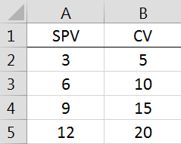

How to open ORIGAMIMS file:

There is a couple ways of opening ORIGAMIMS file:

1. Use the **Menu: File 🡪 Open ORIGAMI MassLynx IM-MS file (.raw)**
2. Use the  button in the toolbar
3. Use the keyboard shortcut: **CTRL+R**

How to determine the Start scan:

1. Change the plot tab to **RT** (Retention Time).

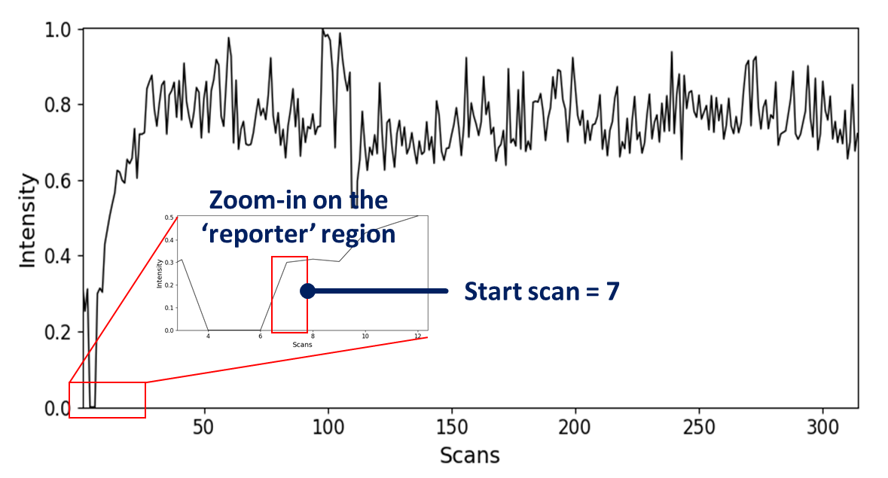

1. Zoom-in on the ‘reporter’ region in the retention time plot. The first value after the break is the start scan. In this case, the start scan is 7 (*i.e*. the first collision voltage in your experiment was applied on the 7th scan).

***Note****: Zooming – drag your mouse inside the plot window. Zooming-out – double click inside the same plot window. More information about* ***plot actions*** *is discussed later on.*

How to determine your ORIGAMIMS parameters:

There are only two ways you can figure out your parameters:

1. You saved them in your lab book or in the header of the MassLynx file (recommended)
2. You have saved them inside MassLynx file using the Save parameters button in **ORIGAMIMS**GUI

If you have not done either of these ways, you can try to figure out your parameters by going to the folder containing **ORIGAMIMS** program and looking for the appropriate *ORIGAMI_log_DATE_TIME.log* file which contains ***all*** commands executed in in **ORIGAMIMS**GUI.

How to annotate ions

Each ion can be annotated with charge state, label, colormap and ORIGAMIMS parameters. While it is rather unlikely that you would need to modify ORIGAMIMS parameters for the same document, it might be necessary if you have multiple documents loaded simultaneously.

To annotate an ion, left-click on the ion of interest in the table and information about it should appear in the **Annotation** box below. Change parameters as required, and press **Apply**.

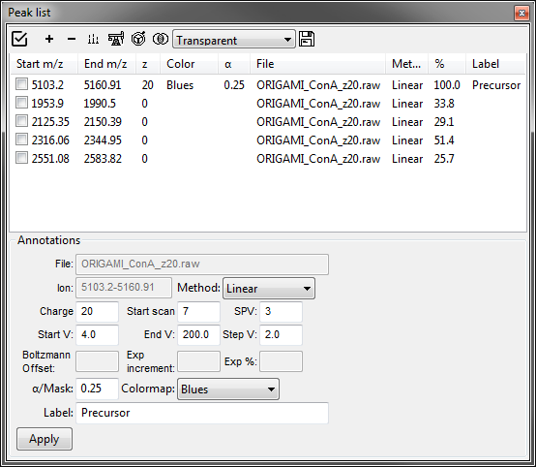

*Peak list panel.*

***Warning:*** *If you decide to change ORIGAMIMS parameters, make sure you have previously extracted and combined that ion. Otherwise, you will be greeted with an error message in the status bar. Also, if you would like to re-combine collision voltages, you will have to select the ‘Override’ and ‘Use internal parameters’ option in the toolbar.*

How to extract ions

Before you can combine collision voltages, you have to extract drift time information for specific ion or ions. You can extract ions by holding **CTRL** on your keyboard and dragging the mouse over a peak of interest. The ion will be added to the *Peaklist Panel*, however it will not be automatically extracted. To extract an ion, you have to go to **Peaklist Panel 🡪  (Extract)** **🡪 Extract…** or use the shortcut, **ALT+E.** You can perform this action on single ion (check the box and select **Extract selected ions**) or in batch mode (**Extract all ions**).

If all went well, you should see a new branch in the *Documents Panel* document tree - **Extracted 2D IM-MS (multiple ions)**.

How to combine collision voltages

Once you extracted mobility data for each ion and filled in appropriate parameters, you can combine collision voltages in the *Peaklist Panel* (**Peaklist Panel 🡪** ** (Process)** **🡪** **Combine CVs…**).

If all went well, you should see a new branch in the *Documents Panel* document tree – **Combined CV RT IM-MS (multiple ions)** and **Combined CV 2D IM-MS (multiple ions)**.

***Warning****: Remember that if you loaded multiple ORIGAMIMS-type files in, the parameters in GUI can (but might not be) used for all of them. If you would like to use specific parameters for specific document, you will have to select specific ions using the checkboxes in the peaklist and use the ‘Combine CVs for selected ions (ORIGAMI)’ option.*

How to process ions

In some cases, it might be necessary to process single or multiple ions at once, in order to either improve their aIM-MS map or compare to one another. Processing can involve thresholding (noise removal), smoothing and/or normalisation.

Before you can process ions, you must choose desired settings in the Settings Panel (i.e. smoothing function, threshold value and/or normalisation function). To process ions, you simply go to Peaklist Panel 🡪  (Process) 🡪 Process…. You can either apply the chosen settings to all ions (Process all ions) or to the ones selected in the table (Process selected ions).

*Warning: It is critical that you process ions of the same type (i.e. you should either be working on ‘Combined’ or ‘Extracted’ ions only). If you mix the two types together, it might be hard to track down (other than visualising or saving to a file) which one belongs to which type. By default, if the document has both ‘Extracted’ and ‘Combined’ ions present in the document tree, ORIGAMI will try to use the ‘Combined’ dataset first.*

How to overlay ions

In order to visualise more than one ion simultaneously, either from the same or different documents, ORIGAMI has two methods available: ‘Mask’ and ‘Transparent’. These overlay methods display two plots on top of one another, and depending on the selection, either apply a low-intensity mask or transparency filter.

In addition to the overlay methods, statistical methods such as ‘Mean’, ‘Standard Deviation’, ‘Variance’, ‘Root Mean Square Deviation’ and others are also available, however these are more suitable for comparison of ions between different documents or text files, rather than from within a single document.

In order to overlay ions together, select two species in the table, press on the Peaklist Panel 🡪  (Overlay) 🡪 Overlay 2D (selected). A pop-up should appear to create a *New Document* where all comparison data is kept, separate from the raw data document. It is usually more suitable to normalise the 2D array prior to displaying them together, since large differences in intensity can lead to artefacts in the resultant image.

*Note: You can change the parameters that determine the quality of the overlay functions in the Annotation panel by changing the value of Transparency text box and selecting a different colormap for each ion. Typical values for ‘Mask’ methods are 0.25, whilst for ‘Transparent’ 0.5 and 1 should be used. By changing this value, one of the selected ions will be more or less pronounced.*

Analysis of Multiple MassLynx files (combining collision voltages):

Combing collision voltages for multiple MassLynx files is equally straightforward as the ORIGAMIMS method. The basic steps are: Open multiple MassLynx files 🡪 Fill-in collision voltage parameters in the table 🡪 Extract ions 🡪 Combine collision voltages. More details can be found below.

How to open multiple MassLynx files:

There is a couple ways of opening multiple MassLynx files simultaneously:

1. Use the **Menu: File 🡪 Open Multiple MassLynx IM-MS file (.raw)**
2. Use the  button in the toolbar
3. Use the keyboard shortcut: **CTRL+SHIFT+R**

How to fill-in collision voltage parameters:

Once multiple files were opened, a new panel should appear (*Multiple Files Panel*) which should have a list of MassLynx files. To fill in the collision voltages, simply double-click on the item in the ‘Energy’ column. This field is usually auto-filled in if the collision voltage was recorded in the MassLynx file.

***Warning****: Make sure you sort your list of MassLynx files from low-to-high by clicking on the column ‘Energy’.*

How to extract ions

Before you can combine collision voltages, you have to extract drift time information for specific ion or ions. You can add ions to the peak list table by holding **CTRL** key on your keyboard and dragging the mouse over a peak of interest. The ion will be added to the *Peaklist Panel*, however it will not be automatically extracted. To extract an ion, you have to go to **Peaklist Panel 🡪  (Extract)** **🡪 Extract…** or use the shortcut, **ALT+E**. You can perform this action on single ion or in batch mode.

If all went well, you should see a new branch in the *Documents Panel* document tree - **Combined CV 2D IM-MS (multiple ions)** which contains raw data for each selected ion.

How to combine collision voltages

Actually, if you have filled in your collision voltages earlier on, this would have already been done for you.

How to process ions

In some cases, it might be necessary to process single or multiple ions at once, in order to either improve their aIM-MS map or compare to one another. Processing can involve thresholding (noise removal), smoothing and/or normalisation.

Before you can process ions, you must choose desired settings in the Settings Panel (i.e. smoothing function, threshold value and/or normalisation function). To process ions, you simply go to Peaklist Panel 🡪  (Process) 🡪 Process…. You can either apply the chosen settings to all ions (Process all ions) or to the ones selected in the table (Process selected ions).

*Warning: It is critical that you process ions of the same type (i.e. you should either be working on ‘Combined’ or ‘Extracted’ ions only). If you mix the two types together, it might be hard to track down (other than visualising or saving to a file) which one belongs to which type. By default, if the document has both ‘Extracted’ and ‘Combined’ ions present in the document tree, ORIGAMI will try to use the ‘Combined’ dataset first.*

How to overlay ions

In order to visualise more than one ion simultaneously, either from the same or different documents, ORIGAMI has two methods available: ‘Mask’ and ‘Transparent’. These overlay methods display two plots on top of one another, and depending on the selection, either apply a low-intensity mask or transparency filter.

In addition to the overlay methods, statistical methods such as ‘Mean’, ‘Standard Deviation’, ‘Variance’, ‘Root Mean Square Deviation’ and others are also available, however these are more suitable for comparison of ions between different documents or text files, rather than from within a single document.

In order to overlay ions together, select two species in the table, press on the Peaklist Panel 🡪  (Overlay) 🡪 Overlay 2D (selected). A pop-up should appear to create a *New Document* where all comparison data is kept, separate from the raw data document. It is usually more suitable to normalise the 2D array prior to displaying them together, since large differences in intensity can lead to artefacts in the resultant image.

*Note: You can change the parameters that determine the quality of the overlay functions in the Annotation panel by changing the value of Transparency text box and selecting a different colormap for each ion. Typical values for ‘Mask’ methods are 0.25, whilst for ‘Transparent’ 0.5 and 1 should be used. By changing this value, one of the selected ions will be more or less pronounced.*

Peak finding and automatic charge state assignment:

The peak finding algorithm can operate in MS, RT or RT/MS mode to find peaks and areas of interest in the respective windows. Here, however, we are interested in find peaks in the mass spectrum window, and ideally, automatically assigning charge state. The basic steps to use the *Peak Finding* tool include: Loading a file with MS information 🡪 Adjusting peak finding parameters 🡪 Finding peaks 🡪 Adding found peaks to the *Peaklist Panel*. In order to speed-up analysis and improve the analysis workflows, the peak finding algorithm includes a simple isotope finding algorithm, to try to predict the charge state of high-resolution mass spectrum; while it gets things wrong occasionally, it is relatively reliable.

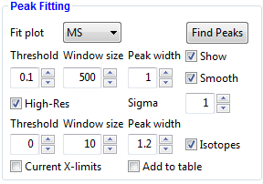

*Peak fitting panel*

How to open file with MS information

Opening files was covered earlier on, briefly, you can open ORIGAMIMS style files using the keyboard shortcut **CTRL+R** (or **CTRL+SHIFT+Q** to open more than one), single or multiple MassLynx files (IM-MS) using **CTRL+SHIFT+R** or drift tube MassLynx files using **CTRL+F**.

Adjusting peak finding parameters

The efficiency of the peak finding algorithm is dependent on several parameters including: **Threshold**, **Window size** and **Smoothing** settings. These determine the sensitivity of the algorithm and can vary depending on the type of mass spectrum that is being examined. In case of proteins where the peak density is quite low, the value of Window size can be set quite high (i.e. 1500-2500), whereas for small molecules values of 500 should be considered. The threshold value is simply responsible to determine what the minimal intensity of the peak is before it is considered a noise peak.

The best practice and advice is to load your mass spectrum and play with the parameters to see what works for you. The parameter **Peak width** determines the size of the envelope around the detected peak. **Smoothing** of the MS peaks is optional, however should be enabled for noisy mass spectra (the degree of smoothing is controlled by the value of **Sigma**).

*Note: Currently, the peak width is constant for all peaks, however in near future I should be able to release a new algorithm which uses the shape of the MS peak to determine the Peak width.*

Charge state detection

In case you would like to predict the charge state of the found peaks, you must enabled the **High-Res** checkbox. This function uses familiar parameters of **Threshold**, **Window size** and **Peak width** to find the isotopes of the selected peak. Here, the window size has to be narrowed down to values of 5-50; the peak width value should be approximately the same as in the peak finding function. Checking the **Isotopes** checkbox will show the found isotope peaks in the mass spectrum window.

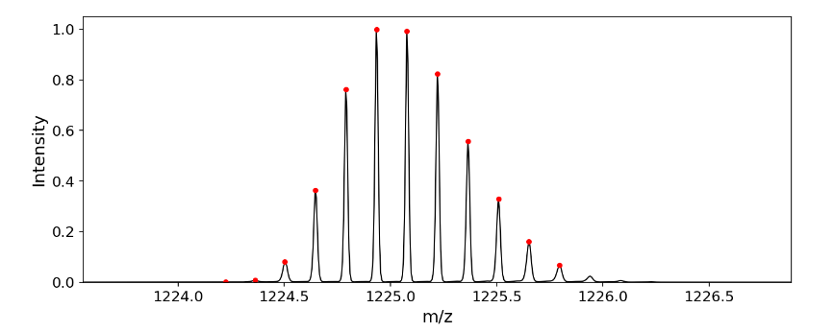

*Mass spectrum of Ubiquitin [M+7H]7+* with detected isotopes.

**Finding and adding peaks to the Peak list table**

In order to add peaks to the *Peak list*, just check the Add to table checkbox. Detected peaks will be automatically added to the table. Make sure to extract data for each peak by selecting **Peaklist Panel 🡪  (Extract)** **🡪 Extract…** or use the shortcut, **ALT+E**.

Graphical User Interface

Main Application Layout

ORIGAMI*ANALYSE*interface is split into three segments. The left side of the GUI contains the *Settings Panel* which enables modification of most of the parameters and the *Documents Panel* which is used to store document information and enables visualisation. The middle part of the GUI contains the *Plot Panel* where all plots are shown. The right part of the GUI is interchangeable and may house any of the additional *Panels (Peaklist, Text, Multiple Files, DT, CCS Calibration* and *others*). The GUI is modular (*i.e.* all part from the *Settings* and *Plot Panels*) and each panel can be docked-out and moved elsewhere in the GUI or sit outside of it.

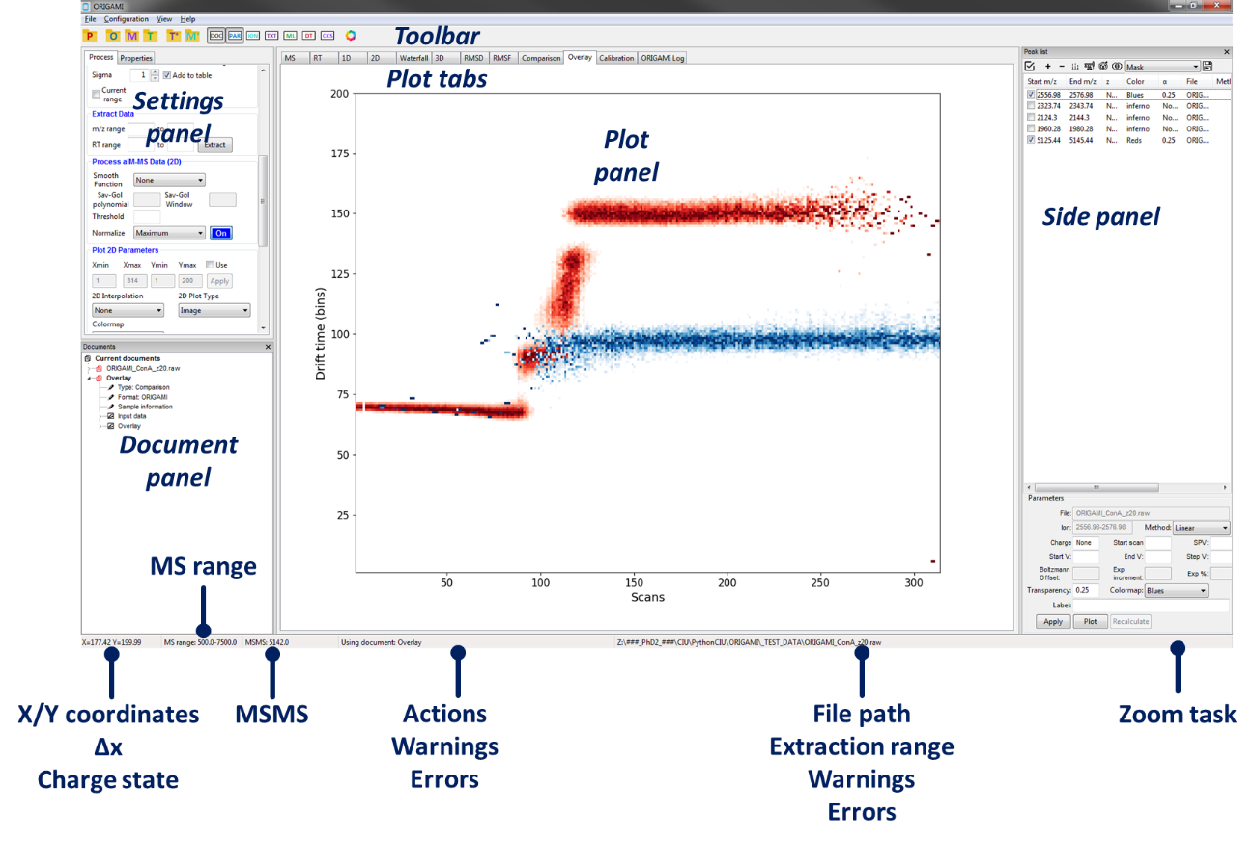

At the bottom of the window, the status bar shows mouse coordinates in the plot area in the *Plot Panel*, the MS range, the MSMS value, current action, any errors or warnings, file path to the recently activated document and current active zooming task.

Plot Viewer (incomplete)

Plot Actions

All actions in the plot area in ORIGAMI are controlled using the left-button of the mouse and selection of keys on your keyboard (**ALT**, **SHIFT** and **CTRL**).

**Zoom-in drag (box)** – drag mouse in the plot area using rectangular fashion

**Zoom-in drag (x-axis)** – drag mouse in the plot area using horizontal fashion

**Zoom-in drag (y-axis)** – drag mouse in the plot area using vertical fashion

**Zoom using mouse wheel (x-axis)** – use the mouse wheel to either zoom-in or zoom-out

**Zoom using mouse wheel (y-axis)** – hold **SHIFT** on your keyboard and use the mouse wheel to either zoom-in or zoom-out

**Zoom-out** – double-click in the plot area or hold **CTRL** on your keyboard + left-mouse click

**Extract ion** – hold **CTRL** on your keyboard + left-drag cursor in the plot area

**Measure** – you can either left-drag mouse in the plot area in horizontal manner (*i.e.* during zooming-in) or hold hold **ALT** on your keybord and left-drag (*i.e.* without zooming-in). The selection width (Δx) is shown in the status bar in the bottom left corner



**Context menus** – right-click in the plot area to reveal plot-specific context menu

***Note:*** *Actions in the 3D plot are slightly different. To zoom in, you have to right-click and push/pull while rotation is enabled by left-click dragging.*

Status bar

The status bar found at the bottom of the window panel displays lots of useful information.

**XY coordinates** – current coordinates for currently selected plot/window

**Δx** – distance in the x-axis (shown when **ALT** or **CTRL** key is pressed)

**z** – charge state for selected mass range (when **ALT** key is pressed)

**MS range** – the mass range that was specified in the MassLynx file

**MSMS value** – the MSMS value that was specified in the MassLynx file

**XY range of region to be extracted** – currently highlighted range in MS, RT or DT/MS window

**Zoom task** – currently enabled mouse task (enabled by hovering over plot area and pressing one of designated shortcut keys on the keyboard)

Toolbar

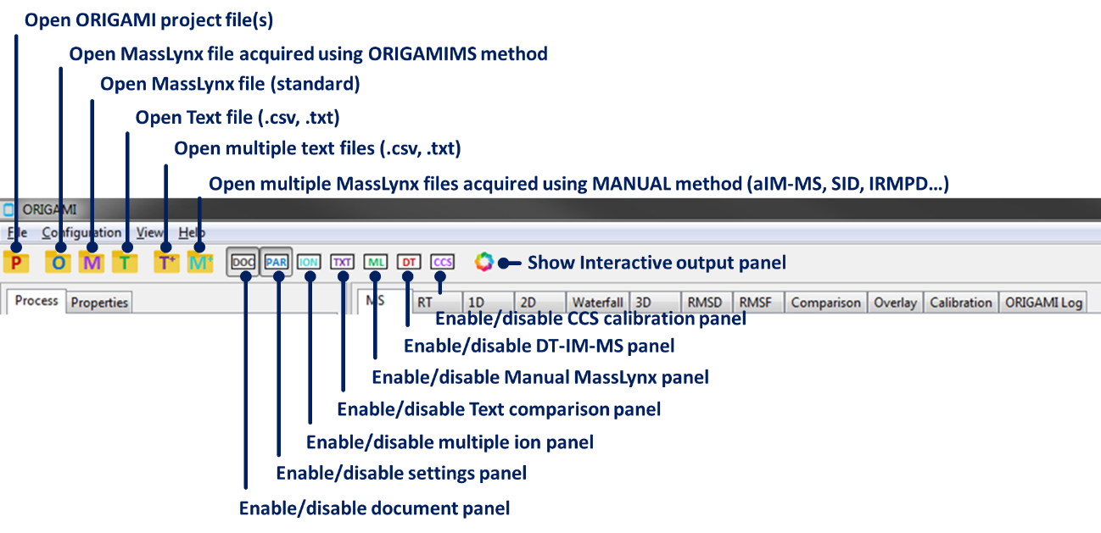

*Toolbar*

* **To open ORIGAMIANALYSE project file** –click on the   button
* **To open ORIGAMIMS MassLynx file** –click on the button
* **To open MassLynx file** –click on the   button
* **To open text file** –click on the   button
* **To open multiple text files** –click on the   button
* **To open multiple MassLynx files** –click on the   button
* **To enable/disable Document panel** –click on the   button
* **To enable/disable Settings panel** –click on the   button
* **To enable/disable Peaklist panel** –click on the   button
* **To enable/disable Text panel** –click on the   button
* **To enable/disable Multiple Files panel** –click on the   button
* **To enable/disable Drift-Time panel** –click on the   button
* **To enable/disable CCS Calibration panel** –click on the   button
* **To enable/disable Interactive Output panel** –click on the   button

Settings Panel

The **Settings Panel** has two tabs. The first, **Process** tab is predominantly to perform any operations on the loaded dataset whereas the second **Properties** is more focused on adjusting output parameters (*i.e.* export format, image resolution and such).

MS Parameters:

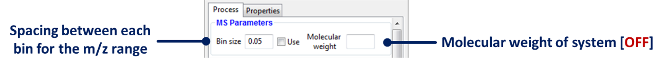

***Warning****: ‘Molecular weight’ is currently not use, however will be available in future release.*

ORIGAMI Parameters:

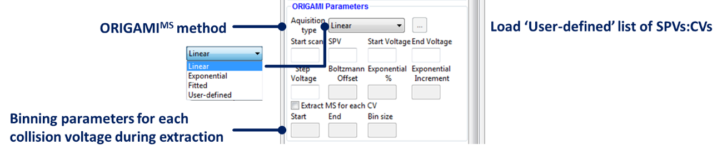

Peak Fitting

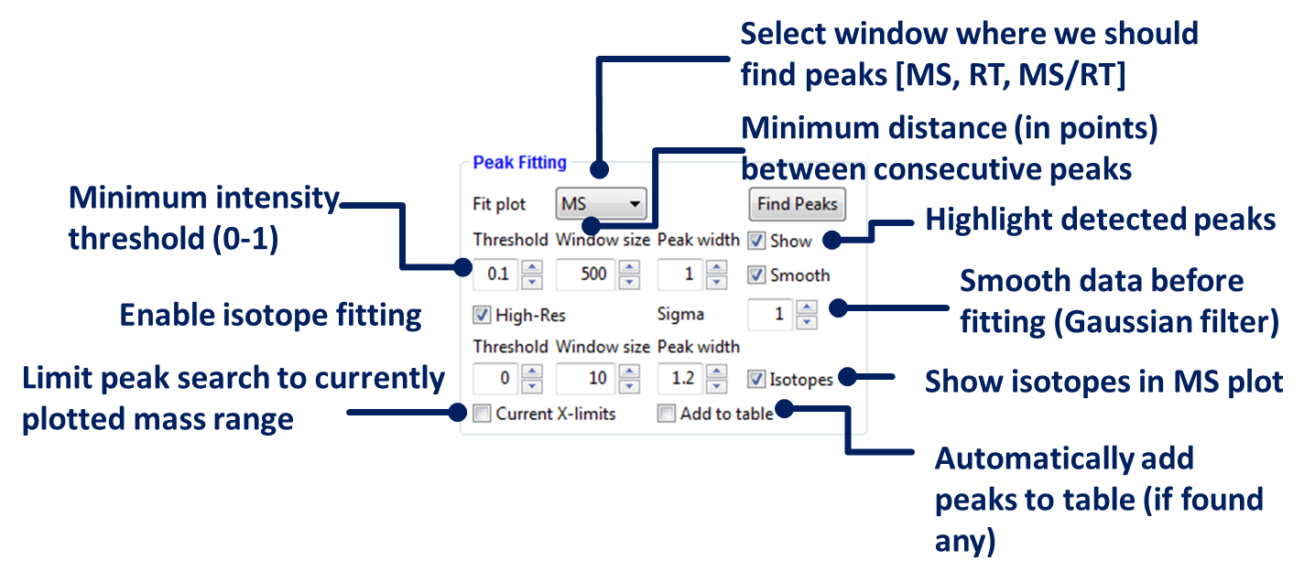

***Warning****: ‘High-Res’ checkbox is currently not use, however will be available in future release.*

Extract Data

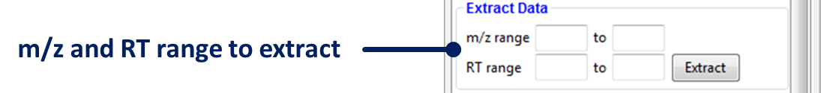

***Warning****: ‘RT range’ boxes are currently not use, however will be available in future release.*

Plot 1D Parameters

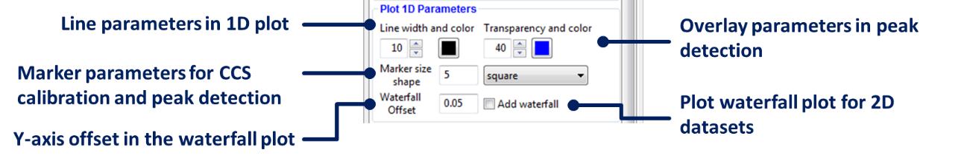

***Warning****: Enabling waterfall plot can have large impact on the performance of ORIGAMI – especially for datasets with large number of scans.*

Process aIM-MS Data (2D)



Plot 2D Parameters

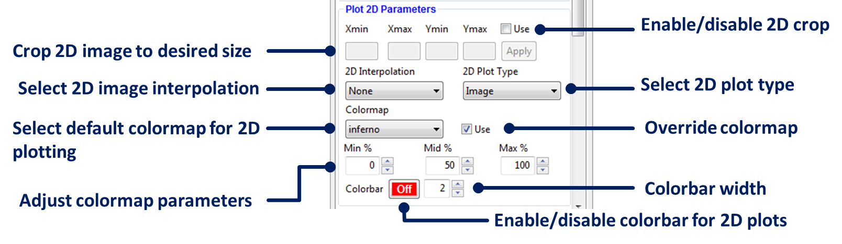

***Note****: The colormap adjustment changes the start, mid and end point of the colormap, which usually is 0-50-100 %. It can be used to improve the visibility of low intensity species. It is disabled for RMSD/RMSF plots where values can range between -1 to +1.*

***Note****: The ‘Use colormap’ override checkbox forces all 2D/3D plots to be plotted with the select default colormap. By unchecking it, you enable individual colormaps to be used.*

Comparison (RMSD) Parameters

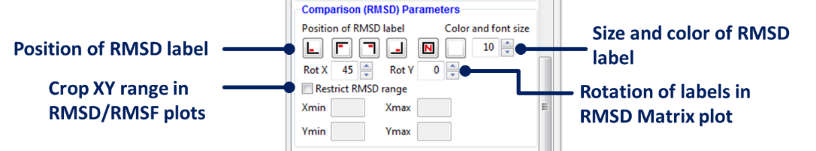

Document Tree Parameters

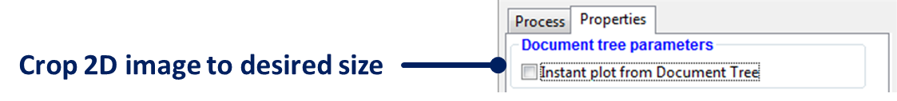

***Note****: Enabling the ‘Instant plot from Document Tree will allow automatic plotting of selected item in the Document Panel.*

Import Ion List

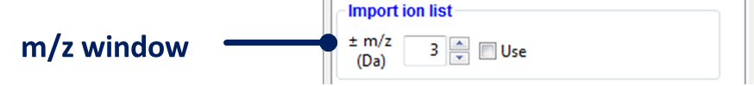

***Note****: Default width of the m/z peak during import of peaklist into the Peaklist Panel – only used if the file was missing header keyword ‘window’.*

Styling Properties

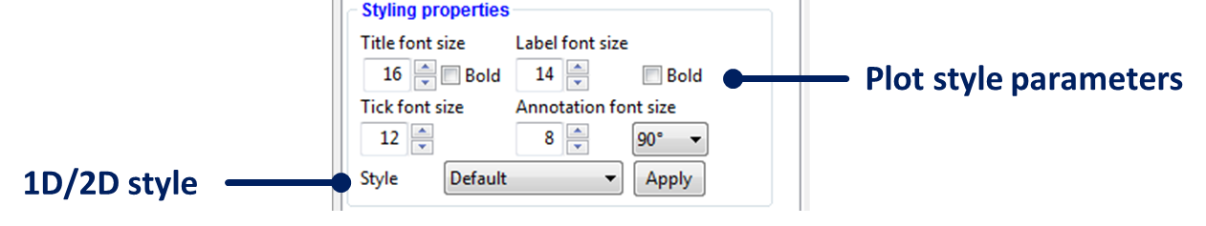

***Warning:*** *Title parameters are currently not use, however will be available in future release.*

Image Properties

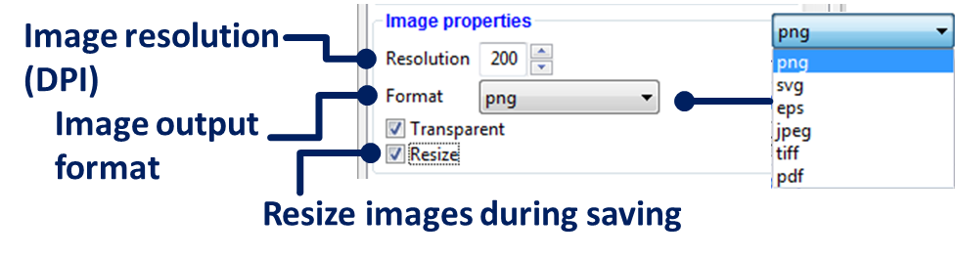

***Note****: When ‘Resize’ is checked, ORIGAMI will replot the plot to a pre-set image sizes. You can change the defaults in the Advances Properties section.*

***Warning:*** *Saving in TIFF format is currently not recommended as it does not use compression which can result in very large file. This will be fixed in a near future.*

Export Properties

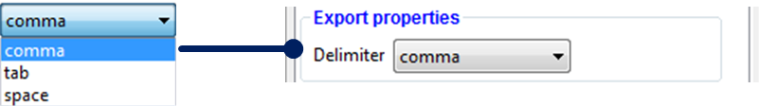

Advanced Properties

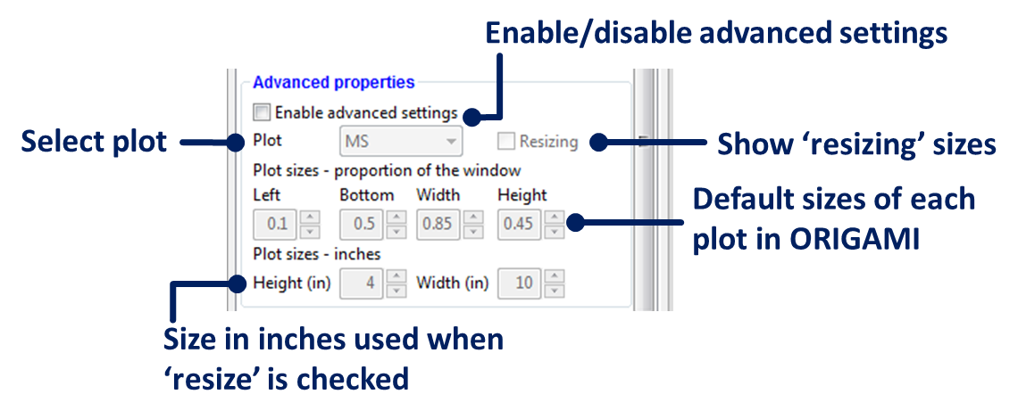

***Note****: Advanced properties are currently limited to setting correct sizes of plots. You can adjust the default size of any plot by selecting the plot, adjusting the left, bottom, width and height parameters and replotting the plot.*

Documents Panel

The main purpose of the *Documents Panel* is to give organised view of the user’s workspace and enable operation on multiple files simultaneously. Each document is built like a tree, with various branches and sub-branches containing associated data. Each element in the document tree can be accessed by using the context menu (right click).

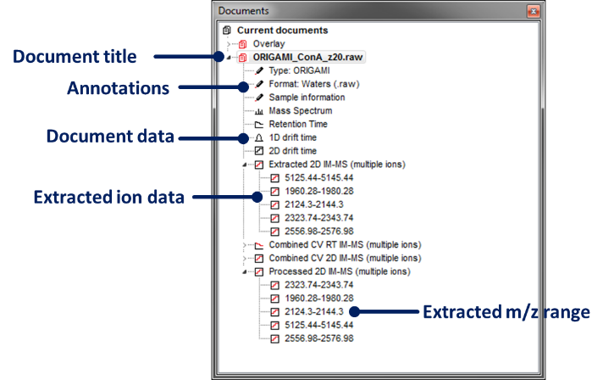

*Documents Panel*

* **To enable document**

Click on any sub-element or title of the document you want to select. Selected document is marked by a bold title and can be determined from the ORIGAMI window name.

* **To save document**

Right-click on any sub-element or title of the document you want to save and select **Save document to file** in the context menu or press **CTRL+P** on your keyboard. A new window will appear where you can select path and name. All documents have .pickle appended to their name.

* **To save all documents**

First select the header ‘Current documents’, then right-click and select **Save all documents**. A new window will appear where you can select path and name for each document.

* **To annotate document**

Right-click on any sub-element or title of the document you want to annotate and select **Notes, Information, Labels…** or press **CTRL+I** on your keyboard. A new window will appear where you can change document (and item parameters) such as charge state, labels, CCS calibration parameters, etc…

* **To show data**

Right-click on the sub-element you want to show and select **Show…** This heading changes depending on what type of data has been selected. In some instances (*i.e.* looking at extracted 2D IM-MS maps), you will be given options to:

* **Show**: generic plotting function. The same action can be accomplished by using the keyboard shortcut **Alt+S**.
* **Process and plot**: the 2D heatmap for selected item will be pre-processed with normalisation, noise removal and smoothing functions. The processing parameters are taken directly from the GUI from **Process aIM-MS Data (2D)**. The same action can be accomplished by using the keyboard shortcut **Alt+P**.
* **Zoom in MS:** the plot window will change to the **MS** panel while the MS range will be restricted to the selected *m/z* range.
* **Show RT plot**: the plot window will change to **RT** panel and the retention time plot will be shown for selected ion.
* **Show 1D IM-MS plot**: the plot window will change to **1D** and the arrival time distribution plot will be shown for selected ion.
* **To save data**

Right-click on the sub-element itself and select **Save data (.csv)**. A new window will appear where you can select filename for the item. Batch saving is possible by right-clicking on the header of the sub-element. Delimiter information is taken from the GUI (**Properties 🡪 Export properties**).

* **To save images**

Right-click on the sub-element itself and select **Save figure (.png)**. A new window will appear where you can select filename for the item. Batch saving is possible by right-clicking on the header of the sub-element. File format, resolution and other parameters are taken from the GUI (**Properties 🡪 Image properties**)

* **To go to folder containing raw data**

Right-click on any sub-element or title of the document and select **Go to folder…** or press **CTRL+G** on your keyboard. If the path to the document is correct, a new Windows window will show up.

* **To delete item**

First select the item, then right-click and select **Delete item**.

* **To delete document**

Right-click on any sub-element or title of the document you want to delete and select **Delete document** in the context menu. A warning message will appear to ask if you definitely want to close the document.

* **To delete all documents**

First select the header ‘Current documents’, then right-click and select **Delete all documents**.

Document Information Panel

Each document in the *Documents Panel* has associated user information, be it mass spectrometry acquisition parameters, experimental conditions, charge state or such. These can be modified for individual elements or for the whole document. The *Document Information Panel* can be accessed by right clicking on the desired document and selecting **Notes, Information, Labels…** or through the shortcut **CTRL+I**.

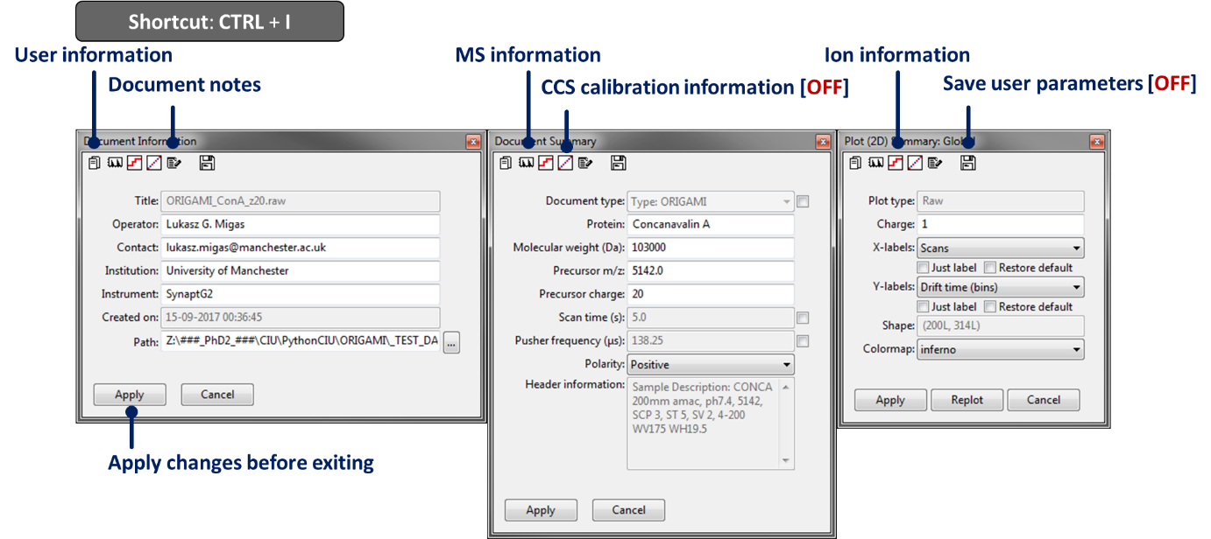*Document Information Panel*

* **To change user parameters**

Go to the ‘Document Information’ window (). Type in your user parameters and press **Apply** and make sure to export configuration file (Menu: **Configuration 🡪 Export Origami Config** or press **CTRL+S** on your keyboard).

* **To change document path**

Go to the ‘Document Information’ window (). Check the checkbox next to the line **Path** and use the button () right next to it to select the new path to the document (or .raw file).

***Note****: This action should be avoided unless the path to the .raw file has changed or the document is viewed on another PC where the path is no longer correct.*

* **To change document type**

Go to the ‘Document Summary’ window (). Check the checkbox next to the line **Document type**, choose your document type and press **Apply**.

***Warning****: This function is not fully operational! Proceed with care.*

* **To change pusher frequency**

Go to the ‘Documents Summary’ window (). Check the checkbox next to the line **Pusher frequency (μs)**, type in your value and press **Apply**.

***Warning****: Pusher frequency is automatically determined from the MassLynx file. If you think it is wrong, please change it.*

* **To change the TOF correction factor (EDC)**

Go to ‘Document Summary’ window (). Check the checkbox next to the line **TOF corr. factor (EDC)**, type in the new value and press **Apply**.

***Warning****: Pusher frequency is automatically determined from the MassLynx file. If you think it is wrong, please change it.*

* **To change document/item charge state**

Go to ‘Plot (2D) summary’ window (). Type in charge value and press **Apply**.

* **To change x- and y-axis labels**

Go to ‘Plot (2D) summary’ window (). Select your label and press **Apply**.

***Warning****: This function is not fully operational! It works but can occasionally do unexpected things…*

* **To change colormap**

Go to ‘Plot (2D) summary’ window (). Select your colormap and press **Apply**.

* **To view and adjust CCS calibration parameters**

Go to ‘CCS Calibration Summary window ().

***Warning****: This function is still under development.*

* **To annotate document**

Go to ‘Notes’ window (). Type in your notes and press **Apply**.

Processing Panels

Peaklist Panel

Peaklist is used to extract, process and visualise various charge states of a single or multiple documents. It acts as a main (but not only) extraction window, specifically for aIM-MS datasets. Peaks can be added by selection in the mass spectrum (press **CTRL** and dragging with left mouse key over the peak of interest), by loading a list of peaks from a .csv file or by using the settings panel. Each peak can be manually annotated.

To enable the panel, click on the  button, **Menu: View 🡪 Enable multi ion panel…** or press **CTRL+3** on your keyboard.

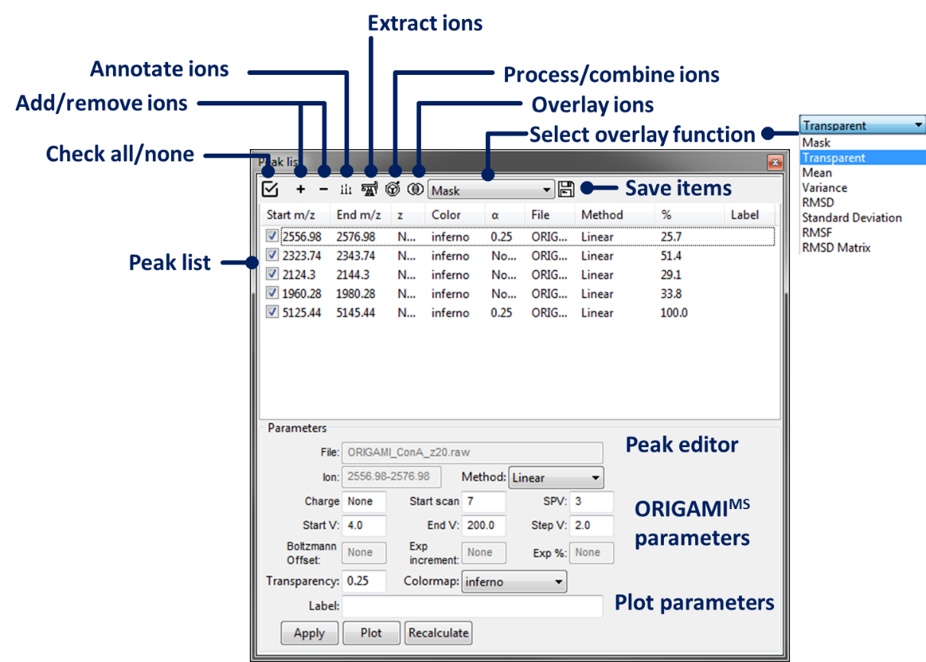

*Peaklist Panel*

* **Check all/none items**

Click on the  button in the toolbar. To unselect all double-click.

* **Add list of ions from .csv/.txt file**

Click on the  button in the toolbar and select **Add list of ions (.csv/.txt)** or press **CTRL+L** on your keyboard. A new window will open where you can select a formatted text file.

***Warning****: The text file should contain the header and columns containing: ‘m/z, window, z, label’. In case it is incorrectly formatted, an error will occur.*

* **Add ions to the list**

There are four ways you can add ions to the table:

1. Load a list of ions from .csv/.txt (as listed above)
2. Type in extraction range in the GUI (**Process 🡪 Extract Data 🡪 m/z range**)
3. Press **CTRL** and drag in the MS window over a peak of interest.
4. Automatically find peaks using the ‘Peak finder’ tool in the GUI (**Process 🡪 Peak Fitting**) – see more in the **Peak Fitting** section

In most cases, you will be required to extract ions before you can visualise them. Discussed below.

* **Create comparison document**

Click on the  button in the toolbar and select **Add new comparison document**.

* **Clear table**

Click on the  button in the toolbar and select **Clear table**.

* **Remove duplicates**

Click on the  button in the toolbar and select **Remove duplicates**.

***Warning****: This function does not function quite properly yet. In case it doesn’t do what you intended, manually select items and remove them using the ‘Remove selected ions’ option.*

* **Remove selected or all ions**

Click on the  button in the toolbar and select **Remove selected ions** or **Remove all ions**. In case of removing all ions, a warning will appear.

* **Show ions in MS**

Click on the  button in the toolbar to show the extracted ions in the MS window (overlayed rectangles).

* **Extract new, selected or all ions**

Click on the  button in the toolbar and select one of the options:

1. **Extract new ions** –the program will only extract ions that have not been previously extracted. Should be used if viewing multiple documents.
2. **Extract selected ions** – the program will only extract ions that have been checked in the table. Should be used if viewing multiple documents.
3. **Extract all ions** –the program will extract all ions for each opened document. In case you have extracted some before, these will be overwritten.

* **Process selected or all ions**

Click on the  button in the toolbar and select one of the options:

1. **Process selected ions** – the program will only process selected ions.
2. **Process all ions** – the program will process all ions for each opened document.

Processing parameters are taken from the GUI.

* **Combine collision voltages for ORIGAMIMS files**

Click on the  button in the toolbar and select one of the options:

1. **Combine CVs for selected ions (ORIGAMI)** – the program will only combine collision voltages for selected ions. Should be used if viewing multiple documents.
2. **Combine CVs for all ions (ORIGAMI)** –the program will combine collision voltages for all ions for each document. In case you have extracted and combined some before, these might be overwritten.

***Warning****: In case you would want to overwrite previously combined data, please click on the ‘Override’ item in the context menu.*

***Warning****: In case you would want to use internal parameters (rather than those from GUI), please click on the ‘Use internal parameters’.*

* **Extract MS for each collision voltage**

Click on the  button in the toolbar and select **Extract MS for each CV (ORIGAMI)**.

***Warning****: Make sure you filled in appropriate parameters in the GUI (Process 🡪 ORIGAMI Parameters)*

* **Select overlay function**

Click on the combo box and select one of the available functions: *Mask, Transparent, Mean, Variance, RMSD, Standard Deviation, RMSF, RMSD Matrix*.

***Warning****: All of the functions require at least two items in the table. These have to be checked.*

* **Overlay ions**

First, select ions in the table and then click on the  button in the toolbar. You can overlay ions in RT (retention time), 1D or 2D (drift time).

***Warning****: Comparison of 1D and RT data is currently not saved to the ‘Comparison document’ nor to the ion document. If you would like to save the image of the comparison, you must right-click in the window and press ‘Save figure’ which will prompt you to select file name.*

* **Annotate ions**

Select peak in the table by left-clicking it. The annotation window will be populated, depending on which peak is selected. Annotate relevant fields and press **Apply.**

* **Export figures**

Click on the  button in the toolbar and select one of the options:

1. **Save selected figure (.png)** – saves figures for selected ions only.
2. **Save all figures (.png)** – saves figures for all ions for each document in the table.

Takes parameters from the GUI (**Properties 🡪 Image properties**)

* **Export data**

Click on the  button in the toolbar and select one of the options:

1. **Save selected 2D (comma delimited)** –saves text file for selected ions only.
2. **Save all 2D (comma delimited)** – saves text files for all ions for each document in the table.

Takes parameters from the GUI (**Properties 🡪 Export properties**)

Text Panel

Text filelist is used to process and overlay multiple text files simultaneously.

To enable the panel, click on the  button, **Menu: View 🡪 Enable multi text panel…** or press **CTRL+4** on your keyboard.

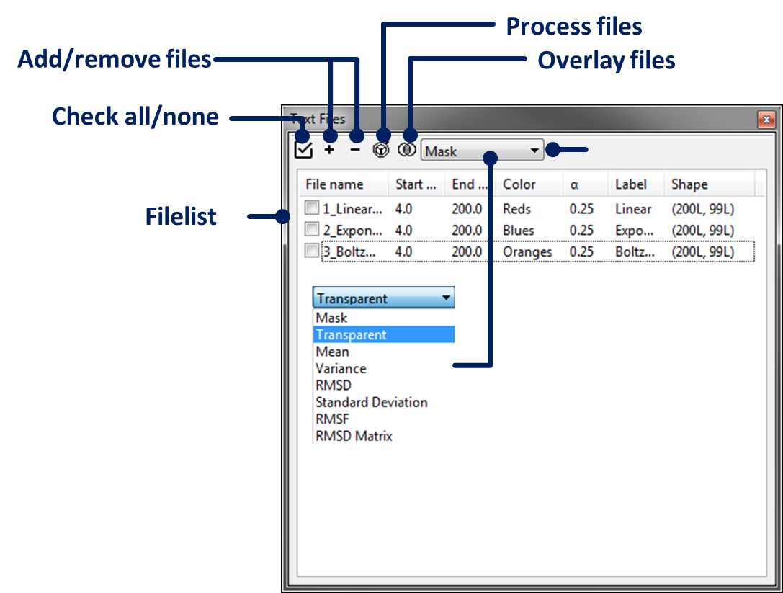

*Text Panel*

* **Check all/none items**

Click on the  button in the toolbar. To unselect all double-click.

* **Add multiple text files**

There are multiple ways you can add text files to the table:

1. Click on the  button in the toolbar and a selection tool will appear. You can select single or multiple files simultaneously. To select more than one file, just hold **CTRL** or **SHIFT** key on your keyboard.
2. Enable the same window using keyboard shortcut: **CTRL+SHIFT+T** or by clicking in **Menu: File 🡪 Open multiple 2D Text files** or click on the  button in the main toolbar.
3. Open single text file by pressing **CTRL+T** on your keyboard, selecting **Menu: File 🡪 Open 2D Text file** or by clicking on the  button in the main toolbar.

* **Create comparison document**

Click on the  button in the toolbar and select **Add new comparison document**.

* **Clear table**

Click on the  button in the toolbar and select **Clear table**.

* **Remove duplicates**

Click on the  button in the toolbar and select **Remove duplicates**.

***Warning****: This function does not function quite properly yet. In case it doesn’t do what you intended, manually select items and remove them using the ‘Remove selected ions’ option.*

* **Remove selected or all items**

Click on the  button in the toolbar and select **Remove selected ions** or **Remove all ions**. In case of removing all items, a warning will appear.

* **Process selected or all ions**

Click on the  button in the toolbar and select one of the options:

1. **Process selected ions** – the program will only process selected ions.
2. **Process all ions** – the program will process all ions for each opened document.

Processing parameters are taken from the GUI.

* **Select overlay function**

Click on the combo box and select one of the available functions: *Mask, Transparent, Mean, Variance, RMSD, Standard Deviation, RMSF, RMSD Matrix*.

***Warning****: All of the functions require at least two items in the table. These have to be checked.*

* **Overlay ions**

First, select items in the table and then click on the  button in the toolbar. You can overlay items in 2D (drift time) only.

Multiple Files Panel

Multiple files panel is used to load a list of MassLynx files which can be processed simultaneously. In most circumstances, the list of files might correspond to activated IM-MS dataset for which collision voltage (or other activation parameter) were sequentially increased. Once a list of files is loaded, the user is prompted to create a new document file which contains individual mass spectra for each file and a summed mass spectrum.

To enable the panel, click on the  button, **Menu: View 🡪 Enable multi MassLynx panel…** or press **CTRL+5** on your keyboard.

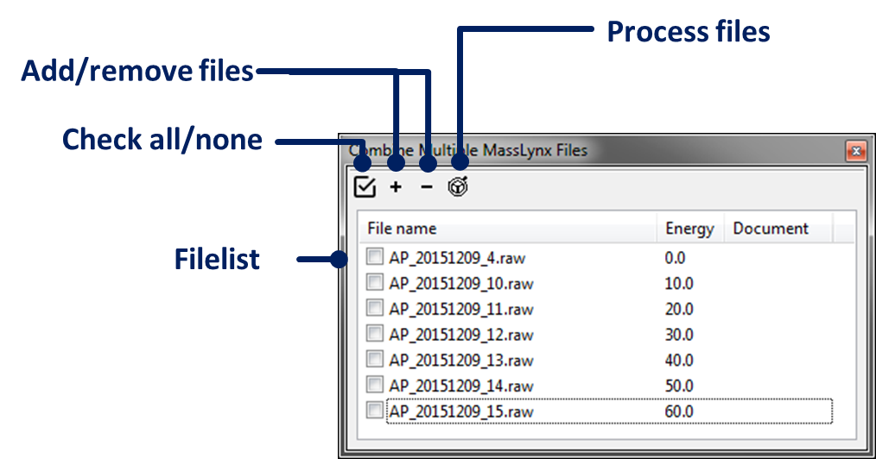

*Multiple Files Panel*

* **Check all/none items**

Click on the  button in the toolbar. To unselect all double-click.

* **Add multiple MassLynx files**

There are multiple ways you can add MassLynx files to the table:

1. Click on the  button in the toolbar and a selection window will appear. You can select single or multiple files simultaneously. To select more than one file, just hold **CTRL** or **SHIFT** key on your keyboard.
2. Enable the same window using keyboard shortcut: **CTRL+SHIFT+R** or by clicking in **Menu: File 🡪 Open multiple MassLynx files** or click on the  button in the main toolbar.

* **Clear table**

Click on the  button in the toolbar and select **Clear table**.

* **Remove selected or all items**

Click on the  button in the toolbar and select **Remove selected ions** or **Remove all ions**. In case of removing all items, a warning will appear.

* **Process files**

Click on the  button in the toolbar and select the only available option:

1. Re-bin summed MS: the summed MS will be re-binned based on the parameters in the GUI (**Process 🡪 MS Parameters 🡪 Bin size**)

* **Extract ions**

See **Peaklist Panel** section for how to add and extract ions.

Drift-Time Panel (incomplete)

CCS Calibration Panel (incomplete)

Interactive Output Panel

The interactive output panel enables saving all figures in an interactive and shareable webpage format viewable in modern internet browsers with JS support. ORIGAMIANALYSE uses the Bokeh visualisation library (<http://bokeh.pydata.org/>) to provide interactive graphics for the 21st century. Plots can be saved in an array of combinations and whole documents can be combined to give one, concise document. Each plot can be saved in an individual tab or as part of collection alongside HTML-rich annotations.

To enable the panel, click on the  button, **Menu: View 🡪 Enable** **Interactive** **Output panel…** or press **SHIFT+Z** on your keyboard.

* **Check all/none items**

Click on the  button in the toolbar. To unselect all double-click.

* **Select specific item format**

You can filter which plots you would like to see in the table by selecting a filter type in the combo box. Available options: *Show All, Selected, Show MS, Show MS (multiple files), Show RT, Show 1D IM-MS, Show 1D plots (MS, DT, RT), Show 2D IM-MS, Show Overlay, Show Statistical*.

* **Add new page style**

Click on the  button in the toolbar to add new page style. You will have to go to **Properties 🡪 Layout properties** and select the new page style to change its parameters. Alternatively you can add new page style from within the GUI.

* **Select and apply page to selected plots (batch)**

Select the page style in the combo box in the toolbar, then select items in the table and press on the  button in the toolbar to apply that style. There are several built-in styles:

1. None – each plot will be added as a separate tab
2. Rows – items with this style will be added horizontally to one another
3. Columns – items with this style will be added vertically to one another

There is no limit on how many styles you create, so you can combine multiple documents together, by simply creating a different page style for each.

***Warning****: After you apply style to the document using the toolbar method, you might have to click on each item to add it to the document file.*

* **Select and apply page to selected plot (single)**

Alternatively, you can click on the item and use the **HTML 🡪 Assign** to page combo box to assign a page to each item individually.

* **Annotate items**

Select item in the table and use the **HTML** panel to add title, header and footnote information in addition to changing the colormap or line color.

***Warning****: This panel is not finalised and will be updated with more features in future versions.*

***Warning****: The Order/# of the plot does not work yet.*

* **Select interactive tools**

Go to **Tools/Annotations** panel and select your preferred tools. Available tools:

* Hover – displays a tooltip over the plot to give information about the plot (*i.e.* m/z, intensity)
* Pan – lets you move the plot as you click on it
* Crosshair – displays a crosshair in the plot to show you the current position of the cursor
* Box Zoom – allows you to left-click in the window to zoom on an area of interest
* Wheel – allows you to use the wheel of your mouse to zoom-in and zoom-out in either X-, Y- or XY-direction
* Save – allows you to save the plot to static image
* Reset – resets the view of the plot

***Warning****: Currently each plot will be given the same set of tools. In future release, you will be able to apply specific toolset to each page.*

***Warning****: I would refrain from selecting other toolbar position than the ‘right’ position. It might not do what you want.*

* **Select active tools**

Select tools you would like to be active when you save the html document.

* **Change plot parameters (i.e. font size, font weight, RMSD label color and others)**

Go to **Properties** and adjust parameters as you wish. These parameters are global, hence will affect each plot.

* **Change image properties (sizes)**

Go to **Properties** and adjust the size of 1D and 2D plots. These parameters are global, hence will affect each plot.

* **Set filename**

Click on the **Set Path** button and select the path and filename for the html document.

***Warning****: Make sure you select at least one plot to add to the html document, otherwise nothing will happen.*

* **Set filename**

Click on the **Save button**. Depending if you checked the **Open in browser after saving**, ORIGAMI will attempt to open the saved document in your PCs web browser. The html documents work in all modern browsers and can also be viewed on mobile phones.

File Formats

ORIGAMIMS:

Standard MassLynx file format, however the collision voltage (or cone voltage) were slowly ramped during single acquisition according to parameters set in the ORIGAMIMS method.

Multiple MassLynx files:

Standard MassLynx file format, however each loaded file (for the same molecule) has different activation energy.

Drift-time MassLynx files (experimental, not made public yet):

Standard MassLynx file format, however data was acquired on a modified linear DT-IMS Synapt and the drift-tube voltage was controlled using WREnS script.

Text files:

The text file can be in comma-delimited or tab-delimited format and is expect to contain x- and y-axis information in the first row and column, respectively. Labels can be changed in the **Notes, Information, Labels…** or by right-clicking on the item in the Documents panel and selecting **Set x-axis label as…** or **Set y-axis label as…**.

Excel files:

Analysis of this file format is currently disabled

Processing Functions

Smoothing:

There are two smoothing functions at the moment:

* Gaussian – smoothing is performed on each element in the 2D array using the Gaussian filter
* Savitzky-Golay – smoothing is performed on each element in the 2D array using the Savitzky-Golay filter

***Warning****: In Savtizky-Golay smoothing, make sure your polynomial is at least 2 and window size is an odd number larger than polynomial value.*

Thresholding:

Can also be thought as ‘Noise removal’. Any value below the threshold value in the 2D array will be set to 0.

Normalisation

There are multiple normalisation functions:

* Maximum – normalises data between values 0-1
* Logarithmic – uses logto base 10 to normalise the 2D array
* Natural log – uses natural log to normalise the 2D array
* Square root – uses square root to normalise the 2D array
* Least Absolute Deviation
* Least Squares

***Note****: Have a look here for more information about the last two options:* [*http://www.chioka.in/differences-between-the-l1-norm-and-the-l2-norm-least-absolute-deviations-and-least-squares/*](http://www.chioka.in/differences-between-the-l1-norm-and-the-l2-norm-least-absolute-deviations-and-least-squares/)

Processing:

The process action is typically applied to 2D datasets and it follows three simple steps. Data can be processed in the *Documents window* or in individual *Panels*.

1. Smoothing – depending on your selection of parameters in the GUI (**Process aIM-MS Data (2D) 🡪 Smooth Function**), the program will perform smoothing action on the 2D dataset
2. Thresholding – depending if you entered threshold value in the (**Process aIM-MS Data (2D) 🡪 Threshold**) box, the program will try to remove noisy peaks. Values can be either 0-1 (if you are viewing normalised data) or 0-maximum intensity if you are viewing not-normalised data
3. Normalisation – depending if you selected to normalise your data (**Process aIM-MS Data (2D) 🡪 Normalize On/Off**), data will be either normalised or not

Extraction

All data extraction is performed using Driftscope *imextract.exe* program. You can use peaklist to perform extraction or type in start m/z to end m/z in the GUI (**Process 🡪 Extract Data 🡪 m/z range**) and press **Extract**.

Overlay:

There are multiple overlay functions available:

***Warning:*** *each selected dataset must of the same shape!*

* **Mask** – this method applies a ‘mask’ value to each dataset to ‘hide’ low intensity peaks and subsequently overlays them on top of each other. The value of ‘mask’ (α) ranges between 0-1, with the optimal being 0.25 (play with this value to optimise your plot). Each dataset can have separate colormap to highlight the differences.
* **Transparent** – this method overlays two images together, while making them transparent. The value of ‘transparency’ (α) ranges between 0-1 (play with this value to optimise your plot). Each dataset can have separate colormap to highlight the differences.
* **Mean** – averages the selected datasets
* **Variance** – computes the variance in the selected datasets
* **Standard Deviation** – computes the standard deviation in the selected datasets
* **RMSD** – computes the root mean square deviation of two selected datasets.

***Warning****: each dataset is normalised to 1 beforehand.*

* **RMSF** – computes the root mean square deviation of two selected datasets in 1D (RMSDCV) and 2D (RMSD). In the case of the RMSDCV, the values are compared for each collision voltage separately

***Warning****: each dataset is normalised to 1 beforehand.*

* **RMSD Matrix** – computes the pairwise root mean square deviation of a list of selected datasets and returns a matrix of RMSD values

Peak Finding

In order to speed-up the analysis process, in particular for complex samples, ORIGAMIANALYSE comes with a rather unsophisticated peak finding function. There are several modes the peak finding functions work, depending on whether you are interested in finding features in the mass spectrum, retention time or both, window.

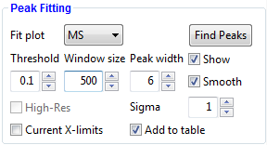

*Peak finding subpanel.*

MS mode:

The function operates by scanning the entire mass range to detect peaks that are above a specified threshold and separated by specified window size. Once peaks are detected, a symmetrical band of *peak width* is used to encompass the found peak. Of course, this is not always the ideal (or desired) solution as MS peaks are rarely symmetrical, hence some adjustments to the detected peaks might be required.

This function is available for all MS file types.

***Note****: This function does not detect charge states of the molecule, yet.*

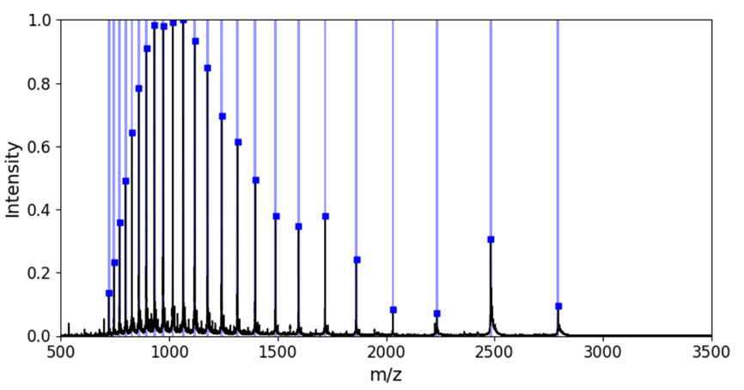

*Typical view following peak finding in the mass spectrum.*

RT mode:

This function operates by scanning the entire retention time region to detect any dips in intensity of the ion current. Once regions have been identified, these are added to the DT-IMS table.

This function is only available for DT-IMS file types currently which have been acquired using WREnS script.

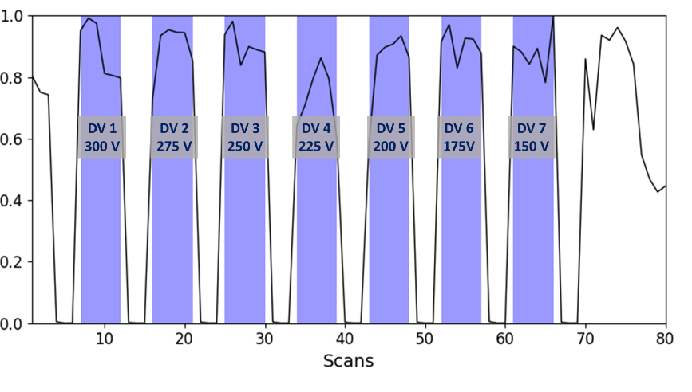

*Retention time plot for a DT-IMS experiment on a modified Synapt G2 where T-Wave mobility cell was replaced with a drift tube. Data was acquired using a bespoke WREnS script where each drift voltage was collected for several scans within a single MassLynx file.*

Hints:

* **To add found peaks to the peak list table**

Check the **Add to table** checkbox. Newly found ions will be automatically added to the table.

***Note****: Make sure you extract ions before trying to do any analysis*

* **To increase peak discovery rate**

Reduce the value of **Threshold** and **Window** **size**.

* **To show found peaks in the plot window**

Check the **Show** checkbox.

* **To smooth peaks before peak searching**

Check the **Smooth** checkbox. Smoothing the mass spectrum (using Gaussian filter) reduces the false discovery rates.

* **To limit the search to specific mass spectrum range**

If you would like to perform peak searching in narrower range than the whole mass spectrum, zoom-in on a portion of the plot area and check the **Current X-limits** checkbox.