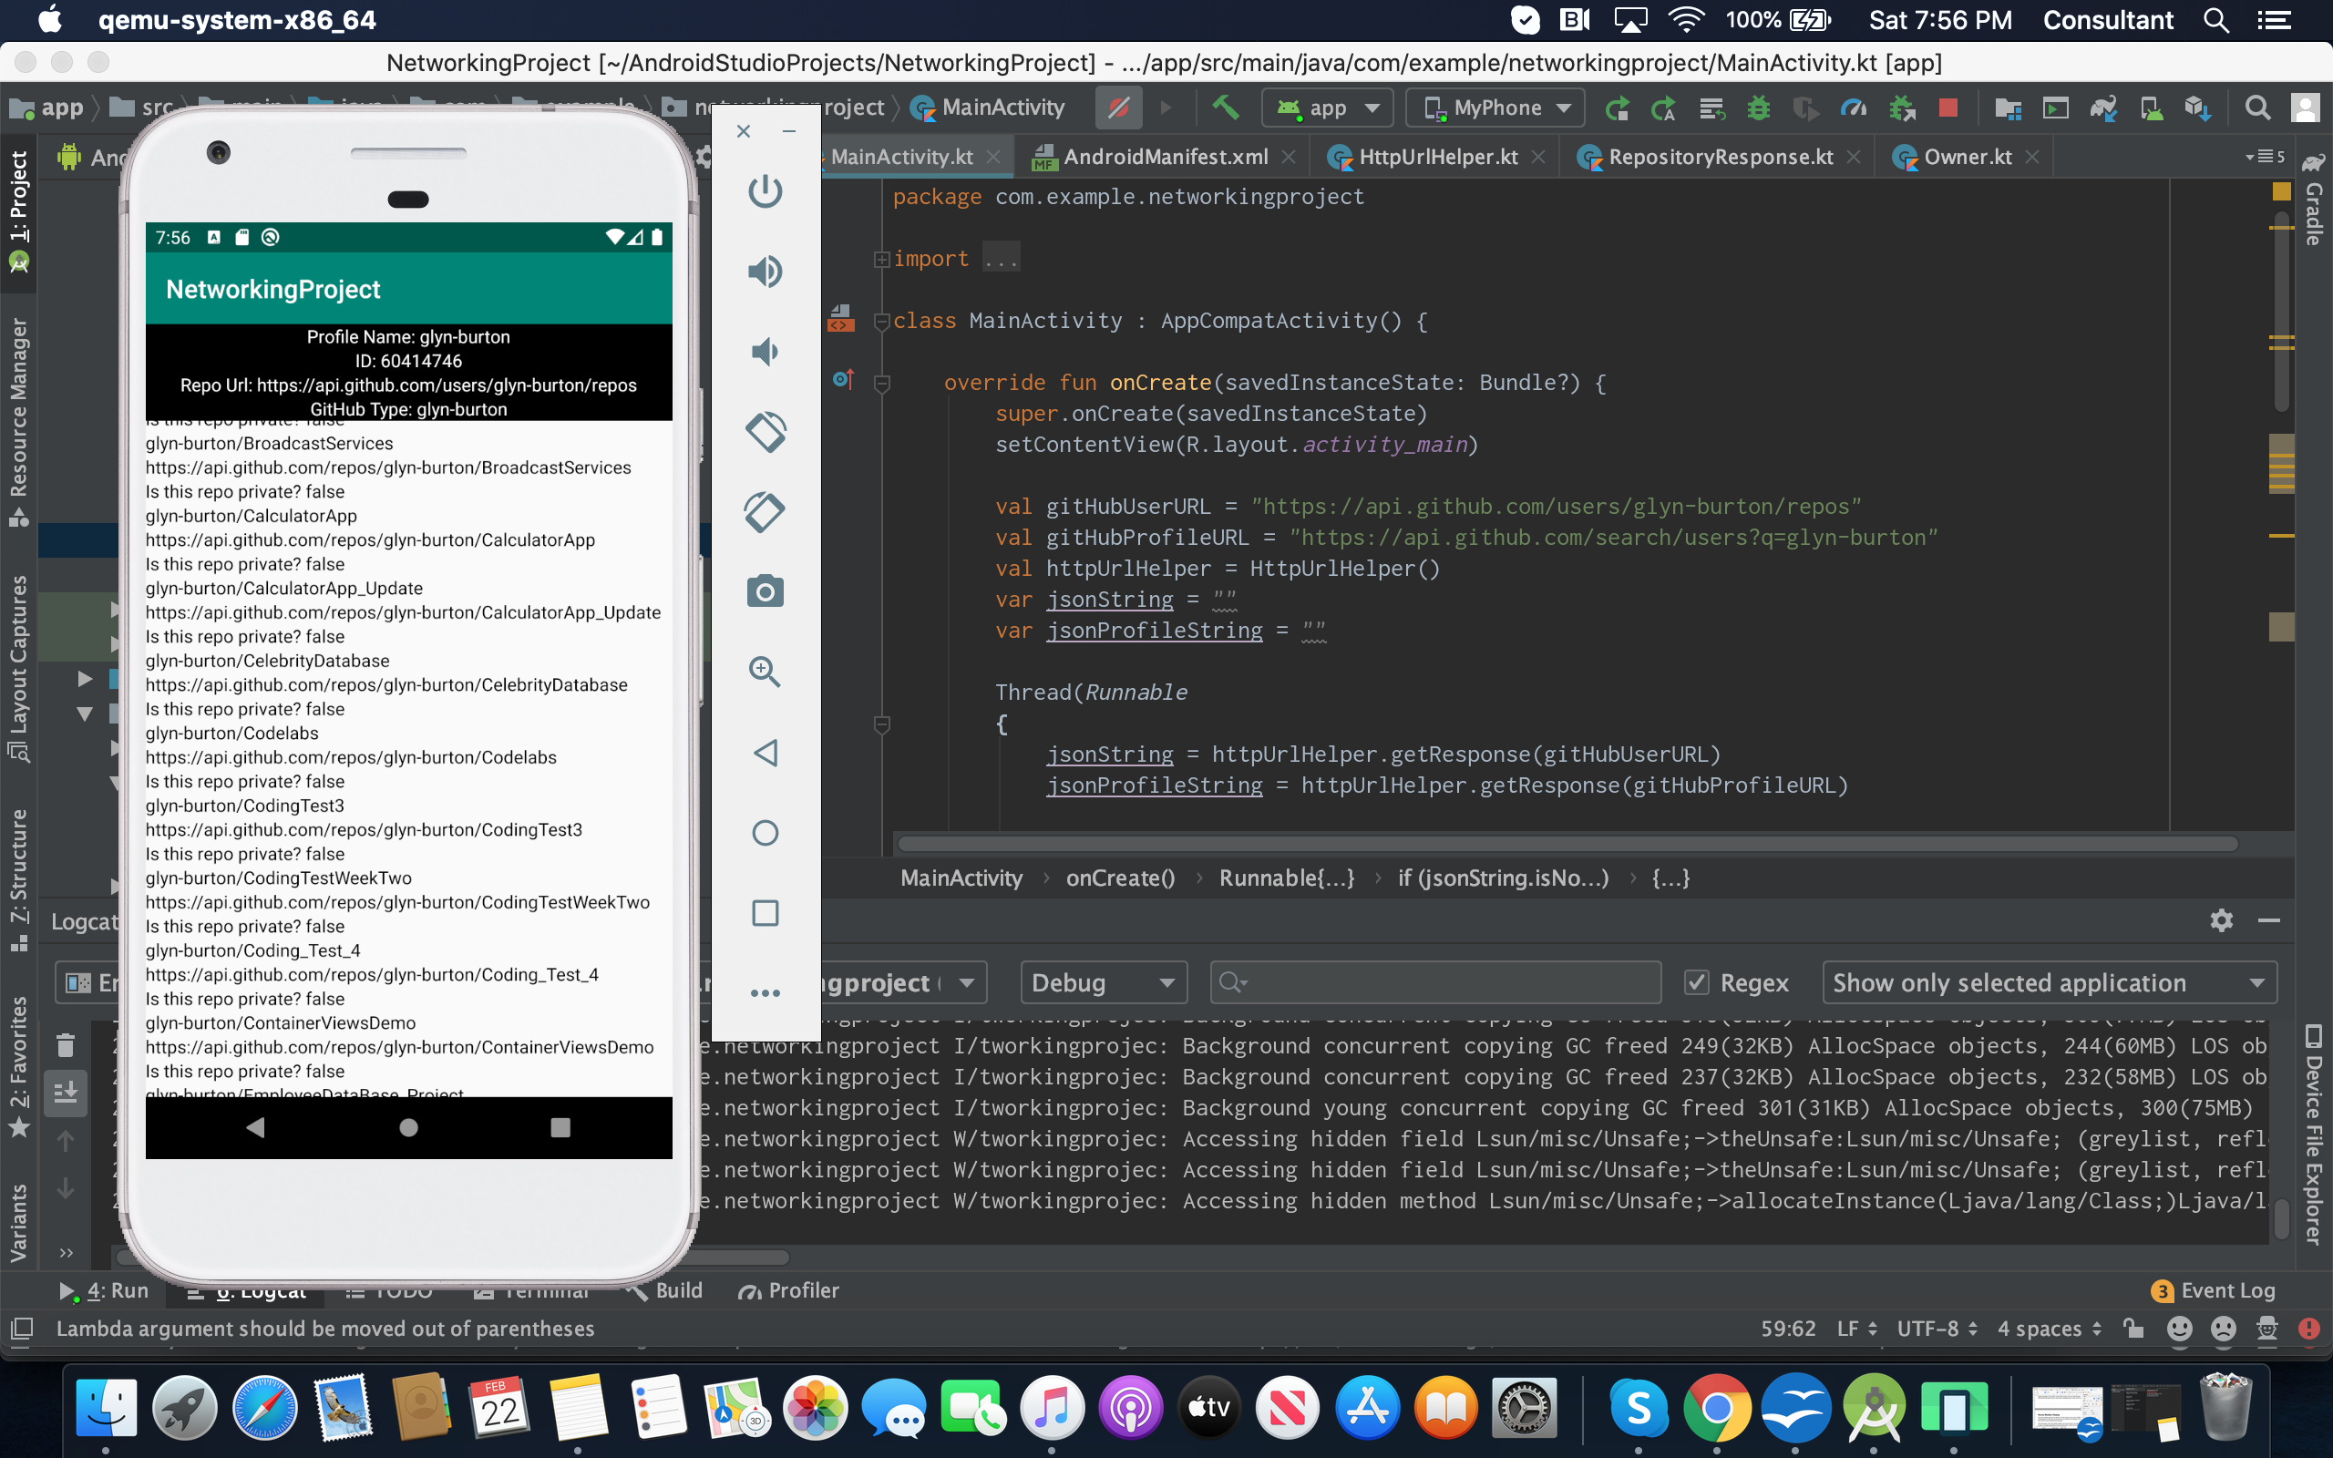
Coding
1. Create an application with two screen
-Screen one: should have your Github profile. Use at least 4 fields from the response to update the views.
-Screen 2: Populate the recyclerView with the repositories you get from your profile. Use at least 3 fields in each item view.

