Tridex introduction
desktop/tridex/working_new/introduction/introduction.odt
Tridex will be a program to run on the raspberry pi to present 3D crosswords to blind people via an audio microphone and loudspeaker/earphones etc.
The program will not be written in the programming language python. It will be in a combination of HTML and Javascript
Blind/partially sighted people are the initial target audience as they may be more adept at the 3D visualisation.
2D coordinated are usually expressed as x & y. Extensions to 3D vary in different contexts. For this reason my 3D model is A across, B behind and C climbing. Imagine you are looking at this picture from the left.
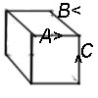

We have a starting list of clues and answers. They are from the Cambridge News so serve only as an example for development.
(tridex/clues/7 letter_2016.ods).
7 letters: The development work is being done assuming a 7 x 7 x 7 cube. This produces 9 2D crosswords clicing in each direction for 3 crosswords.
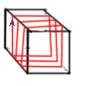 | 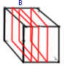 | 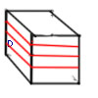

When the program is launched, it makes up an HTML string to draw it later.
Each minicube has an 3 HTML strings to draw it. One for the image of the cube; one for the a,b & d parameters to be displayed and one to show the summary number d*49+b*7+a.
These takes the form:-
The cubes are presented as option from a selection box
cube_H_TML:
Moving from left to right of the picture:
A as B goes down, the cubes move lower in the image.
As A goes up the image is higher of the page and further right.
As D goes up the image goes up too but left is unchanged.
So to get the left hand displacement it is A x a_left +B x b_left
Top displacement = A x A_height + B x B_height - D * D_height.
d_height = 25; b_height = 10; a_height = 10;
b_left = +20;a_left = +20;
htd = d * d_height; hta = xa * a_height; htb = xb * b_height;
top_displacement - htd - hta – htb
left_displacement - (xb * b_left) + (xa * a_left)
gash='['+presented_numbers[i]+']'+presented_words[i];
'<option onClick="answer_selected(\''+gash+'\')">'+gash+'</option>
'<STYLE="position:absolute; top:'+ this.display_height + 'px left:'+ this.display_left +'px">
figures_H_TML:

coords_H_TML:

Pictures of the mini-cubes
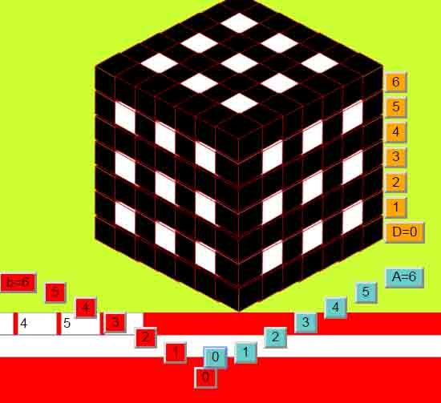  A=0 | 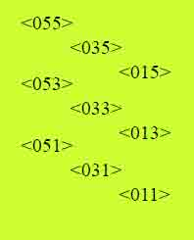 | 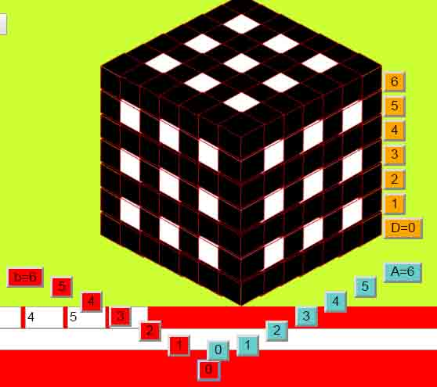  B=0 | 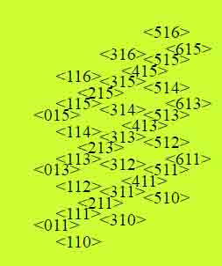 | 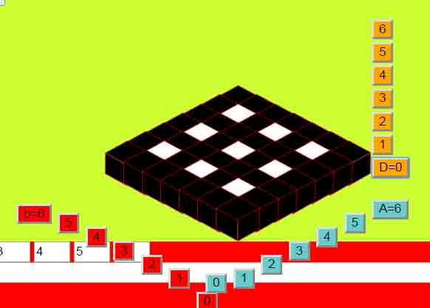  C=0 | 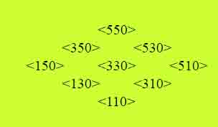
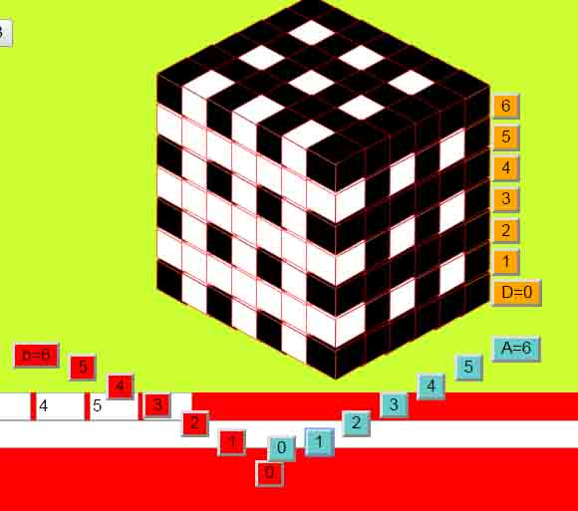  A=1Across C=1,3,5 Up  B=1,3,5 | 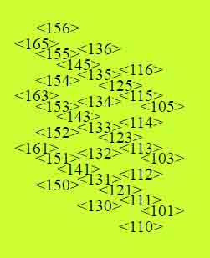 | 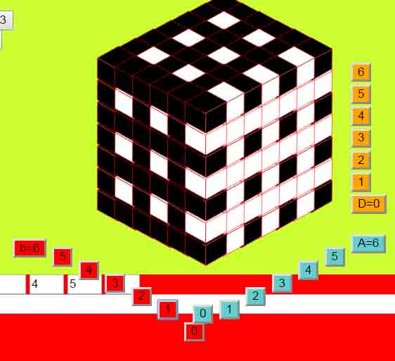  B=1 Across  C=1,3,5 Up  A=1,3,5 |  | 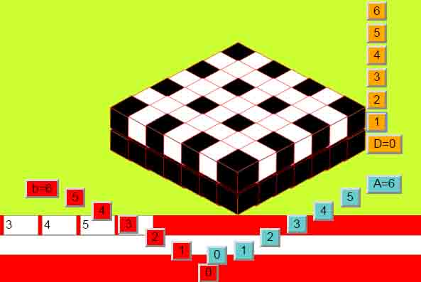  C=1 | 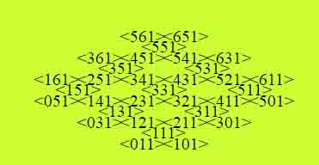
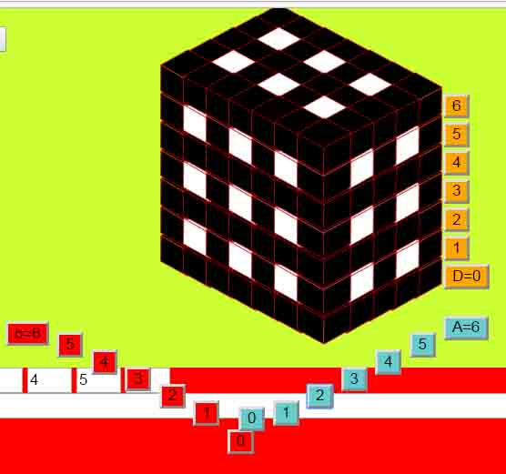  A=2 | 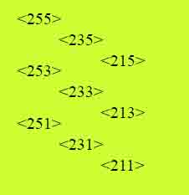 | 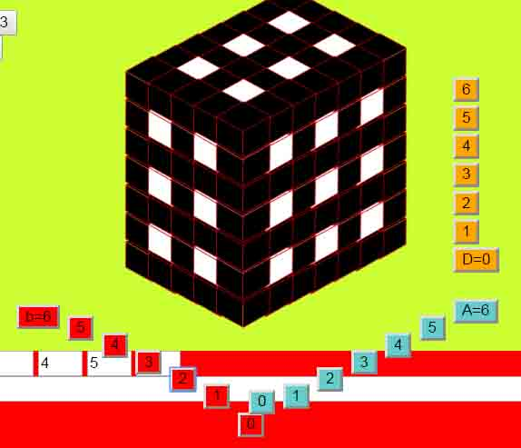  B=2 | 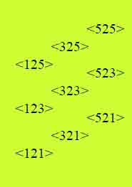 | 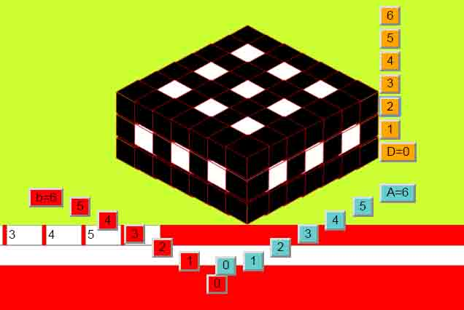  C=2 | 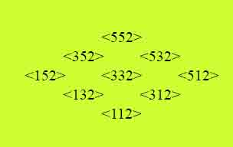
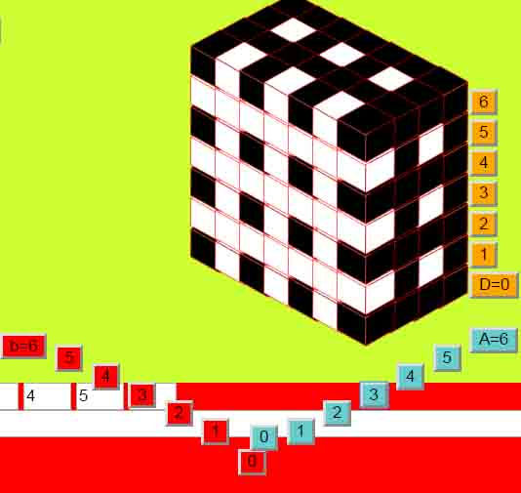  A=3Across C=1,3,5 Up  B=1,3,5 | 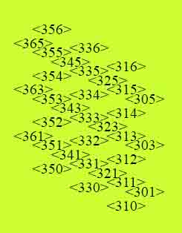 | 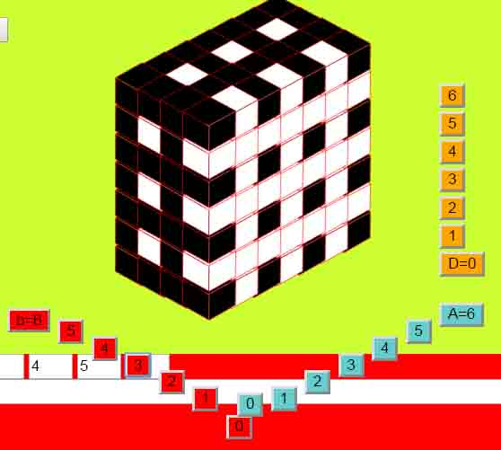  B=3Across  C=1,3,5 Up  A=1,3,5 | 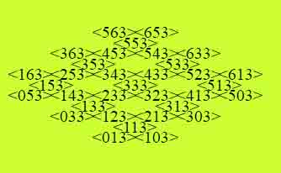 | 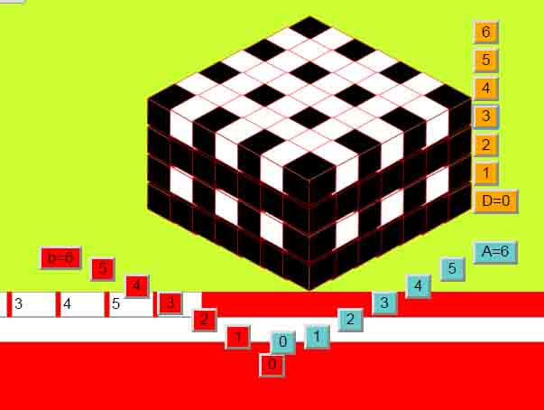  C=3
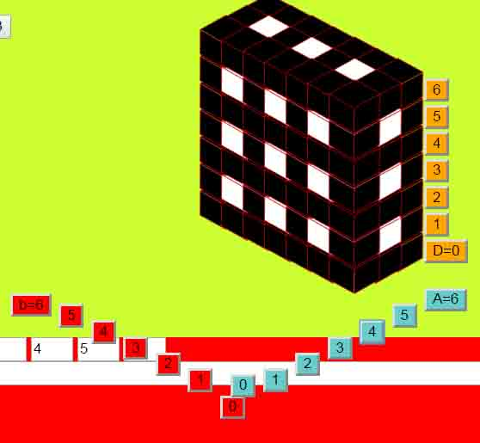  A=4 | 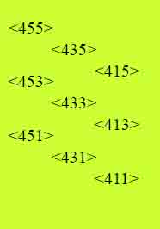 | 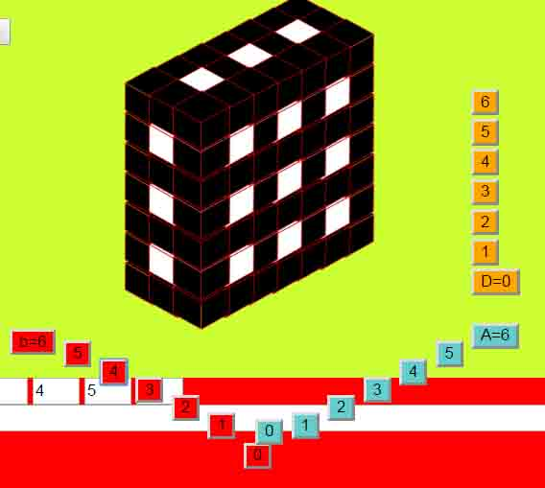  B=4 | 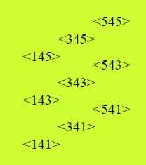 | 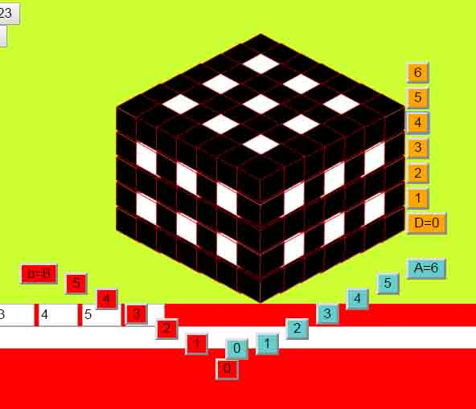  C=4 | 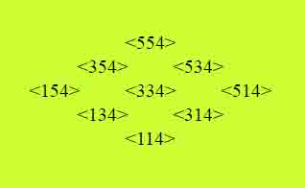
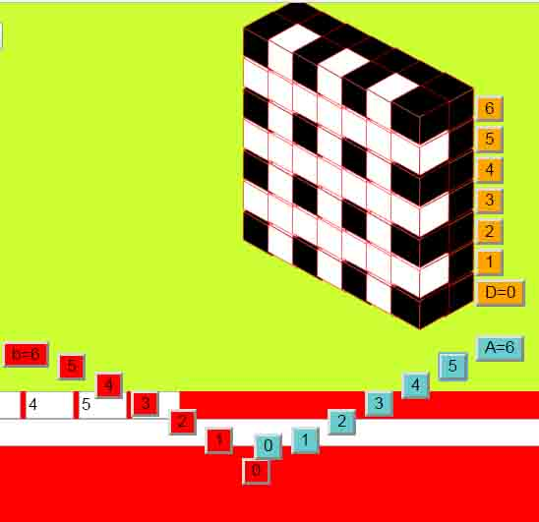  A=5 Across B=1,3,5 Up  C=1,3,5 | 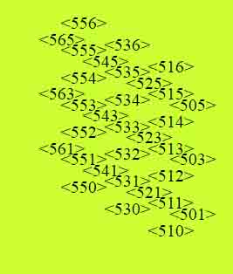 | 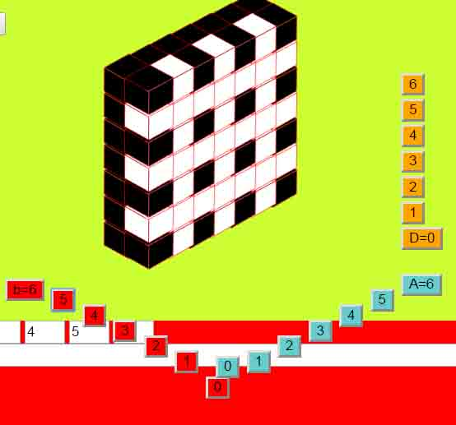  B=5 Across  C-1,3,5 Up  A=1,3,5 | 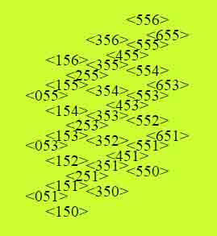 | 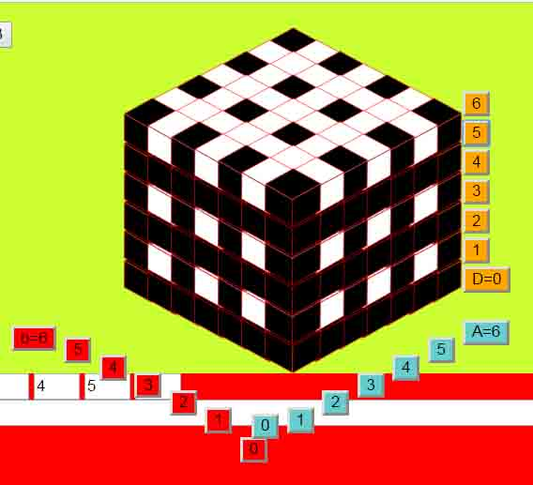  C=5 | 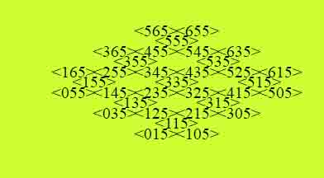
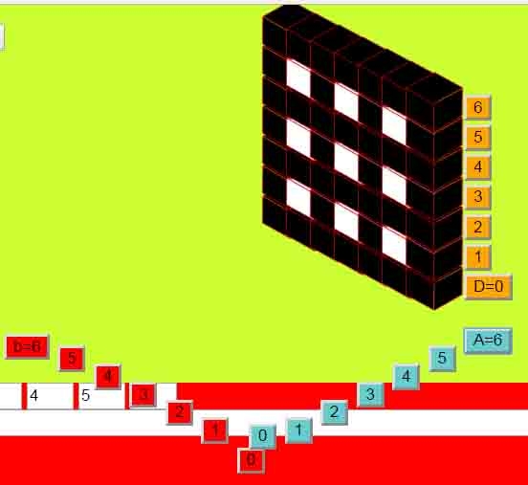  A=6 | 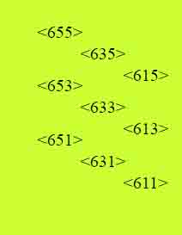 | 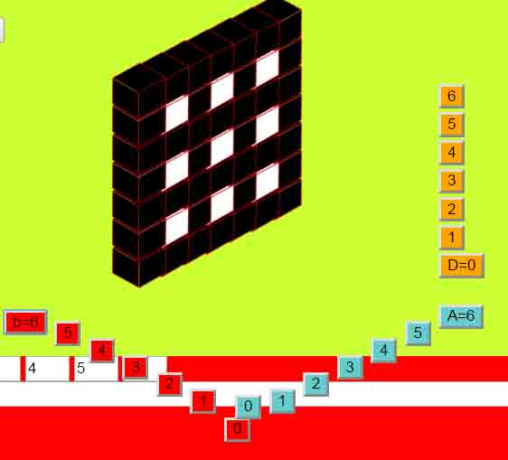  B=6 | 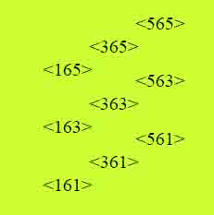 | 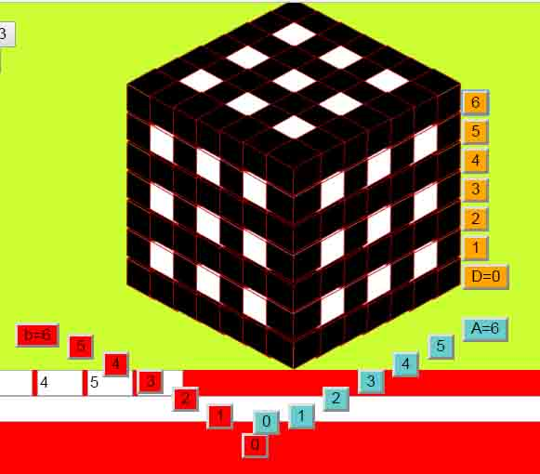  C=6 | 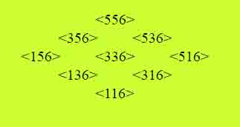

Drawing the mini-cubes:
On three sides of the space are buttons to draw the mini-cubes in different directions
D6
D5
D4
D3
D2
D1
D0
B6 A6
B5 A5
B4 A4
B3 A3
B2 A2
B1 A1
B0 A0
On pressing one of the buttons the user will see that slice of mini-cubes, as in the pictures above.
An example from Button B2:
triggers routine
screen_functions/draw_cube_space_b(6)
This routine sets A_start, A_end, B_inc (increment)
B_start, B_end, B_inc &
D_start, D_end, D_inc
It then calls draw_cube_loop() to gether up the HTML to layout the printed shapes
then add_cube_space(); to put them on the page.

Programming the project
Initial thoughts were to use HTML & Javascript .
Later thoughts suggested python on the pi but this does not seem necessary.
Dreamweaver seems to be a good tool for manipulating HTML for the pictures and Javascript for the logic behind the pictures.
Significant files:
CLUES.js
lists of clues & answers about 2000
Lines in the form:
"[ANSWERS]Clue to this answer",
7 letter_2006.ods (9/2/2017)
functions6.js (18/9/2916)
DATA.js information about the data
style.css formatter
emulate.js This is a set of functions to quickly carry out the tasks to test
draw_base2
CROSSWORD_11 18/9/2016

word_handling2.js
clues_code.js
wordlist.js
scratchpad.html
scratchpad is just a handy place to keep all the function names as there are so many. This has come about as I have taken multiple stabs at the plans
How it works
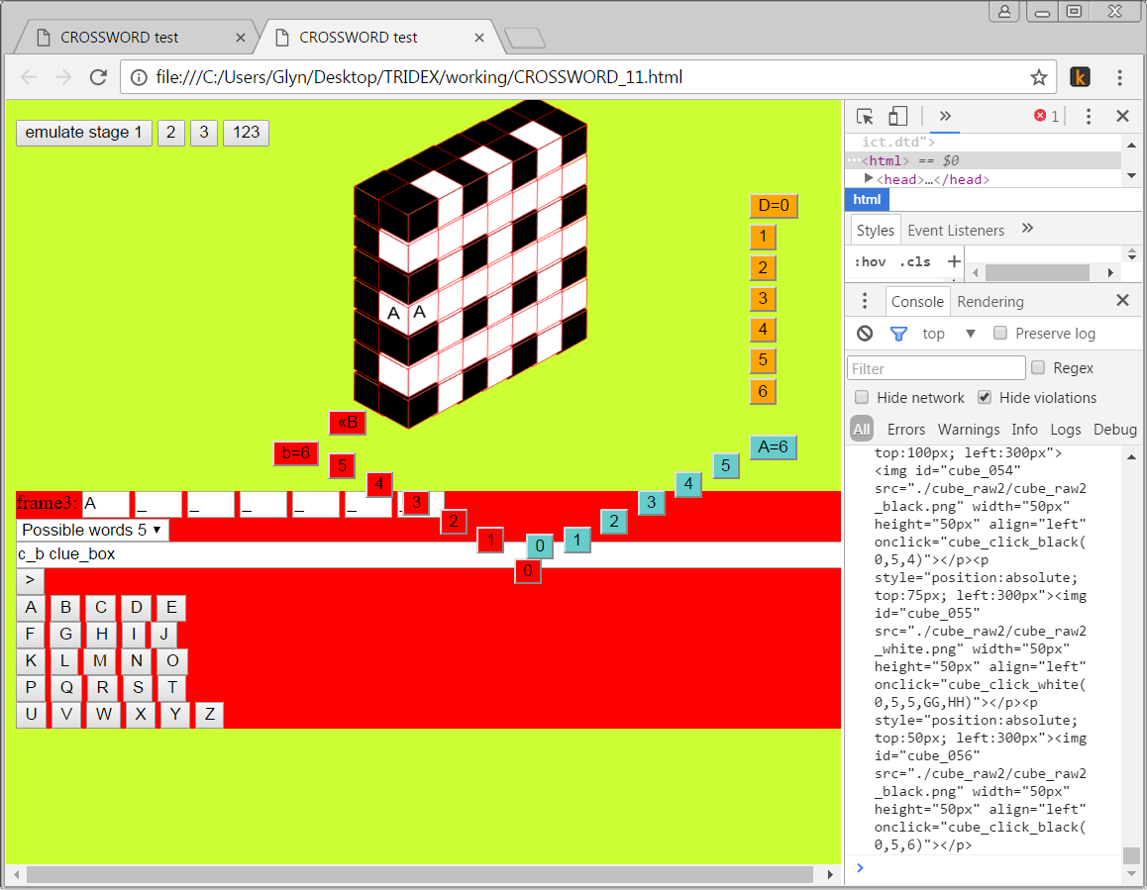 | 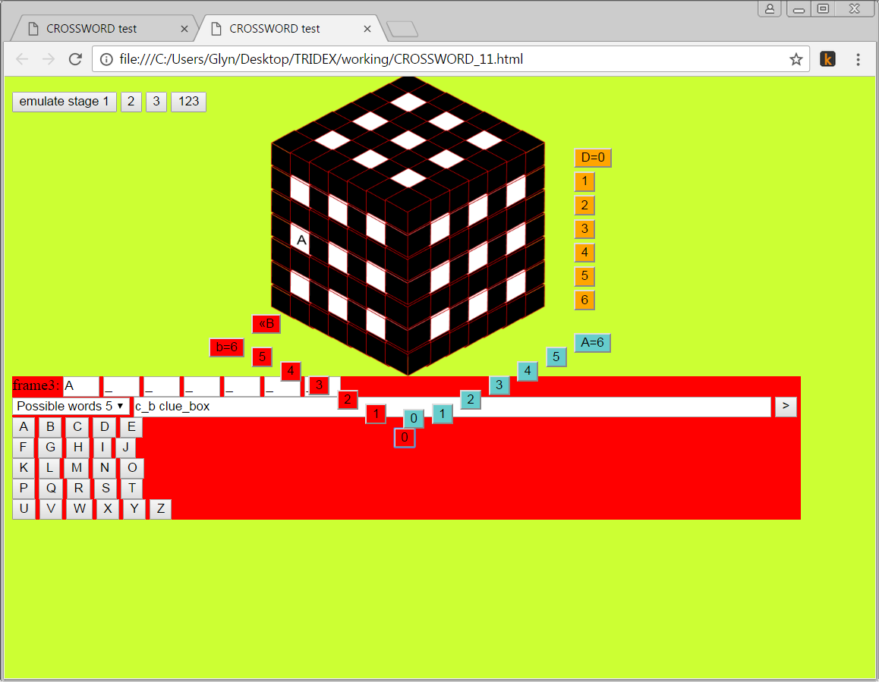

Orange buttons C=0 to 6 Draw horizontal slices (layers) same D(down) value (draw_cube_space_d)
Blue buttons draws slices with same A (across value)(draw_cube_space_a)
Red buttons draw slices with same B(backwards) value(draw_cube_space_b)
Once one clicks on a cube in the main cube, the cube colours yellow and it waits for one to select a letter to go into that cube.
On clicking a letter button, triggers the program to select all the words that could fit this gap. This word list is put into the possible words list
On selecting a word from the possible words list, the program puts the clue into the boxclue box (c_b clue_box).
If this is the required clue to the word (there are several clues to some words), click on the button below (>) to fill the word into the big cube.
Letter buttons buttons to select a letter to be put into a cube space
Functions
HTU_functions.js
string_HTU(HTU_number)
make_HTU(p_a, p_b, p_d)
get_a_from_HTU_number(HTU_in)
get_b_from_HTU_number(HTU_in)
get_d_from_HTU_number(HTU_in)
make_string(inp)

Functions7.js
word_to_select(word)

answer_selected()

fetch_clue(word_chosen)

put_answer_in_direction (answer,HTU_start, ABD_dir_in)
put_answer_in_direction_x(answer,HTU_start)
put_answer_in_direction_y(answer,HTU_start)
put_answer_in_direction_z(answer,HTU_start)

data_change(val) val might mean HTU_number/string

find_words(L1,L2,L3,L4,L5,L6,L7) NOT USED?
Called by data_change

Object orientation
Because the main cube is made up of 7 x 7 x 7 minicubes, I use OO to describe the minicubes.
A Minicube has a string of HTML to draw it on the page.
It has coordinates of where to display on the display page.
It has the path of where on the disc to find the image
It has a colour: black for no letter there; yellow for in progress and white for blank or a letter
It has links to another object which is the Word object.
If white it has a direction – but maybe not as the word would define this!

A Word object has 7 letter links.
It has a space to store the word letters and the clue to the word.
It also has links to audio files for the clue and the word.
It has some data to recognise the word if the doer says it.

