Functions text
screen_functions functions
draw_cube_loop() called from: set_letter; put_letter_in_cube; letter_to_cube
draw_cube_space_a Called from source code
draw_cube_space_b Called from source code
draw_cube_space_c Called from source code
cube_click_black(a_value, b_value, c_value) put onto buttons by compute_pattern()
cube_click_white(a_value, b_value, c_value) put onto buttons by compute_pattern()
do_YELLOW() Test routine only!
NOT USED
get_minicube(a, b, c) Go to minicubes array to return the specified minicube
NOT USED!
user_instruction(i_number) Fill in user instruction of given number into box on screen
save_answer() Take the word & details selected and save into 'answers'
use_answers() Take the word & details from answer into the minicubes
list_answer(answername) Called by use_answers for every possible word address
parse_line(lineText) Take a line like 0_5_5;"The French I hurt, but only in fun";"JESTING"
and set variables from it: coords array of a,b,c coordinates
index as HTU
splitText array of line segments: gash, clue, answer
cube copy of the relevant mini_cubes[]
sequence_change()
Choose debug area for functions or whatever.
word_location functions
function update_words(key_HTU) Go through all word minicubes detecting if the word needs to be updated; look at words_across here
letter_match(cubekey, wordkey)
find_word_HTU (in_HTU , word_ptr) called from:
functions_used 100:find_letter_cubes(current_minicube)
functions_used 92:answer_selected()

word_location data
words_across= new Array();
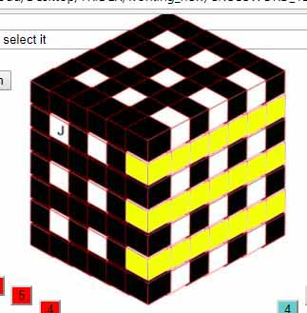  Across 1 | 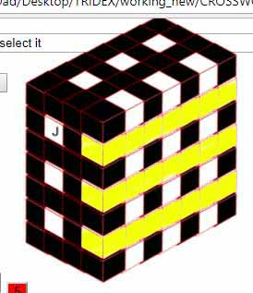  Across 3 | 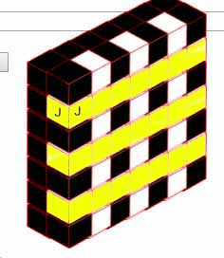  Across 5

words_back = new Array();
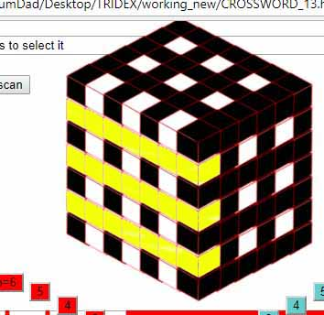  Back 1 | 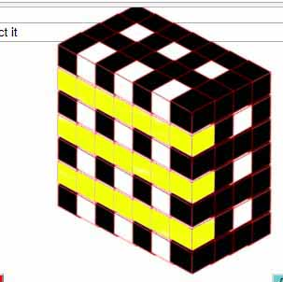  Back 3 | 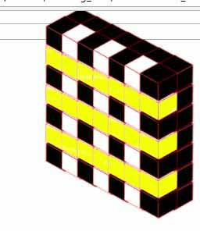  Back 5

word_climb = new Array()
Climb 1

name_list = new Array(); Names of sections of words – NOT USED
words_down = new Array(); probably redundant

