In reply refer to: 08

January 11, 2024

VIA: **(Delivery Method)** govcdm_preferredemail

govcdm_firstname govcdm_lastname

govcdm_address1_line1 govcdm_address1_line2

govcdm_address1_city, govcdm_address1statepicklist govcdm_address1_postalcode

**SUBJECT: Notice of Right to File for EEO Complaint, Case No. govcdm_name**

Dear govcdm_firstname govcdm_lastname:

I am closing the informal counseling on the matter you presented to this office on **govcdm_datetimeofinitialcontact**, Case Number: govcdm_name. Your complaint is as follows:

|  |  |  |
| --- | --- | --- |
| **Basis(es)** | **Claim(s)** | **Date(s) of Occurrence** |
| govcdm_basis | govcdm_claimtype govcdm_claimtypeother | **govcdm_dateofincident** |

Upon receipt of this letter please notify me no later than 5 business days whether the above information is incorrect.

I have enclosed a copy of the Notice of Right to File a Discrimination Complaint (including VA Form 4939). At this point, you have two options available to you. To help you make your decision, I have also enclosed a link to the Equal Employment Opportunity Commission’s (EEOC) website for an overview of the guidelines on the federal sector EEO complaint process. (<https://www.eeoc.gov/federal-sector>)

Please select one of the options below as your final decision:

**Option 1:** You can choose to file a formal complaint of discrimination on some or all of the claim(s) listed above. If you wish to file a formal complaint, please complete, sign, and date the VA Form 4939; returning the form to the address listed on the *Notice of Right to File a Discrimination Complaint.* **You are *strongly encouraged* to email your VA 4939 formal complaint of discrimination.**

**If you decide to file a formal complaint, you have 15 calendar days from receipt of this notice in which to do so.** Please do not mail the VA Form 4939 to me; your formal complaint must be mailed to the address listed on the first page of the enclosed *Notice of Right to File a Discrimination Complaint* or emailed to govcdm_4939email.

Upon receipt of a formal complaint, the Office of Resolution Management, Diversity & Inclusion (ORMDI) will review your complaint and determine if the claim(s)[1] raised meet(s) EEOC’s procedural requirements for continued processing.

If your complaint meets procedural requirements and is accepted by ORMDI for investigation, you will be given the opportunity to submit any documentation in support of your allegations of discrimination to the ORMDI investigator assigned to investigate your complaint, as part of the process for gathering evidence relevant to the merits of your accepted claim(s). There is no need to provide evidence in support of your claim(s) until notified that your claim(s) is accepted for investigation.

**Option 2**: You can take no further action, indicating your wish not to pursue the allegations listed above any further.

If you have any questions or need additional information, call me at 888-566-3982 (work phone: address1_telephone1).

Sincerely,

firstname lastname

EEO Counselor

Enclosure: Notice of Right to File a Discrimination Complaint

VA Form 4939

**NOTICE OF RIGHT TO FILE A DISCRIMINATION COMPLAINT**

**Aggrieved Party: govcdm_firstname govcdm_lastname**

**Case Number:** **govcdm_name**

1. If you are not satisfied with the results of the informal EEO process and believe that you have been subjected to discrimination because of race, color, religion, sex, national origin, age, disability, genetic information, or retaliation, you have the right to file a formal complaint of discrimination. **If you decide to file a formal complaint, you must do so WITHIN FIFTEEN CALENDAR DAYS OF RECEIPT OF THIS NOTICE.**
2. Attached is VA Form 4939, Complaint of Employment Discrimination. If you choose to file a formal complaint at this time, use this form, and carefully read the instructions on the reverse side before completing it. The counselor is available to assist you in filling out this form and to answer any questions you may have about it. If you require assistance, please contact your counselor immediately. **Please note that the 15-calendar day time frame will not be extended due to your need to seek my assistance in completing this form.**
3. You may file a complaint in person, by mail, fax, or e-mail with the District Manager at the address below:

govcdm_ormdistrictmanager, District Manager of govcdm_name

Department of Veterans Affairs

Office of Resolution Management, Diversity & Inclusion (govcdm_districtnumber)

govcdm_address1_line1, govcdm_address1_line2

govcdm_address1_city, govcdm_address1statepicklist, govcdm_address1_postalcode

E Fax: govcdm_fax

Email: emailaddress

1. You must identify each claim you are protesting and provide the date on which each occurred. Your complaint must be limited to the claim(s) you discussed with the counselor. Therefore, if there are any claims that you have not discussed with the counselor, you must do so immediately. Regulations require that you provide the Department with an opportunity to resolve each claim informally at EEO counseling.
2. You are entitled to representation at every stage of the complaint process. You may choose anyone as a representative, unless the person occupies a position within VA that would create a conflict of interest. If you do select a representative, you must inform this ORMDI District Office, in writing, of the representative’s name, telephone number, and business address.
3. If you are a member of the bargaining unit, you may have the right to dispute the events discussed with the counselor through the union grievance procedure. Regulations provide that you may file either a grievance or an EEO complaint about the events in dispute, but not both. Should you file both, whichever you file first (a union grievance or an EEO complaint) will be considered an election to proceed in that forum.
4. If you are complaining about a matter that may be appealed to the Merit Systems Protection Board (MSPB), you may file an EEO complaint or an MSPB appeal, but not both. Whichever you file first (a formal EEO complaint or an MSPB appeal) will be considered an election to proceed in that forum. If the counselor can be of further assistance to you, please advise.

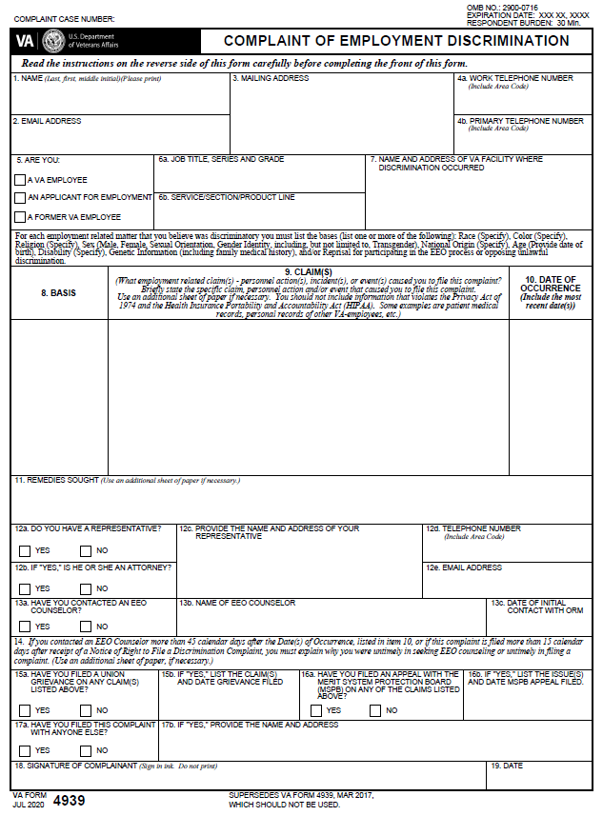

**COMPLAINT OF EMPLOYMENT DISCRIMINATION INSTRUCTIONS**

**Read the following instructions carefully before you complete this form. Please complete all items on the complaint form.**

**GENERAL:** Pursuant to the Equal Employment Opportunity Commission (EEOC) Title 29 Code of Federal Regulations (29 C.F.R.) §1614, VA

Form 4939, Complaint of Employment Discrimination, can be used by VA employees, former employees and applicants for employment who file a formal Equal Employment Opportunity (EEO) complaint of discrimination. This regulation prohibits discrimination based on race, color, religion, gender (sex), national origin, age (40 years and over), physical or mental disability, genetic information (including family medical history), and/or reprisal for participating in the EEO process or opposing unlawful discrimination.

You can obtain assistance from your EEO Counselor in filling out this form. Your EEO Counselor can also answer any questions you may have about this form. In item 8, you should specify the basis of your complaint: race, color, religion, gender (sex), national origin, age *(date of birth)*, physical or mental disability *(specific information about your disability)*, genetic information (including family medical history), and/or reprisal for participating in the EEO process or opposing unlawful discrimination. If you list "Reprisal," please state the nature of the prior EEO activity in which you were engaged, i.e. did you file a prior EEO complaint? Use an additional sheet of paper, if necessary.

It is very important that you be precise as to the dates of all actions or events you are protesting. In addition, the claims listed in item 9, must be limited to those claims discussed with an EEO Counselor *(discussed within 45 calendar days of occurrence of the event, or within 45 calendar days of the effective date, if a personnel action)* or like or related claims. If any of the claims listed in item 9 were discussed with an EEO Counselor, but not within 45 calendar days of their occurrence or of their effective date, you must explain why you waited more than 45 calendar days. If any of the claims listed in item 9 were not discussed with an EEO Counselor, please contact the Office of Resolution Management, Diversity and Inclusion (ORMDI), Regional EEO Officer IMMEDIATELY. The requirement that you contact an EEO Counselor about every claim listed in item 9 will not be waived under any circumstances. Failure to do so will only delay the processing of your complaint.

It is your responsibility to keep the ORMDI informed of your current address. If you move, immediately advise the ORMDI District Office where you filed this complaint of your new address. In addition, you may receive certified and express mail in connection with your complaint. It is your responsibility to claim all certified and express mail. Failure to notify ORMDI of a change in address or to claim certified and express mail may lead to dismissal of your complaint.

**REPRESENTATION:** You may have a representative of your own choosing at all stages of the processing of your complaint. No EEO Counselor,

EEO Investigator or EEO Officer may serve as a representative. (Your representative need not be an attorney, but only an attorney representative may sign the complaint on your behalf.)

**WHEN TO FILE**: Your formal complaint must be filed within 15 calendar days of the date you received the *"Notice of Right to File a*

*Discrimination Complaint"* (NRTF) from your EEO Counselor. If you do not meet this time limit, you must explain why you waited more than 15 calendar days to file. These time limits may be extended under certain circumstances; however, they will NOT be waived and your complaint will NOT be investigated unless you explain your untimeliness and the explanation is acceptable in accordance with EEOC, 29 C.F.R. §1614(c).

**WHERE TO FILE:** The complaint should be filed with the ORMDI District Office identified in the NRTF. You may submit a copy either by mail,

in person, electronically (via e-mail), or by facsimile. Filing instructions are contained in the cover letter attached to the NRTF.

**PRIVACY ACT STATEMENT:** Maintenance and disclosure of VA Form 4939 is made in accordance with the Privacy Act of 1974. Collection

of the information on this form is authorized and/or required by the regulations of the EEOC, 29 C.F.R. §1614. All records, from which information is retrieved, by the name or personal identifier of a respondent, are maintained by a Government-wide Systems of Records: EEOC/GOVT-1, Equal Employment Opportunity Complaint Records and Appeal Records. The information collected will be used by ORMDI to determine whether your complaint is acceptable for investigation and in connection with any subsequent investigation and processing of your complaint. In the course of any investigation, this form may be shown to any individual who may be required by regulations, policies or procedures of the EEOC and/or ORM to provide information in connection with this complaint, including individuals you may have identified as responsible for the acts or events at issue in this complaint. Other disclosures may be: (a) to respond to a request form from a Member of Congress regarding the status of the complaint or appeal; (b) to respond to a court subpoena and/or to refer to a district court in connection with a civil suit; (c) to disclose information to authorized officials or personnel to adjudicate a complaint or appeal; or (d) to disclose information to another Federal agency or to a court or third party in litigation when the Government is party to a suit before the court.

**RESPONDENT BURDEN STATEMENT:** In accordance with the Paperwork Reduction Act of 1995, The Department of Veterans Affairs (VA)

may not conduct or sponsor, and the respondent is not required to respond to this collection of information unless it displays a valid OMB Control Number. The valid OMB Control Number for this information collection is 2900-0716. The collection of this information is voluntary. However, the information is necessary to determine if your complaint of employment discrimination is acceptable for further processing in accordance with EEOC, 29 C.F.R. §1614. The time required to complete this information collection is estimated to average 30 minutes per response, including the time for reviewing instructions, searching existing data sources, gathering and maintaining the data needed, and completing the form. Send comments regarding this burden estimate or any other aspects of this collection, including suggestions for reducing this burden, to VA Clearance Officer (005R1B), 810 Vermont Avenue, Washington, DC 20420. SEND COMMENTS ONLY. DO NOT SEND THIS FORM, A COMPLAINT OF EMPLOYMENT DISCRIMINATION, OR REQUEST FOR BENEFITS TO THIS ADDRESS

REVERSE OF VA FORM 4939, JUL 20

1. A claim is the action(s) the Agency has taken or is taking that causes the aggrieved person to believe s/he is the victim of discrimination for which, if proven, there is a remedy under the federal equal employment statues. It is important to limit your description of the specific claim(s) to one or two sentences.