**ER diagram to Relational model tasks/solutions - 1**

*Assoc. Prof. Mahammad Sharifov*

**TASK 1: The ER conceptual schema diagram for the UNIVERSITY database**

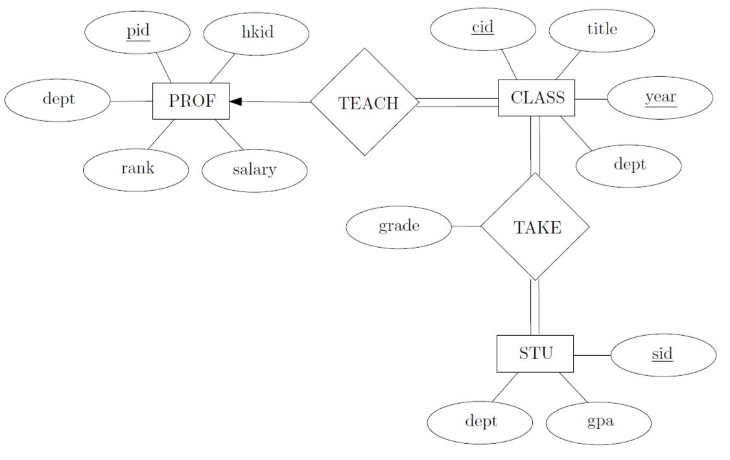

**SOLUTION:**

**PROF profID** dept rank salary

**CLASS classID** title year dept **profID**

**STUDENT studID** dept gpa

**TAKE classID** year **studID** grade

**TASK 2: The ER conceptual schema diagram for the CAR DEALER database**

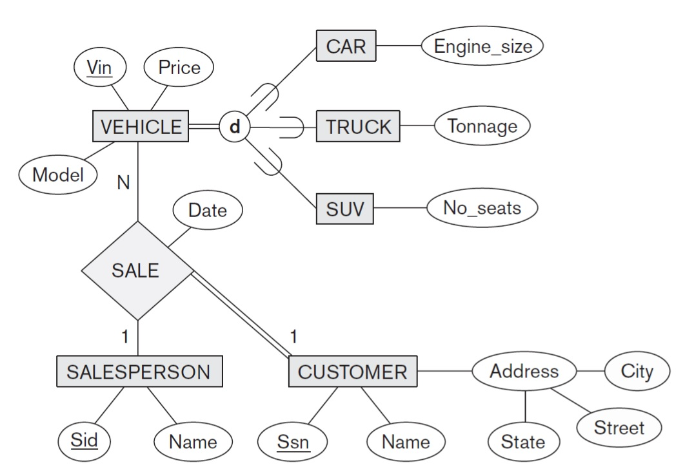

**SOLUTION:**

**VEHICLE VNo** ModelPrice

**CAR VNo** EngineSize

**TRUCK VNo** Tonnage

**SUV VNo** NoSeats

**SALESPERSON SpID** Name

**CUSTOMER CustNo** Name State City Street

**SALE SaleNo** Date **SpID** **CustNo** **VNo**

**TASK 3: The ER conceptual schema diagram for the CAR DEALER database**

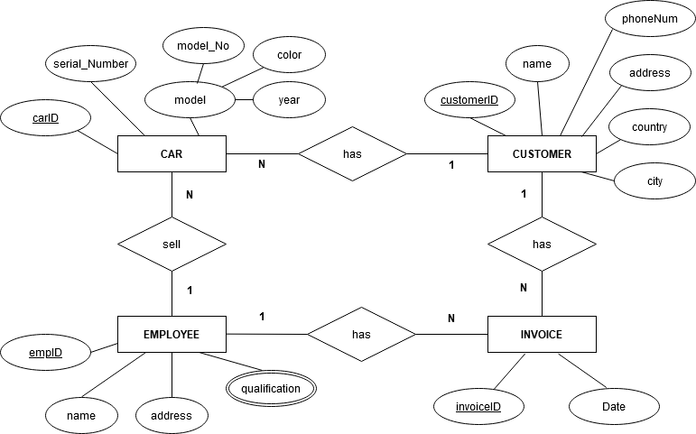

**SOLUTION:**

**CAR** **carID** serial_Number model_No color year customerID empID

**CUSTOMER** **customerID** name phoneNum address country city

**EMPLOYEE** **empID** name address

**QUALIFICATION** **empID** qualification

**INVOICE** **invoiceID** date empID customerID