**ER diagram to Relational model tasks/solutions - 2**

*Assoc. Prof. Mahammad Sharifov*

**TASK 1: The ER conceptual schema diagram for the PRODUCTION database**

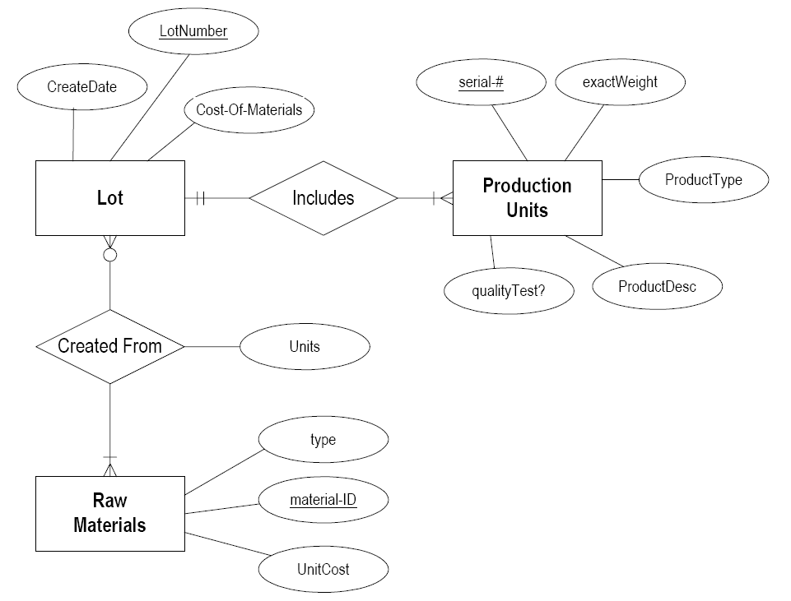

**SOLUTION:**

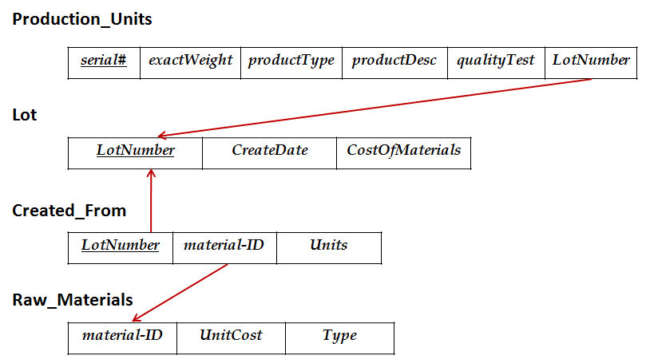

**TASK 2: The ER conceptual schema diagram for the STUDY database**

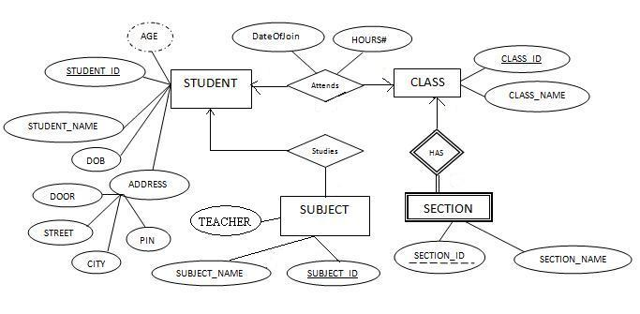

**SOLUTION:**

**STUDENT Student_ID** Student_NameDOBDoorStreetCityPin

**CLASS Class_ID** Class_Name **Student_ID** DateOfJoin Hours

**SUBJECT Subject_ID** Subject_Name Teacher **Student_ID**

**SECTION Section_ID** **Class_ID** Section_Name

**TASK 2: The ER conceptual schema diagram for the SPORT database**

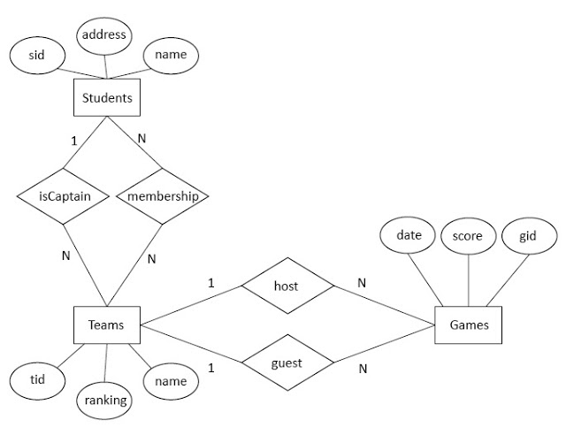

**SOLUTION:**

**STUDENTS SID** NameAddress

**TEAMS TID** NameRankingCaptain

**MEMBERSHIP SID TID**

**GAMES GID** ScoreDateHost_TeamGuest_Team