**Introduction to MySQL foreign key**

A foreign key is a column or group of columns in a table that links to a column or group of columns in another table. The foreign key places constraints on data in the related tables, which allows MySQL to maintain referential integrity.

Let’s take a look at the following customers and orders tables from the sample database.

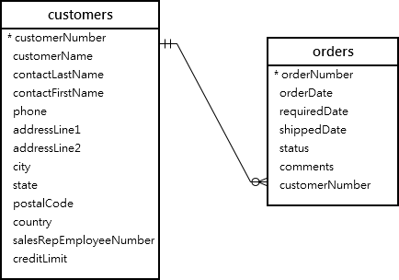

In this diagram, each customer can have zero or many orders and each order belongs to one customer.

The relationship between customers table and orders table is one-to-many. And this relationship is established by the foreign key in the orders table specified by the customerNumber column.

The customerNumber column in the orders table links to the customerNumber primary key column in the customers table.

The customers table is called the *parent table* or *referenced table*, and the orders table is known as the *child table* or *referencing table*.

Typically, the foreign key columns of the child table often refer to the primary key columns of the parent table.

A table can have more than one foreign key where each foreign key references to a primary key of the different parent tables.

Once a foreign key constraint is in place, the foreign key columns from the child table must have the corresponding row in the parent key columns of the parent table or values in these foreign key column must be NULL (see the SET NULL action example below).

For example, each row in the orders table has a customerNumber that exists in the customerNumber column of the customers table. Multiple rows in the orders table can have the same customerNumber.

**MySQL FOREIGN KEY syntax**

Here is the basic syntax of defining a foreign key constraint in the [CREATE TABLE](https://www.mysqltutorial.org/mysql-create-table/) or [ALTER TABLE](https://www.mysqltutorial.org/mysql-alter-table.aspx) statement:

[CONSTRAINT constraint_name]

FOREIGN KEY [foreign_key_name] (column_name, ...)

REFERENCES parent_table(colunm_name,...)

[ON DELETE reference_option]

[ON UPDATE reference_option]

In this syntax:

First, specify the name of foreign key constraint that you want to create after the CONSTRAINT keyword. If you omit the constraint name, MySQL automatically generates a name for the foreign key constraint.

Second, specify a list of comma-separated foreign key columns after the FOREIGN KEY keywords. The foreign key name is also optional and is generated automatically if you skip it.

Third, specify the parent table followed by a list of comma-separated columns to which the foreign key columns reference.

Finally, specify how foreign key maintains the referential integrity between the child and parent tables by using the ON DELETE and ON UPDATE clauses.  The reference_option determines action which MySQL will take when values in the parent key columns are deleted (ON DELETE) or updated (ON UPDATE).

MySQL has five reference options: CASCADE, SET NULL, NO ACTION, RESTRICT, and SET DEFAULT.

* **CASCADE:** if a row from the parent table is deleted or updated, the values of the matching rows in the child table automatically deleted or updated.
* **SET NULL:**  if a row from the parent table is deleted or updated, the values of the foreign key column (or columns) in the child table are set to NULL.
* **RESTRICT:**  if a row from the parent table has a matching row in the child table, MySQL rejects deleting or updating rows in the parent table.
* **NO ACTION:** is the same as RESTRICT.
* **SET DEFAULT:** is recognized by the MySQL parser. However, this action is rejected by both InnoDB and NDB tables.

**In fact, MySQL fully supports three actions: RESTRICT, CASCADE and SET NULL.**

If you don’t specify the ON DELETE and ON UPDATE clause, the default action is RESTRICT.

**MySQL FOREIGN KEY examples**

Let’s create a new database called fkdemo for the demonstration.

CREATE DATABASE fkdemo;

USE fkdemo;

**RESTRICT & NO ACTION actions**

Inside the fkdemo database, create two tables categories and products:

CREATE TABLE categories(

categoryId INT AUTO_INCREMENT PRIMARY KEY,

categoryName VARCHAR(100) NOT NULL

) ENGINE=INNODB;

CREATE TABLE products(

productId INT AUTO_INCREMENT PRIMARY KEY,

productName varchar(100) not null,

categoryId INT,

CONSTRAINT fk_category

FOREIGN KEY (categoryId)

REFERENCES categories(categoryId)

) ENGINE=INNODB;

The categoryId in the products table is the foreign key column that refers to the categoryId column in the  categories table.

Because we don’t specify any ON UPDATE and ON DELETE clauses, the default action is RESTRICT for both update and delete operation.

The following steps illustrate the RESTRICT action.

1) [Insert two rows](https://www.mysqltutorial.org/mysql-insert-multiple-rows/) into the categories table:

INSERT INTO categories(categoryName)

VALUES

('Smartphone'),

('Smartwatch');

2) [Select](https://www.mysqltutorial.org/mysql-select-statement-query-data.aspx) data from the categories table:

SELECT * FROM categories;



3) [Insert a new row](https://www.mysqltutorial.org/mysql-insert-statement.aspx) into the products table:

INSERT INTO products(productName, categoryId)

VALUES('iPhone',1);

It works because the categoryId 1 exists in the categories table.

4) Attempt to insert a new row into the products table with a categoryId  value does not exist in the categories table:

INSERT INTO products(productName, categoryId)

VALUES('iPad',3);

MySQL issued the following error:

Error Code: 1452. Cannot add or update a child row: a foreign key constraint fails (`fkdemo`.`products`, CONSTRAINT `fk_category` FOREIGN KEY (`categoryId`) REFERENCES `categories` (`categoryId`) ON DELETE RESTRICT ON UPDATE RESTRICT)

5) Update the value in the categoryId column in the categories table to 100:

UPDATE categories

SET categoryId = 100

WHERE categoryId = 1;

MySQL issued this error:

Error Code: 1451. Cannot delete or update a parent row: a foreign key constraint fails (`fkdemo`.`products`, CONSTRAINT `fk_category` FOREIGN KEY (`categoryId`) REFERENCES `categories` (`categoryId`) ON DELETE RESTRICT ON UPDATE RESTRICT)

Because of the RESTRICT option, you cannot delete or update categoryId 1 since it is referenced by the productId 1 in the products table.

**CASCADE action**

These steps illustrate how ON UPDATE CASCADE and [ON DELETE CASCADE](https://www.mysqltutorial.org/mysql-on-delete-cascade/) actions work.

1) [Drop](https://www.mysqltutorial.org/mysql-drop-table) the products table:

DROP TABLE products;

2) Create the products table with the ON UPDATE CASCADE and ON DELETE CASCADE options for the foreign key:

CREATE TABLE products(

productId INT AUTO_INCREMENT PRIMARY KEY,

productName varchar(100) not null,

categoryId INT NOT NULL,

CONSTRAINT fk_category

FOREIGN KEY (categoryId)

REFERENCES categories(categoryId)

ON UPDATE CASCADE

ON DELETE CASCADE

) ENGINE=INNODB;

3) Insert four rows into the products table:

INSERT INTO products(productName, categoryId)

VALUES

('iPhone', 1),

('Galaxy Note',1),

('Apple Watch',2),

('Samsung Galary Watch',2);

4) Select data from the products table:

SELECT * FROM products;

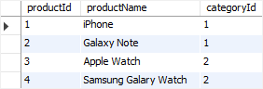

5) Update categoryId 1 to 100 in the categories table:

UPDATE categories

SET categoryId = 100

WHERE categoryId = 1;

6) Verify the update:

SELECT * FROM categories;



7) Get data from the products table:

SELECT * FROM products;

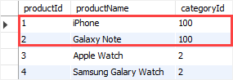

As you can see, two rows with value 1 in the categoryId column of the products table were automatically updated to 100 because of the ON UPDATE CASCADE action.

8) Delete categoryId 2 from the categories table:

DELETE FROM categories

WHERE categoryId = 2;

9) Verify the deletion:

SELECT * FROM categories;



10) Check the products table:

SELECT * FROM products;



All products with categoryId 2 from the products table were automatically deleted because of the ON DELETE CASCADE action.

**SET NULL action**

These steps illustrate how the ON UPDATE SET NULL and ON DELETE SET NULL actions work.

1) Drop both categories and products tables:

DROP TABLE IF EXISTS categories;

DROP TABLE IF EXISTS products;

2) Create the categories and products tables:

CREATE TABLE categories(

categoryId INT AUTO_INCREMENT PRIMARY KEY,

categoryName VARCHAR(100) NOT NULL

)ENGINE=INNODB;

CREATE TABLE products(

productId INT AUTO_INCREMENT PRIMARY KEY,

productName varchar(100) not null,

categoryId INT,

CONSTRAINT fk_category

FOREIGN KEY (categoryId)

REFERENCES categories(categoryId)

ON UPDATE SET NULL

ON DELETE SET NULL

)ENGINE=INNODB;

The foreign key in the products table changed to ON UPDATE SET NULL and ON DELETE SET NULL options.

3) Insert rows into the categories table:

INSERT INTO categories(categoryName)

VALUES

('Smartphone'),

('Smartwatch');

4) Insert rows into the products table:

INSERT INTO products(productName, categoryId)

VALUES

('iPhone', 1),

('Galaxy Note',1),

('Apple Watch',2),

('Samsung Galary Watch',2);

5) Update categoryId from 1 to 100 in the categories table:

UPDATE categories

SET categoryId = 100

WHERE categoryId = 1;

6) Verify the update:

SELECT * FROM categories;



7) Select data from the products table:

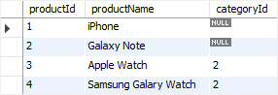

The rows with the categoryId 1 in the products table were automatically set to NULL due to the ON UPDATE SET NULL action.

8) Delete the categoryId 2 from the categories table:

DELETE FROM categories

WHERE categoryId = 2;

9) Check the products table:

SELECT * FROM products;

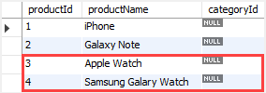

The values in the categoryId column of the rows with categoryId 2 in the products table were automatically set to NULL due to the ON DELETE SET NULL action.

**Drop MySQL foreign key constraints**

To drop a foreign key constraint, you use the ALTER TABLE statement:

ALTER TABLE table_name

DROP FOREIGN KEY constraint_name;

In this syntax:

* First, specify the name of the table from which you want to drop the foreign key after the ALTER TABLE keywords.
* Second, specify  the constraint name after the DROP FOREIGN KEY keywords.

Notice that constraint_name is the name of the foreign key constraint specified when you created or added the foreign key constraint to the table.

To obtain the generated constraint name of a table, you use the SHOW CREATE TABLE statement:

SHOW CREATE TABLE table_name;

For example, to see the foreign keys of the products table, you use the following statement:

SHOW CREATE TABLE products;

The following is the output of the statement:

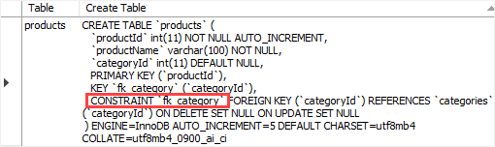

As you can see clearly from the output, the table products table has one foreign key constraint: fk_category

And this statement drops the foreign key constraint of the products table:

ALTER TABLE products

DROP FOREIGN KEY fk_category;

To ensure that the foreign key constraint has been dropped, you can view the structure of the products table:

SHOW CREATE TABLE products;

