**DATA VISUALIZATION**

While working with data, it can be difficult to truly understand your data when it’s just in tabular form. To understand what exactly our data conveys, and to better clean it and select suitable models for it, we need to visualize it or represent it in pictorial form. This helps expose patterns, correlations, and trends that cannot be obtained when data is in a table or CSV file.

**The process of finding trends and correlations in our data by representing it pictorially is called Data Visualization.**

## The Ultimate Guide to Data Visualization

## **What is Data Visualization?**

Data visualization is a field in **data analysis** that deals with visual representation of data. It graphically plots data and is an effective way to communicate inferences from data.

* Using **data visualization**, we can get a visual summary of our data.
* With pictures, maps and graphs, the human mind has an easier time processing and understanding any given data.
* Data visualization plays a significant role in the representation of both small and large data sets, but it is especially useful when we have large data sets, in which it is impossible to see all of our data, let alone process and understand it manually.

**Heatmap in Python.**

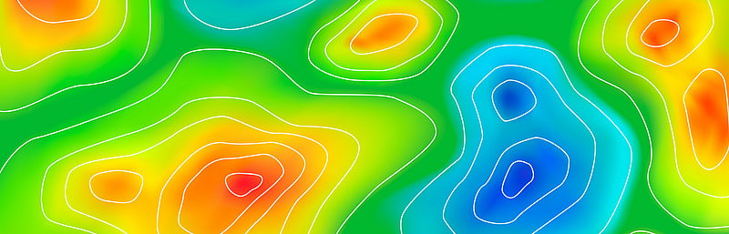

Visualization is an important way to make sense of data and draw informative and actionable insights. A good visual lets the reader get a basic sense of the information with just a glance.

A popular visualization used to view data is a **HEATMAP**. In this lesson, we will explain a heatmap and how to create one in Python using **Matplotlib, Seaborn, and Plotly**.

**What Is a Heatmap?**

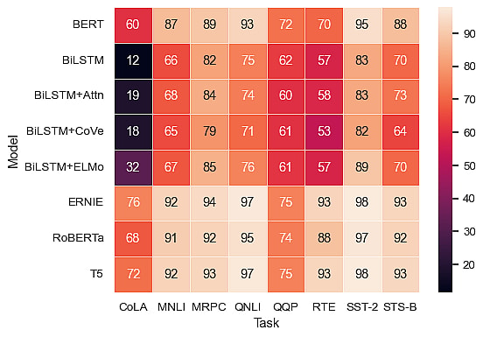

A heatmap is a 2-dimensional image representing data as a matrix or grid of points. A shade of a color plot represents each data point. Darker shades represent higher values than lighter shades.

Heatmaps make it easy to identify patterns, trends, and variations in data. They provide summarised information that lets users quickly see areas of high or low values, clusters, or outliers.

**Where Are Heatmaps Used?**

Heatmaps are helpful in showing how values vary over space. Everyday use cases include:

**Weather**

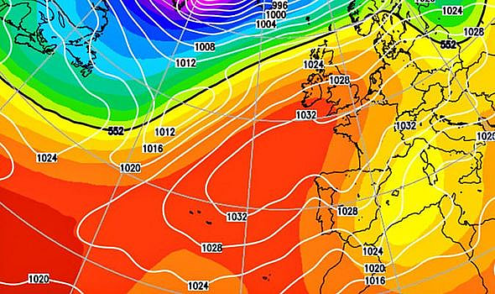

The most popular heatmap most people have seen is a literal heatmap – showing how temperature varies over different places.

This is an example weather forecast from [the Daily Express](https://www.express.co.uk/news/weather/1101867/UK-weather-forecast-hot-forecast-Met-Office-Britain-heat-warm-5-day-forecast-March-2019) showing the expected temperatures as a heatmap. This makes it easier to visualize which places will be hot, cold, or in between.

**Showing Website/App Usage**

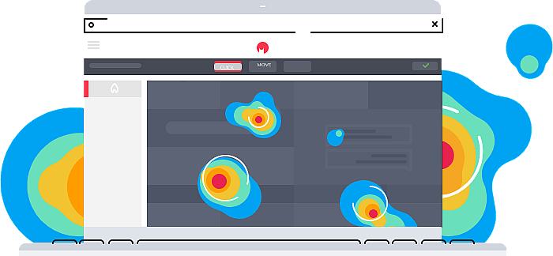

Through tracking mouse movements, clicks, and scrolling patterns, heatmaps help identify popular or neglected areas of a webpage. This can then be used to optimize user interfaces and enhance user experience.

**Medical Imaging**

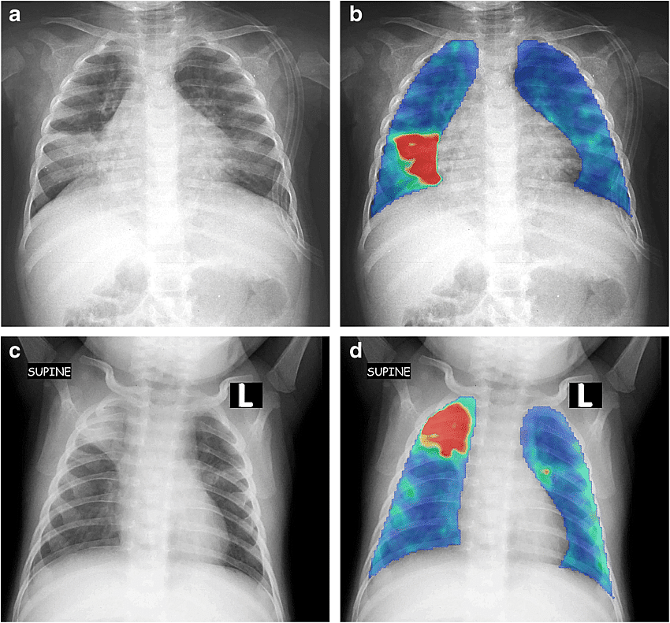

Source: [researchgate.net](https://www.researchgate.net/figure/A-colour-heat-map-helps-visualise-the-working-of-the-texture-system-For-each-chest_fig1_338556943)

Heatmaps visualize areas of high or low activity in the body. This can identify anomalies and diseases and assess the progression or response to treatment in conditions like cancer.

**Libraries for Creating Heatmaps in Python**

Python is a popular language for data analysis and visualization. This is because of its simple syntax and extensive ecosystem. There are multiple libraries that you can use to create heatmaps in Python. These include:

* **Matplotlib** – A popular data visualization library. It is a low-level library that provides more customization options but is complicated.
* **Seaborn** – This visualization library is built on top of Matplotlib and simplifies some of its functions while providing better-looking visualizations.
* **Plotly** – This is a visualization library that provides an easy-to-use API for creating Heatmaps in Python.

In the next section, we will explore how to create heatmaps using all of these libraries.