BAKU HIGHER OIL SCHOOL

PROCESS AUTOMATION ENGINEERING

DEPARTMENT

INFORMATION SECURITY Division

Cryptography

STUDENTS NAMES: *Gulay Nazarova*

STUDENTS IDs: *210104020*

TOPIC:

***“Ecommerce Application: BeTheOne”***

DATE OF SUBMISSION: 04.04.2023

INSTRUCTOR: *Khayyam H. Masiyev*

Contents

Introduction 2

Initial Research 3

Advantages of Ecommerce Application 3

Project scope and constraints 3

Interview 4

Features 5

Requirement Analysis 6

List of requirements 6

Use-case diagrams 8

Diagrams 9

WBS-Work Breakdown Structure 9

ER diagrams 10

Class Diagrams 11

Activity diagram 12

Sequence diagrams 13

Agile Product Management 14

Kanban Board 14

GUI Screenshots 18

Source Code and StripeAPI 19

Test cases and Use cases 23

Cryptography 32

Required links: 34

References 34

# Introduction

Nowadays, thanks to the Internet and other technological advancements, consumers may make purchases from the convenience of their homes or places of employment. The Internet facilitates shopping for the consumer. Also, e-digital commerce's component enables vendors to provide a variety of goods, some of which would be impossible to sell in a physical location. With a single click, transactions may also be cancelled. Online retailers including Amazon, Trendyol, Ebay, Alibaba, Taobao, and Walmart are well-known examples. These websites provide the convenient online buying. The website's search engine allows users to browse for the things they want, with a variety of filtering options and a user-friendly interface for millions of products. Customers should also discuss their orders and experiences with the merchant who published the goods. Consumers could have to update their personal information, make a purchase adjustment, or return a defective item. With a contact form or a chat service, connecting with consumers is also made simpler.

Our intention while building this BeTheOne website was to provide shopping-lovers with high-quality products and demonstrate their fashion skills. The user may learn additional details about the desired product, which will assist in addressing returns of defective goods. BeTheOne decided to use Agile product management approaches as a team. As a result, we divided our job into smaller, more doable projects to start. We discuss our work breakdown structure, which divides the project production into four key steps: planning, implementation, monitoring, and control, and deployment, in Diagrams chapter , which is devoted to diagrams. We have outlined the user needs (product backlogs) and related system requirements in Requirements section.For a hosting,we will use Docker and Kubernetes.

Our project was created as an NestJS application for backend development. We employ several protocols and methods for email verification, video, and database storage in terms of cryptography.

Regarding risk assessment and management, we are quite likely to run into a few online and system-related issues during early production because our project still has to be developed. There are a number of possible dangers that our team is quite likely to confront and handle to some extent. Internet security, system dependability, privacy concerns, customer complaints, adjustments to Google SEO, return of items, and warranty are a few challenges that we will face and work to address during the upcoming product releases.

# Initial Research

## Advantages of Ecommerce Application

Because they may work with many vendors, buyers gain a lot from utilizing C2C platforms. In addition, searches using criteria are accessible. For instance, you may choose from deals for top sellers, top sellers.

High profitability brought on by direct sales is the primary benefit of C2C for sellers. Sellers typically benefit from lower overhead costs. This implies that for business owners, there is no need to spend money on overhead costs like rent, office supplies, or salaries. It is unquestionably a positive that the transaction fee is not excessive. The finest one is effectiveness in selling handcrafted and environmentally friendly goods, as well as other distinctive or individual items. The amount of visitors and potential consumers entering a physical or online store depends on chance, shop location or convenience, proper promotion, marketing, and repeat business from existing customers. A C2C eCommerce marketplace "stall," however, has a significantly better chance of receiving visits and transactions since customers go to that platform specifically to seek for the goods and services it offers. Moreover, the C2C eCommerce marketplace's online nature makes your goods and services available to a global clientele, boosting the likelihood that a conversion will occur.

## Project scope and constraints

The primary objective of this project is to create an e-commerce web application that offers users a safe setting in which to buy and sell products. and the product (online or offline). The program will also perform other beneficial tasks, including collecting consumer reviews .Additionally, users feel secure because authentication features we use in our app.

Considering the project's limits, the most important one is that it must be finished within the allowed budget. In addition, as a team, we aim to complete the project's primary capabilities in three months. Given the likely limitations of our time, we will eventually examine additional functionality like the integration of third-party payment gateways. Our major objective is to establish a peer-to-peer ecosystem that will simplify the payment and product delivery processes. Thus, further consideration of online transactions will not be given. Additionally, only a small number of browsers, mainly Google Chrome, Firefox, and Opera, should be used in order to benefit from all the sophisticated capabilities of this service.

## Interview

Interview steps:

1. Selecting candidates;

2. Requesting data that is required for the project;

3. Evaluation of interview findings and responses to questions;

4. The discussion documentation procedure;

Interview Questions and Answers:

1. What is the project's purpose?

- This web application's goal is to give people safe online shopping while protecting the environment. We are working on integrating fashion to ecommerce in a way that users do not only do shopping, but also they will become amateur stylists .

2. What potential issues could arise in the future?

- Since our app is not mobile friendly,while users enter site site via phones,they will encounter some problems which leads to users’ losing their interest on our app.

3. How do we vary from similar projects? – In our future improvements of our project,users could get weekly report about their outfit(that they buy from our app) and could get match result with celebrities’ outfit.

4. How will the advertising system be offered?

- Certain areas, particularly the leftside, will be set aside for sponsored advertisements, specifically on our website, and time accuracy will be determined in accordance with the amount received from cooperative businesses.

5. How will you handle problems with money?

- All cooperating businesses will receive paid advertisement services to market their goods on our platform..

# Features

* User registration and login: The app should allow users to create an account, log in and log out. This is essential for tracking user activity.
* Product catalog: The app should have a product catalog with clear and detailed descriptions of each item, including product images, price, and availability.
* Shopping cart: The app should provide a shopping cart where users can add, edit, and remove items from their orders.
* Checkout and payment processing: The app should allow users to complete their purchases using a secure payment gateway. Payment options should include credit card and debit card.
* Search functionality: The app should have a search feature that enables users to search for products by category, name and other attributes.
* Ratings and reviews: The app should enable users to leave ratings and reviews of products they have purchased, which can help other users make informed buying decisions.

## 

# Requirement Analysis

## List of requirements

**1.Free software – Ecommerce app should be free.(U.R.):**

* *Source code is open-source(S.R.)*
* Open source libraries should be used to make the project financially-attainable.(F.R)

(e.g. Firebase, Stripe API)

**2.Registered users can login via email and password or they can use Google Authentication(U.R):**

* ***Authentication and Authorization is made by backend. (S.R.)***

*Functional requirements:*

* User sessions will be controlled with JWT tokens(F.R)
* Firebase Auth provider will be used which utilizes JWT.(F.R)

*Non-functional requirements:*

* Emails are unique (N.F)
* Firebase will handle all requests related to authentication and Admin SDK for backend (written in Nestjs) will also be used.(N.F)

**3.Users should add products to wishlist and should view whole list, so that they could make changes: (U.R)**

* *Data is stored in local storage(S.R)*
* “Add to cart” icon should be visible. (F.R.)
* The system must allow registered users to select a product, add it to the wish list to buy. (F.R.)
* The system must allow buyers to view details about the product when he/she clicks on the product. (F.R.)
* The system must allow buyers to remove a product from the wish list. (F.R.)
* The system must allow buyer to see all the products in wish list whenever he/she goes to wish list page. (F.R.)
* Buyer clicks on the small “heart” icon to add it to the wish list. (N.F.R.)
* Buyer clicks on the “heart button” again in order to remove the selected item. (N.F.R.)
* The red heart button turns red right after pressing it while adding. (N.F.R.)
* The red heart button turns white right after pressing it while removing. (N.F.R.)

**4.Secure communication forum where all users and admin could send messages to each other(U.R):**

* *Messages will be stored in Firebase (SR)*
* *Message will be sent from client to client of receiver within Firestore (SR)*
* Messages should be end-to-end encrypted. (with SSL/TLS encryption)(N.F.R.) Messages will be sent to client to Firestore, then broadcasted to all users(N.F.R)

**5.** **As a user should be able to change his/her profile details.(U.R)**

**Update profile user history:**

* *Update process should occur in Firebase(SaaS)(S.R)*
* A user navigates to his/her profile page. (F.R)
* After selecting personal info section, the fields of adequate properties are provided. (F.R)
* Once changes are made, to save the changes.(F.R)
* Reauthentication will be provided by Firebase.(N.F.R)

**6. User wants to search and filter the product-by-product name or manufacturer name, so that he/she can find what they are looking for conveniently. (U.R.)**

* *Product search should be done on Stripe API in backend(S.R)*
* System must allow filtering and searching by product name. (F.R.)
* System must allow filtering and searching by manufacturer name. (F.R.)
* The number of products visible on the page should fit the page size, and if there more than one-page, user should use Add More button. (F.R.)
* System must inform user in case the search item is not found. (F.R.)
* Search box. (F.R.)

**7. User should be able to recover the password to his/her account, so that he/she will be able to access the account in case I forgot the password.**

**Forgot password user story:**

* *Forgot password should be done on Firebase(SaaS)(S.R)*
* The user navigates to the login page.(F.R)
* The user selects <forgot password> option. (F.R)
* For password recovery, user should enter a valid email . (F.R)
* This email will receive the link from the system. (F.R)
* When user clicks the link,it will redirect to set new password page. (F.R)

**8.Non-registered(new) user should register on the application, so that they can take advantage of the functionalities and be in the shopping process. (U.R)**

Registration interface user story:

* *Firebase Admin SDK should be used.(S.R)*
* In Sign Up page, the fields for filling credentials contain placeholders with a grey-colored background and black text. (N.F.R.)
* Required personal data must include display name, email, phone number (F.R.)
* The password should be provided by the user with the real time checker of the password policy. If it does not satisfy the criteria like the length or strength, a user will be warned with a red-colored text. (F.R.)
* The system must provide a Signup button on bottom of the “Sign Up” page. After filling the form, the user should press this button. (F.R.)

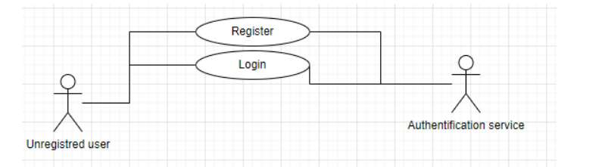

**9.User could make a comment about products and sellers, so that she/he can help other users to be informed rightly and admin to act if it is needed.**

Comment user story:

* *For storing comments , Firestore should be used(S.R)*
* The system must allow one user to write comments (there is no limit in comment number) about one product even if they did not buy this product. (F.R.)
* Registered users will be able to share their feedback on the proper box which is on the product page. (N.F.R.)
* The system should not restrict the character number. (N.F.R.)

## Use-case diagrams

**Use case diagrams for registered and non-registered users:**

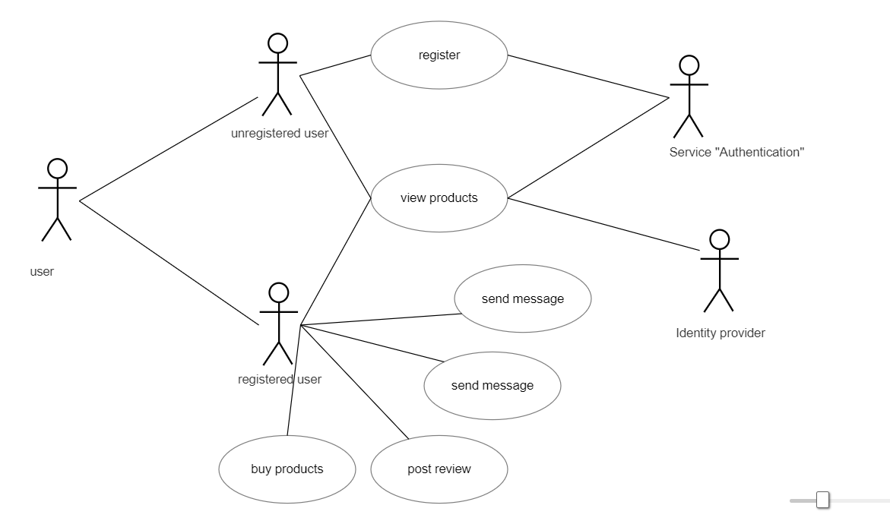

* Unregistered users(ordinary user) can view the products, so that they could decide whether to register or not.
* New user can register so that thy take advantage of some functionalities that our app has provided to other registered users.
* In order to view their activities ,user can log in their account.

**Use case diagram for products:**

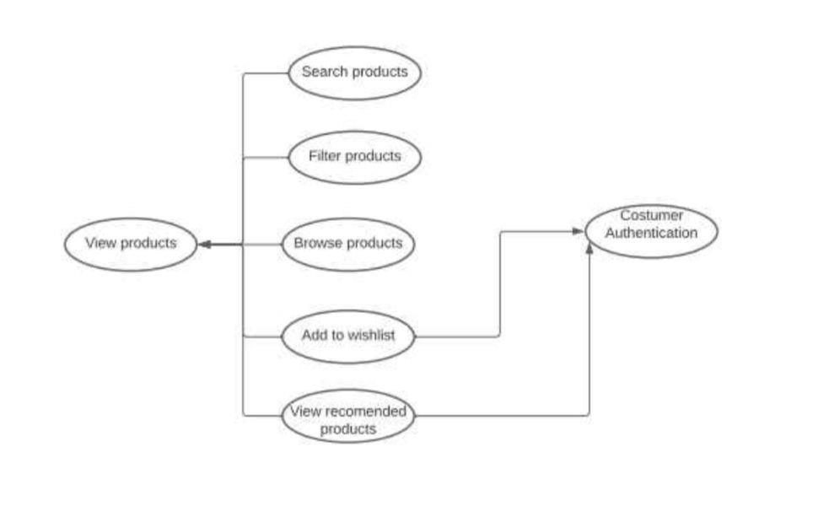

* Ordinary user may want to view the products page for deciding whether to register or not.
* Registered users(in this case they are buyers) may want to add the product to the wish list and view the whole list to control them regularly and make changes.
* User may want to search and filter the product by product name or seller username.

# Diagrams

## WBS-Work Breakdown Structure

The project is visually and hierarchically deconstructed in the Work Breakdown Structure (WBS) for our e-commerce website. Based on the needs of our clients, it is constructed in only three easy steps:

Deliver to the scope of our project; 2. Specify the tasks within each of the aforementioned deliverables; and 3. Divide the tasks into more specific subtasks.

In our work breakdown structure for the e-commerce website, all subdivisions refer to achievable tasks that may be given to a single group member, while the ultimate deliverables remain at the top of the tree diagram:

E

-

commerce

website with video

call Project WBS

Planning

Project

ement

Requir

lysis

ana

Research

Hosting

Options

Design Site

User

Interface

Technical

Specification

Report

trategy

Test S

ument

Doc

Pl

an

Implem

entation

Devel

op the

bsite

We

ecture

Archit

elop

Dev

bsite

We

Develop

Product

Database

Develop

Backend

ring and

Monito

ntrol

Co

Perform Risk

Management

Perform Quality

Assurance

Perform Issue

Management

yment

Deplo

Perform

Deployment

The WBS keeps the work organized and ensures that no task escapes one's attention because it is physically impossible for a single project manager to think about all the tasks that need to be completed. An e-commerce website roadmap can be created using this approach. It aids in mitigating potential risks of cost overrun and scope creep while assisting our team in meeting project deadlines.

## ER diagrams

All of the key entities, their characteristics, and relationships are thoroughly mapped out in this online retail ERD. From browsing to payment, it provides the broad outlines of all the parties involved. Making an ERD for a shopping system can help to make sure that all the crucial components are included in our system. By purchasing or placing an order, the system can encode the customers' information. Both the information and the transactions of the customers can be seen by the administrator. They are capable of handling the data required for maintaining information and keeping track of customer requests. Security and monitoring of the seller information and customer information status were characteristics that were incorporated in the system ER diagram. Reports that served as a record of the system's transactions also included a list of these elements and their details.

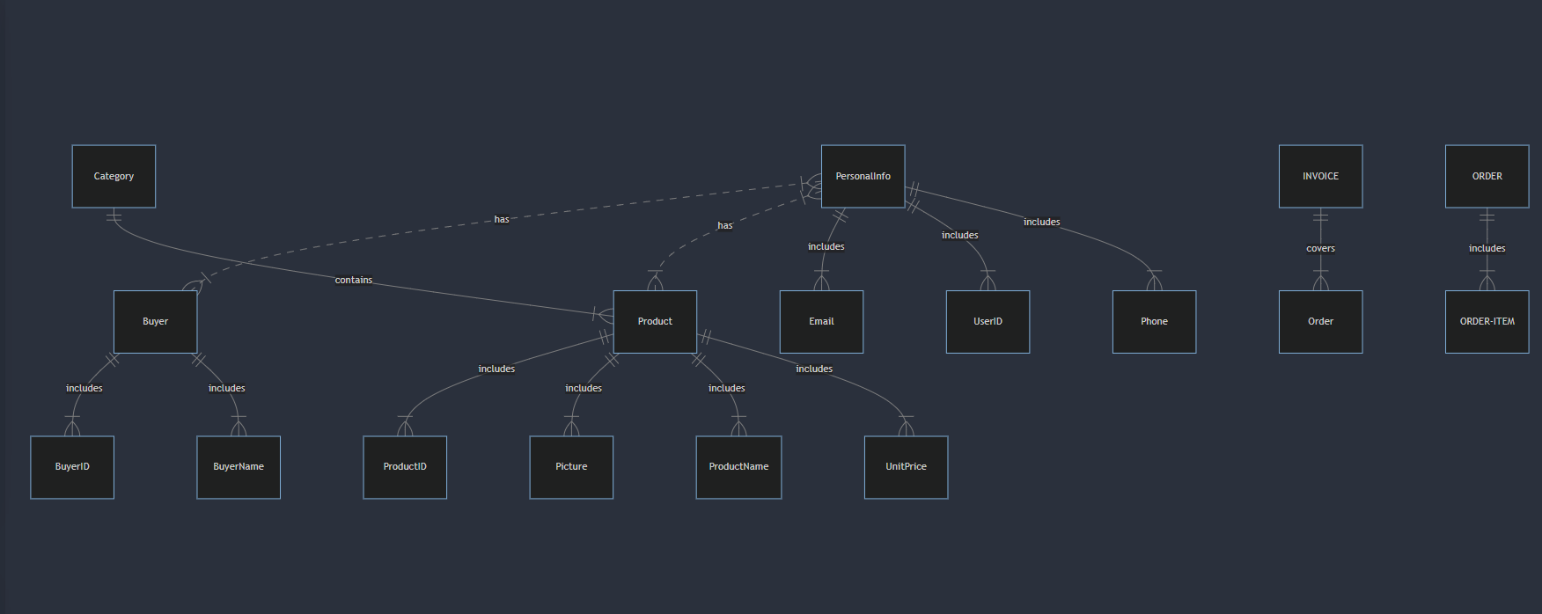

## Class Diagrams

Our class diagram, which displays a domain model for online purchasing, is provided here.

As we have used Stripe API for payment, product processing(adding, deleting products),we do not need to create databases, classes and interfaces while developing backend structure of our app. The diagram's goal is to define some basic concepts from the "lexicon" of online shopping, including Customer, Web User, Account, Shopping Cart, Product, Order, Payment, and interactions between them. It might serve as a point of connection for programmers and business analysts. Every single consumer has a distinct ID that is connected to just one account. Shopping cart and orders belong to the account. For the purpose of making online purchases, customers could register as website users. Since orders can also be placed over the phone or through catalogs, a customer is not forced to use the internet to make purchases. A login name for a website is also an ID number.

## Activity diagram

The flow of activity via a sequence of actions is depicted in the activity diagram. An essential diagram for describing the system is the activity diagram. The action or system operation that was mentioned was the activity. Describe every feature or action consumers can do on our website in the user side activity diagram. Online shoppers can explore or search for products, view specific products, add them to their shopping carts, view and edit their carts, and then check out.

The user can always view products . It is believed that user registration and login occur at checkout and transcation process as it redirects to StripeAPI where users can purchase their favourite product securely.

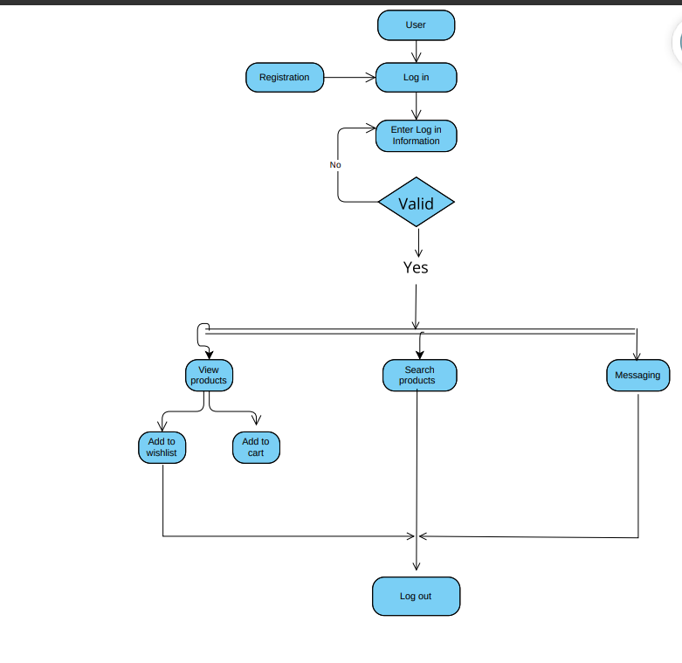

## Sequence diagrams

• When a user accesses the shopping application, the homepage displays application.

* The details for each product must appear when clicking on it.
* All users can view products and even add products to wishlist. When they want to buy the product they should be redirected to signup/login page.
* The system must provide a SignUp button on bottom of the “Sign Up” page. After answering all the questions, the user should press this button.
* When they want to buy the products , they will be redirected to StripeAPI’s payment page. In this page, they could choose number of items, or even delete the product from the list.
* Once, they finish their payment process they will receive order confirmation.

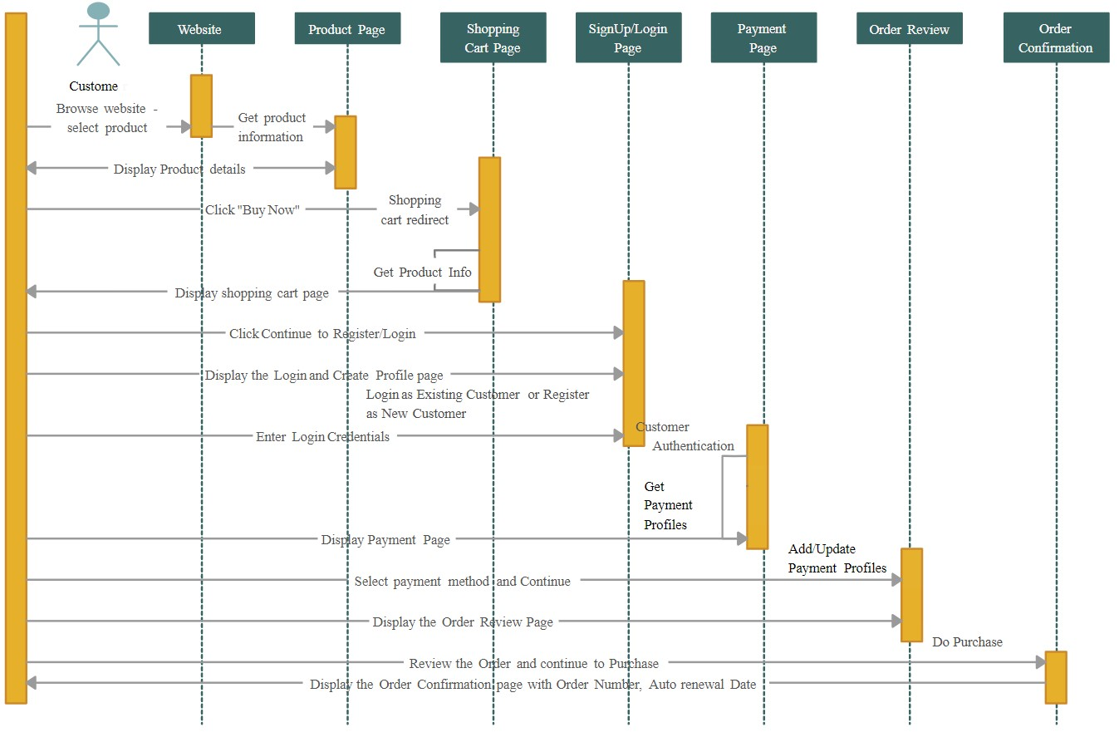

# Agile Product Management

## Kanban Board

At many different businesses, kanban boards help to continuously improve workflow management.

They support the effective execution of all projects and the management of intricate procedures. Orders appear as cards on our Kanban board. An online store category of goods included by an order can be determined by a card's color. Because each order must be sent up to 14 days after we get it from a customer, cards have icons that let us know about the high priority task (red arrow) and the number of days left to send the shipment. The icon with the remaining days will appear on a card when we enter the date in the "Due date" field on a dispatch that needs to be sent. Attachments enable us to centralize all relevant documentation for a given order.

|  |  |  |  |
| --- | --- | --- | --- |
| **Backlog** | To do | In progress | Done |
| Guest User    Accept. Criteria: Guest user views products.    High | Items should be presented with comprehensive information on the home page and subsequent pages. | The creation of a home page with a list of products with Edit, Remove, and Create options is ongoing. | On the home page, visitors can view the products. |
| New User    Accept. Criteria: Users register by providing the necessary user information.  High | The registration page has to be ready. | The Register page work is currently underway. |  |
| Logged out user    Accept. Criteria: Someone who was previously logged out logs in. | The login page needs to be ready. | Page for logging in is being created. | . |

|  |  |  |  |
| --- | --- | --- | --- |
| High |  |  |  |
| Forget Password    Accept. Criteria: Password recovery for registered users is done by confirmation email.    High | It is recommended to create a forgot password page and related features (send reset email). | The Forgot Password feature is still being developed. | Function is not available. |
| User data  modification    Accept. Criteria: logged-in user updates email and contact information.    Second Level | A function to update profiles and settings needs to be created. | It is being developed to allow users to modify their data. | In progress |

|  |  |  |  |
| --- | --- | --- | --- |
| Add to Wish List    Accept. Criteria: A button is clicked by the user buyer to add a goods to their wish list.    Second Level | It is necessary to construct the update wish list function and related functions. | A wish list feature is in the works. |  |
| Searching and  filtering    Accept. Criteria: User searches and filters products. | It should be possible to search for items based on seller and product names. It is necessary to design filters for alphabetical order, price, and location. | It is being designed to have search and filter capabilities. | . |

|  |  |  |  |
| --- | --- | --- | --- |
| High |  |  |  |

|  |  |  |  |
| --- | --- | --- | --- |
| Chat Box    Accept. Criteria: Users have a chance to talk to each other on the forum  Second Level | The chat box portion needs to be ready. Functions to write ,send and receive messages. | Chat Box feature is in the works. | Users can contact via chat box messaging. |

## GUI Screenshots

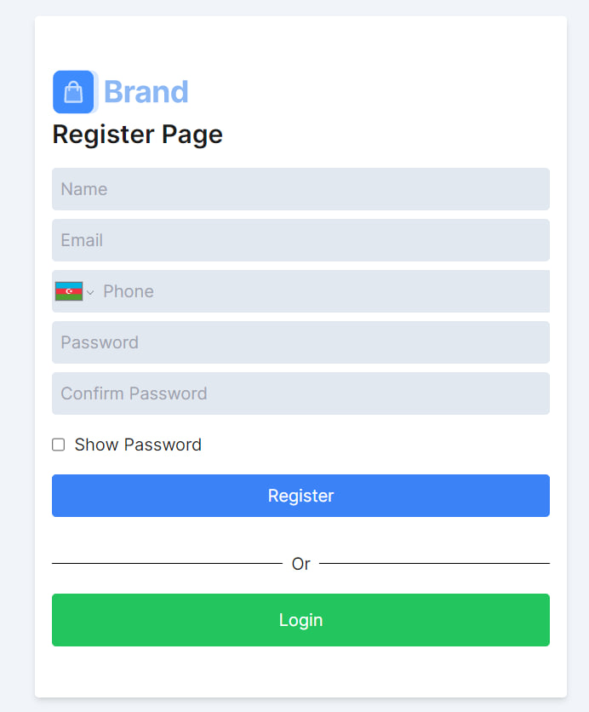

## 

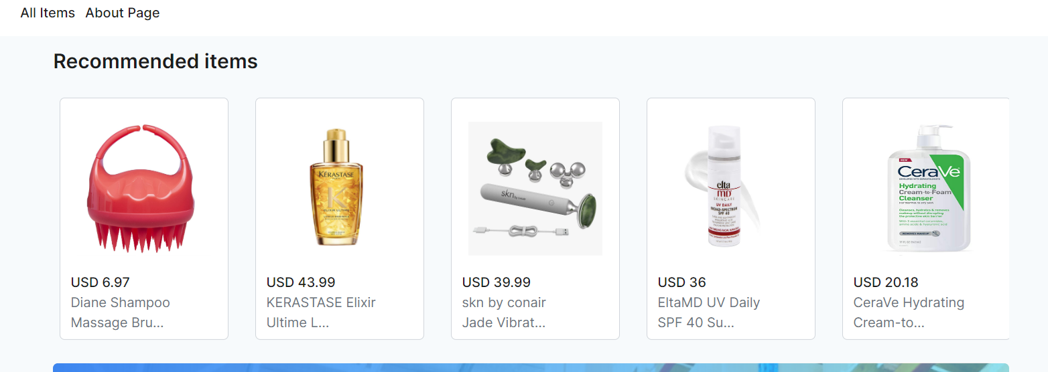

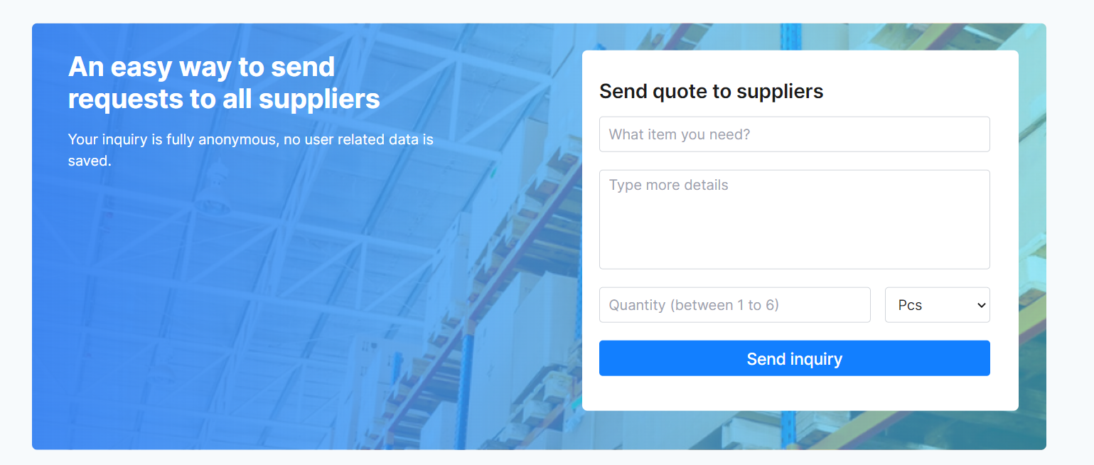

## Source Code and StripeAPI

The following images are some parts of the project’s source code and StripeAPI

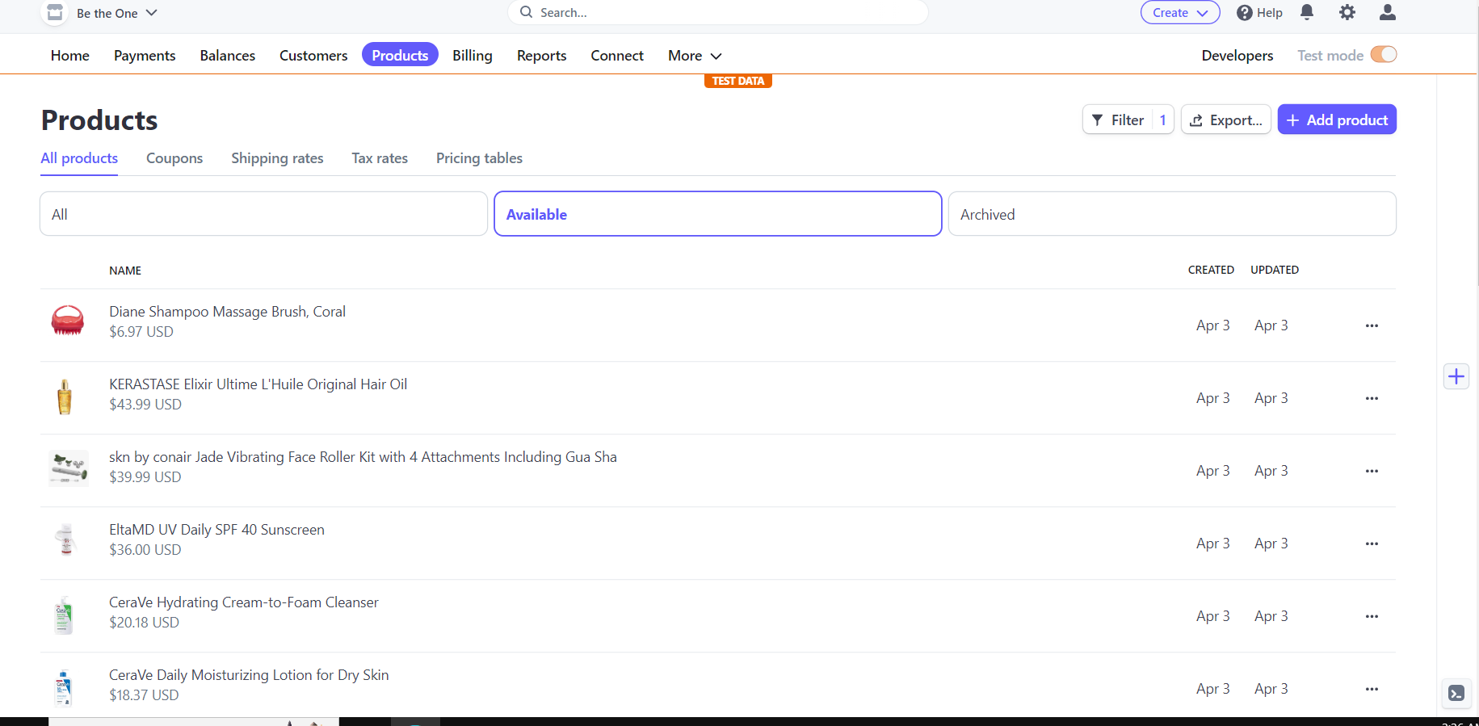

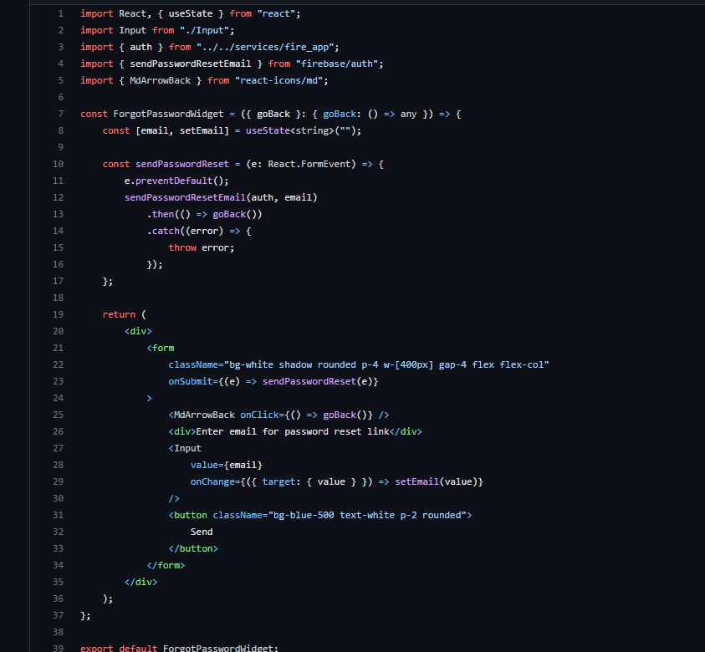

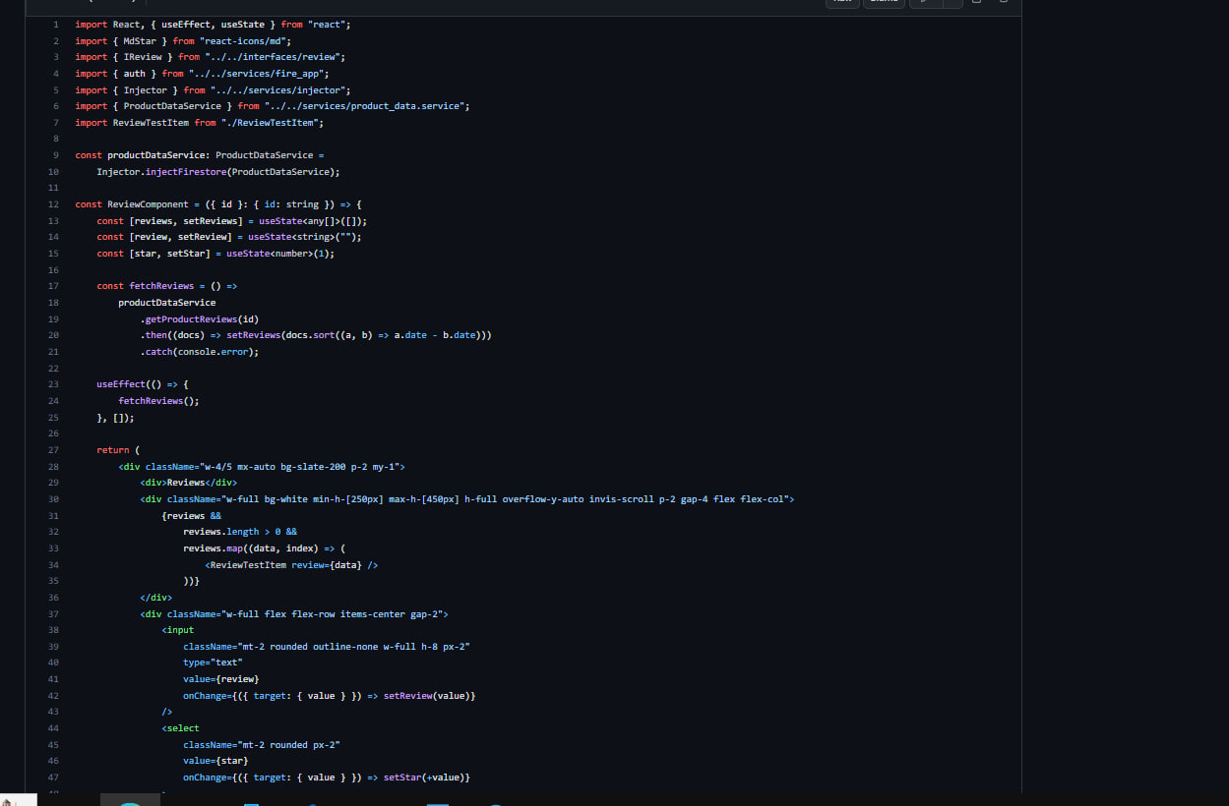



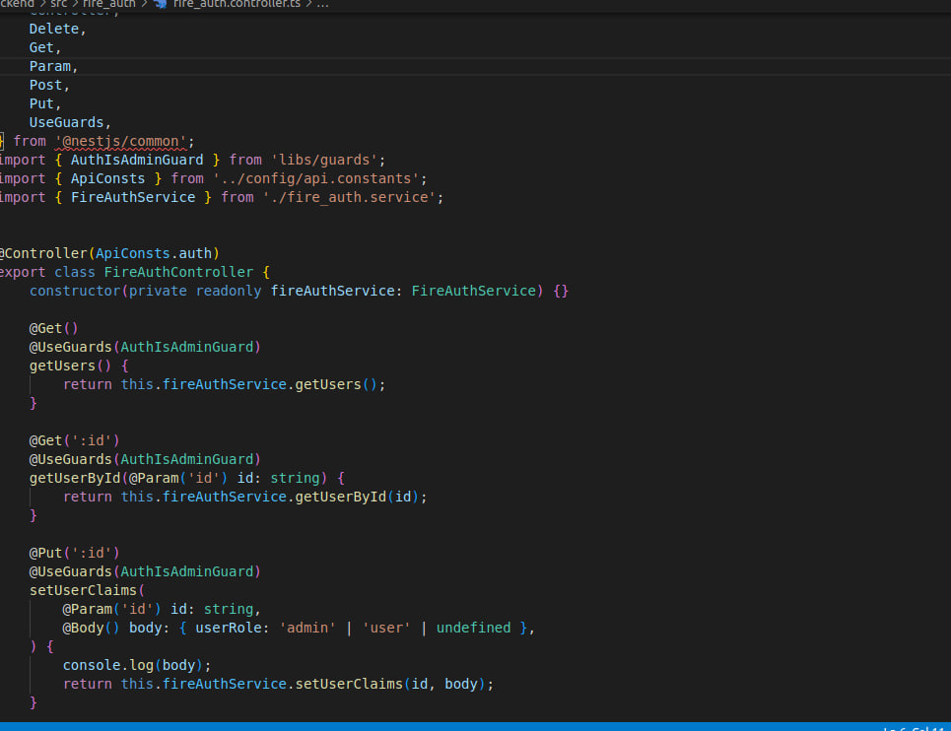

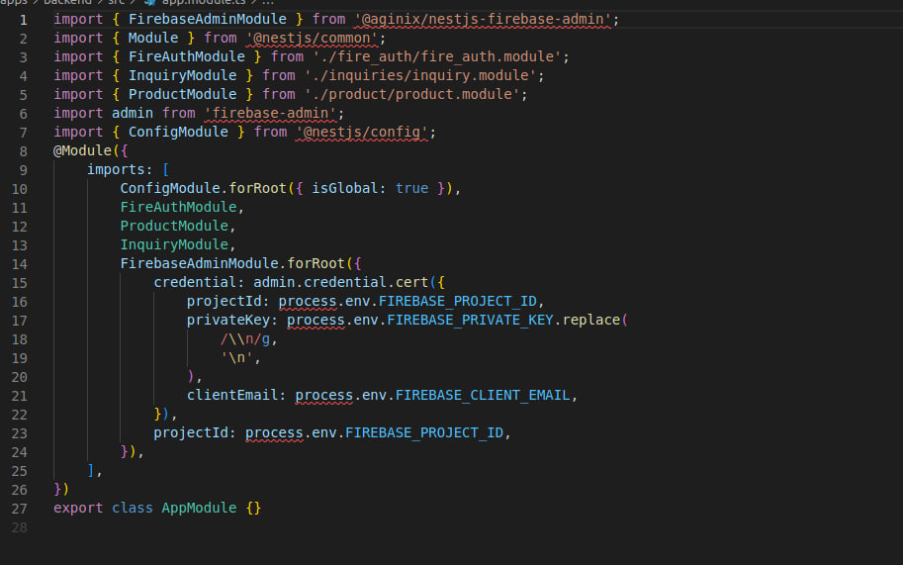

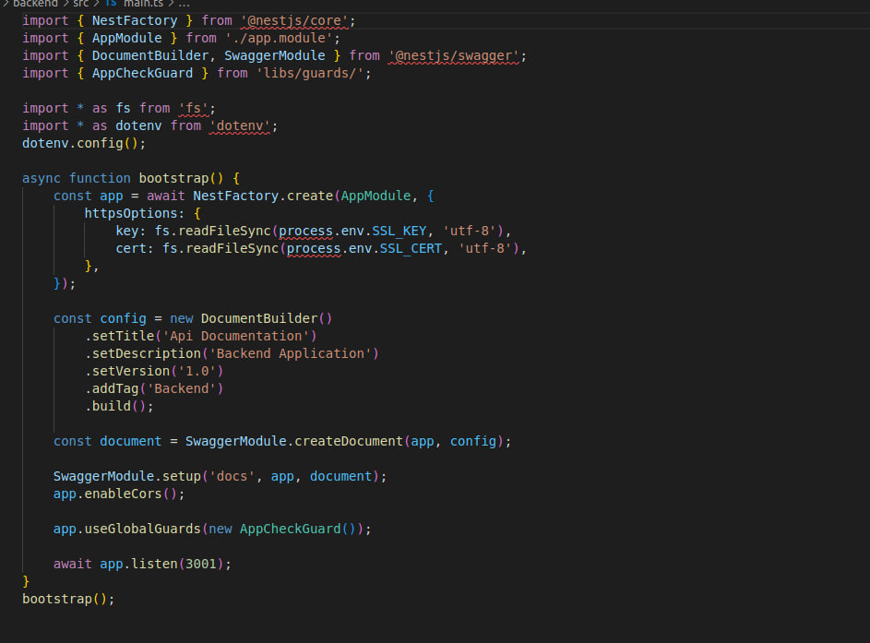

## Test cases and Use cases

**Use cases for registration page:**

|  |  |  |
| --- | --- | --- |
| **Use Case ID** | **Use Case Title** | **Description** |
| UC-01 | supplying the necessary information and credentials | Fields on the sign-up page that need credentials filled out have placeholders with grey text. Display name(username),password, email, phone number. |
| UC-02 | Password validation | With the real-time password policy checker, the user must supply the password. A warning in red language will if it does not meet the requirements for length or strength. |
| UC-03 | Signup button | On the "Sign Up" page's bottom, the system must include a Signup button. |
| UC-04 | OTP | The user will get OTP code via the phone number they entered |

|  |  |  |  |  |  |  |  |
| --- | --- | --- | --- | --- | --- | --- | --- |
| **Test Case ID** | **Test Case Title** | **Test Case**  **Descripti on** | **Pre-requests for test case for executing** | **Execution steps** | **Expected results** | **Result** | **Owner/ Developer** |
| UC-01--  TC-01 | supplying the necessary information and credentials | Verify the mandatory fields by leaving them blank. | Guest user / Unregistered user | 1. Click the Register button without entering any data in the field. | 1.The app will give the error “Data is not provided correctly) | **Pass** | G.Nazarova |
| UC-01--  TC-02 | Filling credentials and | Check by  filling all the | Guest user/ Unregistered user | 1. Fill in accurate data in the | 1. Users should be | **Pass** |  |

|  |  |  |  |  |  |  |  |
| --- | --- | --- | --- | --- | --- | --- | --- |
|  | providing required data | required fields. |  | required fields. 2. Click the Register button. | registered successfully.  2. A successful  registration message should show |  |  |
| UC-  01—  TC-03 | Filling credentials and providing required data | Verify if blank spaces are passed in required fields | Guest/  Unregistered user. | 1. Pass blank spaces in required fields. 2. Click on the Register button. | 1. Blank spaces should trim. 2. A validation error message for required fields should be visible. | **Pass** |  |
| UC-02-TC-04 | Password validation | Check the password limit when enter value less than minimum. | Guest / Unregistered user, user data =  234efsA | 1. Enter  value which  is  alphanumeri c but less than 8. 2. Click on Register button. | 1. The password field must be filled with dots.   **2.**Password policy error should appear | **Pass** |  |
| UC-  02—  TC-05 | Password validation | Check the password when passing only numbers. | Guest/ Unregistered user, user data =  12345678 | 1. Enter a value in numbers which is in between 832. 2. Click on Register button. | 1. The password field should be filled with dots.   **Password policy error should appear** | **Pass** |  |
| UC-  03— TC—06 | Submit button | Check the password when passing valid data. | Guest/ Unregistered user, user data = dfseA86g | 1. Enter value in alphanumeri c which is in between 832  2.Click on | 1. The password field should be filled with dots. 2. It should show | **Pass** |  |

|  |  |  |  |  |  |  |  |
| --- | --- | --- | --- | --- | --- | --- | --- |
|  |  |  |  | Register button. | validation message. |  |  |
| UC-  03—  TC-07 | Submit button | Verify if the password required rules are not satisfied in the password | Guest/ Unregistered user, user data =  24se | 1. Enter the password   which does  not satisfies the required rule.   1. Click on Register button | 1. The password field should be filled with dots. 2. It should display error with required   rules for password value. | **Pass** |  |
| UC-  04—  TC-09 | OTP | Check if the phone number is valid and is used by the real user | Registered user./Unregistered  user | 1.Enter the OTP code received via the phone number | 1.The OTP code should be written in the prompt page.  2If the code is valid.It will redirect to home/login page. | Pass |  |

**Use cases for login page:**

|  |  |  |
| --- | --- | --- |
| **Use Case ID** | **Use Case Title** | **Description** |
| UC-01 | Filling credentials | In Log / Sign In page, fields for email address and password are provided with real-time checker. |
| UC-02 | OTP code | Once the user click login button,the page will prompt to enter OTP code. |
| UC-03 | Confirmation data-error message | If the user email is not found, the user will be informed with a red-colored text:  “This email has not been registered”. |
| UC-05 | Password validation | User has 5 chances to enter the password correctly. Otherwise, the Log In page will refresh automatically. |

**Test Case for login page:**

|  |  |  |  |  |  |  |  |
| --- | --- | --- | --- | --- | --- | --- | --- |
| **Test**  **Case ID** | **Test Case Title** | **Description** | **Prerequests for test case for executing** | **Execution steps** | **Expected results** | **Result** | **Owner/ Developer** |
| UC-01-TC-01 | Filling credentials | Check the required fields by not filling any data. | Registered / Logged out user. | 1. Do not enter any value in the field and click on the Register button. | 1. It should show a mandatory symbol (*) on mandatory fields. | **Pass** |  |
| UC-01-TC-02 | Filling credentials | Check user should Log  in by filling  all the required fields. | Registered / Logged out user. | 1. Enter valid values in the required fields. 2. Click the Log in button. | 1. Users should be logged in successfully. 2. User should be directed to home page. | **Pass** |  |
| UC-01-TC-03 | Filling  credentials | Verify if blank spaces are passed in | Registered / Logged out user. | 1. Passed blank spaces in required fields. 2. Click on | 1. Blank spaces should trim. 2. A validation error message for required | **Pass** |  |
|  |  | required fields. |  | the Log in button. | fields should be visible |  |  |
| UC-02-TC-04 | Confirmation data - authentication | Match the entered email to the one in the database. | Registered / Logged out user. | 1. Enter the email. 2. Click on the Log in button. | 1.Corresponding field should be filled.  2. Matching should be realized. | **Pass** |  |
| UC-03-TC-05 | Confirmation  data – error message | Matching fails and error message should appear. | Registered / Logged out user. | 1. Enter the email. 2. Click on the Log in button. 3. The email does not match the one in database. | 1.Corresponding field should be filled.  2. Matching should fail. 3. Error message should appear. | **Pass** |  |

|  |  |  |  |  |  |  |  |
| --- | --- | --- | --- | --- | --- | --- | --- |
| UC-04-TC-04 | Password validation | Verify if the password is correct. | Registered / Logged out user, user entering test data = 24se. | 1. Enter the password which is not correct. 2. Click on Log in button. | 1. The password field should be filled with dots. 2. It should display error. | **Pass** |  |
| UC-04-TC-05 | Password validation | Count the number of trials. | Registered / Logged out user. | 1. Enter wrong  credentials 5 times. | 1. Message should be displayed about log in trial expiration. | **Fail** |  |

**Use cases for product images:**

|  |  |  |
| --- | --- | --- |
| **Use Case ID** | **Use Case Title** | **Use Case Description** |
| UC-01 | Product type | Different product types may be suitable for different display layouts. |
| UC-02 | Product information | User should see product description. |
| UC-03 | Display product information | User should see the products on Products Page, and details by clicking on the Details button. |

**Test cases for product pages:**

|  |  |  |  |  |  |  |  |
| --- | --- | --- | --- | --- | --- | --- | --- |
| **Test**  **Case**  **ID** | **Test**  **Case**  **Title** | **Description** | **Prerequests for test cases for executing** | **Execution steps** | **Expected results** | **Result** | **Owner/ Developer** |
| UC-  01—  TC-01 | Product type | Check if the user can search for different type of product. | Registered/  Unregistered  user | 1. Register 2. Log in to seller account.   1. Click search bar 2. Enter product   category.   1. Click search button. | 1. Receive OTP message. 2. Be redirected to Home Page. 3. Search bar opens 4. The empty fields should be filled. 5. Products related to written category will be displaeyed | Pass |  |

|  |  |  |  |  |  |  |  |
| --- | --- | --- | --- | --- | --- | --- | --- |
| UC-  02—  TC-03 | Product informati on | Check if the product details can be read | Registered user | 1. Register as 2. Log in to seller account.   1. Click on the product | 1. Receive confirmation message. 2. Be redirected to Home Page. 3. Product description page will   Open. | Pass |  |
| UC-  04—  TC-04 | Display product | Check if the product details can be | Non-registered | 1. Go to website. | 1. Home Page should open. | Pass |  |
|  | informati on. | seen | registered user. | 2.Click on Details button for a product. | 2. Product details should be seen. |  |  |

**Use cases for chat forum:**

|  |  |  |
| --- | --- | --- |
| **Use Case ID** | **Use Case Title** | **Description** |
| UC-01 | Join to a chat | Message/chat button should be available |
| UC-02 | Send message | Once entering the chat page, user could send message to all users in the forum. |

**Test cases for chat forum:**

|  |  |  |  |  |  |  |  |
| --- | --- | --- | --- | --- | --- | --- | --- |
| **Test Case ID** | **Test**  **Case**  **Title** | **Description** | **Pre-requests**  **for test case for executing** | **Execution steps** | **Expected results** | **Result** | **Owner/ Developer** |
| UC-01—  TC-01 | Join a chat | Message/chat button should be available | Logged in user | 1.After logging in,user could click message button | 1.User will chat page | **Pass** |  |
| UC-02—  TC-02 | Send message | Once entering the chat page, user could send message to all users in the forum. | Logged in user | 1.After entering chat page user could start typing in message bar  2.Press send button | 1.User input will appear  2.Message will be sent to all of the users of the forum  . | **Pass** |  |
|  |  |  |  |  |  |  |  |

# Cryptography

A complex network of several application development platforms, database management systems, systems software, and network infrastructure are all necessary for the effective operation of e-commerce security. To secure sensitive data during transactions, our e-commerce web application employs a number of cryptographic methods and encryption protocols. These algorithms have been applied to secure database encryption, video calls, and email verification.

We have used HTTPS protocol for our app, which mainly uses SSL/TLS certificate to encrypt communication between the user’s web browser and ecommerce server. As we have used https, data transferred between the server and user is encrypted and can not be seen by anyone. (which prevents Man-In-The-Middle Attack). They offer several benefits, such as encryption, authentication, integrity, trust, and compliance. Encryption helps to protect data in transit from interception and eavesdropping. Authentication ensures that both the client and server are verified, which helps to prevent impersonation and unauthorized interception of data. Integrity ensures that data transmitted between the client and server is not tampered with. Trust is established using digital certificates issued by trusted Certificate Authorities (CAs) to ensure that the parties are who they claim to be. Finally, SSL/TLS helps organizations comply with regulations, such as the Payment Card Industry Data Security Standard (PCI-DSS). Overall, SSL/TLS provides a secure and reliable way to transmit data over the internet, which is essential for online transactions and other sensitive communications.

For Authentication purposes, we have used OTP(One-Time Passwords),which is generated by Hash-based One-Time Password (HOTP) or Time-based One-Time Password (TOTP) algorithms. Every time we login/register, the app will prompt the user to enter the OTP ,which is sent via phone number. OTP offers several advantages, including increased security, no need for password memorization, ease of use, time-bound validity, and versatility. OTP is versatile and can be used for multiple purposes, such as two-factor authentication, multi-factor authentication, and password resets. Overall, OTP provides a secure and user-friendly way to protect user accounts by generating unique passwords for each login attempt.

As we have used Firebase for our backend services,Firebase provides us with cryptographic solutions within the several services:

* Firebase Authentication:we have stored all user details(usernames,phone numbers,passwords) which provides user authentication automatically with JWT.
* Firebase Realtime Database:we have used this services for chatting system and “comments and review” page. It uses NoSQL database.This services increase security,as it ensures that only authorized users have access to database.

4.We have stored our passwords in Firebase with encrypted format.Encryption is provided us from the authentication service itself.

5.In chat field,as we used FireStore,all of the messages will be secret and messages are end-to-end encrypted.

6.We have provide users Google Auth,which increases the level of authentication.As google services also provides this auth with cryptographic solutions.

# Required links:

* github page: <https://github.com/glynzr/BeTheOne-Backend.git>

<https://github.com/glynzr/BeTheOne-Frontend.git>

* Website link: <https://betheone.svdev.me>

<https://betheone-api.svdev.me>

# References

* [E-Commerce Advantages and Disadvantages | Apruve](https://blog.apruve.com/e-commerce-advantages-and-disadvantages)
* <https://elogic.co/blog/ecommerce-website-development-project-plan-a-guide-to-your-project-preparation/>
* [Stripe API reference – curl](https://stripe.com/docs/api)
* [Firebase Documentation (google.com)](https://firebase.google.com/docs?authuser=0&hl=en)