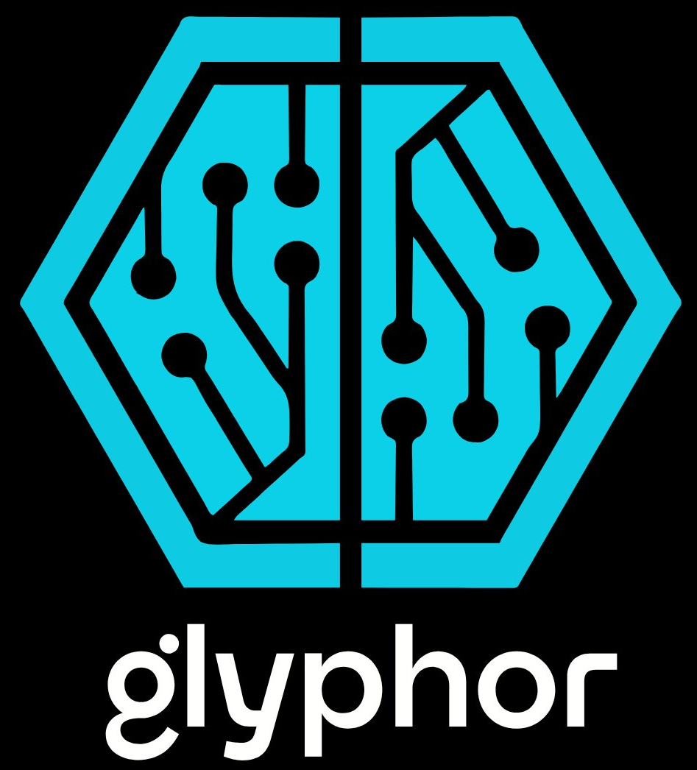

Strategic Analysis: Competitive Landscape
Autonomous Agents

CONFIDENTIAL
Glyphor, Inc.

Section Heading

This founder-grade strategy report analyzes the competitive landscape for Glyphor, focusing on its dual-engine ecosystem: Glyphor Fuse (Autonomous Development Teams/ADT) and Glyphor Pulse (AI Video/Creative). As of early 2026, the autonomous AI agent market is experiencing explosive growth—projected to reach...
The 'Cursor vs. Devin Paradigm': The software engineering market is fundamentally bifurcated into continuous co-editing (Cursor) and task delegation (Devin). Glyphor ADT aligns with the delegation model. Therefore,...

Cross-Framework Insight
Cross-Framework Insight body text. Specific, evidenced, grounded.

KEY FINDING Critical information or decision point. One clear, direct statement.

Data Table
Metric | Value | Threshold | Status
CMO Performance | 0.60 | 0.65 | ⚠ Below
Success Rate | 74.6% | 85% | ⚠ Below
CLO Performance | 0.78 | 0.65 | ✓ Pass
Nexus Completion | 88.9% | 80% | ✓ Pass

