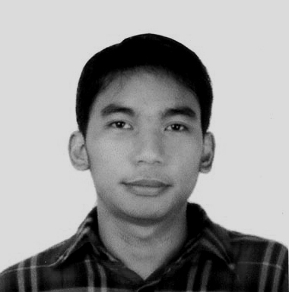
Dominique C. Larobis
76 Balaga Dr. Alopez Ext. Labangon Cebu City
Contact #: 09434891652
Email Address: larobisdominique@gmail.com

OBJECTIVES: To secure a full time position, In which i can provide my current skills, knowledge and understanding as well as be challenged so that I may further improve not only myself but the employer I am working for. I am assertive, self motivated person, I work best when I am challenged and given opportunity to improve.

EDUCATION:

University of Cebu Main
Bachelor of Science in Information Technology
Sanciangko Street, Cebu City

Computer Technician
Accumulated 48 training hours
Tesda Compound, Archbishop Reyes Avenue Cebu City

WORKING EXPERIENCE:

February 2008 – 2009
ACS, A Xerox Company - 6th Floor Skyrise 2 Building IT Park, Lahug
Data Entry

PERSONAL INFORMATION:

Nick Name : Doms, Minik
Gender : Male
Age : 27
Date of Birth : June 5, 1986
Place of Birth : Manila
Civil Status : Single
Citizenship : Filipino
Height : 5’5
Weight : 120 lbs
Religion : Roman Catholic

CHARACTER REFERENCES:

Lester R. Laborte Project Development Officer II
DSDW Field Office 7
M.J. Cuenco Ave. cor Gen. Maxilom Ave., CC
0922-687-5775

April Acebedo Admin Specialist
Author Solutions Philippines, Inc.,
Asia Town IT Park, Lahug, 6000 Cebu City
0906-631-3071

Rolyn Soliman Assistant Junior Accountant
Price Gases Inc
Tintay, Talamban
09225921177

