JAY HAYAG
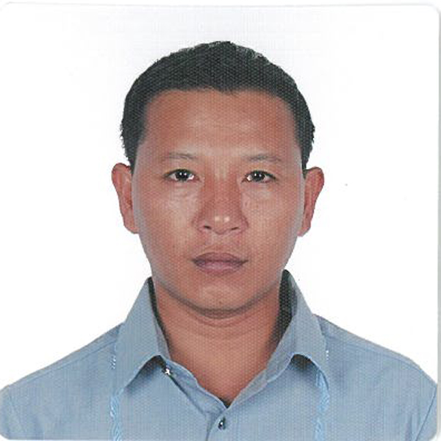
incotitoi11@gmail.com
Mobile # 09232718771

OBJECTIVE:
To work efficiently, effectively, and economically in the attainment of the company’s aims and objectives.

PERSONAL BACKGROUND

City Address : Bacayo Ext. corner Andres Abellana Sts., Guadalupe, Cebu City
Permanent Address : Banga, Bayawan City, Negros Oriental
Date of Birth : June 23, 1974
Place of Birth : Davao General Hospital, Davao City
Height : 5’2”
Weight (kls) : 60 kls
Civil Status : Married
Father : Felix Quiniquito
Occupation : Environmental Aide (Bayawan City Hall, Bayawan City, Negros Oriental) - retired
Mother : Delia Francisco Hayag
Occupation : Elementary School Teacher

EDUCATIONAL BACKGROUND

Elementary : Banga Central School (Bayawan City) 1986
High School : Negros Oriental National Agricultural School (Bayawan City) 1990
College : Bayawan College (Bayawan City) 1996
Course : Bachelor in Sendary Education Major in Mathematics
Examination Passed : Licensure Examination for Teachers (August, 1997)

WORK EXPERIENCES

Teacher : Bayawan College, Bayawan City (June1996-March 1999)
Physics Teacher : Negros Oriental State University, Bayawan Campus (June 1999-Mar 2000)
Teacher : Bayawan College, Bayawan City (June 2000 – March 2004)

Merchandiser : Megapharm Kheim Philippines Inc, Talamban Cebu City (May2004-June 2005)
Job Description:
- Ensure product off take at Colonnade Supermarket
- Pick up purchase orders in the absence of the salesman
- Ensure stock availability in the outlet

Salesman : Cord Chemicals Inc., Tisa, Cebu City (June 2005- June 2007
Area of Assignment : Negros Oriental, Siquijor, Lapulapu, Mandaue, Northern Cebu & Leyte
Job Description :
- Conduct sales and collection in the area assigned.
- Increase sales by including new products availability.
- Increase sales by adding new accounts by leniently looking for new prospects.
- Conduct massive marketing and promotion in the area being assigned

Medical Sales Representative : Dynasty Pharmaceuticals, Sampaloc, Manila (October 2007 – January 2012) promoted to District Sales Manager for Western Visayas in June 2011
Area of Assignment : Negros and Siquijor Islands
Job Description/Accomplishments
- Open the market of cephalosporins of the company in Bacolod and Negros Occidental.
- Make product inclusions at Bacolod Adventist Medical Center, Bacolod City.
- Join biddings at Siquijor Provincial Hospital, San Jose Municipal Hall and WVRMC, Iloilo City
- Successful inclusion of the product lines to Angel Salazar Provincial Hospital, San Jose, Antique through the Provincial Government of Antique through CONSIGNMENT AGREEMENT.
- Successful tie-ups with doctors for certain product lines.
- Successful contract with Southern Negros Doctor’s Hospital, Kabankalan City
- Inclusion of the product at fronting drugstores and chain drugstore in Bacolod City

