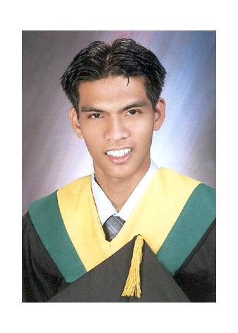

VIC ELLURAN SILVANO
39 Gochan Subd. Kabulakan Banawa Cebu City Philippines 6000
Contact number: 09102111287
Email Address: vicsil_05@yahoo.com

OBJECTIVE: To enhance my knowledge in job-related applications and to share my capabilities in rendering good service and good employee to the company.

PERSONAL DATA

Sex: Male
Civil Status: Single
Age: 30 years old
Birth Date: January 26, 1984
Place of Birth: Tuban Sta. Cruz Davao Del Sur
Citizenship: Filipino
Height: 5 ft. & 11 Inches
Weight: 160 lbs.
Religion: Roman Catholic
Language/Dialects: English, Visayan and Tagalog
Skills: Adobe Photoshop CC, Adobe After Effects CC, Adobe
Premiere CC, MS Office, VB 6.0 programming, xhtml tagging

WORK EXPERIENCE

NST Pictures Inc.
Skyrise 1 IT Park Lahug Cebu City

Graphic Artist / Editor September 2013 – December 2013
- To edit all pictures from the client using Adobe Photoshop Pro CC. Studies and familiarizes oneself with project rules, specifications and updates of the assigned project.
- After editing all the pictures we will put it into the Adobe After Effects which have the animation templates to make it cinematic pictures of the client.
- Mixing the music and editing video using the Adobe Premiere Pro CC.

Innodata Xml Content Factory Inc.
HVG IT Park Subangdaku, Mandaue City, Cebu

Production Associate & Specs Analyst 2007 – 2013
- Responsible for the execution of tasks in production such as encoding, data processing, formatting, scanning, checking and other tasks necessary in the delivery of the product to the client.
- Studies and familiarizes oneself with project rules, specifications and updates of the assigned project.
- Ensures that daily production output meets the quota and accuracy
requirements of the assigned task.
- Ensures that the steps specified and the work instructions are followed and in conformance to the specifications of the client.
- Performs other tasks and processes that may be assigned which are necessary and the capture, conversion and storage of data.

EDUCATIONAL BACKGROUND

    - College
Name of School: University of the Visayas
Graduated: College
Course: Associate in Computer Technology

    - High School
Name of School: Ramon Duterte Natoinal High School
Graduated: Secondary

    - Elementary
Name of School: Tuban Elementary School
Graduated: Primary

CHARACTER REFERENCES

Name: Roy Gumbao
Position: Senior Process Manager
Company Address: Innodata Xml Content Factory Inc.
HVG IT Park Subangdaku, Mandaue City, Cebu
Cell No.: (032)230-7000

Name: Marben Navarro
Position: Consultant Cocoresearch Institute, Inc.
Company Address: Rm. 806 richville corporate tower, madrigal
Business park, alabang, muntinlupa City
Cell No.: 09273889578
Email Add.: marben_navarro@yahoo.com

