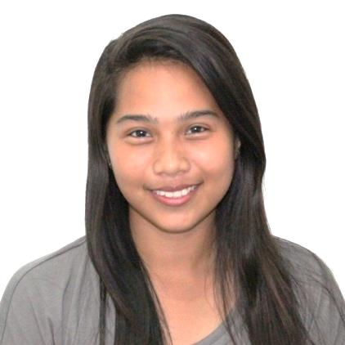**Ires P. Caya**

Calero, Lilo-an, Cebu City

cayaires@gmail.com

09235124642 / 09239333398

**OBJECTIVE**

I would like to work for a company that will enhance the skills I already have as well as provide the opportunity for personal and professional growth and advancement opportunities.

**EDUCATIONAL ATTAINMENT**

College Graduate – March 2014

**Bachelor of Science in Information Technology**

University of San Jose – Recoletos

Basak, Pardo, Cebu City

**WORK EXPERIENCE**

**OJT (Web Developer)**

Onomatopoeia Incorporated

Barangay Capitol Site, Cebu City, Cebu

**OJT (Data Entry)**

Social Security System

SSS Bldg., Osmena Blvd., Cebu City

**PERSONAL INFORMATION**

Age : 20

Date of Birth : March 04, 1994

Place of Birth : Cumpang, Tayud, Liloan, Cebu

Sex : Female

Civil Status : Single

Citizenship : Filipino

Religion : Roman Catholic

Language Used: English, Filipino, Cebuano

**COMPUTER SKILLS**

* Knowledgeable in Programming language (PHP, JAVA, and C++, C#, Codeigniter), Networking, Web Design, Proficient in Microsoft Office 2007 and older version (Word, Excel, and Power Point); CSS, HTML and other computer applications.

**SUMMARY OF SKILLS**

* Is computer literate
* Has good communication skills
* Has good interpersonal skills
* Can work on less supervision
* Has strong attention to detail and analytical skills
* Self-motivated, patient, competent, and well-determined

**CHARACTER REFERENCES**

**ENGR. GENE ABELLO**

Computer Programming I Teacher, Object Oriented Programming II Teacher, Database Systems II Teacher

College of Information, Computer and Communications Technology

University of San Jose – Recoletos

(032) 417-9500/local 122

**MRS. MA. LORNA D. MIRO**

Computer Programming II Teacher, Data Structures and Algorithms Teacher

College of Information, Computer and Communications Technology

University of San Jose - Recoletos

(032) 417-9500/local 122

**MRS. JOSEPHINE PETRALBA**

Database Systems I Teacher, System Analysis and Design Teacher,

College of Information, Computer and Communications Technology

University of San Jose-Recoletos

(032) 417-9500/local 122

**MR. EMERSON ALLER**

English Teacher

College of Arts and Sciences Teacher

University of San Jose – Recoletos

09327356113