**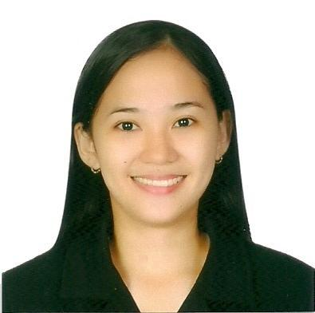  
Christine C. Tampus**  
Humay-Humay Lapu-Lapu City  
Cebu City, 6015  
Cellphone no. 09322131859  
Email Add : [christinetampus94@gmail.com](mailto:christinetampus94@gmail.com)

**OBJECTIVE:**

To obtain a position that will enable me to use my strong educational background, and ability to work well with people.

**PERSONAL DETAILS:**

* Date of Birth : March 06, 1994
* Place of Birth : Humay-Humay Lapu-Lapu, Cebu
* Age : 20
* Sex : Female
* Civil Status : Single
* Nationality : Filipino
* Religion : Roman Catholic
* Height : 5’2”
* Weight : 48 kgs
* Father’s Name : Marcelo R. Tampus
* Occupation : Self Employed
* Mother’s Name : Alfonsa C. Tampus
* Occupation : Self Employed
* Language spoken : English, Tagalog, Cebuano

**EDUCATION SUMMARY:**

* BACHELOR OF SCIENCE IN COMPUTER SCIENCE

University of Cebu Lapu-lapu and Mandaue Campus

A.C Cotes Avenue, Looc, Mandaue City, Philippines

Graduated - April 02, 2014

* SECONDARY EDUCATION

Pajo National High School

Pajo Lapu-lapu City

* PRIMARY EDUCATION

Central Elementary School

Looc Lapu-lapu City

**PROFESSIONAL STRENGTHS:**

* Self Motivated and Determined
* Fast learner
* **Learning agility and effective personal communication skills**
* Ability to work in a team and under pressure
* Hardworking and Self Confidence

**TECHNICAL PROFICIENCY:**

* Languages: Java, Visual Basic, PHP, C#, HTML
* Applications: MS Visual Studio, MS Office, Adobe
* Database Systems: DB2, Access

**ADDITIONAL DETAILS**

**INTEREST AND HOBBIES**

Surfing Net  
Playing Volleyball, Badminton  
Photo Editing  
Dancing  
Reading Books

**REFERENCES:**  
Neil Marvin J. Gerson  
Layout Designer  
Xlibris Philippines Inc  
Asiatown IT Park Apas, Cebu City 6000  
Cellphone no. 09227722271  
  
Mr. Japeth Lahaylahay

Teacher

College of Computer Studies

Cellphone no.092336162694

I hereby affirm that the above information is correct and true to the best of my knowledge and belief.

CHRISTINE C. TAMPUS