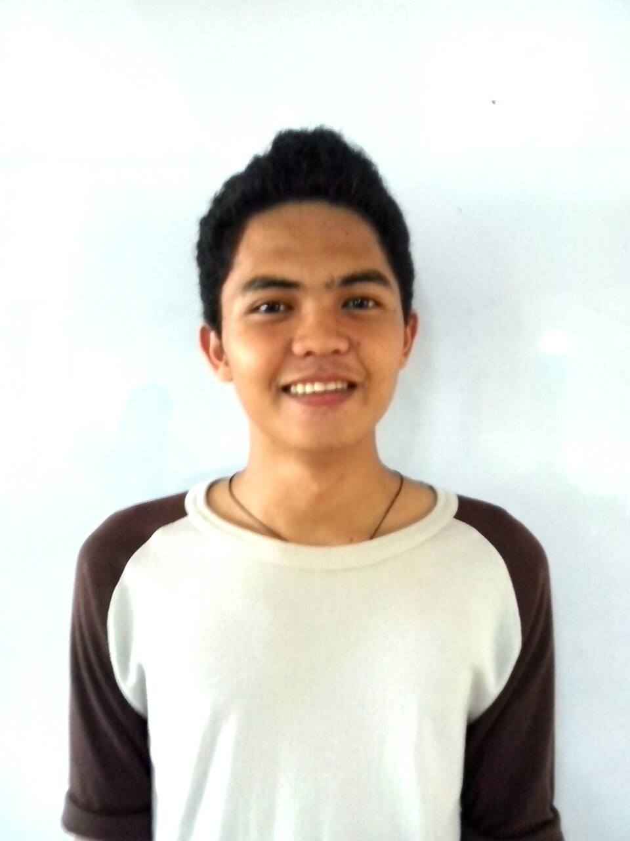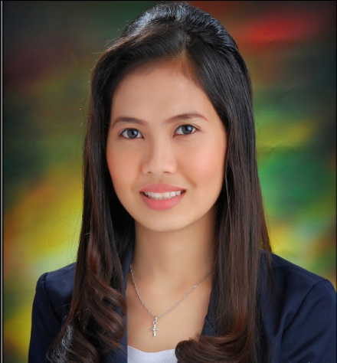Resumé

**LORENCIANO S. DRAMAYO**

Soong 1, Mactan, Lapu-Lapu City 6015

0943-824-1707 / (032) 239-1923

superirevenge@yahoo.com

**PERSONAL INFORMATION**

Date of Birth : March 18, 1994

Place of Birth : Mactan Lapu-Lapu City, Cebu

Civil Status : Single

Nationality : Filipino

Religion : Roman Catholic

Dialect Spoken : Cebuano, Filipino, English

Mother’s Name : Lucille S. Dramayo

Father’s Name : Leopoldo C. Dramayo

**EDUCATIONAL BACKGROUND**

Tertiary : ***University of Cebu Lapu-Lapu and Mandaue***

(2010 – 2014) Bachelor of Science in Information Technology

A.C Cortes Ave., Looc Mandaue City

Secondary : ***University of Cebu in Lapu-lapu and Mandaue***

(2006 – 2010) A.C. Cortes Avenue, Looc, Mandaue City

Primary : ***Soong Elementary School***

(2000 – 2006) Soong Center, Mactan, Lapu-lapu City

**WORK EXPERIENCE**

**April - June 2013: *Coralpoint Group of Companies, Inc.***

2nd floor Mactan Marina Mall,

Lapu-Lapu City 6015

On-the-Job Trainee

**EXTRA AND CO-CURRICULAR INVOLVEMENT**

* Member of University of Cebu – College of Computer Studies Computer Technologist Alliance (UCLM-CCS-CTA)
* Member of College of Computer Studies – Elite Programmers (CCS-EP)
* Member of University of Cebu – College of Computer Studies Computer Technologist Alliance Officer (2012-2014)
* Joined UCLM CCS Java Competition (2011-2012) – awarded as 2nd Place.
* 1st placer in Web Designing Contest held at UCLM(2011-2012)
* Complied Cisco Certificate(Cisco 1 - Cisco 4)

**SEMINARS/TRAININGS ATTENDED**

February 2011 : ***I.T. Trend Seminar***

University of Cebu Lapu-Lapu and Mandaue, A.C. Cortes Ave.,

Looc Mandaue City Cebu.

February 2011 : ***PHP Seminar***

University of Cebu Lapu-Lapu and Mandaue, A.C. Cortes Ave.,

Looc Mandaue City Cebu.

August 2011 : ***Study Habits Seminar***

University of Cebu Lapu-Lapu and Mandaue, A.C. Cortes Ave.,

Looc Mandaue City Cebu.

September 2012 : ***Grammarly Seminar***

University of Cebu Lapu-Lapu and Mandaue, A.C. Cortes Ave.,

Looc Mandaue City Cebu.

February 2013 : ***ICT Congress Smart Seminar***

New Cebu Coliseum Complex, Sanciangko St., Cebu City

December 2013 : ***iOS Basics Seminar***

University of Cebu Lapu-Lapu and Mandaue, A.C. Cortes Ave.,

Looc Mandaue City Cebu.

December 2013 : ***C# Seminar***

University of Cebu Lapu-Lapu and Mandaue, A.C. Cortes Ave.,

Looc Mandaue City Cebu.

January 2014 : ***Software Testing Strategies Seminar***

University of Cebu Lapu-Lapu and Mandaue, A.C. Cortes Ave.,

Looc Mandaue City Cebu.

January 2014 : ***Cloud Computing Seminar***

University of Cebu Lapu-Lapu and Mandaue, A.C. Cortes Ave.,

Looc Mandaue City Cebu.

February 2014 : ***Technopreneurship Seminar***

SM City Cebu Trade Hall

**CHARACTER REFERENCES**

**MS. AURORA C. MIRO** Chairperson/Dean – CCS Department University of Cebu LapuLapu & Mandaue A.C Cortes Ave., Looc Mandaue City 0932-865-4524

**MS. ANALLY B. ALLABA**Faculty Member – CCS Department(Cisco)   
University of Cebu LapuLapu & Mandaue  
A.C Cortes Ave., Looc Mandaue City   
0908-559-4656

**MS. SHEILA MARIE ALEGRADO**Technical Support Representative  
TeleTech Customer Management Center  
Oakridge IT Center, 880 A.S. Fortuna St., Mandaue City  
0923-149-7857

**Applicant’s Signature**